Feature Selection

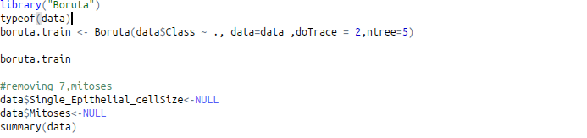

C4.5 Classifier

Fuzzy K means

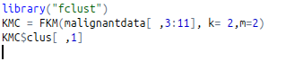

knn

k means

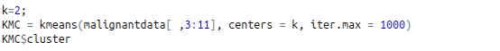
fuzzy knn
