# Login to the Postgres container

# Now connect the container to psql db.

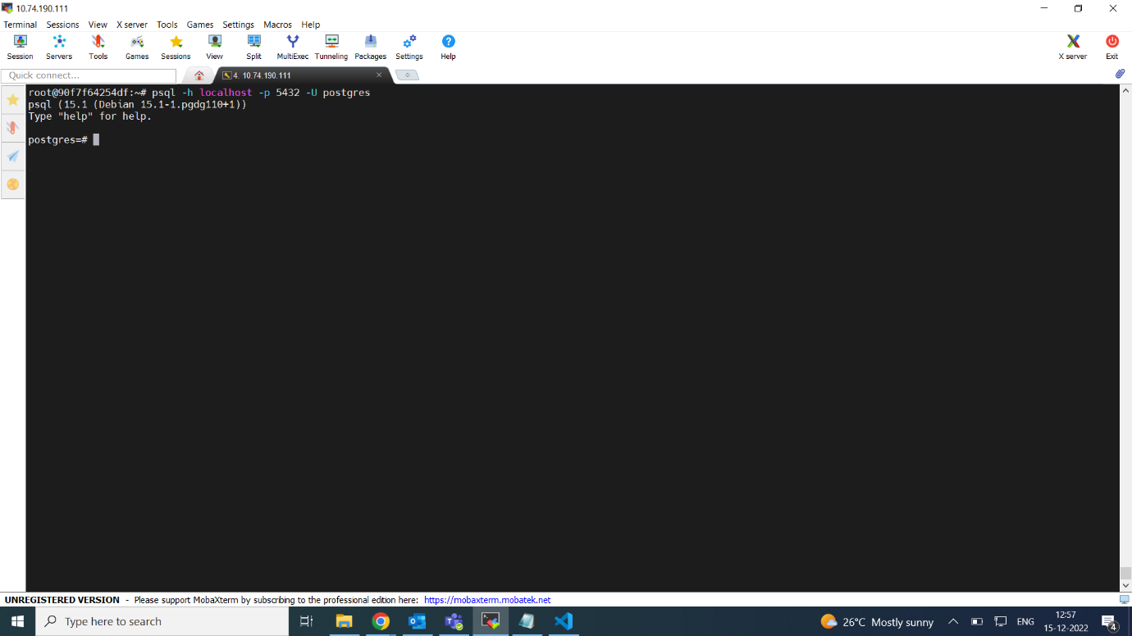

# Create a new DB in postgres and create a new User with Password Make User as Super User, Grant all Admin access to User

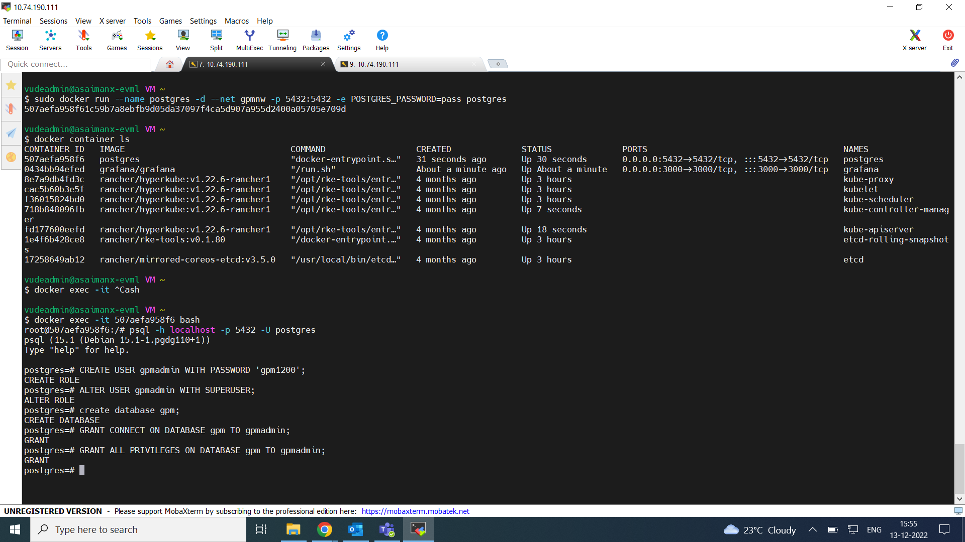

# Create Table and Insert records into Jira table from csv file

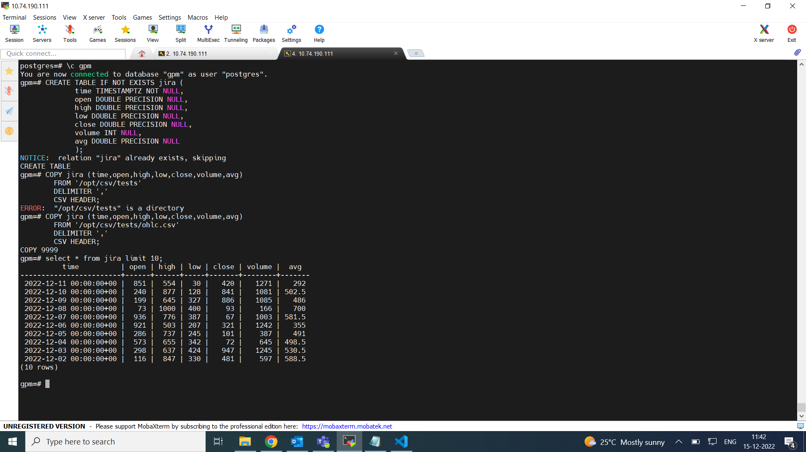

# Login to Grafana and create the PostgreSQL Data source

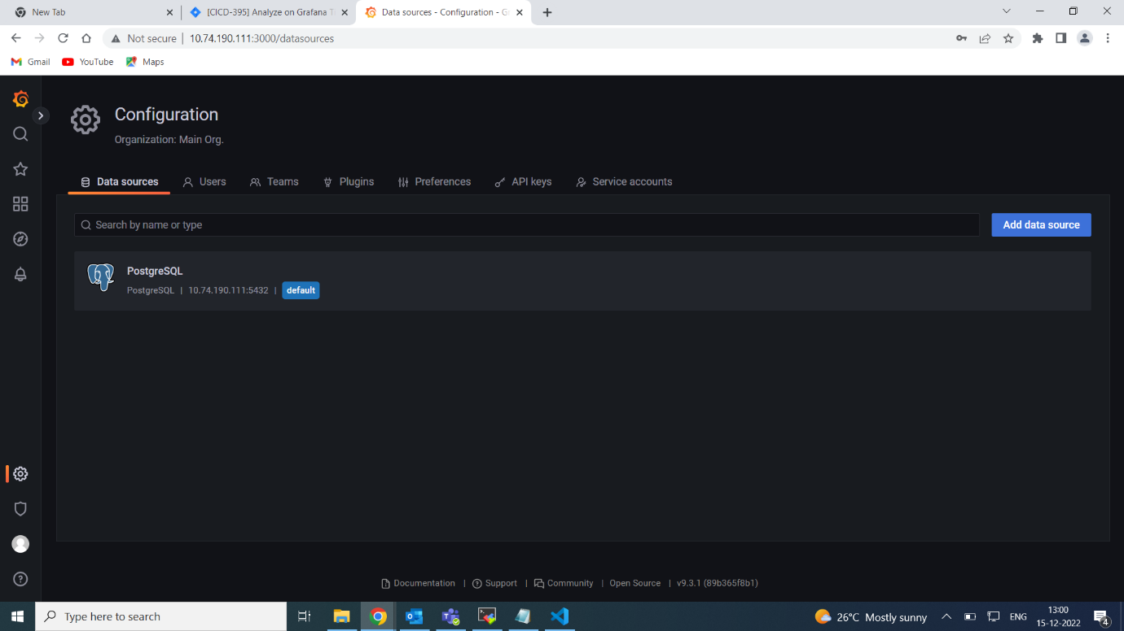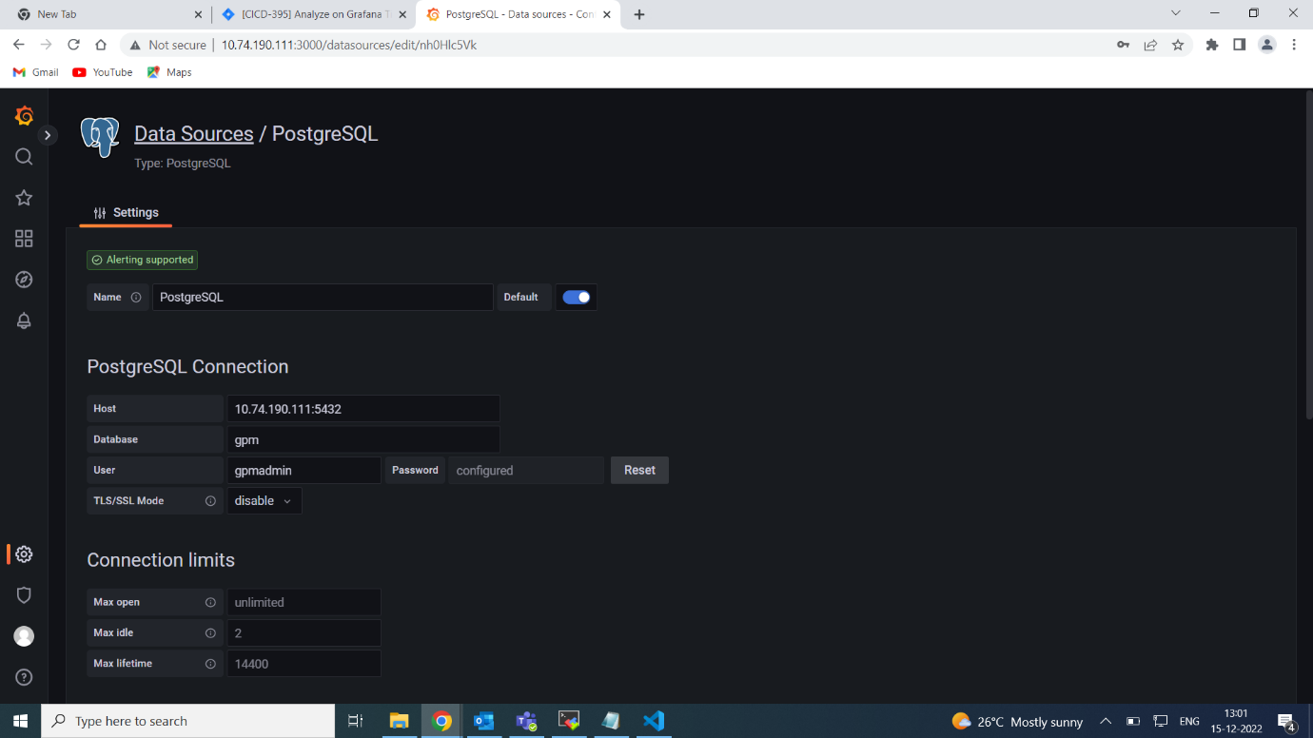

# Create the New dashboard and add a new panel

# Add query in PostgreSQL data source

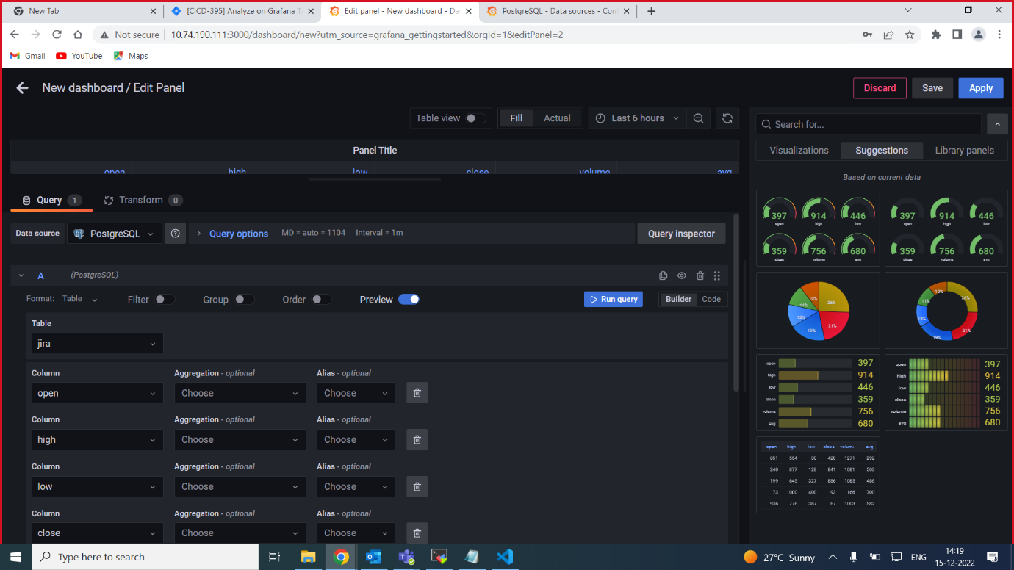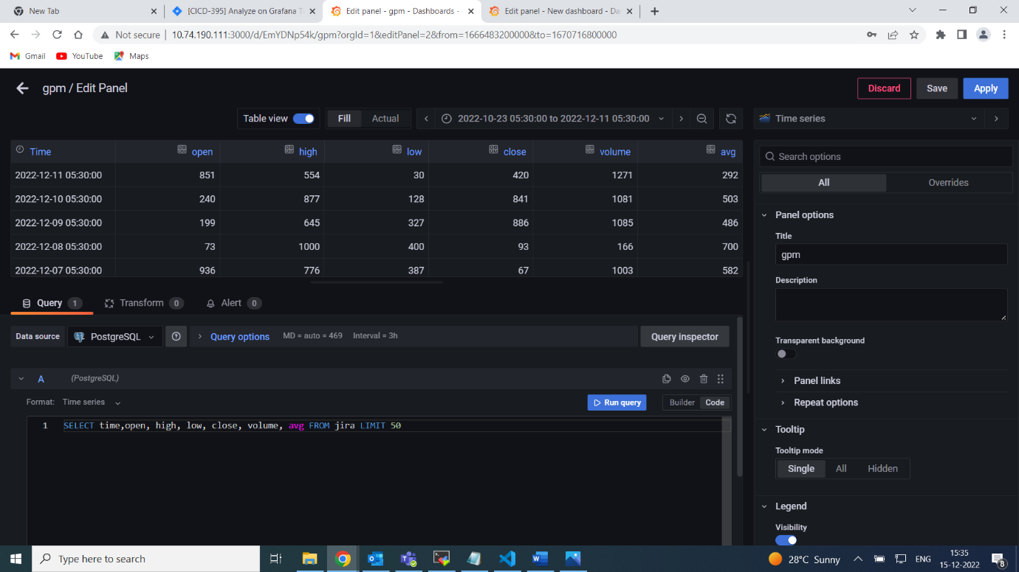

# Select Time series graph for visualization

