# **Enterprise Java**

**Practical**

**Name: - Shivbahadur Vishwakarma**

**Roll No: - 44**

**BSc. IT SEM: - V**

**Collage: MVLU Andheri East**

Practical 1a)

**Index.html** –

Code: -

<html><head><title>Calculator App </title></head><body>

<form action="CalculateServlet" >

Enter First Number <input type="text" name="txtN1" ><br>

Enter Second Number <input type="text" name="txtN2"

><br>

Select an Operation

<input type="radio" name="opr" value="+">ADDTION

<input type="radio" name="opr" value="-">SUBSTRACTION

<input type="radio" name="opr" value="*">MULTIPLY

<input type="radio" name="opr" value="/">DIVIDE <br>

<input type="reset">

<input type="submit" value="Calculate" >

</form></body></html>

################################

**CalculateServlet.java –**

**Code: -**

import java.io.IOException;

import java.io.PrintWriter;

import javax.servlet.ServletException;

import javax.servlet.http.HttpServlet;

import javax.servlet.http.HttpServletRequest;

import javax.servlet.http.HttpServletResponse;

public class CalculateServlet extends HttpServlet {

public void doGet(HttpServletRequest request, HttpServletResponse response)

throws ServletException, IOException {

response.setContentType("text/html;charset=UTF-8");

PrintWriter out = response.getWriter();

out.println("<htmi><head><title>Serviet CalculatorServiet</title></head><body>");

double n1 = Double.parseDouble(request.getParameter("txtN1"));

double n2 = Double.parseDouble(request.getParameter("txtN2"));

double result =0;

String opr=request.getParameter("opr");

if(opr.equals("+")) result=n1+n2; if(opr.equals("-")) result=n1-n2;

if(opr.equals("*")) result=n1*n2; if(opr.equals("/")) result=n1/n2;

out.println("<h1> Result = "+result); out.println("</body></html>");

}

}

**Output: - Practical 1a)**

**Input value**

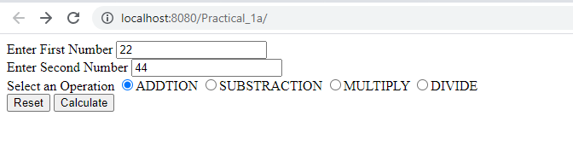

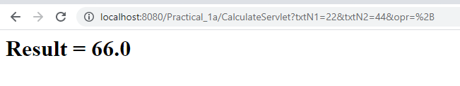

**########################### Practical 1b #################################**

**Q. Create a servlet for a Login page. If the username and password are correct then it says message "Hello<username>" else a message "login failed".**

**Code:**

**Index.html**

<html>

<head>

<title>Login Form </title>

</head>

<body>

<form action="LoginServlet" >

Enter User ID <input type="text" name="username" ><br>

Enter Password <input type="Password" name="Password"><br>

<input type="reset">

<input type="submit" value="Click to Login" >

</form>

</body

</html>Top of Form

**LoginServlet.java**

import java.io.IOException;

import java.io.PrintWriter;

import javax.servlet.ServletException;

import javax.servlet.http.HttpServlet;

import javax.servlet.http.HttpServletRequest;

import javax.servlet.http.HttpServletResponse;

public class LoginServlet extends HttpServlet {

public void doGet(HttpServletRequest request, HttpServletResponse response)

throws IOException{

response.setContentType("text/html;charset=UTF-8");

try (PrintWriter out = response.getWriter()) {

String uname = request.getParameter("username");

String Password = request.getParameter("Password");

if(uname.equals("admin") && Password.equals("12345"))

{

out.println("<body bgcolor=blue> ");

out.println("<h1>Welcome !!! " + uname);

}

else

{

out.println("<body bgcolor=red>");

out.println("<h1>Login Failed");

}

}

}

}

**Output:**

**Login form**

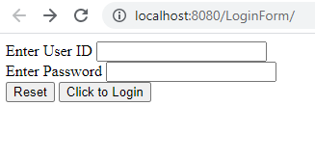

**Login successful**

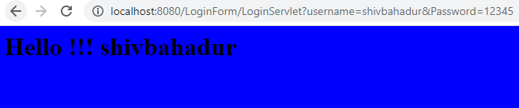

**Login failed**

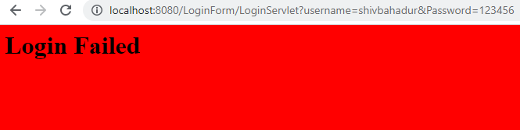

############################ Practical -1c #################################

**Q**. **Create a registration servlet in java using JDBC. Accept the details such as Username, Password, Email, and Country from the user using HTML Form and store the registration details in the database.**

Code:-

**Index.html -**

<!DOCTYPE html>

<html><head><title>Registration Page</title></head>

<body>

<form action="RegisterServlet" >

<H1>Welcome to Registration page</H1>

Enter User Name <input type="text" name="txtUid"><br>

Enter Password <input type="password" name="txtPass"><br>

Enter Email <input type="text" name="txtEmail" ><br>

Enter Country <input type="text" name="txtCon" ><br>

<input type="reset" ><input type="submit" value="REGISTER" >

</form>

</body>

</html>

**RegisterServlet.java -**

import java.io.IOException;

import java.io.PrintWriter;

import java.sql.*;

import javax.servlet.ServletException;

import javax.servlet.http.HttpServlet;

import javax.servlet.http.HttpServletRequest;

import javax.servlet.http.HttpServletResponse;

public class RegisterServlet extends HttpServlet {

public void doGet(HttpServletRequest request, HttpServletResponse response)

throws ServletException, IOException {

response.setContentType("text/html;charset=UTF-8");

PrintWriter out = response.getWriter();

String id = request.getParameter("txtUid");

String ps = request.getParameter("txtPass");

String em = request.getParameter("txtEmail");

String co = request.getParameter("txtCon");

try{

Class.forName("com.mysql.jdbc.Driver");

Connection con =DriverManager.getConnection("jdbc:mysql://192.168.59.129:3306/LoginDB?useSSL=false","shiv","shiv@123");

PreparedStatement pst = con.prepareStatement("insert into user values(?,?,?,?)");

pst.setString(1,id);

pst.setString(2,ps);

pst.setString(3,em);

pst.setString(4,co);

int row = pst.executeUpdate();

out.println("<h1>"+row+ " Inserted Succesfullyyyyy");

}catch(Exception e){out.println(e);}

}

}

**Output: -**

**Input Page-**

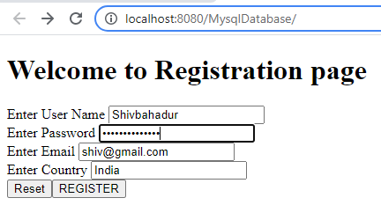

**Successful entry in MySQL Database -**

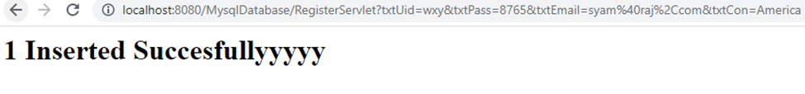

**MySQL Database Entry Output: -**

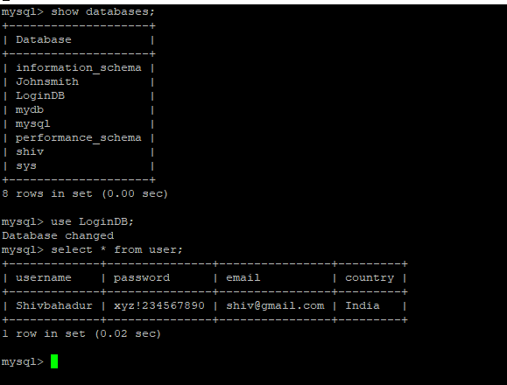

**~~~~~~~~~~~~~~~~~ Practical 2 a ~~~~~~~~~~~~~~~**

**Q.** Using Request Dispatcher Interface create a Servlet which will validate the password entered by the user, if the user has entered "Servlet" as password, then he will be forwarded to Welcome Servlet else the user will stay on the index.html page and an error message will be displayed.

**Code :-**

index.html –

<!DOCTYPE html>

<html>

<head>

<title>Login Form</title></head>

<form action="LoginServlet">

Enter User ID<input type="text" name="uname"><br>

Enter Password<input type="password" name="upass"><br>

<input type="reset">

<input type="submit" value="CLick to Login">

</form>

</html>

**LoginServlet.java –**

import java.io.IOException;

import java.io.PrintWriter;

import javax.servlet.ServletException;

import javax.servlet.http.HttpServlet;

import javax.servlet.http.HttpServletRequest;

import javax.servlet.http.HttpServletResponse;

import javax.servlet.RequestDispatcher;

public class LoginServlet extends HttpServlet {

public void doGet(HttpServletRequest request, HttpServletResponse response)

throws ServletException, IOException {

response.setContentType("text/html;charset=UTF-8");

PrintWriter out = response.getWriter();

out.println("<html><head>");

out.println("<title>Servlet LoginServlet</title></head>");

String uname = request.getParameter("uname");

String upass = request.getParameter("upass");

if(uname.equals("shivbahadur") && upass.equals("password123")){

RequestDispatcher rd = request.getRequestDispatcher("WelcomeServlet");

rd.forward(request, response);

}

else{

out.println("<body bgcolor=red >");

out.println("<h1> Login Fail !!! </h1>");

RequestDispatcher rd = request.getRequestDispatcher("/index.html");

rd.include(request, response);

}

out.println("</body>");

out.println("</html>");

}

}

**WelcomeServlet.java –**

import java.io.IOException;

import java.io.PrintWriter;

import javax.servlet.ServletException;

import javax.servlet.http.HttpServlet;

import javax.servlet.http.HttpServletRequest;

import javax.servlet.http.HttpServletResponse;

import javax.servlet.RequestDispatcher;

public class WelcomeServlet extends HttpServlet {

public void doGet(HttpServletRequest request, HttpServletResponse response)

throws ServletException, IOException {

response.setContentType("text/html;charset=UTF-8");

PrintWriter out = response.getWriter();

out.println("<html><head>");

out.println("<title>Servlet LoginServlet</title></head>");

String u = request.getParameter("uname");

out.println("<body bgcolor=blue>");

out.println("<h1> Welcome to the Servlet page !!!!!!! </h1>" + u + "Roll number 44");

out.println("</body>");

out.println("</html>");

}

}

**Output –**

**Login page-**

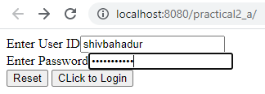

**Login Success-**

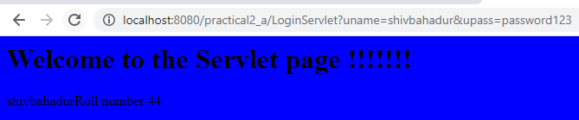

**Login Failed –**

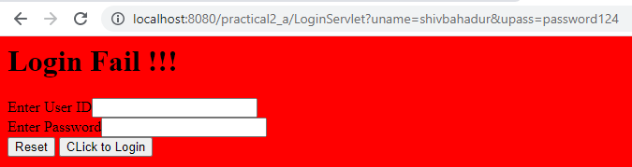

Bottom of Form