finder = find_lr(model, 0.003, 0.03)

Epoch 1/1

360/360 [==============================] - 233s 647ms/step - loss: 8.5006 - gender_output_loss: 0.7230 - image_quality_output_loss: 1.0490 - age_output_loss: 1.5210 - weight_output_loss: 1.0980 - bag_output_loss: 0.9941 - footwear_output_loss: 1.0850 - pose_output_loss: 1.0044 - emotion_output_loss: 1.0261 - gender_output_acc: 0.5340 - image_quality_output_acc: 0.5240 - age_output_acc: 0.3723 - weight_output_acc: 0.6114 - bag_output_acc: 0.5314 - footwear_output_acc: 0.4456 - pose_output_acc: 0.5978 - emotion_output_acc: 0.7002 - val_loss: 8.2040 - val_gender_output_loss: 0.7004 - val_image_quality_output_loss: 1.0024 - val_age_output_loss: 1.5100 - val_weight_output_loss: 1.0486 - val_bag_output_loss: 0.9560 - val_footwear_output_loss: 1.0496 - val_pose_output_loss: 0.9519 - val_emotion_output_loss: 0.9851 - val_gender_output_acc: 0.5500 - val_image_quality_output_acc: 0.5520 - val_age_output_acc: 0.3623 - val_weight_output_acc: 0.6374 - val_bag_output_acc: 0.5542 - val_footwear_output_acc: 0.4510 - val_pose_output_acc: 0.6170 - val_emotion_output_acc: 0.7120

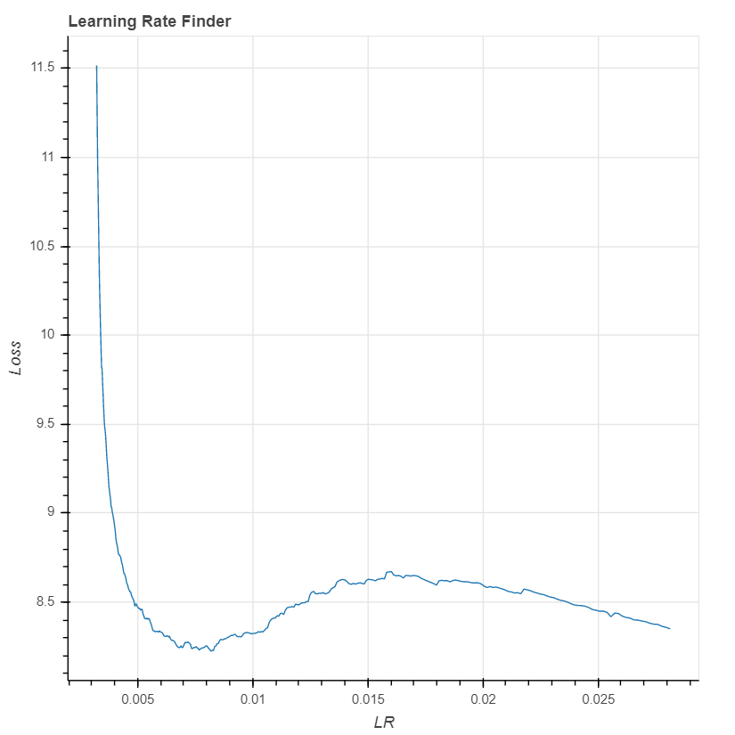

finder = find_lr(model, 0.0003, 0.003)

Epoch 1/1

360/360 [==============================] - 233s 647ms/step - loss: 8.2864 - gender_output_loss: 0.7186 - image_quality_output_loss: 1.0316 - age_output_loss: 1.5024 - weight_output_loss: 1.0501 - bag_output_loss: 0.9646 - footwear_output_loss: 1.0622 - pose_output_loss: 0.9812 - emotion_output_loss: 0.9757 - gender_output_acc: 0.5332 - image_quality_output_acc: 0.5177 - age_output_acc: 0.3589 - weight_output_acc: 0.6060 - bag_output_acc: 0.5272 - footwear_output_acc: 0.4610 - pose_output_acc: 0.5874 - emotion_output_acc: 0.6999 - val_loss: 9.1461 - val_gender_output_loss: 0.7154 - val_image_quality_output_loss: 1.1286 - val_age_output_loss: 1.7201 - val_weight_output_loss: 1.1366 - val_bag_output_loss: 1.0508 - val_footwear_output_loss: 1.1165 - val_pose_output_loss: 1.1003 - val_emotion_output_loss: 1.1779 - val_gender_output_acc: 0.5558 - val_image_quality_output_acc: 0.5450 - val_age_output_acc: 0.3824 - val_weight_output_acc: 0.5734 - val_bag_output_acc: 0.4705 - val_footwear_output_acc: 0.5133 - val_pose_output_acc: 0.5572 - val_emotion_output_acc: 0.7109

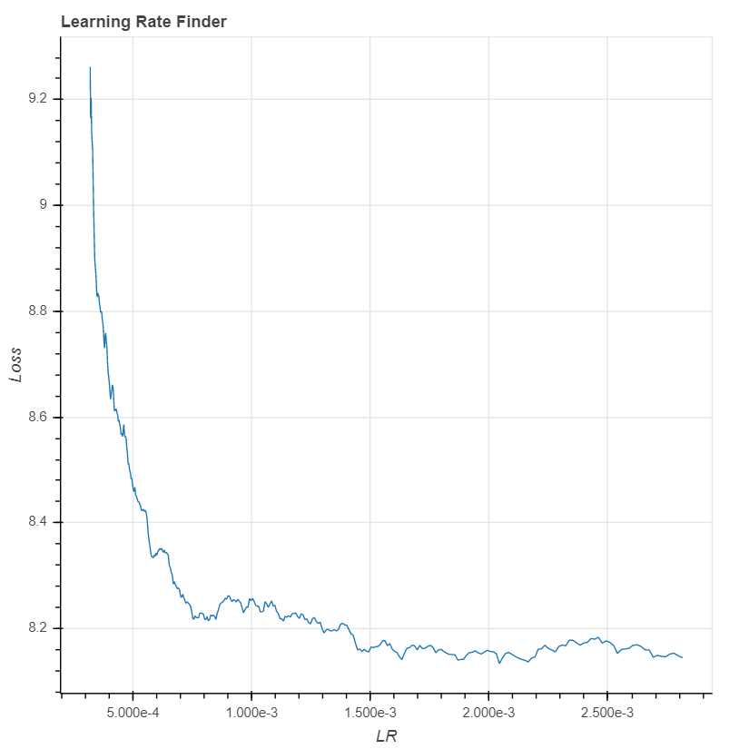

finder = find_lr(model, 0.00003, 0.0003)

Epoch 1/1

360/360 [==============================] - 109s 303ms/step - loss: 8.5906 - gender_output_loss: 0.7517 - image_quality_output_loss: 1.0850 - age_output_loss: 1.5218 - weight_output_loss: 1.0783 - bag_output_loss: 1.0209 - footwear_output_loss: 1.1234 - pose_output_loss: 1.0075 - emotion_output_loss: 1.0019 - gender_output_acc: 0.5226 - image_quality_output_acc: 0.4798 - age_output_acc: 0.3377 - weight_output_acc: 0.6061 - bag_output_acc: 0.4853 - footwear_output_acc: 0.4263 - pose_output_acc: 0.5713 - emotion_output_acc: 0.6957 - val_loss: 8.2634 - val_gender_output_loss: 0.7104 - val_image_quality_output_loss: 1.0411 - val_age_output_loss: 1.5387 - val_weight_output_loss: 1.0451 - val_bag_output_loss: 0.9557 - val_footwear_output_loss: 1.0397 - val_pose_output_loss: 0.9765 - val_emotion_output_loss: 0.9561 - val_gender_output_acc: 0.5432 - val_image_quality_output_acc: 0.5378 - val_age_output_acc: 0.3874 - val_weight_output_acc: 0.6274 - val_bag_output_acc: 0.5196 - val_footwear_output_acc: 0.4621 - val_pose_output_acc: 0.6014 - val_emotion_output_acc: 0.7082

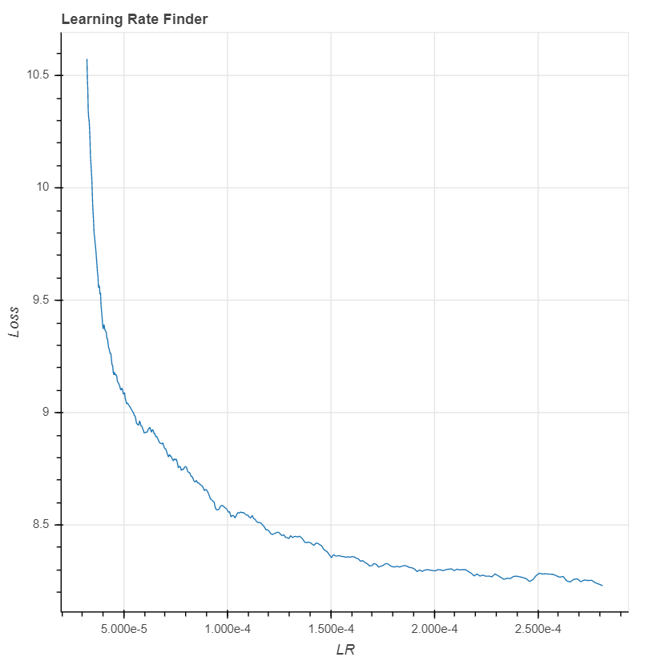

finder = find_lr(model, 0.000003, 0.00003)

Epoch 1/1

360/360 [==============================] - 108s 300ms/step - loss: 9.4017 - gender_output_loss: 0.8174 - image_quality_output_loss: 1.1944 - age_output_loss: 1.6175 - weight_output_loss: 1.1610 - bag_output_loss: 1.2235 - footwear_output_loss: 1.2246 - pose_output_loss: 1.0833 - emotion_output_loss: 1.0800 - gender_output_acc: 0.5021 - image_quality_output_acc: 0.4023 - age_output_acc: 0.2859 - weight_output_acc: 0.5791 - bag_output_acc: 0.3656 - footwear_output_acc: 0.3724 - pose_output_acc: 0.5030 - emotion_output_acc: 0.6637 - val_loss: 8.3405 - val_gender_output_loss: 0.7232 - val_image_quality_output_loss: 1.0377 - val_age_output_loss: 1.5048 - val_weight_output_loss: 1.0602 - val_bag_output_loss: 0.9624 - val_footwear_output_loss: 1.0979 - val_pose_output_loss: 0.9771 - val_emotion_output_loss: 0.9772 - val_gender_output_acc: 0.5341 - val_image_quality_output_acc: 0.5405 - val_age_output_acc: 0.3566 - val_weight_output_acc: 0.6052 - val_bag_output_acc: 0.5497 - val_footwear_output_acc: 0.4085 - val_pose_output_acc: 0.5961 - val_emotion_output_acc: 0.7116

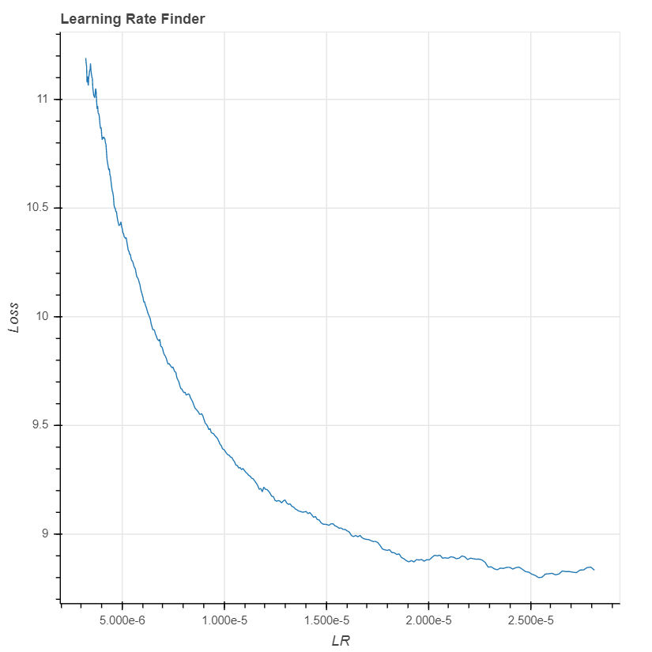

finder = find_lr(model, 0.0000003, 0.000003)

Epoch 1/1

360/360 [==============================] - 109s 302ms/step - loss: 10.6623 - gender_output_loss: 0.9290 - image_quality_output_loss: 1.4551 - age_output_loss: 1.7370 - weight_output_loss: 1.2381 - bag_output_loss: 1.6897 - footwear_output_loss: 1.3330 - pose_output_loss: 1.1638 - emotion_output_loss: 1.1167 - gender_output_acc: 0.4674 - image_quality_output_acc: 0.2766 - age_output_acc: 0.2301 - weight_output_acc: 0.5356 - bag_output_acc: 0.1742 - footwear_output_acc: 0.3157 - pose_output_acc: 0.3990 - emotion_output_acc: 0.6227 - val_loss: 9.1232 - val_gender_output_loss: 0.7532 - val_image_quality_output_loss: 1.1443 - val_age_output_loss: 1.5856 - val_weight_output_loss: 1.1647 - val_bag_output_loss: 1.2155 - val_footwear_output_loss: 1.1774 - val_pose_output_loss: 1.0443 - val_emotion_output_loss: 1.0382 - val_gender_output_acc: 0.5000 - val_image_quality_output_acc: 0.3700 - val_age_output_acc: 0.2558 - val_weight_output_acc: 0.5766 - val_bag_output_acc: 0.2893 - val_footwear_output_acc: 0.3595 - val_pose_output_acc: 0.5058 - val_emotion_output_acc: 0.6887

