Recently, new tools designed to simplify the interaction between humans and computers have hit the market: Chatbots or Virtual Assistants. In banking, chatbots and virtual assistants are some of the industry’s newest tools designed to simplify the interaction between humans and computers.

What exactly is a chatbot?
A chatbot is an artificial intelligence (AI) software that can simulate a conversation (or a chat) with a user in natural language through messaging applications, websites, mobile apps or through the telephone.
Why are chatbots important? A chatbot is often described as one of the most advanced and promising expressions of interaction between humans and machines. However, from a technological point of view, a chatbot only represents the natural evolution of a Question Answering system leveraging Natural Language Processing (NLP). Formulating responses to questions in natural language is one of the most typical Examples of Natural Language Processing applied in various enterprises’ end-use applications.

Behind the scenes: How a chatbot works
There are two different tasks at the core of a chatbot:
- user request analysis
- returning the response
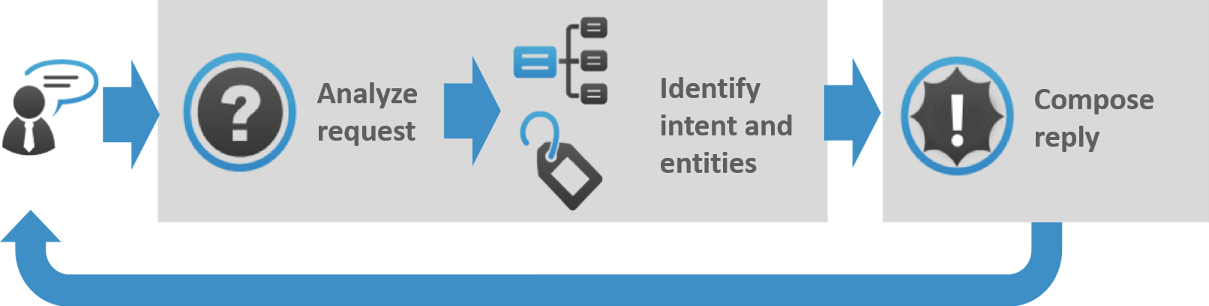

How Chatbot Works
How a Chatbot Works: As you can see in this graphic, a chatbot returns a response based on input from a user. This process may look simple; in practice, things are quite complex.

User request analysis: this is the first task that a chatbot performs. It analyzes the user’s request to identify the user intent and to extract relevant entities.
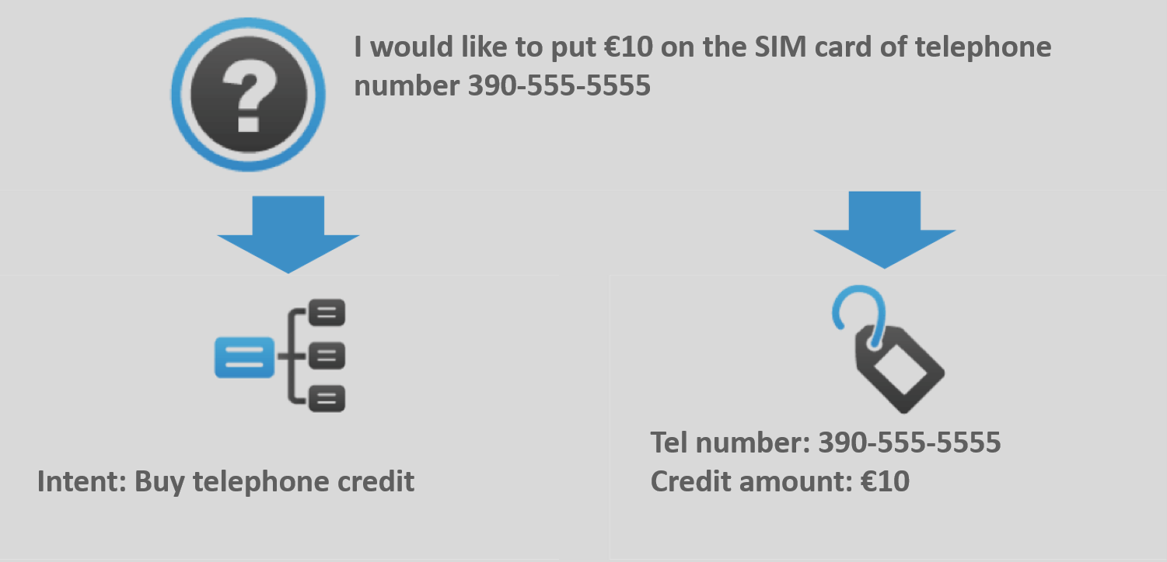

How a Chatbot Works: Example of user request analysis.
The ability to identify the user’s intent and extract data and relevant entities contained in the user’s request is the first condition and the most relevant step at the core of a chatbot: If you are not able to correctly understand the user’s request, you won’t be able to provide the correct answer.
Returning the response: once the user’s intent has been identified, the chatbot must provide the most appropriate response for the user’s request. The answer may be:

• a generic and predefined text
• a text retrieved from a knowledge base that contains different answers
• a contextualized piece of information based on data the user has provided
• data stored in enterprise systems
• the result of an action that the chatbot performed by interacting with one or more backend application
• a disambiguating question that helps the chatbot to correctly understand the user’s request

Uses
- Customer support
- Frequently Asked Questions
- Addressing Grievances
- Appointment Booking
- Automation of routine tasks
- Address a query

Which chatbot application is right for you?
In order to achieve the desired results, the combination of different AI forms such as natural language processing, machine learning and semantic understanding may be the best option.
In upcoming posts, we will give you an overview of the main chatbot applications so you can evaluate them based on your specific needs and desired goals.

Advantages of Chatbots

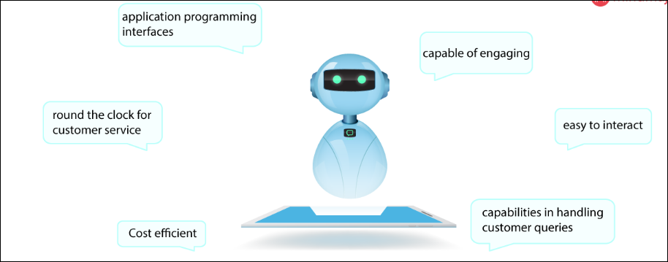

The advantages of chatbots are as follows:
- They are capable of engaging customers in a friendly manner.
- A simple interface makes it easier to interact with.
- Interactions are made possible via social media platforms like Twitter, Facebook, etc. Chats are served through application programming interfaces (APIs).
- Chatbots have extraordinary capabilities in handling customer queries.
- Chatbots work efficiently round the clock for customer service.
- Cost-efficient and are easy to build.

Models for a Chatbot:
When creating a chatbot, the goal is to automate the process altogether and to reduce human intervention. The first step in creating a chatbot involves inputting thousands of existing interactions between customers and customer service representatives to teach the machine which words/phrases are sensitive to the business. The next step is preprocessing which involves incorporating grammar to identify any misspellings.
Then the next step is to identify the kind of chatbot we would like to implement. There mainly are two models:

- Retrieval-based model- These models are much easy to build and give more predictable responses. They make use of context in the conversation for selecting the best response from a predefined list of messages that they got trained from. The context includes all the previous conversations, and the saved variables.

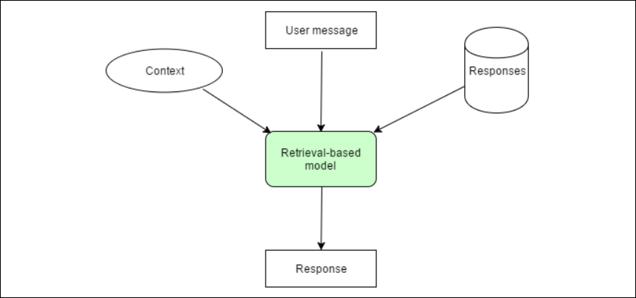

- Generative based model: A generative model chatbot doesn’t use any predefined repository. This kind of chatbot is more advanced because it learns from scratch using “Deep Learning.”
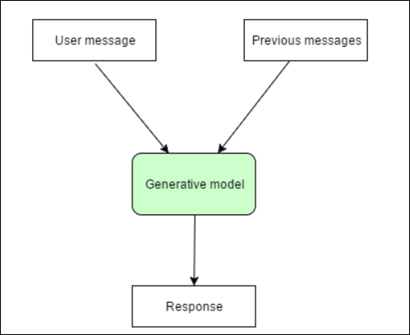

Pros and Cons:
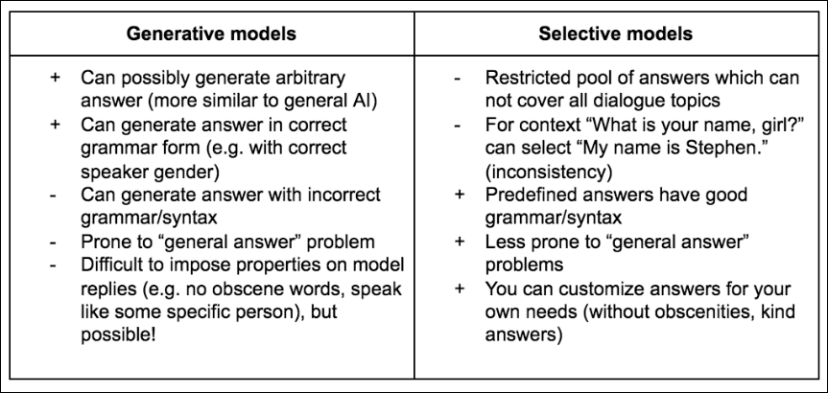

Architecture of AI chatbot
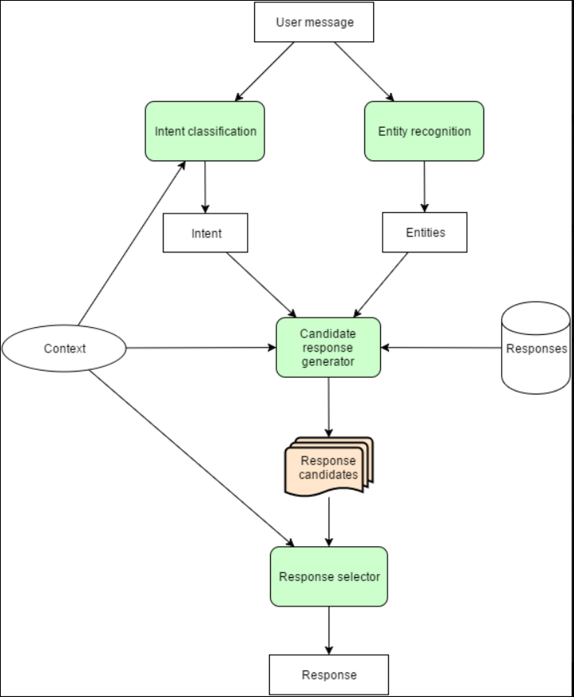

Message processing begins with understanding what the user is talking about.
- An intent classification module identifies the intent of the user messages. Typically, it is a selection of one out of many predefined intents, though more sophisticated bots can identify multiple intents from one message.
- An entity recognition module extracts structured bits of information from the message. The weather bot can extract the location and date.
- The candidate response generator is doing all the domain-specific calculations to process the user request. It can use different algorithms, call a few external APIs, or even ask a human to help with response generation. The result of these calculations is a list of response candidates. All these responses should be correct according to the domain-specific logic. They can’t be just tons of random responses. The response generator must use the context of the conversation as well as intent and entities extracted from the last user message. Otherwise, it can’t support multi-message conversations.
- The response selector just scores all the response candidate and selects a response which should work better for the user.

