Building A ChatBot
With DialogFlow
For Corona Prediction

Recently, new tools designed to simplify the interaction between humans and computers have hit the market: Chatbots or Virtual Assistants. In banking, chatbots and virtual assistants are some of the industry’s newest tools designed to simplify the interaction between humans and computers.

What exactly is a chatbot?
A chatbot is an artificial intelligence (AI) software that can simulate a conversation (or a chat) with a user in natural language through messaging applications, websites, mobile apps or through the telephone.
Why are chatbots important? A chatbot is often described as one of the most advanced and promising expressions of interaction between humans and machines. However, from a technological point of view, a chatbot only represents the natural evolution of a Question Answering system leveraging Natural Language Processing (NLP). Formulating responses to questions in natural language is one of the most typical Examples of Natural Language Processing applied in various enterprises’ end-use applications.

Behind the scenes: How a chatbot works
There are two different tasks at the core of a chatbot:
- user request analysis
- returning the response
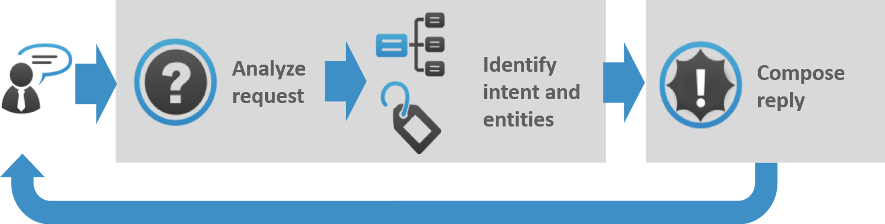

How Chatbot Works
How a Chatbot Works: As you can see in this graphic, a chatbot returns a response based on input from a user. This process may look simple; in practice, things are quite complex.

User request analysis: this is the first task that a chatbot performs. It analyzes the user’s request to identify the user intent and to extract relevant entities.
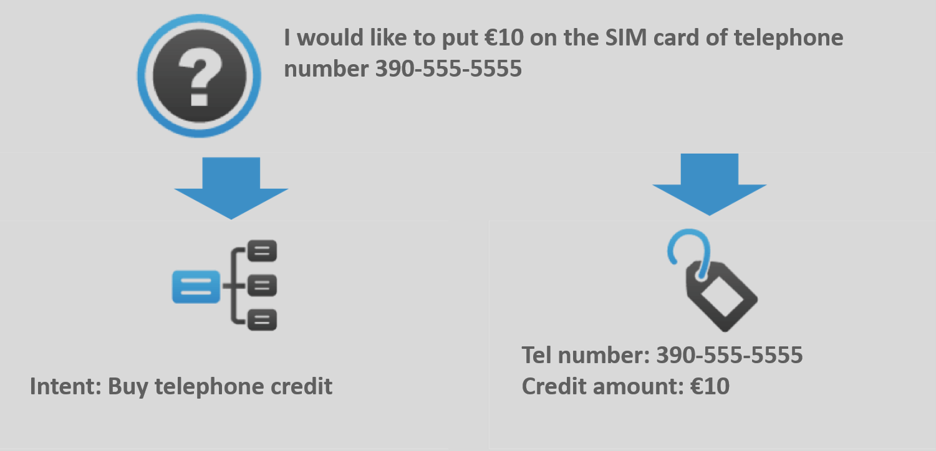

How a Chatbot Works: Example of user request analysis.
The ability to identify the user’s intent and extract data and relevant entities contained in the user’s request is the first condition and the most relevant step at the core of a chatbot: If you are not able to correctly understand the user’s request, you won’t be able to provide the correct answer.
Returning the response: once the user’s intent has been identified, the chatbot must provide the most appropriate response for the user’s request. The answer may be:

• a generic and predefined text
• a text retrieved from a knowledge base that contains different answers
• a contextualized piece of information based on data the user has provided
• data stored in enterprise systems
• the result of an action that the chatbot performed by interacting with one or more backend application
• a disambiguating question that helps the chatbot to correctly understand the user’s request

Uses
- Customer support
- Frequently Asked Questions
- Addressing Grievances
- Appointment Booking
- Automation of routine tasks
- Address a query

Which chatbot application is right for you?
In order to achieve the desired results, the combination of different AI forms such as natural language processing, machine learning and semantic understanding may be the best option.
In upcoming posts, we will give you an overview of the main chatbot applications so you can evaluate them based on your specific needs and desired goals.

Advantages of Chatbots

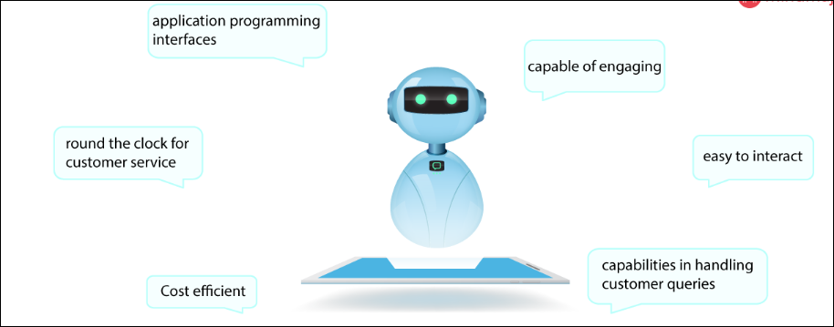

The advantages of chatbots are as follows:
- They are capable of engaging customers in a friendly manner.
- A simple interface makes it easier to interact with.
- Interactions are made possible via social media platforms like Twitter, Facebook, etc. Chats are served through application programming interfaces (APIs).
- Chatbots have extraordinary capabilities in handling customer queries.
- Chatbots work efficiently round the clock for customer service.
- Cost-efficient and are easy to build.

Models for a Chatbot:
When creating a chatbot, the goal is to automate the process altogether and to reduce human intervention. The first step in creating a chatbot involves inputting thousands of existing interactions between customers and customer service representatives to teach the machine which words/phrases are sensitive to the business. The next step is preprocessing which involves incorporating grammar to identify any misspellings.
Then the next step is to identify the kind of chatbot we would like to implement. There mainly are two models:

- Retrieval-based model- These models are much easy to build and give more predictable responses. They make use of context in the conversation for selecting the best response from a predefined list of messages that they got trained from. The context includes all the previous conversations, and the saved variables.

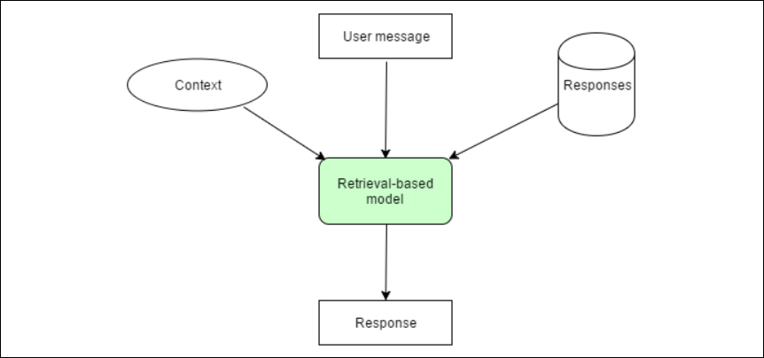

- Generative based model: A generative model chatbot doesn’t use any predefined repository. This kind of chatbot is more advanced because it learns from scratch using “Deep Learning.”
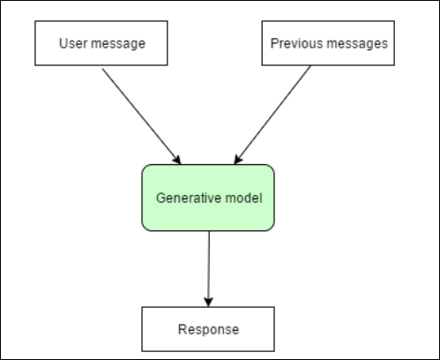

Pros and Cons:
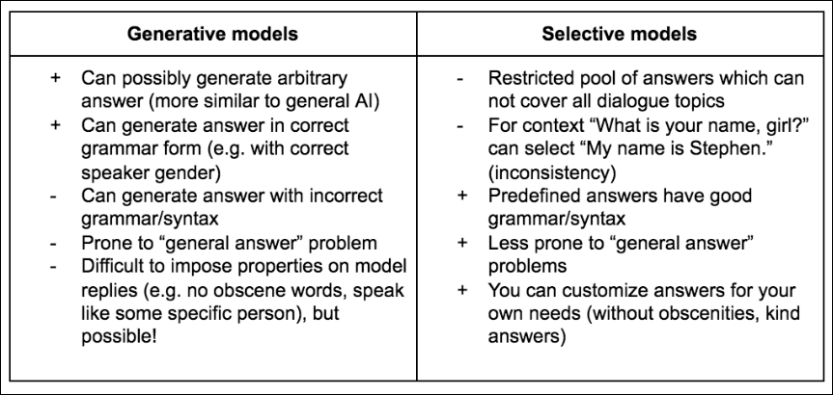

Architecture of AI chatbot
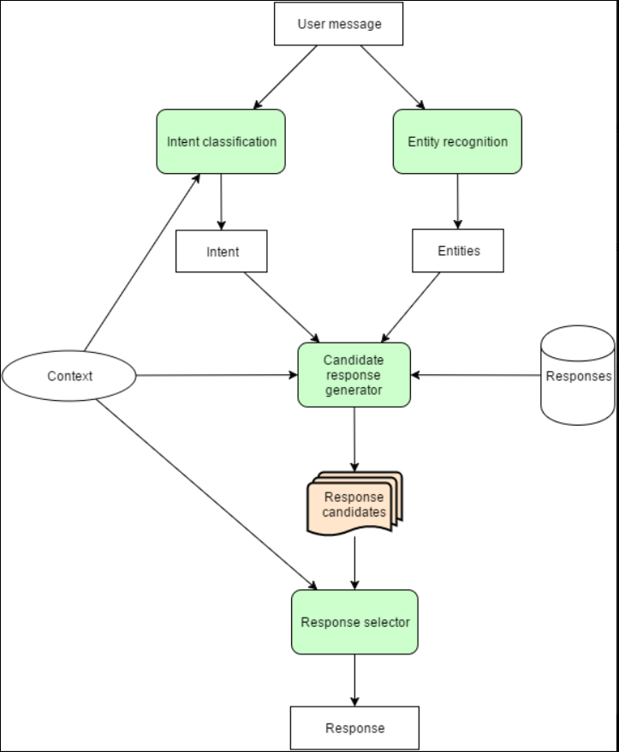

Message processing begins with understanding what the user is talking about.
- An intent classification module identifies the intent of the user messages. Typically, it is a selection of one out of many predefined intents, though more sophisticated bots can identify multiple intents from one message.
- An entity recognition module extracts structured bits of information from the message. The weather bot can extract the location and date.
- The candidate response generator is doing all the domain-specific calculations to process the user request. It can use different algorithms, call a few external APIs, or even ask a human to help with response generation. The result of these calculations is a list of response candidates. All these responses should be correct according to the domain-specific logic. They can’t be just tons of random responses. The response generator must use the context of the conversation as well as intent and entities extracted from the last user message. Otherwise, it can’t support multi-message conversations.

- Google Dialogflow
  - Introduction:
Dialogflow is a natural language understanding platform that makes it easy to design and integrate a conversational user interface into your mobile app, web application, device, bot, interactive voice response system, and so on. Using Dialogflow, you can provide new and engaging ways for users to interact with your product.
Dialogflow can analyze multiple types of input from your customers, including text or audio inputs (like from a phone or voice recording). It can also respond to your customers in a couple of ways, either through text or with synthetic speech.
  - Signup For Dialogflow:
You need to have a google account to signup for Dialogflow.
- Go to https://dialogflow.com/ and click on ‘Sign Up for Free’ button.
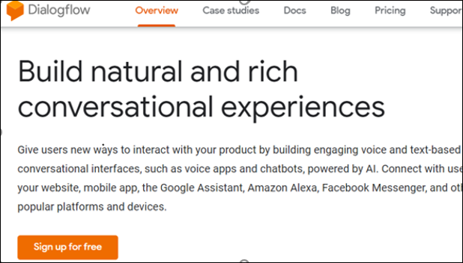
- Click ‘sign-in with Google’.
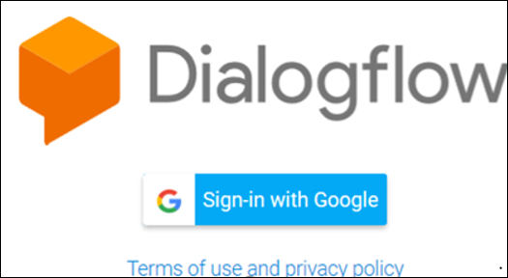
- Select your google account and once you are redirected, click on ‘Go To Console’ on the upper right corner of the screen.
  - Dialogflow Console:
Dialogflow provides a web user interface called the Dialogflow Console (open console). You use this console to create, build, and test agents. The uses are:
- Create Agents
- Create Intents
- Create entities
- Fulfillment to connect to other APIs.
- Integrate the bot with other platforms
- Analyze agent performance
- Test the agent in conversation simulator.

- Building a chatbot using google Dialogflow
  - The problem statement:
To build a chatbot which can answer all the queries of a customer and whenever a customer does an enquiry, it automatically send the customer the course details. Also an email is sent to the support team to assist the customer futher with their queries.
  - Agent:
A Dialogflow agent is a virtual agent that handles conversations with your end-users. It is a natural language understanding module that understands the nuances of human language. A Dialogflow agent is similar to a human call center agent. You train them both to handle expected conversation scenarios, and your training does not need to be overly explicit.
    - Creating an Agent:
  - Click on Create Agent from the left menu.

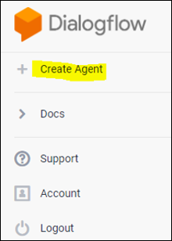
  - Provide the name of the agent and click on the SAVE button to create the Agent.
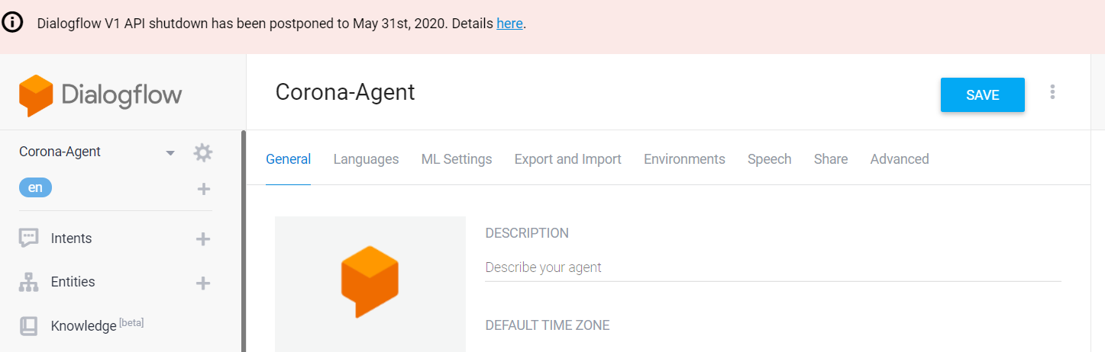
  - After saving, the agent is shown in the left hand side of your console. You can click the gear icon (highilighted in orange) to edit the agent settings.
  - Intent:
An intent categorizes an end-user's intention for one conversation turn. For each agent, you define many intents, where your combined intents can handle a complete conversation. When an end-user writes or says something, referred to as an end-user expression, Dialogflow matches the end-user expression to the best intent in your agent. Matching an intent is also known as intent classification.
The following diagram shows the basic flow for intent matching and responding to the end-user:
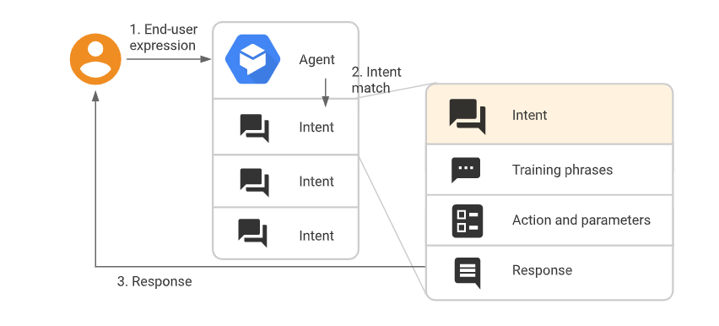
    - Creating an Intent:
    - Click the + add button next to Intents in the left sidebar menu. Enter a name for your intent. Your intent name should represent the end-user expressions it recognizes and click Save.
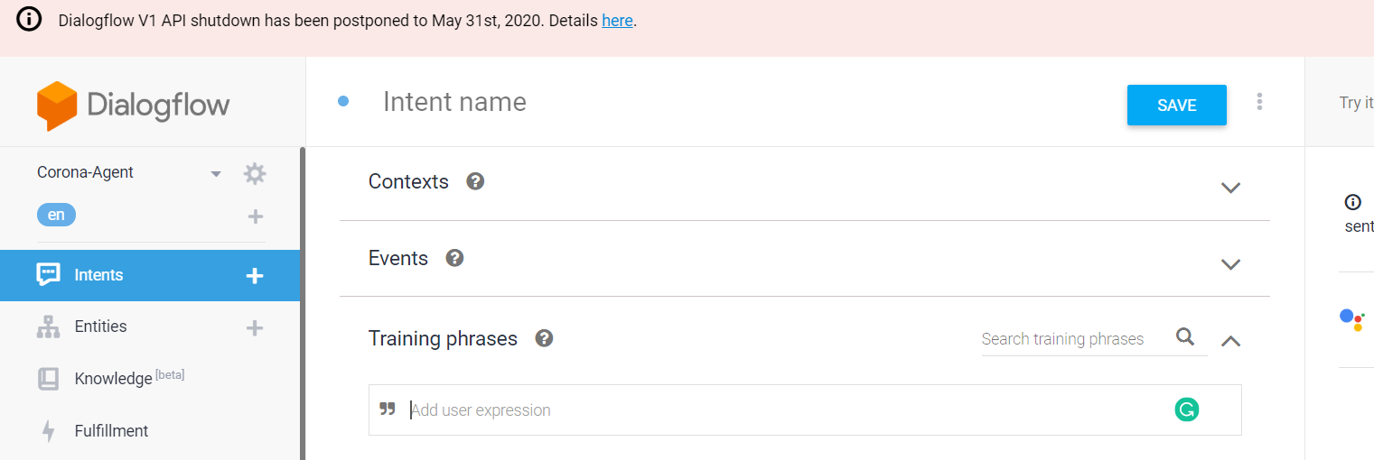
      - Training Phrases:
Training phrases are example phrases for what end-users might type or say, referred to as end-user expressions. For each intent, you create many training phrases. When an end-user expression resembles one of these phrases, Dialogflow matches the intent.
Adding the training Phrases:
- Click the text field that shows "Add user expression".
- Type your training phrases and press the Enter key after each.
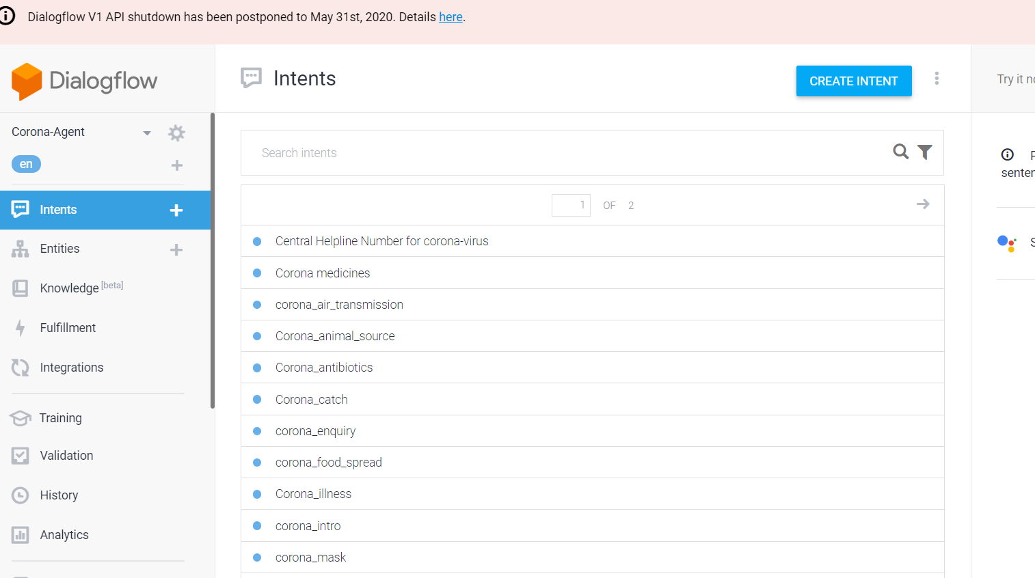
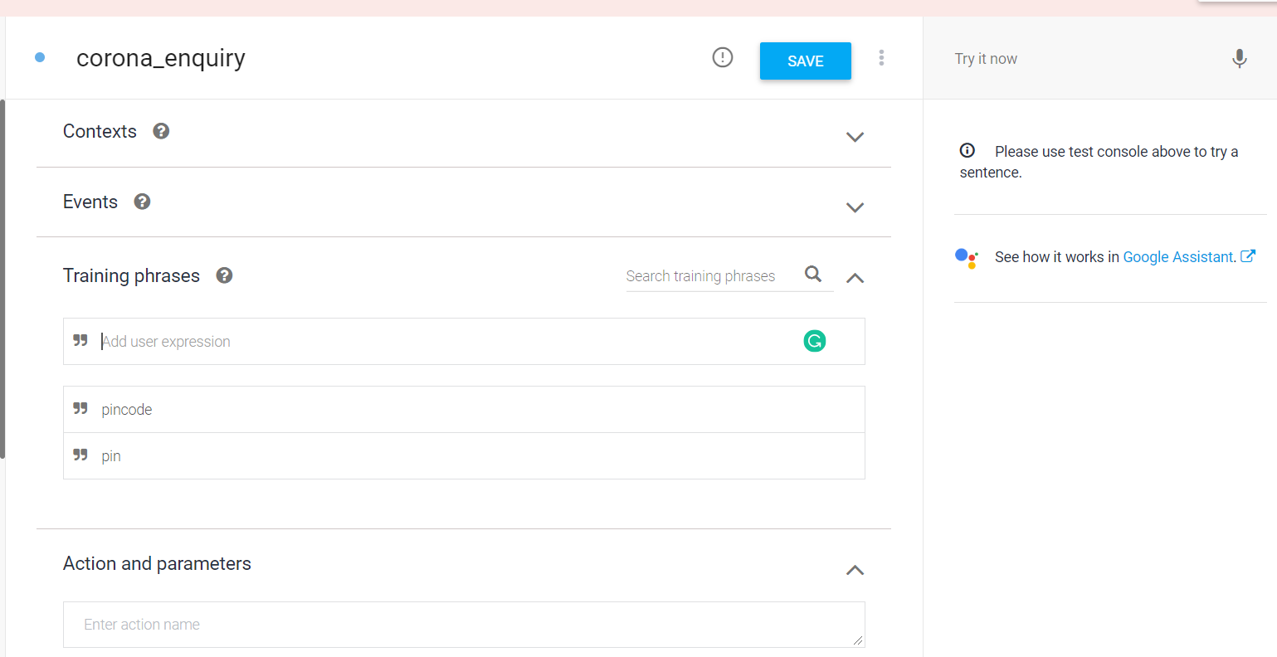
      - Extracting the Entities:
When an intent is matched at runtime, Dialogflow provides the extracted values from the end-user expression as parameters. Each parameter has a type, called the entity type, which dictates exactly how the data is extracted. Unlike raw end-user input, parameters are structured data that can easily be used to perform some logic or generate responses.
Each intent parameter has a type, called the entity type, which dictates exactly how data from an end-user expression is extracted.
Dialogflow provides predefined system entities that can match many common types of data. For example, there are system entities for matching dates, times, colors, email addresses, and so on. You can also create your own custom entities for matching custom data.
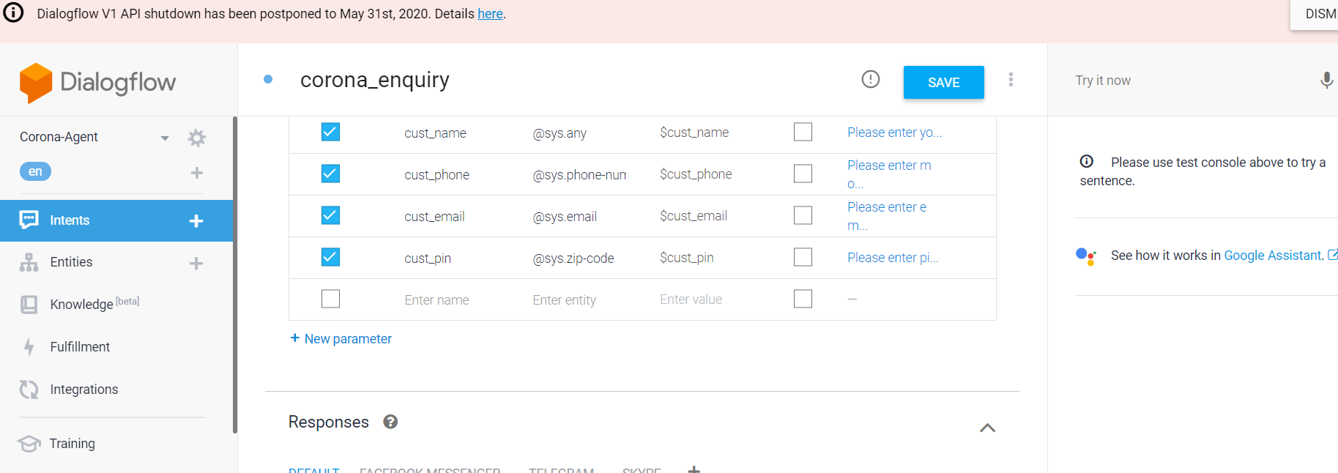
      - Specifying custom Responses:
Intents have a built-in response handler that can return responses after the intent is matched. This feature only supports static responses, though you can use parameter references in these responses to make them somewhat dynamic. This is helpful for recapping information provided by the end-user. For example, your intent response could look like: "Okay, I booked a room for you on $date".
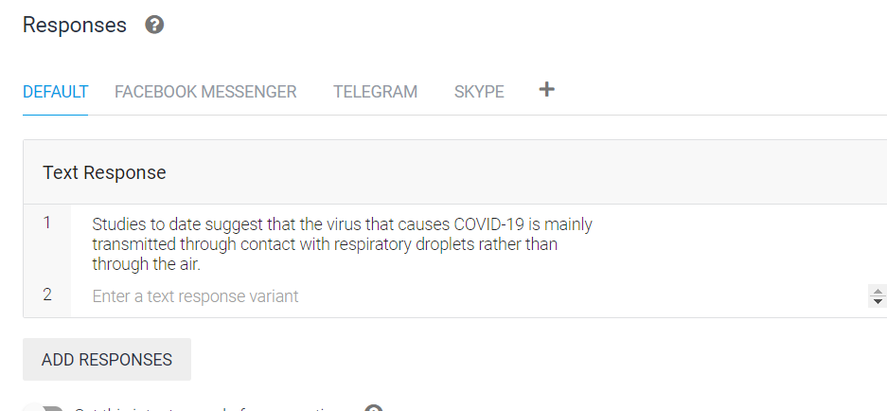
  - Fulfillment:
By default, your agent responds to a matched intent with a static response. If you're using one of the integration options, you can provide a more dynamic response by using fulfillment. When you enable fulfillment for an intent, Dialogflow responds to that intent by calling a service that you define. For example, if an end-user wants to schedule a haircut on Friday, your service can check your database and respond to the end-user with availability information for Friday.
Each intent has a setting to enable fulfillment. If an intent requires some action by your system or a dynamic response, you should enable fulfillment for the intent. If an intent without fulfillment enabled is matched, Dialogflow uses the static response you defined for the intent.
When an intent with fulfillment enabled is matched, Dialogflow sends a request to your webhook service with information about the matched intent. Your system can perform any required actions and respond to Dialogflow with information for how to proceed. The following diagram shows the processing flow for fulfillment.
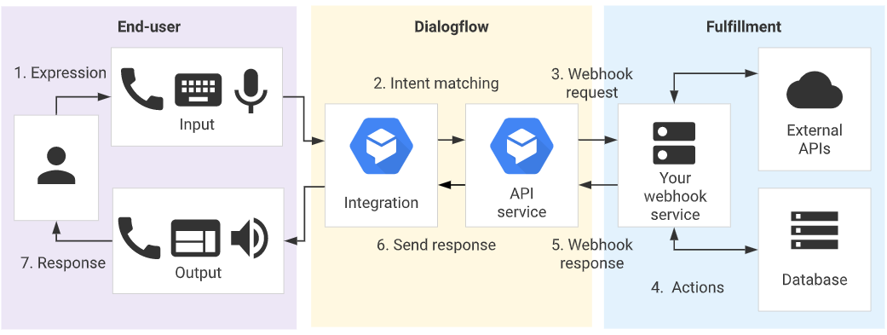
- The end-user types or speaks an expression.
- Dialogflow matches the end-user expression to an intent and extracts parameters.
- Dialogflow sends a webhook request message to your webhook service. This message contains information about the matched intent, the action, the parameters, and the response defined for the intent.
- Your service performs actions as needed, like database queries or external API calls.
- Your service sends a webhook response message to Dialogflow. This message contains the response that should be sent to the end-user.
- Dialogflow sends the response to the end-user.
- The end-user sees or hears the response.
The entire code for fulfilment can be found at https://github.com/viratsagar/iNeuron_academics_bot
    - Functionalities achived in fulfilment:
  - Sending an email to the customer with the syllabus and all the course details based on the course selected.
  - Sending an email to the Support team to further contact the customer for further clarification.
    - Webhook for fulfilment:
    - Select Fulfillment in the left sidebar menu.
    - Toggle the Webhook field to Enabled.
    - Provide the details for your webhook service in the form. If your webhook doesn't require authentication, leave the authentication fields blank.
    - Click Save at the bottom of the page.
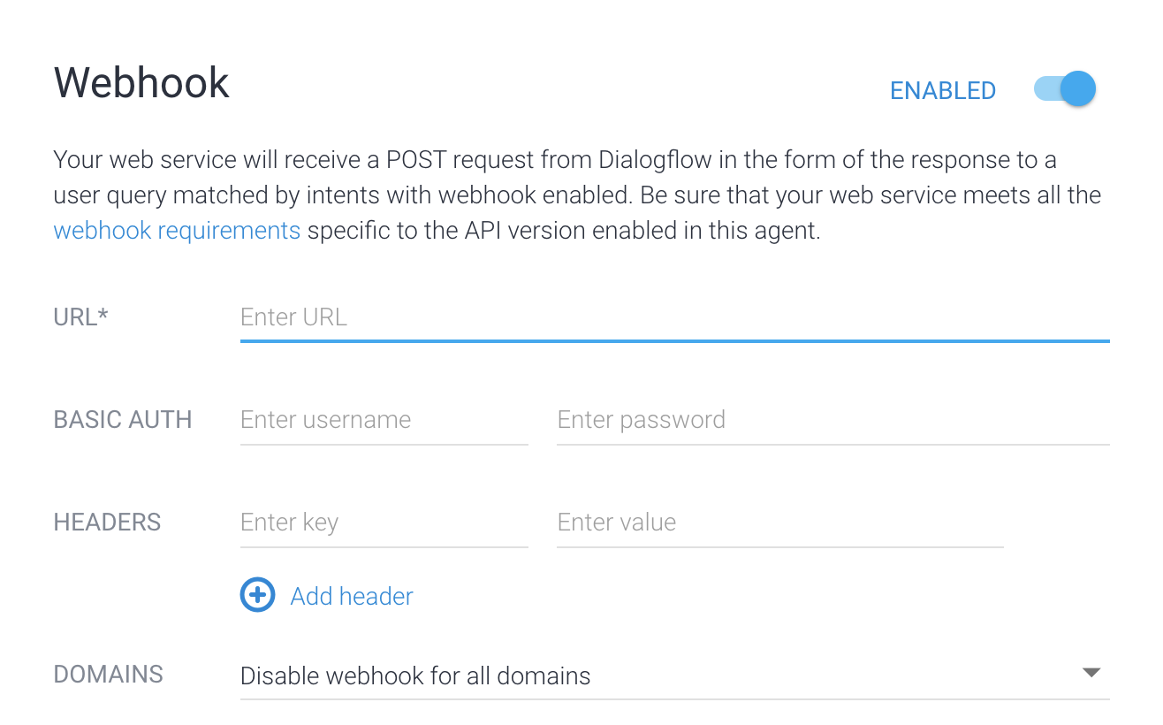
    - Fulfilment Request and Response:
To see the request being sent to the webhook call, click the ‘Diagnostic info’ button.
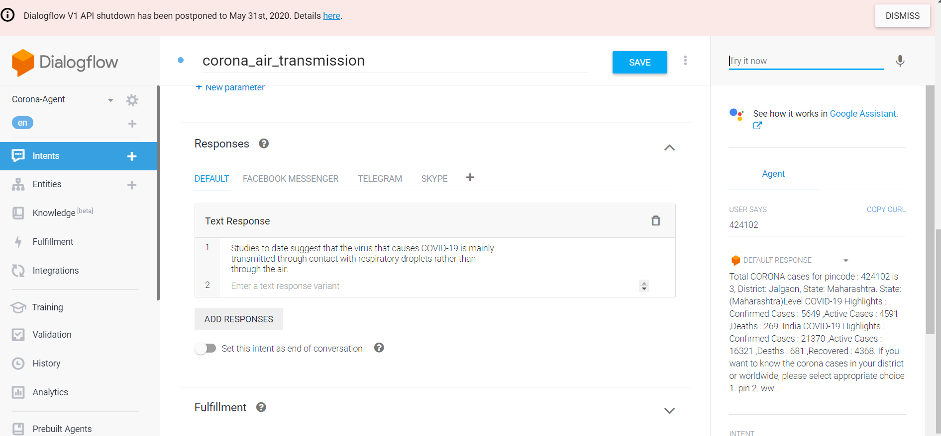
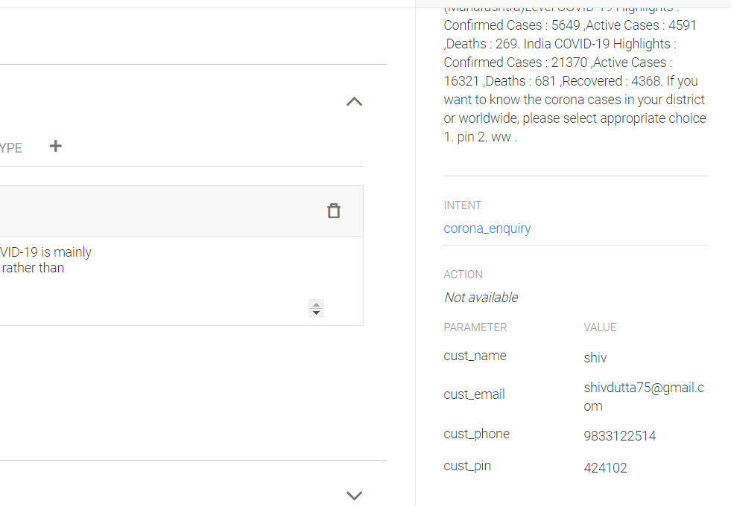

After clicking, you’ll see the following structure:
{
"responseId": "029d58fc-5096-4554-8cac-980c9c6df6ef-eec93b43",
"queryResult": {
"queryText": "424102",
"parameters": {
"cust_name": "shiv",
"cust_email": "shivdutta75@gmail.com",
"cust_phone": "9833122514",
"cust_pin": "424102"
},
"allRequiredParamsPresent": true,
"fulfillmentText": "Total CORONA cases for pincode : 424102 is 3, District: Jalgaon, State: Maharashtra. State:(Maharashtra)Level COVID-19 Highlights : Confirmed Cases : 5649 ,Active Cases : 4591 ,Deaths : 269. India COVID-19 Highlights : Confirmed Cases : 21370 ,Active Cases : 16321 ,Deaths : 681 ,Recovered : 4368. If you want to know the corona cases in your district or worldwide, please select appropriate choice 1. pin 2. ww .",
"fulfillmentMessages": [
{
"text": {
"text": [
"Total CORONA cases for pincode : 424102 is 3, District: Jalgaon, State: Maharashtra. State:(Maharashtra)Level COVID-19 Highlights : Confirmed Cases : 5649 ,Active Cases : 4591 ,Deaths : 269. India COVID-19 Highlights : Confirmed Cases : 21370 ,Active Cases : 16321 ,Deaths : 681 ,Recovered : 4368. If you want to know the corona cases in your district or worldwide, please select appropriate choice 1. pin 2. ww ."
]
}
}
],
"intent": {
"name": "projects/corona-agent-bmyrsi/agent/intents/6e0c7e73-53f7-4898-ba12-cb09b2b7972a",
"displayName": "corona_enquiry"
},
"intentDetectionConfidence": 1,
"diagnosticInfo": {
"webhook_latency_ms": 3888
},
"languageCode": "en"
},
"webhookStatus": {
"message": "Webhook execution successful"
}
}The Request above gives you the idea of how to parse the requests in your webhook service.
We’ll discuss the webhook code in detail during the session.
  - Knowledge base:
Knowledge connectors complement defined intents. They parse knowledge documents (for example, FAQs or articles) to find automated responses. To configure them, you define one or more knowledge bases, which are collections of knowledge documents.
For this project, we have created a knowledge document which contains all the FAQs of the sudents and we have integrated the same with the bot.
    - Creating a Knowledge base
- To create a knowledge base, click on ‘Knowledge’ on the left hand side of your console and then click ‘CREATE KNOWLEDGE BASE’.
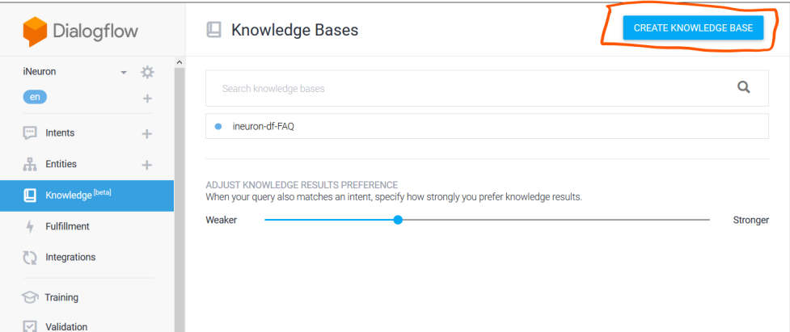
- Give the name of your knowledge base and click ‘Save’.
- Once created, you’ll see a message stating that no knowledge document has been created yet. Click ‘create the first one’ to start creating your document.
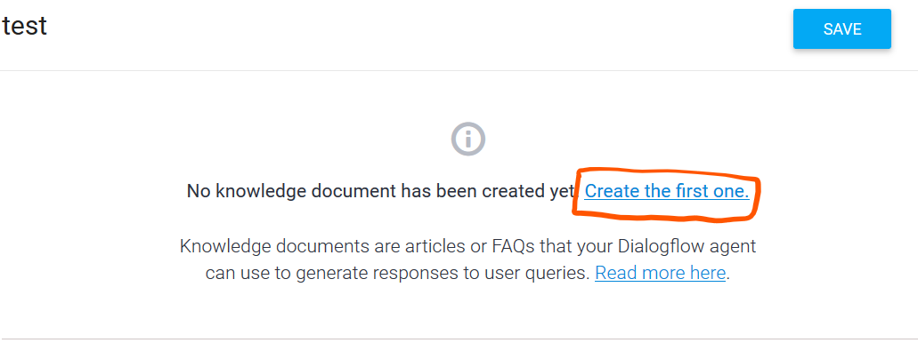
- Select FAQ and text/CSV and the upload the FAQ CSV file created and then click Create.
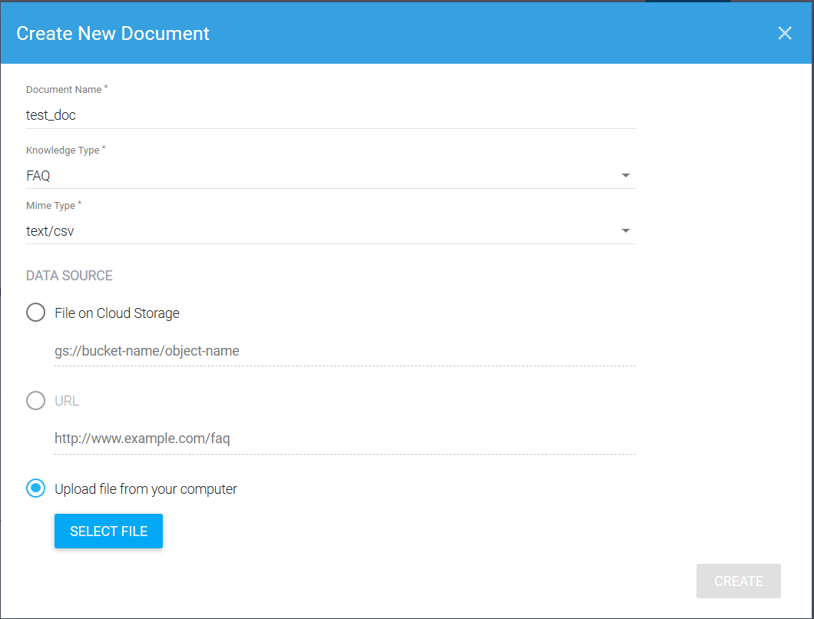
- Scroll down to the Responses section and add responses as desired:
      - When defining the first response for the intent, use $Knowledge.Question[1] and $Knowledge.Answer[1] where you want the question and answer to be supplied.
      - The index for $Knowledge.Question and $Knowledge.Answer starts at 1, so increase this index when adding more responses.

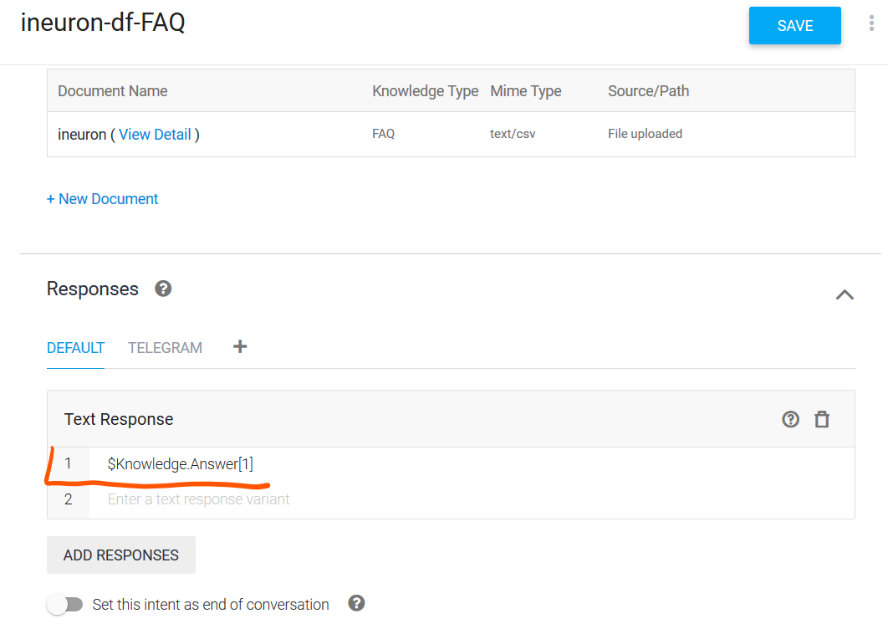
- Click SAVE once you are done editing.

  - Test the Agent:
You can now test the agent from the ‘test it now’ section.

  - Integration:
Dialogflow integrates with many popular conversation platforms like Google Assistant, Slack, and Facebook Messenger. If you want to build an agent for one of these platforms, you should use one of the many integrations options. Direct end-user interactions are handled for you, so you can focus on building your agent.
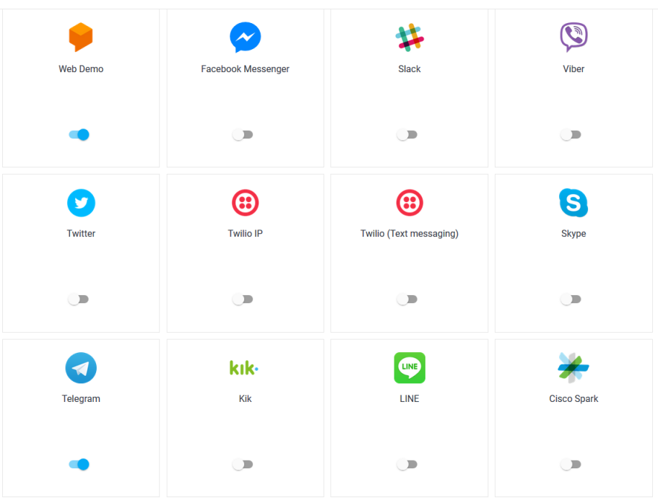

    - Integration with Telegram:
Dialogflow Telegram Integration allows you to easily create Telegram bots with natural language understanding based on the Dialogflow technology.
In order to set up the Telegram integration for your agent, you'll need the following:
- Telegram account.

3.7.1.2 Creating a Bot in Telegram
- Login to Telegram and go to https://telegram.me/botfather
- Click the Start button in the web interface or type /start
- Click on or type /newbot and enter a name
- Enter a username for the bot, ending in "bot" (e.g. garthsweatherbot)
- Copy the generated access token

3.7.1.3 Setting Up Dialogflow
- In Dialogflow, go to Integrations in the left hand menu
- Click on the Telegram tile
- Paste the Access Token into the related field
- Click the Start button

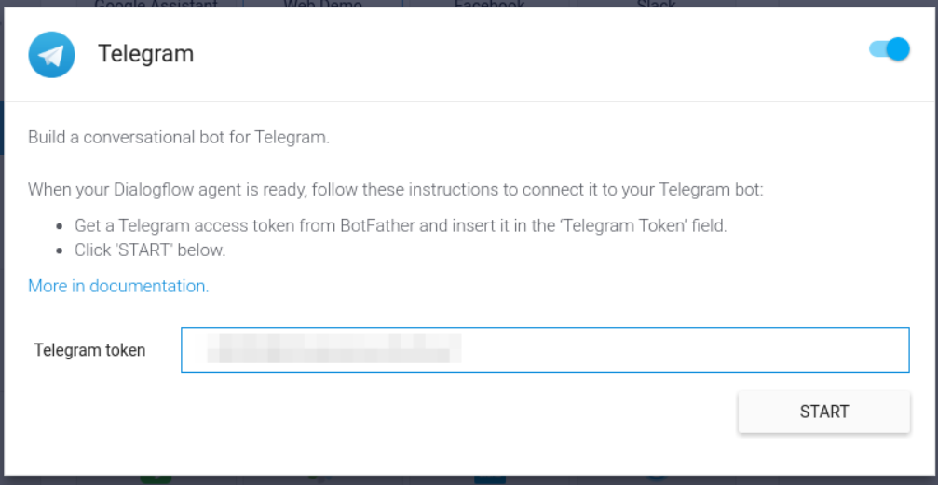

Now you can search your bot in telegram and you can chat with it.
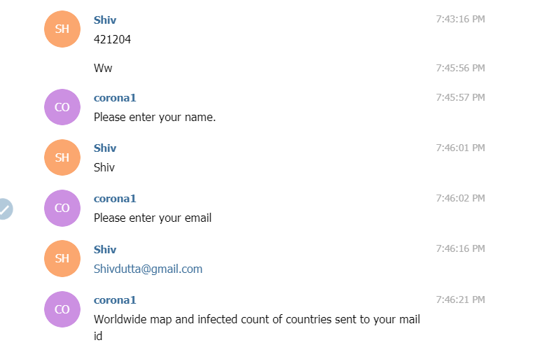

Facebook Integration is similar to Amazon Lex, Please refer lex document
