Diagnostic Lab Operational Analytics
An End-to-End Data Engineering & Analytics Solution for Modern Lab Operations
Author: Shivek
Live Demo: https://labops-insights.streamlit.app/

Executive Summary
Diagnostic labs handle thousands of samples daily, but tracking their exact status; from collection and courier transit to lab processing and final reporting, is notoriously difficult. This product acts as a unified intelligence layer. It gathers fragmented operational data, validates it, and generates a live dashboard that pinpoints bottlenecks, measures Turnaround Times (TAT), and flags missed Service Level Agreements (SLAs). It helps decision-makers ensure operational reliability, minimize delays, and improve client satisfaction.

Business Problem
Private diagnostic labs face several significant operational hurdles:
- Manual Sample Tracking: Searching for sample statuses across spreadsheets and legacy, siloed systems.
- Delayed Turnaround Time (TAT): Lack of standardized measurement across labs forces reactive management.
- Courier Inefficiency: Missing visibility into courier delays, route issues, and SLA non-compliance.
- Rejections & SLA Breaches: Unclear rejection root causes and unnoticed delays lead to poor customer experience.
- Fragmented Operational Visibility: Directors and managers lack a single, unified view to direct the day-to-day operations effectively.

Solution Overview
To address these challenges, we built a comprehensive Diagnostic Lab Analytics Dashboard. This centralized tool offers:
- Demo Mode: An instantly available, synthetic-data powered sandbox to explore capabilities.
- Upload Mode: The flexible ability to ingest real-world lab data natively via CSV.
- Alerts and Insights: Auto-generated alerts pinpointing delayed samples and SLA breaches.
- Executive Overview: High-level key performance metrics for corporate leadership.
- Lab & Courier Performance: Detailed views isolating the efficiency and bottlenecks of specific labs and courier vendors.
- Test Analytics: Volume, turnaround times, and rejection rates filtered by specific test types.
- Sample Journey View: Deep dive into the precise timestamps of an individual sample’s path to completion.

Data Flow & Workflow
- Upload / Demo:
  - Upload Mode: Users drag and drop flat files containing raw lab metrics.
  - Demo Mode: If no data is available, built-in synthetic generation builds realistic profiles.
- Schema Mapping & Validation: An intelligent ingestion layer aligns external data schemas to the standardized internal model, dropping corrupt records and validating key dates to avoid logic errors.
- Core Processing Engine: Metrics, flags, delays, TAT, and breaches are computed in memory.
- Dashboard Generation: The unified schema powers a rich, interactive Streamlit frontend with modular, intuitive views.

Supported Data Inputs (Important)

We understand that every lab’s Laboratory Information System (LIS) exports data in a different format. The platform supports common lab exports, but the current Upload Mode works best when the submitted CSV schema aligns with our app’s expected structure and backend aggregation logic.

At present, the upload flow may require schema compatibility for the dashboard to process the data correctly. However, the backend can be adapted to match how a specific lab stores and structures its data, allowing us to generate the exact operational analysis from their actual dataset on the dashboard. A comprehensive Demo Mode is also available for users to preview the platform without sharing any real data.

Key Features
- KPI Cards: Instant view of total samples, delays, and completion rates.
- SLA Breach Monitoring: Automatic flagging when couriers or labs take too long.
- Delay & Rejection Analysis: Identify root causes by drilling into locations or test types.
- Insight Generation: Actionable textual alerts dynamically created from the data.
- Downloadable Reports: Easy 1-click export of data to CSV for external meetings.
- Template Files: Standardized formats to guide future ingestion.

Architecture Overview
- Ingestion Layer: Accepts CSV files, validating file formats and preventing corruption.
- Validation Layer: Enforces logical rules (e.g., Report time must be after Collection time).
- Mapping & Normalization Layer: Standardizes column naming conventions into a unified Star-Schema model.
- Metrics Engine: Aggregates facts calculating SLA compliance, durations, and status identifiers.
- Insights Engine: A module designed to automatically summarize the most critical operational red flags.
- Dashboard UI: The final presentation layer built on Streamlit with interactive Plotly visualizations.

Business Value
By implementing this platform, a diagnostic business achieves:
- Better Operational Visibility: Move away from spreadsheets to a unified dashboard.
- Faster Issue Identification: Resolve SLA bottlenecks on the same day instead of the end of the month.
- Improved Reporting: Automate what used to be a 4-hour manual weekly reporting task.
- Time Savings: Increase operational efficiency by standardizing operations oversight.
- Better Decisions: Make structural, data-backed choices about courier contracts and lab staffing.
- Possible Client Use Cases: Use as an internal operational product, or re-brand as a client-facing portal for hospitals.

Limitations & Assumptions
- Upload Mode Schemas: Upload mode may require manual schema mapping if the columns vary significantly from the standard configuration.
- Feature Dependency: Some advanced analytics depend heavily on the availability of specific columns in the raw input.
- Synthetic Demo Data: The Demo mode only utilizes synthetically generated data to showcase functionality.

Future Roadmap
- More Flexible Schema Mapping: AI-driven auto-detection of column metadata.
- Scheduled Reports: Scheduled delivery of daily operations PDFs.
- Alert Integrations: Automated push notifications via Email or WhatsApp.
- Cloud Database Integration: Connect directly to cloud warehouses (BigQuery/Snowflake) instead of local flat files.

Screenshots:
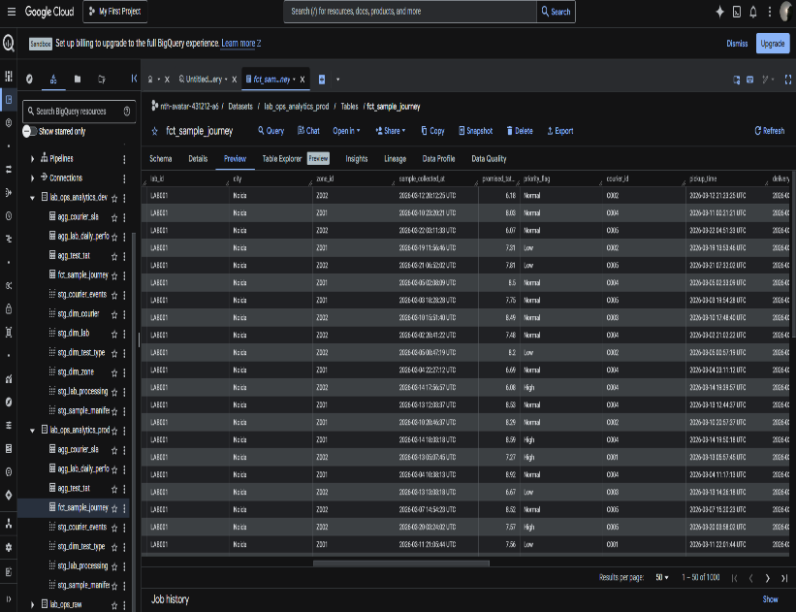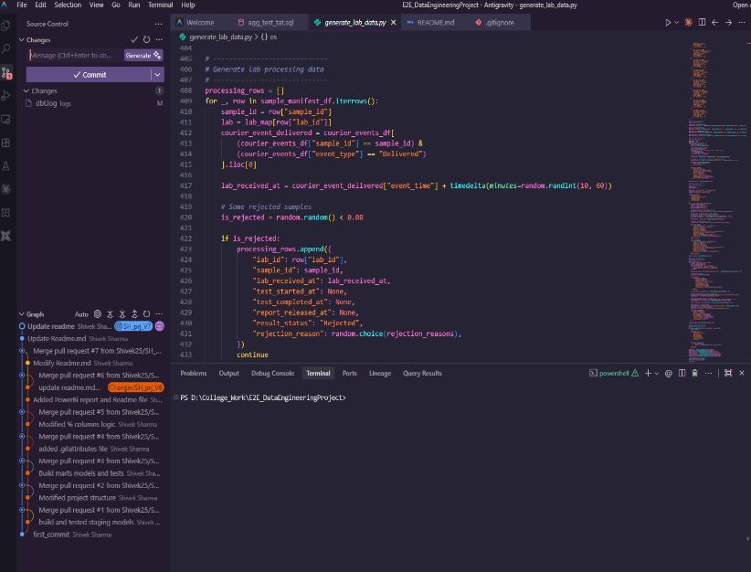
(Our BigQuery project) (Project Code Construction)

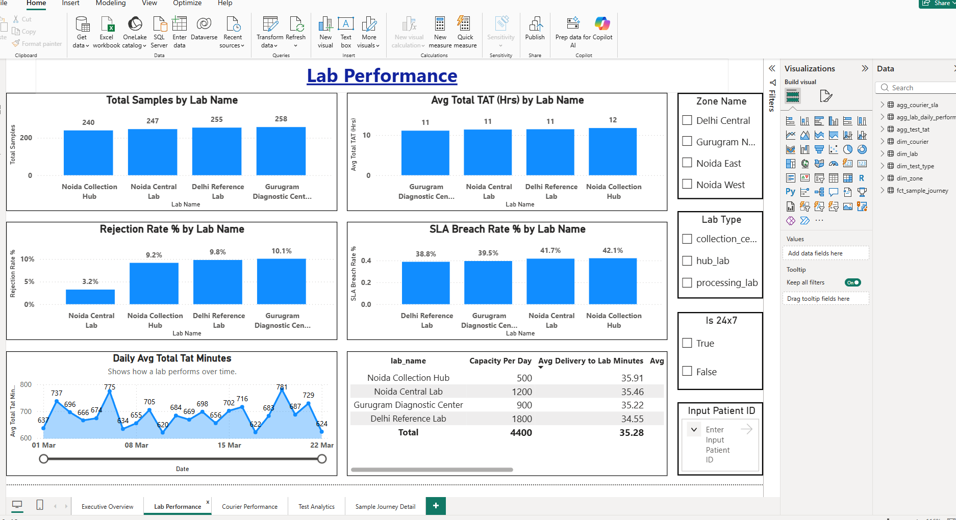
(Power BI Dashboard of our Project)
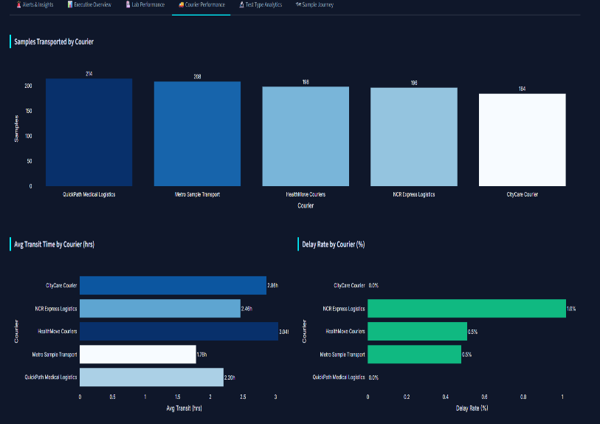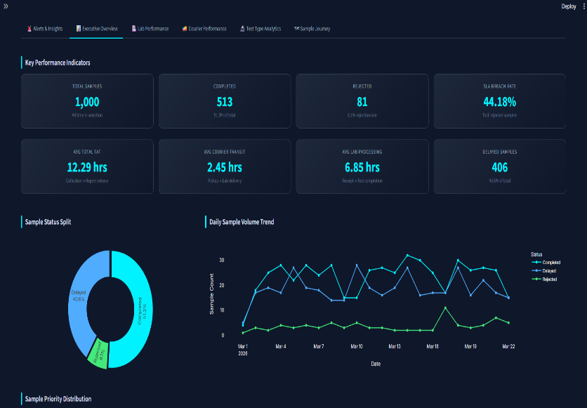
(Web App Dashboard of our project)

Conclusion
The Diagnostic Lab Operational Analytics platform transforms raw, fragmented operational data into a clear and actionable strategic overview for diagnostic labs. By consolidating sample movement, courier tracking, lab processing, turnaround times, and rejection patterns into a single unified dashboard, the platform enables faster operational visibility and more informed decision-making.
The system helps identify bottlenecks, monitor SLA breaches, track courier efficiency, analyze lab performance, and standardize operational reporting across the sample lifecycle. Its alerting and insight-driven approach reduces the dependency on manual tracking and disconnected Excel-based workflows, improving both internal efficiency and overall service reliability.

The platform has been designed with flexibility and scalability in mind. While the current version supports schema-based CSV uploads and demo datasets, the backend architecture can be further adapted to integrate with different laboratory data structures and workflows based on client requirements. This makes the solution practical not only as a demonstration platform, but also as a foundation for real-world operational analytics implementations in diagnostic environments.
Overall, the project demonstrates a production-relevant approach to healthcare operations analytics and showcases how data engineering, operational intelligence, and interactive reporting can work together to improve performance in the fast-paced diagnostic industry.

