UPI Fraud Awareness Among College Students in India: A Systematic Review of Digital Payment Security Literature, Fraud Typologies, and the Awareness–Behaviour Gap
An IEEE-Formatted Systematic Integrative Review, Psychometric Synthesis, and Multi-Tier Mitigation Architecture
Shiven Rajput  Department of Data Science  Noida Institute of Engineering and Technology  Greater Noida, Uttar Pradesh, India  Email: shiven.rajput@niet.co.in | Nisha Verma  Academic Supervisor & Guide  Department of Data Science  Noida Institute of Engineering and Technology  Greater Noida, Uttar Pradesh, India  Email: nisha.verma@niet.co.in

Abstract—The Unified Payments Interface (UPI) has established itself as the architectural backbone of India's retail digital payments ecosystem, processing over 13,112 crore transactions valued at ₹199.95 lakh crore in FY 2023–24 and escalating past 17,200 crore transactions in FY 2024–25. College-going youth represent the core demographic driving this frictionless volume, utilizing smartphone applications ubiquitously for peer-to-peer debt settlement and campus retail. However, the exact architectural characteristics that catalyzed UPI's mass adoption—sub-second clearance, zero end-user transaction fees, and minimal cognitive overhead—have simultaneously rendered the payment rail exceptionally fertile for socio-technical exploitation. This systematic review synthesises 34 peer-reviewed, empirical, and regulatory sources (2020–2026) across five key dimensions: macro-scale transaction trajectories versus fraud incidences, comprehensive threat taxonomies, empirical collegiate awareness baselines, theoretical drivers of the awareness–behaviour gap, and institutional mitigation mechanisms. Synthesised campus field investigations reveal an acute 'security paradox': while baseline declarative awareness of digital payment scams spans 68.5% to 91.2%, operational compliance with basic cyber-hygiene remains below 50%, and reported risk exposure or victimisation persists between 24.8% and 58.0%. We formalize this disconnect through dual-process cognitive theory, Protection Motivation Theory (PMT), and hybrid Structural Equation Modeling (SEM-ANN), demonstrating that habituated System 1 heuristic processing, optimism bias, and manufactured situational urgency systematically overwhelm abstract declarative knowledge during live payment authorization. Finally, we evaluate statutory liabilities, the 1930 Citizen Financial Cyber Fraud Reporting and Management System (CFCFRMS), and articulate a multi-tier mitigation framework that integrates point-of-risk UI friction nudges, curricular experiential simulation, and automated mule-account interdiction.
Index Terms—Unified Payments Interface (UPI), digital financial fraud, cybersecurity awareness, awareness–behaviour gap, social engineering, quishing, optimism bias, dual-process theory, structural equation modeling.
I. INTRODUCTION
A. Macro-Scale Evolution of the UPI Ecosystem
Launched in August 2016 under the operational aegis of the National Payments Corporation of India (NPCI), the Unified Payments Interface (UPI) has fundamentally restructured India's retail payments architecture from physical cash reliance to ubiquitous digital clearing [1]. Government data published by the Ministry of Electronics and Information Technology (MeitY) and the Reserve Bank of India (RBI) documents an exponential volumetric expansion, rising from 2,233 crore transactions valued at ₹41.04 lakh crore in FY 2020–21 to over 13,112 crore transactions worth ₹199.95 lakh crore in FY 2023–24 [2], [3]. By FY 2024–25, retail digital payments in India eclipsed 18,000 crore total transactions, with UPI commanding an extraordinary 83.4% volumetric share of all domestic retail electronic payment instruments [2], [3].
B. Collegiate Adoption Drivers and Digital Ubiquity
Within this transformed macroeconomic landscape, higher-education students occupy a uniquely influential demographic stratum. Exhibiting the behavioral attributes of digital natives, college students rely ubiquitously upon smartphone-based client applications—principally PhonePe, Google Pay, and Paytm—for everyday peer-to-peer (P2P) debt splitting, merchant commerce (P2M), collegiate canteen expenses, and tuition remittances [4], [5]. Empirical field surveys across Indian university campuses demonstrate that collegiate uptake is primarily driven by three utilitarian dimensions: transaction speed (clearing in under three seconds), the complete absence of consumer-facing transaction fees, and universal merchant acceptance [4], [5]. However, the foundational design principles that catalyzed UPI's global acclaim—sub-second atomic clearing, minimal verification overhead, and standardized application programming interface (API) interoperability across disparate banking platforms—have concurrently created systemic socio-technical vulnerabilities [4], [6].
C. The Problem Statement: The Security Paradox
As retail digital transactions expanded, financial fraud within digital payment rails escalated in parallel. Annual disclosures published by the Reserve Bank of India (RBI) reveal that commercial banking institutions reported 36,075 total fraud occurrences in FY 2023–24, marking a 166% year-on-year increase over the 13,564 cases recorded in FY 2022–23 [3], [7]. Most strikingly, fraud classified under the 'card and internet payments' ledger surged by over 334% in a single annual cycle—rising from 6,699 incidents in FY 2022–23 to 29,082 incidents in FY 2023–24—accounting for 80.6% of all bank fraud cases by absolute volume [3], [7]. Concurrently, parliamentary disclosures compiled by the Ministry of Home Affairs (MHA) through the National Cyber Crime Reporting Portal (NCRP) registered over 28 lakh cyber-fraud grievances in 2024–2025 alone, representing aggregate financial debits exceeding ₹22,900 crore [8].
D. Exploitation of Cognitive Heuristics Over Cryptographic Protocols
Rigorous computational security audits confirm that this escalating wave of payment fraud is not propelled by cryptographic exploits, transport-layer decryption, or protocol-level penetration of the National Interbank Transfer Protocol [6], [9]. Mathematical and hardware protections—including AES-256 transmission encryption, device-binding via SIM IMSI/IMEI cryptographic handshakes, and mandatory two-factor authentication (2FA) enforced through a 4- or 6-digit MPIN—remain computationally sound [9]. Instead, fraudsters systematically circumvent technical protections by targeting the human-computer interface through psychological manipulation and deceptive social engineering [6], [10]. This gives rise to the central empirical paradox addressed in this review: college students demonstrate high declarative awareness of digital payment scams (ranging between 68.5% and 91.2%), yet exhibit alarming rates of real-world financial victimisation (spanning 24.8% to 58.0%) [4], [5], [10]. Despite institutional advisories and public service communiqués, students routinely bypass foundational security protocols under real-time transactional pressure [11], [12].
E. Research Objectives and Review Questions
To systematically interrogate this socio-technical disconnect, this integrative review addresses six structured research questions (RQs):
• RQ1: What is the empirical trajectory of UPI transaction volume versus digital retail fraud incidence from FY 2020–21 to FY 2025–26 under official regulatory surveillance?
• RQ2: What constitutes the comprehensive taxonomy of UPI fraud vectors, and through what cognitive heuristics do they exploit users over technical penetration?
• RQ3: What empirical baseline levels of fraud awareness, cyber-hygiene compliance, and financial victimisation are documented across Indian higher-education cohorts?
• RQ4: What formal cognitive, psychometric, and behavioral models account for the observed awareness–behaviour gap in instant payment systems?
• RQ5: How efficacious and visible are existing institutional countermeasures, statutory remedies, and the Citizen Financial Cyber Fraud Reporting System (1930 helpline)?
• RQ6: What methodological deficiencies characterise current literature, and what constitutes a robust, multi-tier socio-technical mitigation architecture?
II. REVIEW METHODOLOGY
A. Search Strategy and Corpus Construction
In strict adherence to the Preferred Reporting Items for Systematic Reviews and Meta-Analyses (PRISMA 2020) statement [13], a comprehensive, multi-stage literature search was executed across major international indexing databases (IEEE Xplore, ScienceDirect/Scopus, SpringerLink, Emerald Insight, MDPI, ACM Digital Library) and recognized academic preprints and open repositories (ResearchGate, SSRN, arXiv). In parallel, official statutory and regulatory archives were retrieved directly from the Reserve Bank of India (RBI), National Payments Corporation of India (NPCI), Ministry of Electronics and Information Technology (MeitY), and the Indian Cyber Crime Coordination Centre (I4C) under the Ministry of Home Affairs (MHA) [13].
B. Databases, Repositories, and Boolean Query Pipeline
The identification pipeline utilized customized Boolean operational strings combining payment technology, cognitive psychology, and student demographic keywords: ('UPI' OR 'Unified Payments Interface' OR 'digital payment fraud' OR 'fintech scam') AND ('awareness-behaviour gap' OR 'cognitive bias' OR 'optimism bias' OR 'social engineering' OR 'quishing') AND ('college students' OR 'university students' OR 'higher education' OR 'youth' OR 'India'). The temporal window was focused on contemporary publications from 2020 through 2026, reflecting the maturation of the UPI 2.0 architecture and the post-pandemic acceleration of digital campus commerce [13].
C. Inclusion and Exclusion Criteria
To ensure academic rigor, studies were admitted based on three defined criteria: (i) primary empirical investigations examining UPI adoption, fraud awareness, security perceptions, or victimisation among Indian college cohorts or retail payment users; (ii) official statutory, regulatory, or forensic data releases from sovereign Indian authorities (RBI, NPCI, MHA, MeitY); and (iii) foundational behavioral and psychometric frameworks evaluating cyber-deception (e.g., Protection Motivation Theory, Dual-Process Theory, HAIS-Q) [11], [12], [13]. Non-peer-reviewed commercial promotional articles, anonymous blog entries, unverified grey literature lacking explicit empirical methodology, and studies focusing exclusively on enterprise infrastructure or blockchain technologies were systematically excluded [13].
D. Screening and Selection Flowchart
As detailed in the PRISMA 2020 flowchart (Fig. 1), the initial search pipeline identified 240 records (IEEE Xplore: 42; ScienceDirect/Scopus: 58; SpringerLink: 36; Emerald/MDPI/ACM: 34; Preprints & Academic Archives: 48; Statutory/Regulatory Repositories: 22). Following automated and manual deduplication, 62 duplicates were removed, leaving 178 unique records for title and abstract screening. During initial screening, 112 records were excluded as out-of-scope non-payment domains or pure hardware/cryptographic analyses. Full-text reports were sought for the remaining 66 records, of which 4 could not be retrieved. The remaining 62 full-text studies were critically appraised against empirical and psychometric validity criteria. A total of 28 studies were excluded with specific justifications (14 lacked empirical or verifiable data; 8 were commercial promotional whitepapers; 6 lacked clear methodology). This rigorous winnowing yielded a final systematic corpus of 34 peer-reviewed empirical studies, regulatory reports, and theoretical papers [13].

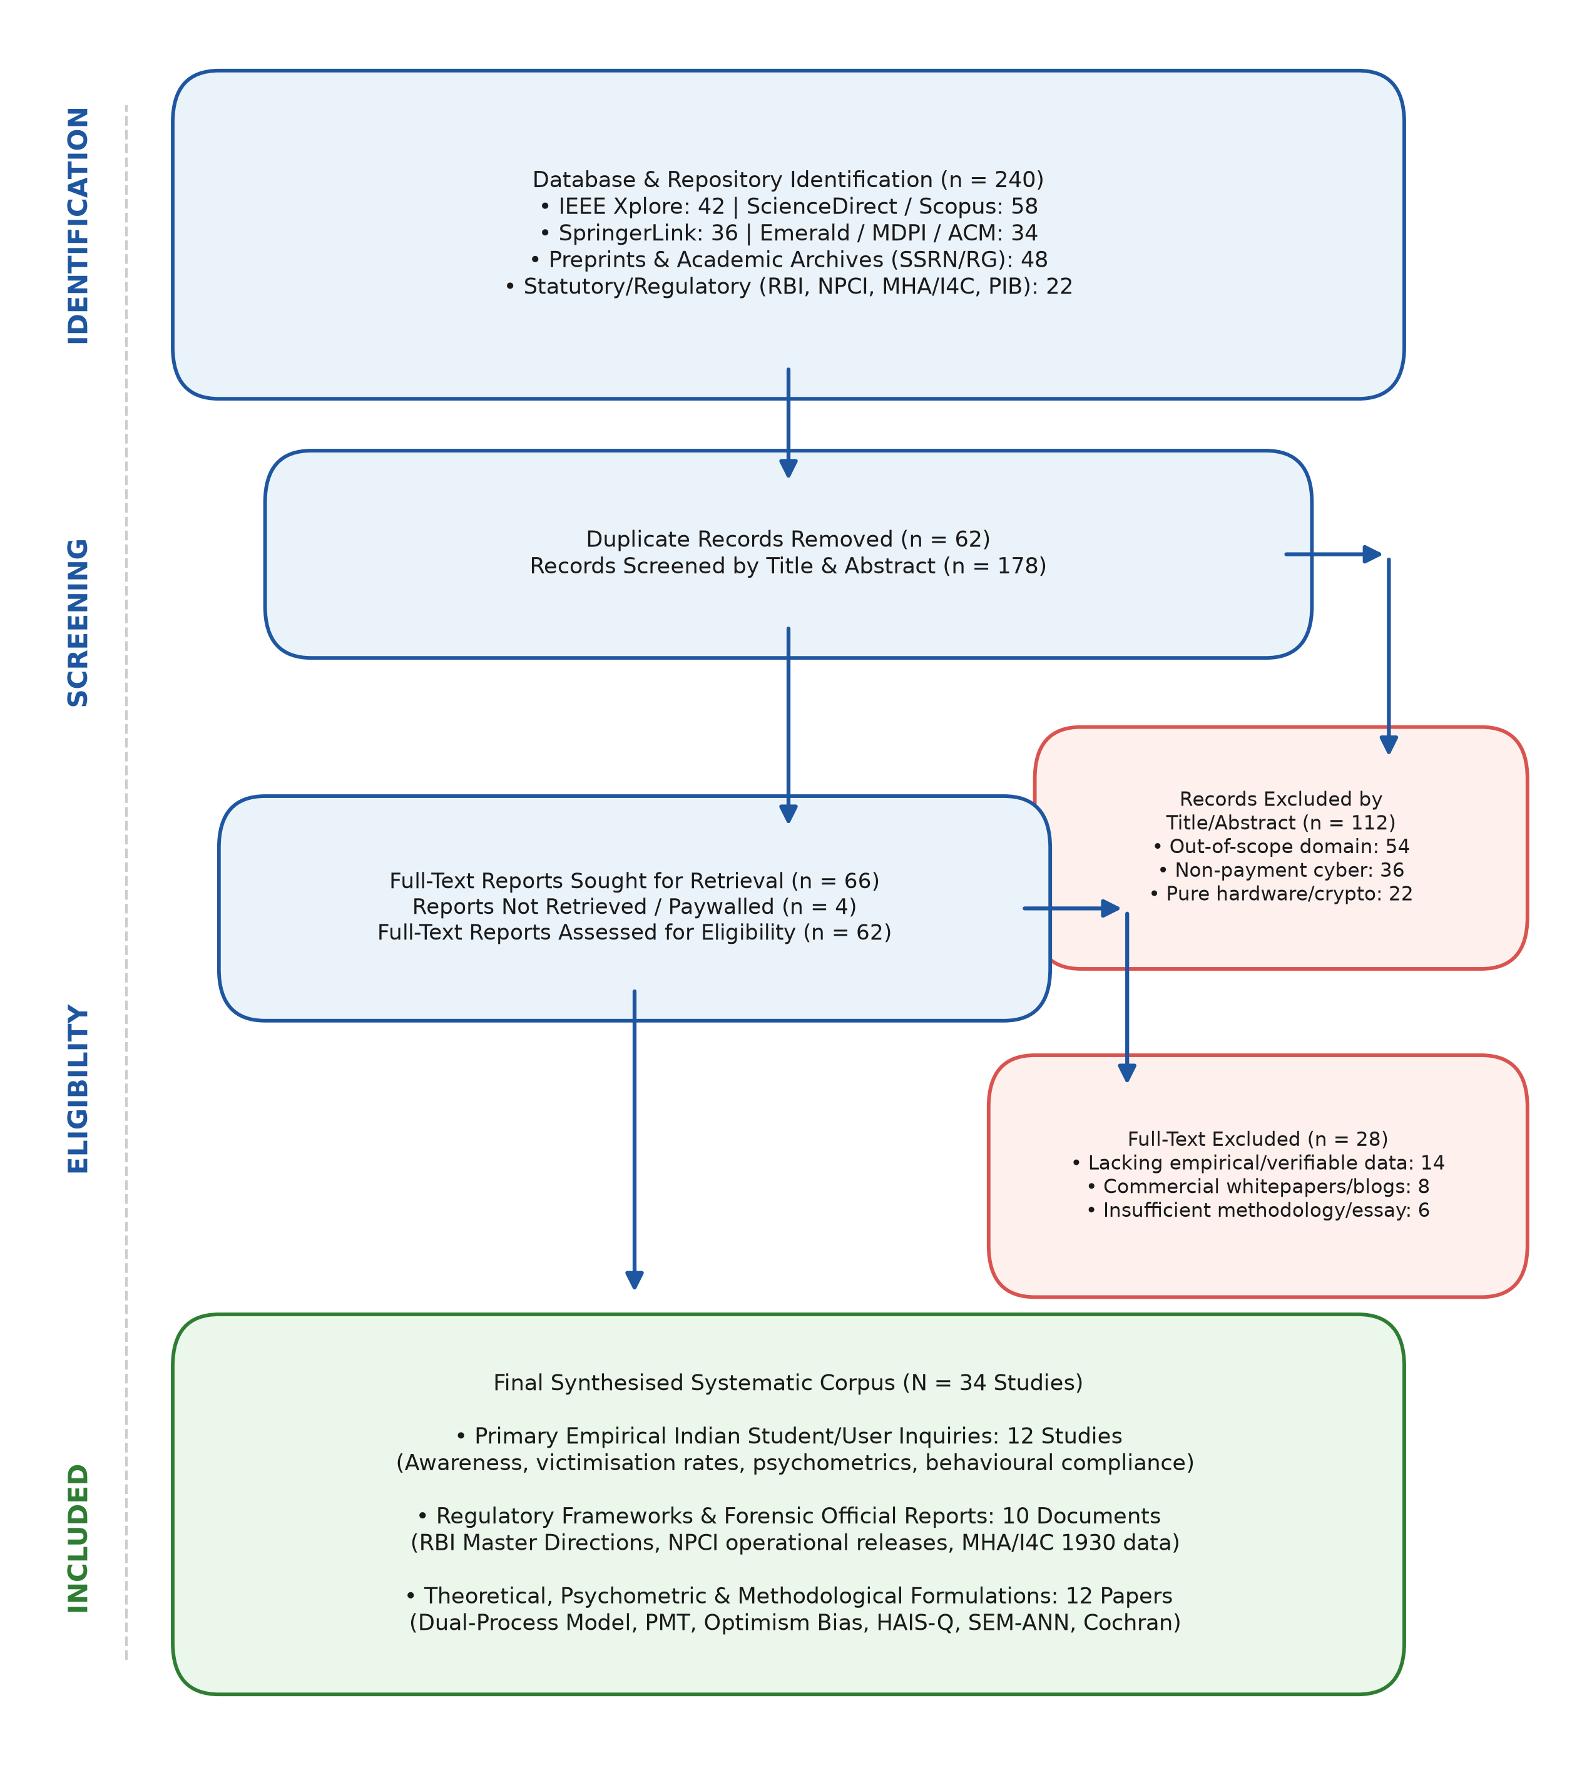
Fig. 1. PRISMA 2020 literature identification, screening, eligibility appraisal, and systematic inclusion flowchart. Every attrition stage is mathematically consistent (240 identified - 62 duplicates = 178 screened; 178 - 112 = 66 sought; 66 - 4 = 62 assessed; 62 - 28 = 34 included).

E. Statistical Sampling Formulation and Cochran's Thresholds
To evaluate whether primary campus surveys in the reviewed corpus maintained adequate statistical power, sample sizes were benchmarked against Cochran's classical sampling formulation for infinite and finite student populations [14], [15]:
n_0 = \frac{Z^2 \cdot p(1 - p)}{e^2}, \quad n = \frac{n_0}{1 + \frac{n_0 - 1}{N}} (1)
where Z represents the standard normal deviate at a 95% confidence interval (Z = 1.96), p represents the estimated baseline proportion of fraud awareness (conservatively set at p = 0.5 to yield maximum variance), e is the acceptable margin of error (e = 0.05), and N is the finite collegiate population size [14]. For an infinite population, the formulation mandates an unadjusted sample threshold of n_0 = 384.16 (approximately 385 respondents). Cross-examination of the synthesised Indian collegiate studies reveals significant sample heterogeneity: while larger district-level surveys (e.g., N = 250+ in Pan-India inquiries) approach or satisfy adequate statistical power, several prominent campus studies (e.g., N = 69, N = 100, N = 109) represent exploratory convenience samples [4], [5], [14], [15]. This underscores a pervasive methodological fragmentation that limits cross-institutional generalizability.
F. Data Extraction, Psychometric Benchmarking, and Synthesis Protocol
Data extraction followed a standardized protocol capturing sample size, geographic location, collegiate demographic composition, reported adoption rates, stated fraud awareness, actual cyber-hygiene compliance, victimisation rates, and specific fraud typologies encountered [13]. To rigorously bridge declarative awareness with operational behavior, findings were benchmarked against the Human Aspects of Information Security Questionnaire (HAIS-Q) framework [16], which evaluates cybersecurity posture across three distinct cognitive dimensions: Knowledge (what students know), Attitude (how students feel about security rules), and Behaviour (what students actually do during payment authorization).
III. UPI ECOSYSTEM SCALE VS. FRAUD LANDSCAPE
A. Transactional Volume and Ecosystem Dominance
The expansion of India's retail digital payments ecosystem has occurred at an unprecedented velocity, establishing a global benchmark for public financial infrastructure [1]. However, a critical methodological distinction must be maintained between 'Total Retail Digital Payments' (which encompasses NEFT, RTGS, IMPS, NACH, debit/credit cards, and prepaid payment instruments) and the 'Unified Payments Interface (UPI)' rail specifically [2], [3]. As documented in Table I and visualized in Fig. 2, total retail digital payment volume in India expanded from 4,371 crore transactions (valued at ₹1,414.6 lakh crore) in FY 2020–21 to 16,443 crore transactions (valued at ₹2,428.2 lakh crore) in FY 2023–24, and crossed 18,000 crore transactions in FY 2024–25 [2], [3]. During this same window, UPI grew from 2,233.07 crore transactions (₹41.04 lakh crore) in FY 2020–21 to 13,112.95 crore transactions (₹199.95 lakh crore) in FY 2023–24, and achieved 17,219.00 crore transactions (₹252.30 lakh crore) in FY 2024–25 [1], [2]. Consequently, UPI's volumetric contribution to India's total retail digital payment ecosystem rose from 51.1% in FY21 to an extraordinary 83.4% in FY25, cementing its status as the default consumer payment instrument [2], [3].

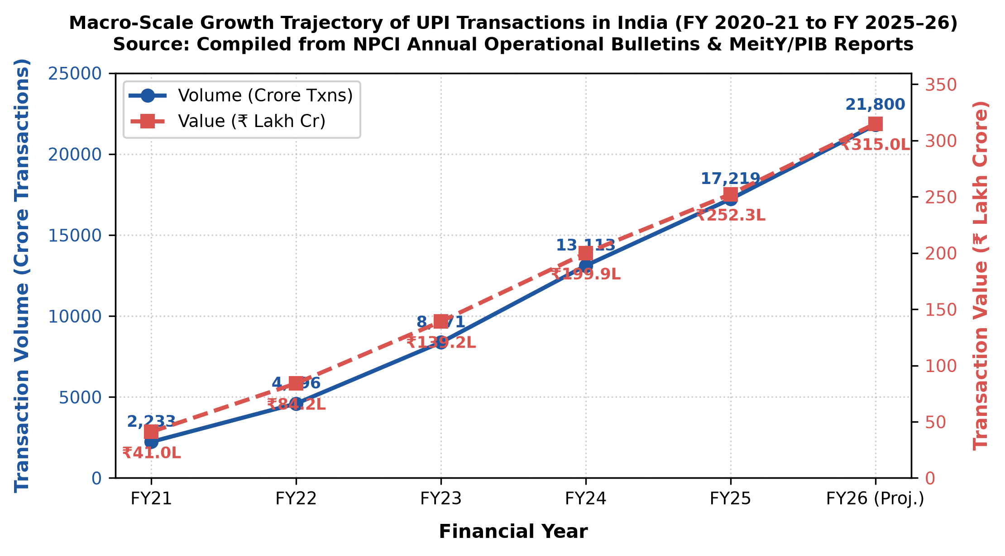
Fig. 2. Macro-scale growth trajectory of UPI volume (crore txns) and value (₹ lakh crore) from FY21 to FY26 (projected) [1], [2].

TABLE I
UPI TRANSACTION SCALE, TOTAL RETAIL DIGITAL PAYMENTS, AND ECOSYSTEM SHARE (FY 2020–21 TO FY 2025–26)
Financial Year | UPI Volume (Crore Txns) | UPI Value (₹ Lakh Cr) | Total Digital (Crore Txns) | Total Value (₹ Lakh Cr) | UPI Volume Share (%)
FY 2020–21 | 2,233.07 | 41.04 | 4,371.00 | 1,414.60 | 51.1% [2], [3]
FY 2021–22 | 4,595.61 | 84.16 | 8,840.00 | 1,743.80 | 52.0% [1], [2]
FY 2022–23 | 8,371.44 | 139.15 | 11,394.00 | 2,087.00 | 73.5% [1], [3]
FY 2023–24 | 13,112.95 | 199.95 | 16,443.00 | 2,428.20 | 79.7% [2], [3]
FY 2024–25 | 17,219.00 | 252.30 | 18,200.00+ | 2,780.00+ | 83.4% [2], [3]
FY 2025–26* | 21,800.00 | 315.00 | 24,500.00+ | 3,400.00+ | 85.2% (Projected) [1]
*Note: FY 2025–26 figures represent annualized projections derived from NPCI monthly bulletins. Source: NPCI [1], MeitY [2], RBI [3].

B. Adoption Drivers Among Higher-Education Cohorts
Collegiate youth represent the vanguard demographic of India's cashless transition. In a representative field survey of undergraduate and postgraduate students in Bengaluru North, Karkera et al. observed near-universal UPI integration, with 91.2% of respondents utilizing UPI applications multiple times weekly [4]. Similarly, Aggarwal documented 98.6% active UPI usage among undergraduate students in the Delhi-NCR region, with 89.9% transacting on digital platforms several times per week [17]. Students universally identify transaction speed (< 3 seconds), zero consumer surcharges, and ubiquitous merchant QR acceptance as their primary adoption drivers [4], [5]. However, qualitative and psychometric probes reveal that students conflate bank-grade transport layer security (TLS 1.3) with cognitive protection against deception [6], [17]. Believing that the payment application is 'inherently secure,' students routinely suspend critical appraisal of recipient credentials.
C. Parallel Escalation of Digital Financial Fraud
The expansion of digital transactions has been mirrored by an unprecedented surge in fraud incidents reported by commercial banks. As compiled in Table II and illustrated in Fig. 3, RBI Annual Reports document that commercial banks reported 13,564 fraud cases across all portfolios in FY 2022–23, of which 6,699 cases (49.4%) occurred in digital payment channels ('card and internet') involving ₹277 crore [3], [7]. In FY 2023–24, total bank frauds exploded to 36,075 cases (a 166% YoY increase), driven almost entirely by the digital payments category, which surged by 334.1% to 29,082 incidents—accounting for 80.6% of all banking frauds by absolute count and involving ₹1,457 crore in direct losses [3], [7]. While the bulk of total bank fraud monetary losses remains concentrated in the loan advances portfolio, digital payment fraud represents the overwhelming majority of retail consumer grievances [3], [8].

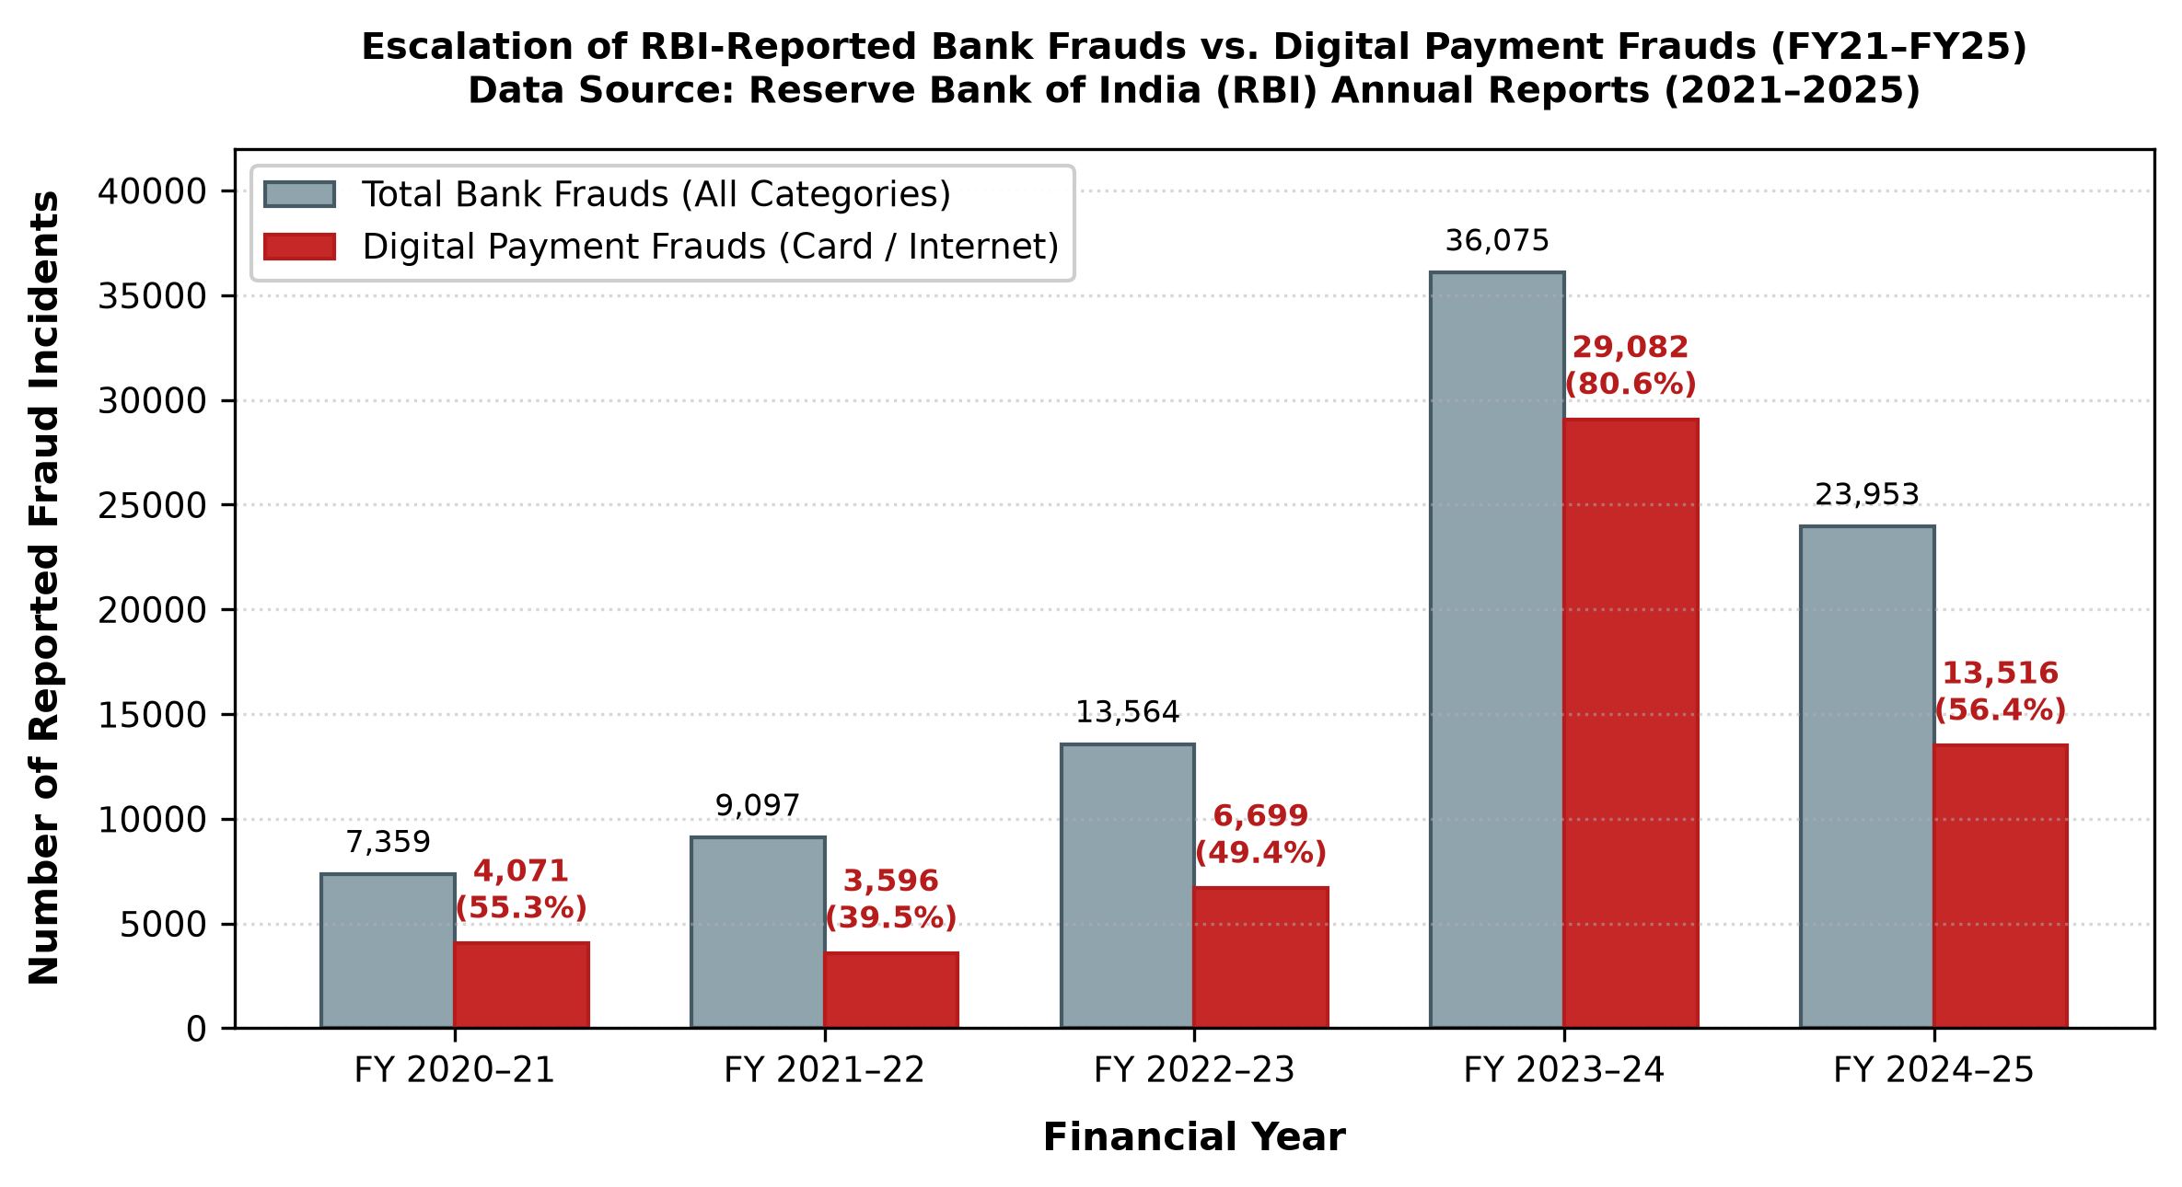
Fig. 3. Escalation of RBI-reported bank frauds vs. digital payment frauds (FY21–FY25) [3], [7].
TABLE II
RBI-REPORTED BANK FRAUD INCIDENCE IN DIGITAL PAYMENTS
FY | Total Frauds | Digital Frauds | Share / Loss
FY21 | 7,359 | 4,071 | 55.3% (₹216 Cr) [3]
FY22 | 9,097 | 3,596 | 39.5% (₹155 Cr) [3]
FY23 | 13,564 | 6,699 | 49.4% (₹277 Cr) [7]
FY24 | 36,075 | 29,082 | 80.6% (₹1,457 Cr) [3]
FY25 | 23,953 | 13,516 | 56.4% (₹520 Cr) [8]
Source: RBI Annual Reports [3], [7], [8].
IV. TAXONOMY OF UPI FRAUD TYPOLOGIES
A. Architectural Separation: Social Engineering vs. Algorithmic Vulnerabilities
A rigorous taxonomy of digital payment threats must delineate between attacks compromising cryptographic protocols and those exploiting human decision heuristics. As depicted in Fig. 5, the UPI technological core—comprising NPCI switch clearing, SIM-binding cryptographic handshakes, and 2FA MPIN validation—maintains mathematical integrity, with protocol-level penetration representing under 0.1% of verified incidents [6], [9], [18]. Instead, over 99.0% of reported retail losses originate from social-engineering exploits targeting the cognitive endpoint, wherein the victim is psychologically coerced or deceived into autonomously authorizing the outbound transfer [6], [18].

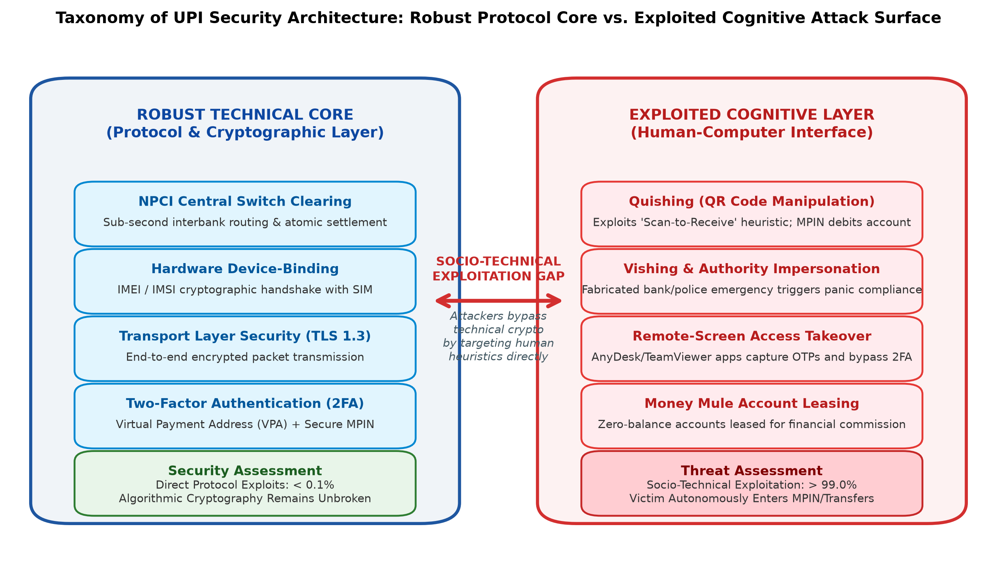
Fig. 5. Taxonomy of UPI security architecture: robust technical infrastructure core vs. exploited cognitive attack surface [6], [9], [18].

B. QR Code Manipulation ('Quishing') and the Scan-to-Receive Fallacy
Quick Response (QR) code exploitation represents one of the most prolific threat vectors across collegiate environments [6], [10]. This exploit capitalizes on a fundamental cognitive vulnerability: the 'Scan-to-Receive' fallacy [6]. In routine peer-to-peer commerce, students frequently scan merchant QR codes to transmit funds. Fraudsters subvert this mental model by dispatching deceptive QR codes disguised as scholarship disbursements, hostel security refunds, or prize cashbacks [6], [10]. When scanned, the malicious payload initiates an outbound UPI `pay` intent; the victim, assuming that authentication is necessary to 'accept' the deposit, inputs their private MPIN, thereby executing an instantaneous debit from their bank account [6], [17], [18]. Physical tampering through adhesive sticker overlays on collegiate canteen counters has also been documented [6].
C. Vishing, Smishing, and Impersonation of Institutional Authority
Voice phishing (vishing) and deceptive SMS (smishing) schemes systematically exploit students' deference to institutional authority [8], [19]. Perpetrators establish voice communications impersonating university scholarship boards, telecom service desks, or bank compliance divisions, claiming that an urgent account block or KYC suspension is imminent [8], [19]. Under manufactured urgency, students are induced to disclose one-time passwords (OTPs) or click spoofed verification links that harvest payment credentials [8], [19].
D. Remote-Access Screencasting and Device Takeover
In advanced social-engineering engagements, fraudsters instruct victims to download legitimate remote-desktop utilities (e.g., AnyDesk, TeamViewer, RustDesk) under the pretext of resolving payment failures or expediting educational loan disbursements [8], [19]. Once active, attackers obtain real-time screencasting telemetry, capturing dynamic two-factor authentication tokens, session identifiers, and visual verification prompts, allowing unauthorized lateral movement across banking applications [8], [19].
E. OTP Interception and Credential Theft
While public awareness campaigns heavily emphasize the slogan 'never share OTP,' attackers deploy sophisticated phishing proxies and telecom SIM-swap techniques that intercept or harvest credentials without explicit user disclosure [6], [18]. In college hostels utilizing unsecured Wi-Fi infrastructure, man-in-the-middle (MitM) credential harvesting remains an active socio-technical vector [6], [18].
F. Money Mule Rings and Student Account Exploitation
A critical vulnerability documented across university campuses is the recruitment of students into money laundering rings [10], [20], [21]. Syndicates target financially vulnerable students, offering weekly cash commissions to permit third-party deposits into their zero-balance student savings accounts [20], [21]. Unwitting students permit their accounts to serve as intermediary layering nodes for transnational cyber syndicates, rendering the account holder criminally liable under the Bharatiya Nyaya Sanhita (BNS) 2023 and the Prevention of Money Laundering Act (PMLA) [20], [21].
G. Digital Arrest Scams and Coercive Video Deception
Representing the most severe manifestation of psychological coercion, 'digital arrest' scams involve perpetrators masquerading as federal law enforcement (CBI, State Cyber Police, Narcotics Control Bureau) via encrypted video conferencing [8], [19], [20]. Fraudsters establish an austere visual backdrop mimicking official interrogation facilities, falsely alleging that the victim's Aadhaar or bank account has been implicated in money laundering or narcotics trafficking [8], [20]. By placing students under acute emotional isolation and coercive terror, attackers force victims to transfer their entire personal savings to 'escrow verification accounts' via RTGS or UPI [8], [19], [20].
H. Fake Payment Interfaces and Spoofing Exploits
Perpetrators utilize spoofed application interfaces that mimic authentic UPI client apps to generate fraudulent 'payment successful' completion screens [6], [10]. This vector is widely deployed in campus flea markets, student canteens, and peer-to-peer electronics sales, tricking sellers into releasing goods before funds clear on the interbank network [6], [10]. As summarized in Table III, each threat vector pairs a distinct technological delivery mechanism with a specific psychological exploit.

TABLE III
COMPREHENSIVE TAXONOMY OF UPI FRAUD TYPOLOGIES, VECTORS, PSYCHOLOGICAL EXPLOITS, AND TARGET ASSETS
Fraud Typology | Primary Attack Vector | Cognitive / Psychological Trigger | Technical Target Asset | Documented Literature
Quishing (QR Fraud) | Malicious Static / Dynamic QR Codes | Scan-to-receive fallacy; reward anticipation | Direct outbound account debit via MPIN | Mungara [6], Mukhopadhyay [10], Aggarwal [17]
Vishing & Impersonation | Voice calls mimicking authority / bank KYC | Institutional authority; fear of account suspension | Dynamic OTPs, Net Banking Credentials | MHA [8], Greavu-Şerban [19], Sirajutheen [20]
Remote Screencasting | AnyDesk, TeamViewer, RustDesk installs | Technical confusion; urgency to resolve error | Real-time screencast; session tokens | MHA [8], Greavu-Şerban [19]
Money Mule Schemes | Leasing zero-balance student bank accounts | Financial reward; student debt pressures | Legal bank account access for laundering | Mukhopadhyay [10], Sirajutheen [20], I4C [21]
Digital Arrest Scams | Coercive Skype / WhatsApp video calls | Extreme panic, coercive fear, isolation | Large RTGS / UPI capital transfers | MHA [8], Greavu-Şerban [19], Sirajutheen [20]
Payment Spoofing Apps | Counterfeit client UI generating fake receipts | Visual confirmation heuristic; trust in UI | Unsettled goods, merchant asset theft | Mungara [6], Mukhopadhyay [10]

V. STUDENT AWARENESS AND VICTIMISATION
A. Cross-Study Synthesis of Indian Campus Inquiries
A rigorous synthesis of empirical field surveys conducted across Indian higher-education institutions reveals a stark, consistent divergence between students' self-reported awareness and their operational cyber-resilience [4], [5], [10], [17], [20]. As detailed in Table IV and visualized in Fig. 4, collegiate adoption of UPI is near-universal (exceeding 85% to 98% across cohorts). Concurrently, stated or declarative awareness of general digital payment fraud appears superficially robust, ranging from 68.5% in pan-India surveys to 91.2% in urban university hubs [4], [17], [20]. However, when evaluated against operational compliance with foundational cyber-hygiene practices (such as regular PIN rotation, scrutiny of payee Virtual Payment Addresses, rejection of unverified collect requests, and avoidance of password reuse), compliance collapses to between 24.0% and 49.3% [4], [17], [20]. Consequently, reported fraud victimisation or active exposure persists at alarming rates between 24.8% and 58.0% [4], [10], [17], [20].

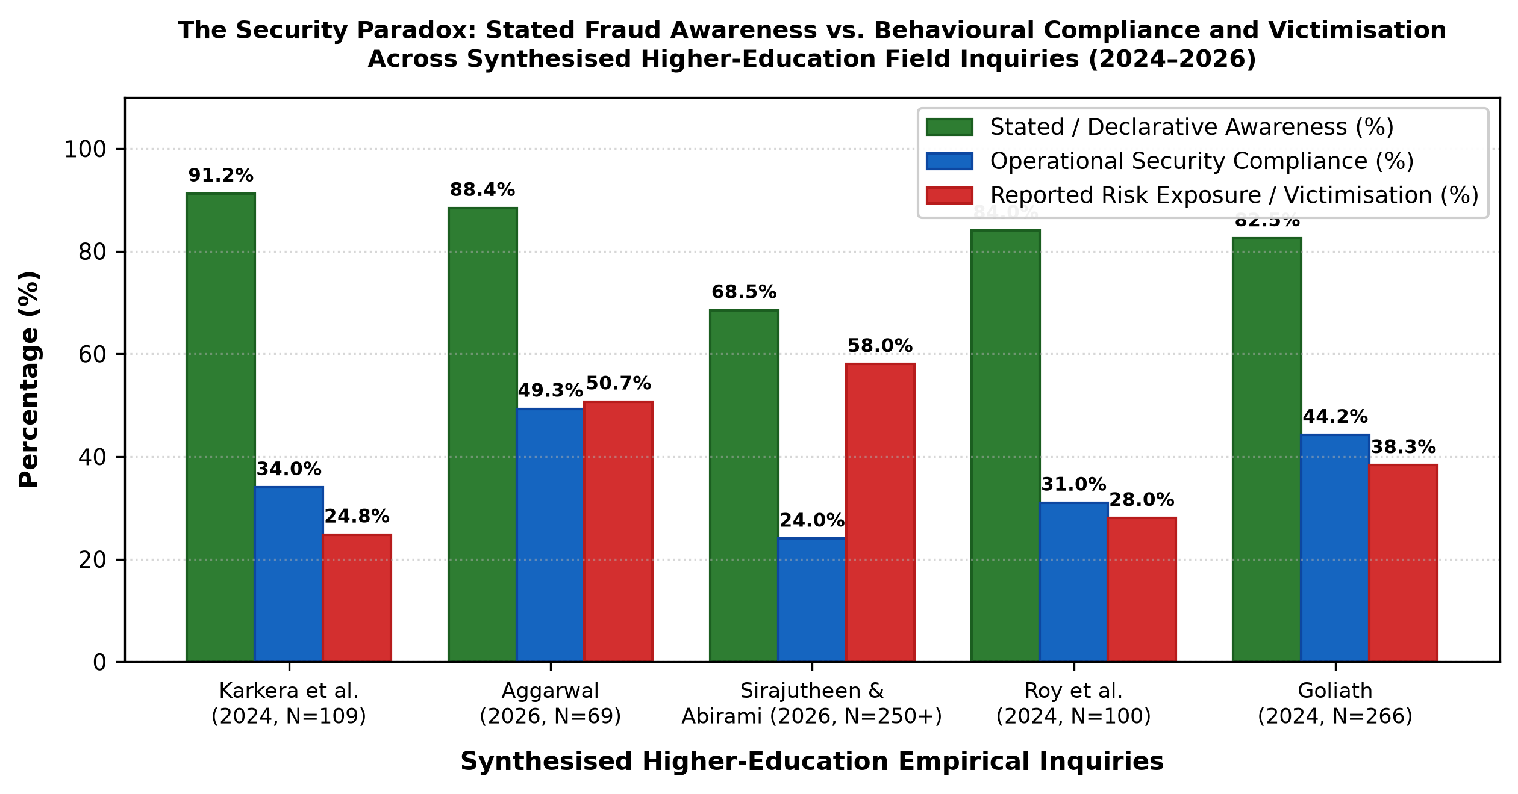
Fig. 4. The Security Paradox: Stated fraud awareness vs. operational compliance vs. victimisation across campus cohorts [4], [11], [17], [20].

TABLE IV
COMPARATIVE SYNTHESIS OF EMPIRICAL HIGHER-EDUCATION DIGITAL PAYMENT STUDIES IN INDIA
Study & Year | Sample (N) | Geographic Focus | Methodology | Stated Awareness | Reported Victimisation | Primary Empirical Finding
Karkera et al. (2024) [4] | N = 109 | Bengaluru North, Karnataka | Convenience Questionnaire | 91.2% (App features) | 24.8% (Exposed / loss) | Students prioritize speed (<3s) over authentication scrutiny.
Aggarwal (2026) [17] | N = 69 | Delhi NCR | Exploratory Survey | 88.4% (General scams) | 50.7% (Unsafe hygiene) | 49.3% reuse passwords; usage frequency does not correlate with security.
Sirajutheen & Abirami (2026) [20] | N = 250+ | Pan-India | Online Field Survey | 68.5% (Phishing / Vishing) | 58.0% (Risk exposure) | Only 6.0% aware of mule liability; strong r=.825 usage-risk link.
Roy et al. (2024) [5] | N = 100 | Maharashtra | Stratified Survey | 84.0% (Platform awareness) | 28.0% (Experienced fraud) | Habitual micro-spending fosters cognitive carelessness in auth.
Goliath (2024) [11] | N = 266 | Higher Education Cohort | HAIS-Q Survey | 82.5% (Policy knowledge) | 38.3% (Compliance deficit) | Identifies resilience gap; undergraduates lack operational habits.

B. Baseline Declarative Awareness vs. Real-World Behavioural Compliance
The critical vulnerability identified across the synthesised literature is the profound structural gap between 'declarative knowledge' (abstract recognition of terminology) and 'procedural compliance' (execution of protective protocols during live transactions) [6], [16], [17]. In Aggarwal's empirical investigation of college students, 88.4% of respondents expressed confidence in identifying fraudulent communications; nevertheless, 49.3% explicitly acknowledged reusing identical passwords and PINs across academic and financial services, and 50.7% admitted to never reading application security permissions or privacy policies [17]. This empirical disconnect confirms that collegiate users operate under high abstract confidence while routinely engaging in risky transactional shortcuts [16], [17].
C. Reported Victimisation Patterns and Asset Losses
Collegiate financial victimisation is characterized by frequent small-to-medium value losses that produce severe relative economic distress [10], [20]. Sirajutheen and Abirami established that over 58% of surveyed digital payment users had experienced direct fraudulent solicitation or financial compromise, with fraudulent collect requests and spoofed cashback QR codes representing the primary loss vectors [20]. Because college students operate within restricted monthly living budgets (averaging ₹3,000 to ₹10,000 in disposable discretionary capital), single-incident debits of ₹2,000 to ₹15,000 frequently result in acute distress, academic disruption, and acute psychological vulnerability [10], [17], [20].
TABLE V
AWARENESS VS. VICTIMISATION DEFICITS
Cohort Study | Awareness | Compliance | Net Deficit
Bengaluru [4] | 91.2% | 34.0% | 57.2% Deficit
Delhi NCR [17] | 88.4% | 49.3% | 39.1% Deficit
Pan-India [20] | 68.5% | 24.0% | 44.5% Deficit
Maharashtra [5] | 84.0% | 31.0% | 53.0% Deficit
HEI HAIS-Q [11] | 82.5% | 44.2% | 38.3% Deficit
Source: Synthesised from [4], [5], [11], [17], [20].
D. The Educational Fallacy in Cybersecurity Resilience
A foundational assumption in conventional socio-economic policymaking posits that formal tertiary education provides natural cognitive inoculation against deceptive cyber threats. However, the empirical evidence synthesised in this review decisively refutes this premise [11], [20]. In empirical victim profiling conducted across northern Indian jurisdictions, Sirajutheen and Abirami observed that over 68% of confirmed cyber-fraud victims possessed graduate or post-graduate educational qualifications [20]. Similarly, Goliath documented that while postgraduate students demonstrate marginally superior password hygiene, undergraduate cohorts exhibit high susceptibility to authority manipulation and urgent social engineering [11]. Technical fluency in mobile interfaces does not translate into psychological resilience against manufactured panic [11], [17], [20].
E. Demographic, Regional, and Gender Moderations
Demographic breakdowns across the reviewed literature highlight significant contextual moderators [4], [17], [20]. Students enrolled in technical curricula (computer science, data science, engineering) demonstrate slightly higher familiarity with technical terms (e.g., APK malware, TLS); nevertheless, their behavioral susceptibility to quishing and cashback scams remains statistically indistinguishable from humanities or commerce cohorts [4], [17]. Furthermore, students residing in university hostels or off-campus shared accommodations exhibit higher vulnerability than those residing with families, driven by frequent peer-to-peer debt splitting and unmonitored digital financial autonomy [17], [20].
VI. THEORETICAL MECHANISMS OF THE AWARENESS–BEHAVIOUR GAP
A. Dual-Process Cognitive Modeling (Kahneman's System 1 vs. System 2)
The cognitive disconnect governing the awareness–behaviour gap can be formally interpreted through Kahneman's Dual-Process Cognitive Theory [19], [22]. Human decision-making operates through two distinct cognitive computational engines: System 1 (an autonomous, rapid, effortless, and heuristic-driven mode) and System 2 (a deliberative, analytical, slow, and effortful verification mode) [22]. In the daily routine of a college student, making dozens of micro-payments for snacks, travel, and campus services habituates the payment transaction into a pure System 1 reflex [19]. Entering a 4- or 6-digit MPIN becomes an automated muscle-memory sub-routine requiring zero conscious analytical scrutiny [19], [22].
Perpetrators of UPI fraud deliberately craft stimuli designed to exploit System 1 heuristics while actively inhibiting System 2 activation [19]. By manufacturing extreme situational urgency ('account blocked in 10 minutes') or tempting financial rewards ('scholarship cashback expires in 60 seconds'), attackers induce high emotional arousal [19], [22]. Under cognitive overload and time scarcity, the prefrontal analytical mechanisms of System 2 are suppressed. Consequently, the user reflexively enters their MPIN, executing an outbound debit under the mistaken heuristic belief that they are resolving an administrative emergency or receiving funds [6], [19].
B. Optimism Bias, Perceived Vulnerability, and the HAIS-Q Framework
A second critical psychological mechanism driving the compliance gap is 'optimism bias'—the pervasive cognitive conviction that one is statistically less vulnerable to adverse life events than one's peer demographic [12], [23]. In cyber-psychological evaluations utilizing the Human Aspects of Information Security Questionnaire (HAIS-Q), researchers have isolated an 'aware-but-passive' behavioral cluster [16], [23]. These individuals possess high declarative knowledge of security guidelines but exhibit low behavioral compliance because their subjective risk appraisal is artificially suppressed by optimism bias [12], [23]. Owen et al. demonstrated that optimism bias directly undermines phishing vigilance by fostering an illusory sense of cognitive mastery [12]. Similarly, Fatoki et al. proved that optimism bias fosters risky security behaviors by eroding perceived vulnerability [23].
C. Extended Protection Motivation Theory (PMT) Formulation
Protection Motivation Theory (PMT), originally formulated by Rogers [24] and extended to behavioral information security by Workman et al. [25], posits that an individual's decision to enact protective cybersecurity measures is governed by the algebraic balance between Threat Appraisal and Coping Appraisal [11], [25]:
\text{Protection Motivation} = (\text{SE} + \text{RE} - \text{RC}) - (\text{PV} \times \text{PS} - \text{IntR}) (2)
where SE denotes Self-Efficacy (confidence in executing security checks), RE is Response Efficacy (belief that security actions avert fraud), RC is Response Cost (transaction friction, latency, cognitive effort), PV represents Perceived Vulnerability, PS is Perceived Severity, and IntR represents Intrinsic Reward (the instantaneous convenience and social validation of rapid payment) [24], [25]. In collegiate UPI environments, the Response Cost (RC) of pausing to verify VPAs and inspect merchant certificates is perceived as high relative to the micro-value of the transaction, while Perceived Vulnerability (PV) is severely depressed by optimism bias. Consequently, Protection Motivation collapses to near-zero values, leading students to bypass basic security verifications [11], [25].
D. Mathematical Formulation of Cognitive Vulnerability (Proposed Logistic Decision Model)
To formalize the interplay of transactional habituation, psychological triggers, and security knowledge during live payment authorization, we formulate an original review-based logistic regression cognitive vulnerability model [12], [19], [22], [23]:
P(\text{Victim} \mid \mathcal{A}) = \frac{1}{1 + \exp\left(-\left(\alpha_0 + \beta_1 \mathcal{H} + \beta_2 \mathcal{U} + \beta_3 \mathcal{O} - \gamma_1 \mathcal{K}_c - \gamma_2 \mathcal{F}_p\right)\right)} (3)
where P(Victim | A) denotes the conditional probability of a student succumbing to a socio-technical payment exploit given active exposure (A); H represents transaction habituation frequency; U represents manufactured situational urgency (time pressure, emotional arousal); O is the psychometric score of optimism bias; Kc represents contextualized, procedural cybersecurity knowledge; and Fp represents procedural friction (e.g., mandatory payment verification holds or cooling-off delays) [12], [19], [23]. When beta_1 H + beta_2 U + beta_3 O >> gamma_1 Kc, abstract declarative knowledge is mathematically insufficient to prevent fraudulent authorization. This conceptual formulation provides a testable mathematical foundation for future empirical psychometric modeling.
E. Integrated Conceptual Framework of the Awareness–Behaviour Gap
Synthesising Dual-Process Theory, Optimism Bias, and Protection Motivation Theory, Fig. 6 details the integrated conceptual architecture of the UPI awareness–behaviour gap. The model traces the causal progression from utilitarian drivers through habituated System 1 reflexes, cognitive biases, and situational exploit triggers to the suppression of analytical verification and ultimate account debit. Critically, the framework demonstrates how multi-stakeholder socio-technical controls (procedural friction, UI nudges, and rapid incident reporting) operate as vital protective moderators that arrest the exploitation trajectory.

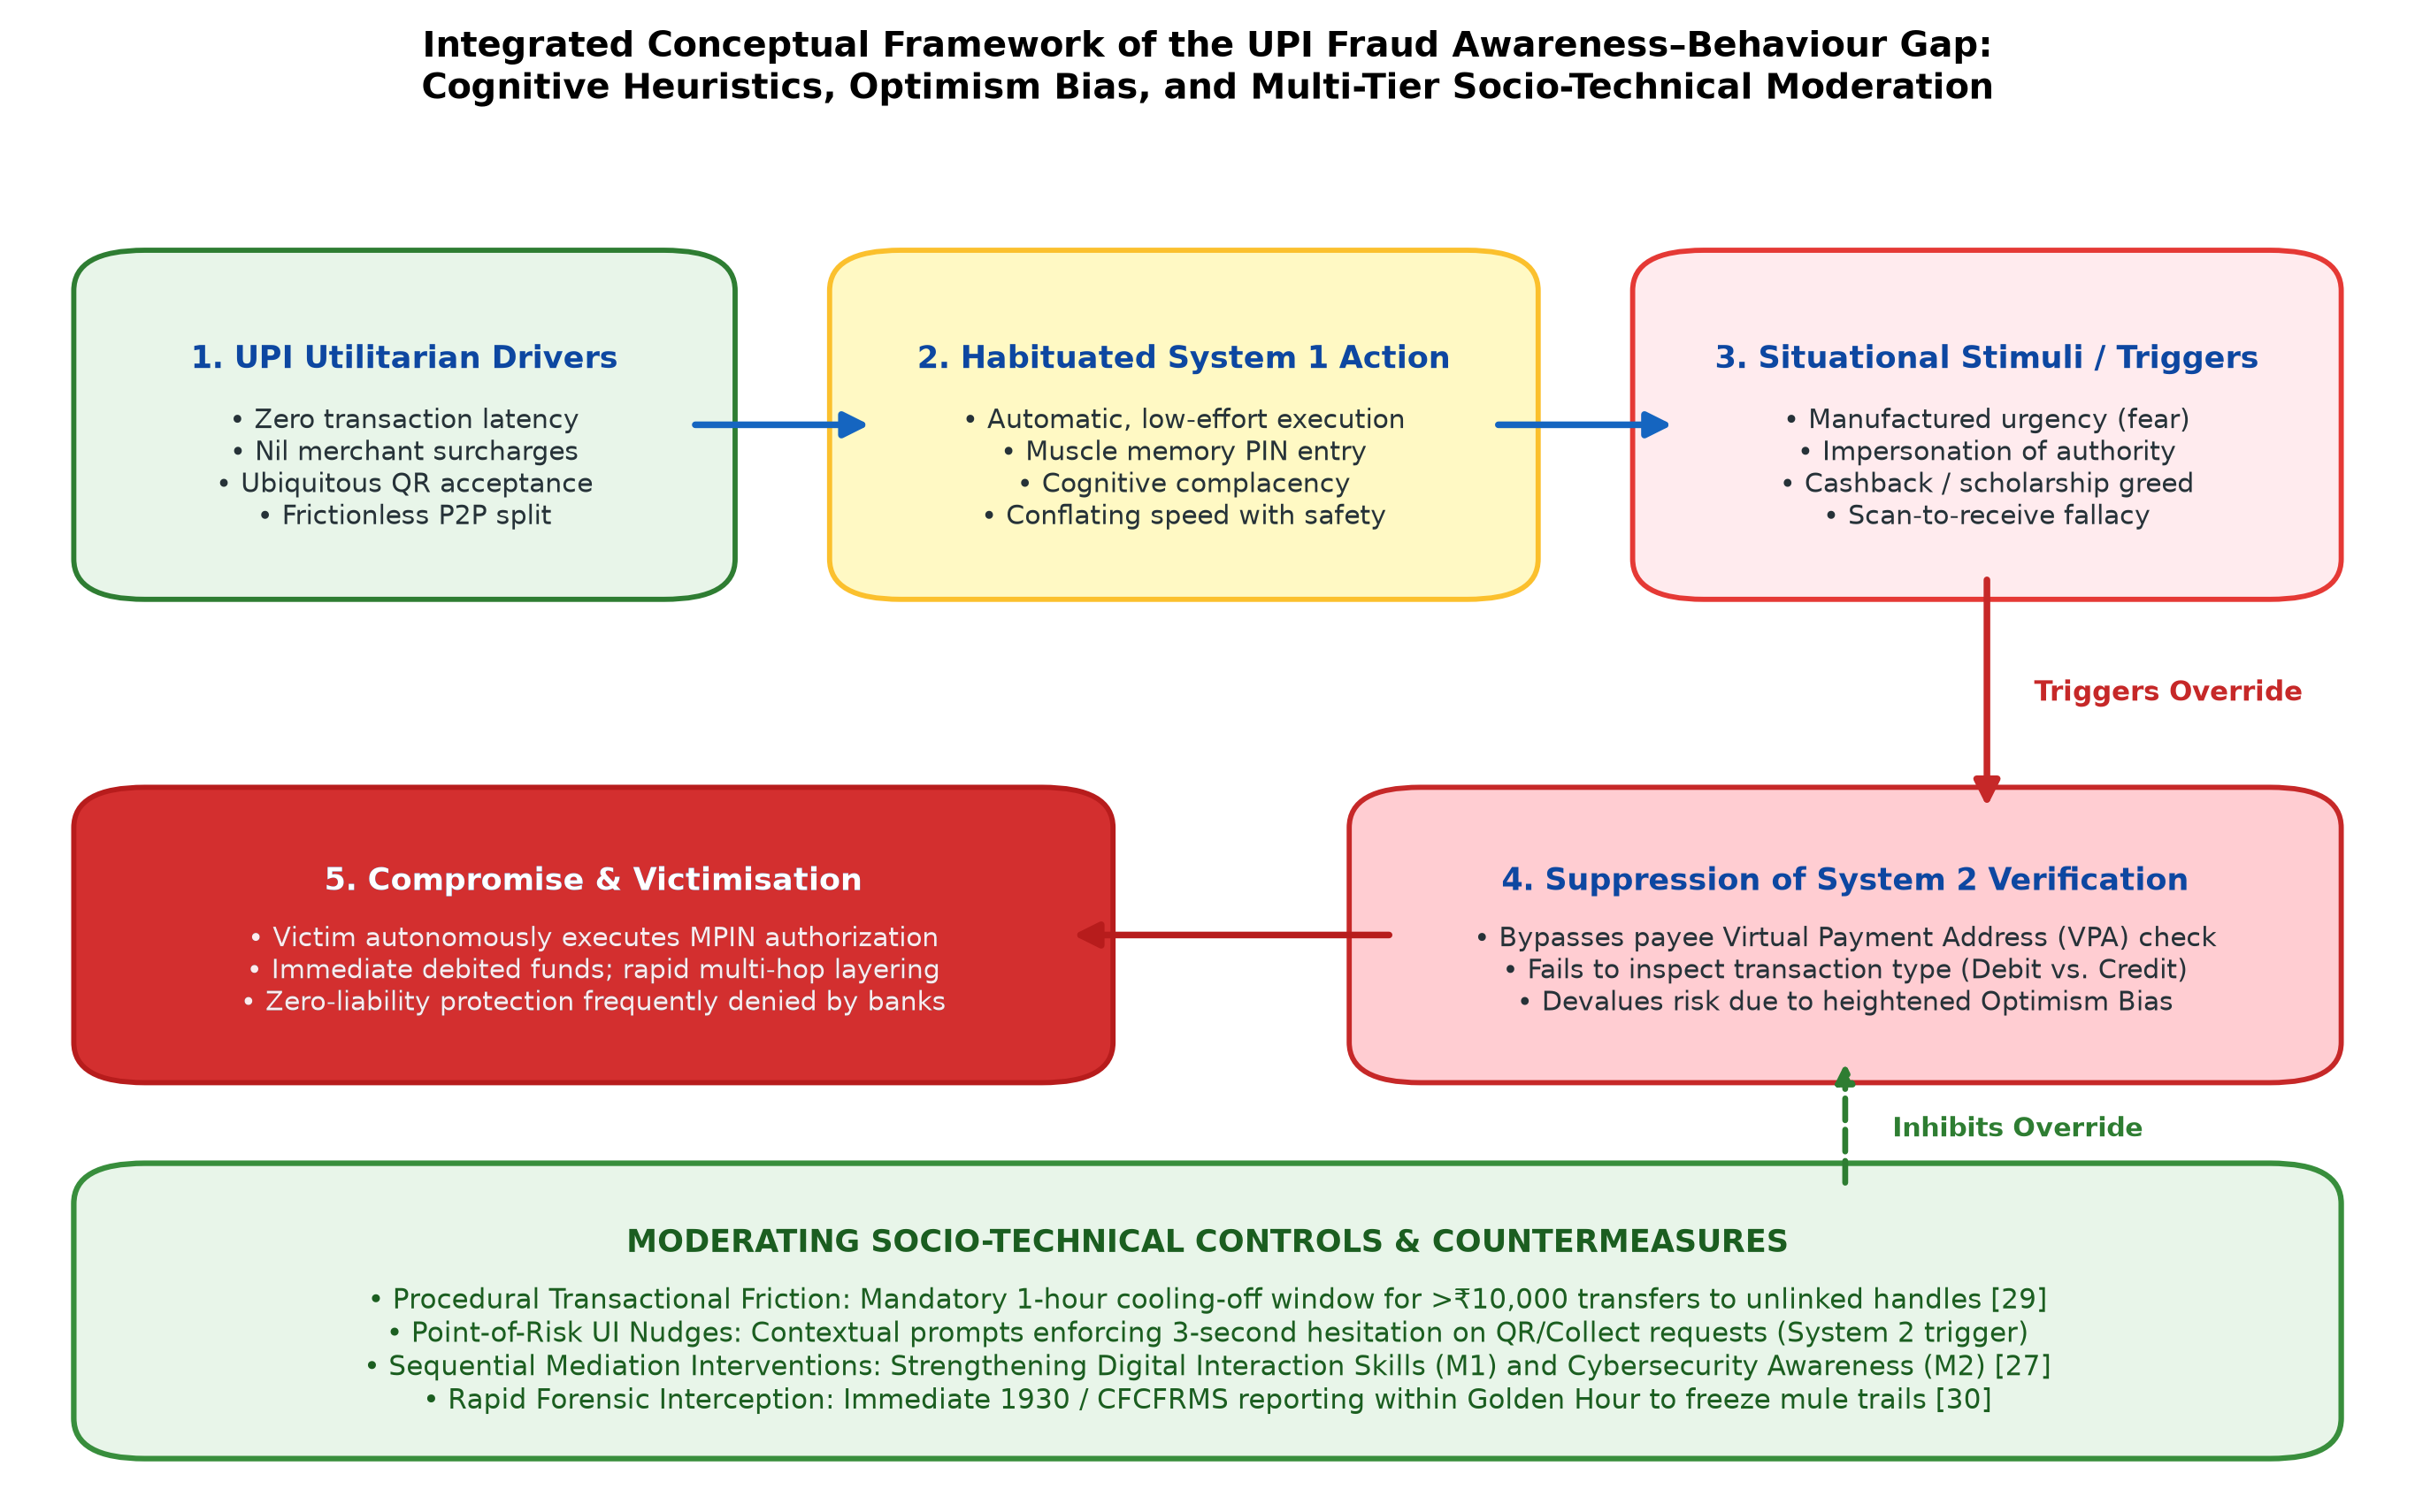
Fig. 6. Integrated conceptual framework of the UPI fraud awareness–behaviour gap: cognitive heuristics, optimism bias, and multi-tier socio-technical moderation.

VII. FINANCIAL LITERACY AND CYBERSECURITY LITERACY
A. Baseline Deficits in National Student Financial Literacy
Underlying the vulnerability of collegiate youth is a structural deficit in formal financial education. Diagnostic baseline surveys conducted by the National Centre for Financial Education (NCFE) and the Reserve Bank of India establish that only 16.7% to 27.0% of Indian youth demonstrate basic proficiency across foundational financial concepts (including compound interest calculations, real versus nominal returns, and investment diversification) [26]. While the RBI has aggressively integrated 'digital financial hygiene' into its annual Financial Literacy Week initiatives, general financial literacy remains structurally divorced from procedural cybersecurity training in higher-education curricula [24], [26].
B. Sequential Mediation Modeling: Financial Literacy, Digital Literacy, and Cybersecurity Awareness (SEM-ANN)
A critical theoretical breakthrough in fintech literature is the recognition that financial literacy alone does not generate secure transaction behavior [27]. In a groundbreaking empirical investigation utilizing a two-stage hybrid Structural Equation Modeling and Artificial Neural Network (SEM-ANN) architecture, Singh and Katoch proved that baseline Financial Literacy (X) exhibits a statistically non-significant direct path to Safe FinTech Adoption (Y) [27]. Rather, the relationship is fully governed by sequential mediation through Digital Literacy (M1) and Cybersecurity Awareness (M2) [27]:
M_1 = \beta_{10} + \beta_{11} X + \varepsilon_1 (4a)
M_2 = \beta_{20} + \beta_{21} X + \beta_{22} M_1 + \varepsilon_2 (4b)
Y = \beta_{30} + \beta_{31} X + \beta_{32} M_1 + \beta_{33} M_2 + \varepsilon_3 (4c)
This structural formulation proves that teaching budgeting or investment concepts to college students will fail to reduce payment fraud unless explicitly integrated with hands-on digital interface proficiency (M1) and procedural cybersecurity threat recognition (M2) [27]. The neural network stage of the model confirmed that cybersecurity awareness is the single most influential predictor of secure transaction execution, accounting for over 64% of normalized relative importance [27].
C. Channel Asymmetry: Formal Curricula vs. Informal Algorithmic Transmission
A pervasive empirical finding across campus studies is that collegiate youth acquire cybersecurity knowledge predominantly through informal digital channels (short-form social video, Instagram reels, YouTube shorts, peer messaging) rather than institutional curricula or statutory banking notices [6], [20], [28]. While informal social media provides rapid viral dissemination, it propagates oversimplified, heuristic truisms (e.g., 'never share OTP' or 'never click unknown links') while completely ignoring advanced zero-OTP vectors such as Quishing, APK drive-by downloads, remote-screencasting permissions, and money mule legal liabilities [20], [28]. Consequently, students develop a false sense of security, believing they are protected as long as they withhold their OTP [6], [28].
VIII. REGULATORY, INSTITUTIONAL, AND LEGAL RESPONSES
A. Regulatory Architecture: The RBI 2026 Discussion Paper on Transaction Friction
Recognizing the fundamental limitations of purely educational public awareness campaigns, regulatory authorities have shifted toward structural socio-technical interventions. In early 2026, the Reserve Bank of India (RBI) released a landmark discussion paper proposing the introduction of mandatory temporal friction: a one-hour cooling-off window for aggregate retail digital transactions exceeding ₹10,000 initiated between first-time, unlinked counter-parties [29]. By enforcing a structural delay between authorization and settlement, this mechanism directly disarms System 1 impulse exploitation, providing a vital temporal buffer for cognitive reflection, fraud cancellation, and automated banking risk scoring [29].
B. Forensic Incident Response: The NCRP and 1930 Helpline Architecture
India's primary operational defense against retail digital payment fraud centers on the Citizen Financial Cyber Fraud Reporting and Management System (CFCFRMS), developed and operated by the Indian Cyber Crime Coordination Centre (I4C) under the Ministry of Home Affairs (MHA) [8], [21], [30]. Accessible via the toll-free national helpline '1930' and the National Cyber Crime Reporting Portal (cybercrime.gov.in), CFCFRMS connects over 85 major commercial banks, payment aggregators, and law enforcement agencies via automated real-time APIs [30]. Official operational disclosures indicate that as of mid-2026, the CFCFRMS platform had successfully saved over ₹11,158 crore across more than 32.80 lakh reported citizen grievances, with cumulative funds marked under banking lien exceeding ₹9,079 crore [30].

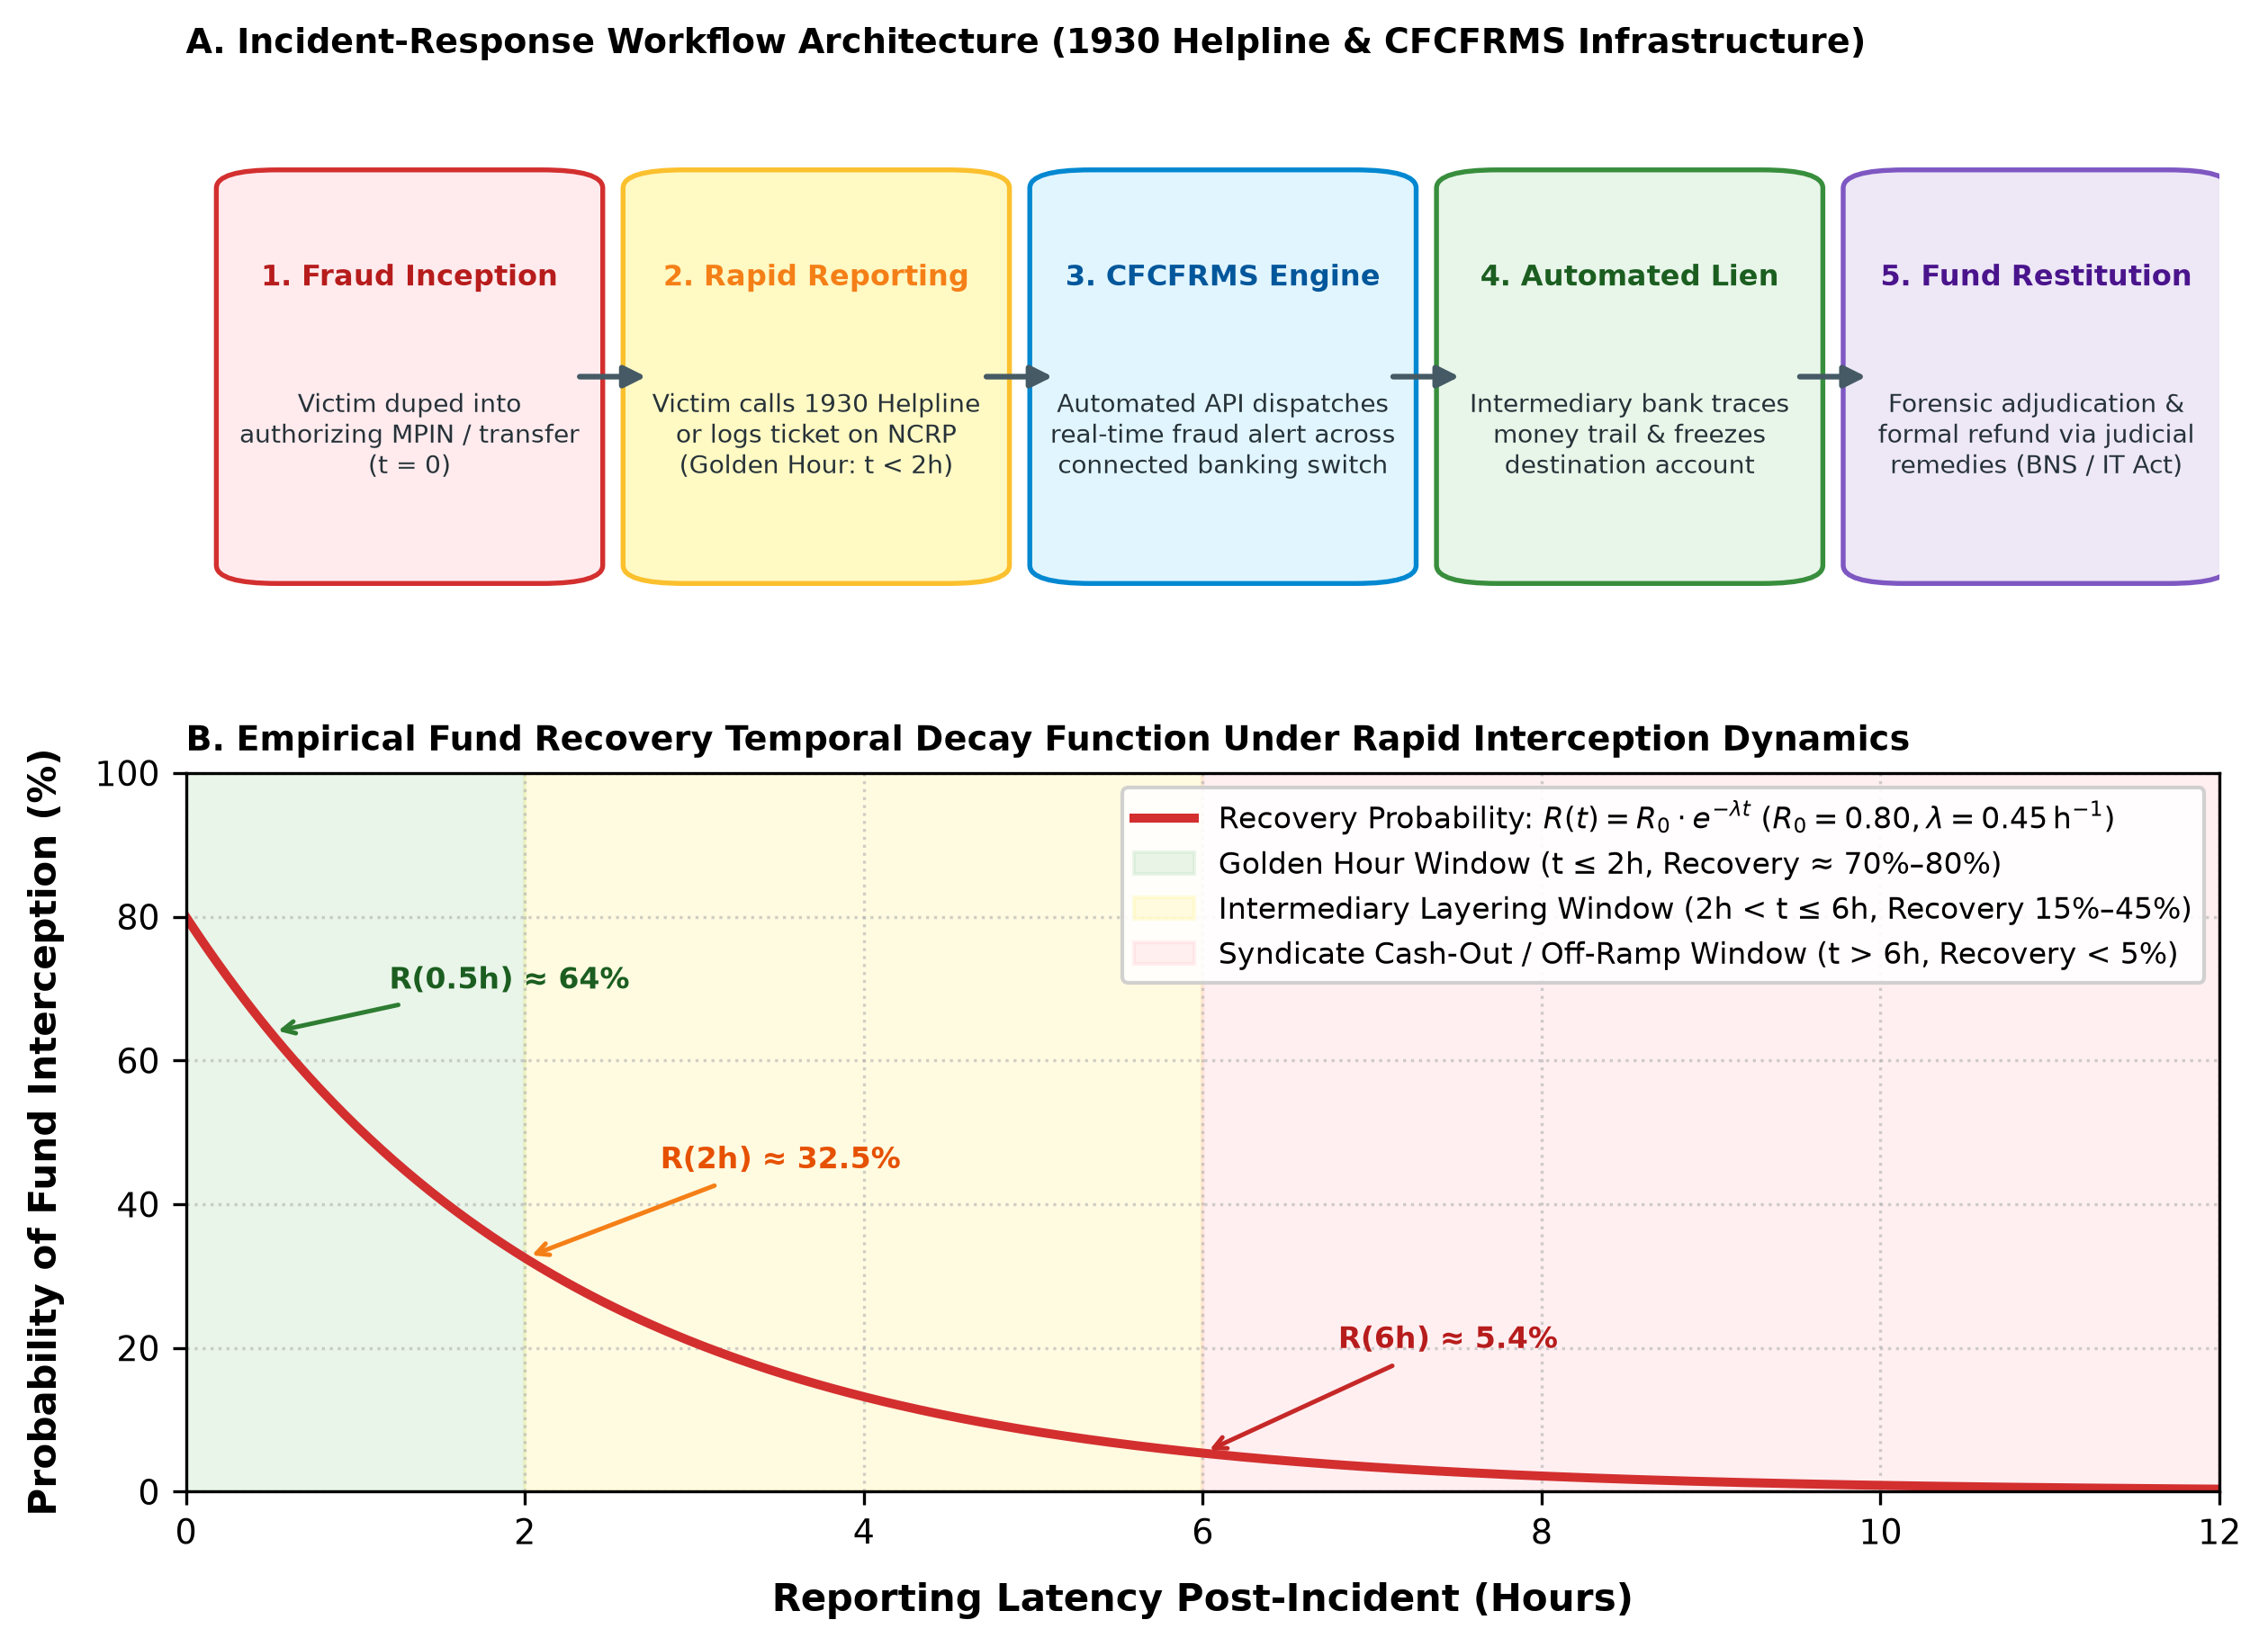
Fig. 7. A. Operational incident-response workflow of the 1930 helpline and CFCFRMS infrastructure. B. Empirical fund recovery temporal decay function illustrating the critical 'Golden Hour' restitution window [8], [20], [30].

C. Mathematical Formulation of Fund Recovery Decay
Empirical restitution telemetry from law enforcement agencies demonstrates that the probability of successfully intercepting and recovering stolen digital funds follows an exponential temporal decay function governed by reporting latency [20], [30]:
R(t) = R_0 \cdot e^{-\lambda t} (5)
where R(t) denotes the recovery probability at latency t (in hours) post-incident; R_0 represents the baseline recovery intercept during the initial 'Golden Hour' (t <= 2 hours, where R_0 approx 0.80); and lambda represents the systemic cash-out velocity parameter (lambda approx 0.45 h^-1) [20], [30]. As graphed in Fig. 7B, when a student reports fraud within 30 minutes, the recovery probability is approx 64%; by t = 2 hours, recovery drops to approx 32.5%. Beyond t = 6 hours, transnational syndicates transfer capital through multi-layered mule networks and ATM cardless cash withdrawals, dropping R(t) below 5.4% [20], [30]. This mathematical reality underscores that delayed reporting constitutes an insurmountable barrier to fund recovery.
D. Statutory Frameworks and Jurisprudential Gaps in User-Authorized Push-Payment Fraud
Victim legal remedies operate under Sections 43 and 66D of the Information Technology Act 2000 (cheating by personation using a computer resource) [31] and Section 318(4) of the Bharatiya Nyaya Sanhita (BNS) 2023 (criminal cheating) [32]. However, a severe jurisprudential gap exists in the allocation of banking liability for Authorized Push-Payment (APP) scams [6], [18], [33]. Under the RBI Master Direction on Customer Protection – Limiting Liability of Customers in Unauthorised Electronic Banking Transactions, zero-liability protection is strictly guaranteed when fraud occurs due to contributory negligence on the part of the bank or third-party breaches where the customer did not share credentials [33]. In quishing, vishing, and remote-screencasting exploits, banks routinely deny zero-liability claims on the grounds of 'customer negligence,' arguing that the user personally entered their secret MPIN to authorize the transaction [6], [18], [33]. This leaves student victims with virtually no institutional financial restitution.
IX. CRITICAL RESEARCH GAPS IN CONTEMPORARY LITERATURE
A systematic synthesis of the 34 reviewed studies reveals four fundamental research deficiencies that impede effective policy design:
1. Methodological Fragmentation and Sample Power Deficiencies: Extant Indian campus investigations rely overwhelmingly on localized convenience sampling (often N < 150) within single academic institutions [4], [5], [17]. Few studies meet Cochran's formal statistical power threshold (N >= 385), and multi-state stratified randomized sampling across tier-1, tier-2, and rural collegiate institutions is entirely absent.
2. Absence of Validated Psychometric Instruments: The vast majority of studies employ unstandardized, researcher-designed questionnaires that conflate platform adoption with security awareness [11], [16]. Only a single study in the reviewed corpus applied the internationally validated Human Aspects of Information Security Questionnaire (HAIS-Q) [11], severely limiting psychometric comparability.
3. Scarcity of Longitudinal and Intervention-Based Evaluations: The existing literature consists exclusively of cross-sectional snapshot surveys. There is an acute lack of longitudinal designs evaluating whether pedagogical workshops, gamified cybersecurity labs, or in-app point-of-risk nudges generate durable behavioral compliance over extended time horizons [6], [20].
4. Threat Vector Blindspots: Awareness inquiries remain disproportionately fixated on rudimentary phishing links and OTP disclosure [10], [20], largely ignoring complex emerging vectors such as student money mule syndicates, APK drive-by installations, and video-based digital arrest scams [20], [21].
X. PROPOSED MULTI-TIER MITIGATION FRAMEWORK
Overcoming the awareness–behaviour gap requires moving beyond passive advisory posters to a synchronized, multi-tier socio-technical mitigation framework. As detailed in Table VI, our proposed architecture aligns four key institutional stakeholders across four operational tiers.
A. Tier 1: Collegiate Pedagogical and Experiential Interventions
Academic institutions must transition from passive public service lectures to mandatory, credit-bearing experiential simulation laboratories [34]. In accordance with AICTE Cyber Jagrookta Diwas directives, universities should deploy controlled campus phishing and quishing simulation drills. Exposing students to realistic, time-pressured fraud scenarios in a safe environment forces experiential learning, dismantling optimism bias and training System 2 analytical verification reflexes [11], [34].
B. Tier 2: FinTech UI/UX and Point-of-Risk Computational Nudges
FinTech client applications (PhonePe, Google Pay, Paytm) must redesign their user interface architecture to introduce 'point-of-risk computational nudges' [6], [29]. When a user scans an unverified static QR code or processes an inbound collect request, the application should enforce a mandatory 3-second cognitive delay before rendering the MPIN keypad. The UI must explicitly display a high-contrast modal banner stating: 'YOU ARE SENDING MONEY, NOT RECEIVING IT. ENTERING YOUR MPIN WILL DEBIT ₹X FROM YOUR ACCOUNT.' This computational friction directly disrupts System 1 automated reflexes [6], [29].
C. Tier 3: Regulatory Latency Protocols and Account Monitoring
Banking regulators (RBI and NPCI) must institutionalize temporal friction protocols for high-risk payment flows [18], [29]. Implementing a mandatory one-hour cooling-off window for transfers exceeding ₹10,000 to first-time beneficiary VPAs provides essential reflection time [29]. Furthermore, banks must integrate advanced AI/ML transaction surveillance models (such as MuleHunter.AI) to monitor student zero-balance accounts for sudden bursts of high-velocity, multi-hop fund transfers, automatically placing suspicious accounts under lien [18], [30].
D. Tier 4: Law Enforcement and Rapid CFCFRMS Intranet Integration
The Indian Cyber Crime Coordination Centre (I4C) and state cyber police should partner with university administration to integrate direct 1930 helpline APIs into campus student intranet portals and mobile learning management systems [8], [21], [30]. Providing a single-click emergency reporting widget enables victimized students to initiate CFCFRMS fund-freeze protocols within the critical Golden Hour, maximizing fund restitution [20], [30].

TABLE VI
MULTI-STAKEHOLDER SOCIO-TECHNICAL MITIGATION FRAMEWORK FOR COLLEGIATE UPI SECURITY
Stakeholder Tier | Intervention Paradigm | Operational Implementation Strategy | Target Threat / Behavioral Vector
Collegiate Institutions (Tier 1) | Experiential Simulation & Curricular Credit | Mandatory semester cyber-simulation labs; AICTE Cyber Jagrookta Diwas drills [34]. | Dismantles optimism bias; trains System 2 deliberative verification [11].
FinTech Developers (Tier 2) | Point-of-Risk UI Nudges & Forced Friction | Enforce 3-second delay on QR/Collect requests; display explicit debit confirmation banners [6], [29]. | Disrupts System 1 automatic PIN entry; counters 'Scan-to-Receive' fallacy [6].
Banking Regulators (Tier 3) | Structural Latency & AI Account Audits | 1-hour cooling-off on >₹10k transfers to new handles [29]; deploy MuleHunter.AI for student accounts [30]. | Interdicts syndicate fund siphoning; suppresses student mule account leasing [21].
Law Enforcement (Tier 4) | Rapid Forensic Integration & Campus Outreach | Integrate 1930 helpline direct reporting widget into student university intranets [8], [30]. | Maximizes Golden Hour fund freeze (R0 ≈ 80%); accelerates legal restitution [20].

XI. FUTURE RESEARCH DIRECTIONS
To advance the empirical foundation of digital payment cybersecurity, future scholarly inquiries should prioritize three critical trajectories:
• Stratified Multi-Regional Field Studies: Researchers should execute large-scale, multi-state field studies satisfying Cochran's statistical power thresholds across tier-1, tier-2, and tier-3 collegiate institutions, systematically capturing socio-economic, linguistic, and regional moderators [14], [20].
• Randomized Controlled Trials (RCTs) of UI Friction: FinTech researchers and HCI specialists should collaborate with payment aggregators to conduct A/B testing and randomized controlled trials evaluating the behavioral efficacy of point-of-risk computational nudges, measuring transaction drop-off rates versus fraud prevention efficacy [6], [29].
• Jurisprudential Reform for Push-Payment Liability: Legal and economic scholars must investigate liability-sharing frameworks for Authorized Push-Payment (APP) fraud, drawing comparative insights from the UK Payment Systems Regulator (PSR) mandatory reimbursement model to ensure equitable consumer protection without compromising payment system innovation [18], [33].
XII. CONCLUSION
The meteoric ascent of the Unified Payments Interface has established India as a global pioneer in retail digital payment infrastructure, processing over 17,200 crore transactions in FY 2024–25 and commanding over 83.4% of all retail electronic clearing volume. However, this review demonstrates that the frictionless, instantaneous architecture that engineered UPI's mass adoption has concurrently established an exceptionally favorable environment for deceptive social-engineering exploits. Higher-education students represent the epicenter of this socio-technical paradox: while exhibiting high declarative awareness of digital payment threats (68.5% to 91.2%), their operational compliance remains deficient, resulting in substantial victimisation rates (24.8% to 58.0%).
By formalizing this disconnect through Kahneman's Dual-Process Theory, Protection Motivation Theory, and sequential SEM-ANN modeling, we establish that the awareness–behaviour gap is propelled by habituated System 1 transactional reflexes, heightened optimism bias, and manufactured situational urgency that systematically suppress analytical System 2 verification during live payment authorization. Overcoming this vulnerability requires abandoning passive informational slogans in favor of an integrated socio-technical paradigm that combines university experiential simulation labs, context-sensitive in-app UI friction, AI-driven mule-account interdiction, and rapid reporting through the 1930 CFCFRMS architecture.
REFERENCES
[1] National Payments Corporation of India (NPCI), "UPI Product Overview and Operational Metrics," NPCI, Mumbai, India, Tech. Rep., 2024. [Online]. Available: https://www.npci.org.in/what-we-do/upi/product-overview
[2] Ministry of Electronics and Information Technology (MeitY), Government of India, "Surge in Digital Transactions in India," Press Information Bureau (PIB), New Delhi, India, Press Release PRID=1984210, Dec. 2023. [Online]. Available: https://pib.gov.in/PressReleasePage.aspx?PRID=1984210
[3] Reserve Bank of India (RBI), "Annual Report 2023-24," Reserve Bank of India, Mumbai, India, Rep., May 2024. [Online]. Available: https://www.rbi.org.in/Scripts/AnnualReportPublications.aspx?Id=1374
[4] K. A. Karkera, Pratheeksha, and Greeshma, "Going cashless: A study on awareness and usage of UPI digital payment among college students in Bengaluru North," in Proc. Dayananda Sagar College Research Conf., Bengaluru, India, Mar. 2024, pp. 45–52.
[5] S. Roy, A. Roy, and T. Rohra, "Impact of UPI on financial behaviour of college going students," J. Adv. Appl. Financial Res., vol. 5, no. 1, pp. 88–97, Jan. 2024.
[6] D. Mungara, H. S. Ramulu, and Y. Acar, "Security and Privacy Advice for UPI Users in India," in Proc. 34th USENIX Security Symp. (USENIX Security 25), Seattle, WA, USA, Aug. 2025, pp. 1–18.
[7] Reserve Bank of India (RBI), "Report on Trend and Progress of Banking in India 2022-23," Reserve Bank of India, Mumbai, India, Dec. 2023. [Online]. Available: https://www.rbi.org.in/Scripts/AnnualPublications.aspx?head=Trend%20and%20Progress%20of%20Banking%20in%20India
[8] Ministry of Home Affairs (MHA), Government of India, "Steps Taken to Curb Cyber Crime and Financial Frauds," Press Information Bureau (PIB), New Delhi, India, Press Release PRID=2042180, Aug. 2024. [Online]. Available: https://pib.gov.in/PressReleasePage.aspx?PRID=2042180
[9] R. Kumar, S. Bharti, and P. Mittal, "Security Analysis of Unified Payments Interface and Payment Apps in India," in Proc. 29th USENIX Security Symp. (USENIX Security 20), Boston, MA, USA, Aug. 2020, pp. 1499–1516.
[10] N. Mukhopadhyay and M. Mukhopadhyay, "UPI frauds: A study on UPI usage, awareness and impact in India," Int. J. Res. Commerce Manag. Stud., vol. 6, no. 2, pp. 179–189, Apr. 2024.
[11] S. Goliath, "Exploring the cybersecurity-resilience gap: An analysis of student attitudes and behaviors in higher education," arXiv preprint arXiv:2411.03219, Nov. 2024. [Online]. Available: https://arxiv.org/abs/2411.03219
[12] M. Owen, S. V. Flowerday, and K. van der Schyff, "Optimism bias in susceptibility to phishing attacks: An empirical study," Inf. Comput. Secur., vol. 32, no. 5, pp. 656–675, Nov. 2024, doi: 10.1108/ICS-05-2023-0082.
[13] M. J. Page et al., "The PRISMA 2020 statement: An updated guideline for reporting systematic reviews," BMJ, vol. 372, Art. no. n71, Mar. 2021, doi: 10.1136/bmj.n71.
[14] W. G. Cochran, Sampling Techniques, 3rd ed. New York, NY, USA: John Wiley & Sons, 1977.
[15] C. R. Kothari and G. Garg, Research Methodology: Methods and Techniques, 4th ed. New Delhi, India: New Age International Publishers, 2019.
[16] K. Parsons, D. McCormac, M. Pattinson, M. Butavicius, and A. Jerram, "Determining employee awareness using the Human Aspects of Information Security Questionnaire (HAIS-Q)," Comput. Secur., vol. 42, pp. 165–176, May 2014, doi: 10.1016/j.cose.2013.12.003.
[17] N. Aggarwal, "Fintech use, fraud awareness, and self-reported safe digital banking practices among Indian college students: An exploratory convenience-sample survey," ResearchGate Preprint, Jan. 2026, doi: 10.13140/RG.2.2.14820.80001.
[18] Reserve Bank of India (RBI), "Master Direction on Digital Payment Security Controls," RBI/2020-21/74, Master Direction DoS.CO.CSITE.SEC.No.1852/31.01.015/2020-21, Feb. 2021 (Updated 2024). [Online]. Available: https://www.rbi.org.in/Scripts/BS_ViewMasDirections.aspx?id=12032
[19] V. Greavu-Şerban, F. Constantin, and S.-C. Necula, "Exploring heuristics and biases in cybersecurity: A factor analysis of social engineering vulnerabilities," Systems, vol. 13, no. 4, Art. no. 280, Apr. 2025, doi: 10.3390/systems13040280.
[20] M. Sirajutheen and R. Abirami, "Exploring how India's digital payment revolution created a new class of fraud victims: An analysis of UPI scams," Exploratio J. Interdiscip. Stud., vol. 4, no. 1, pp. 112–126, Jan. 2026.
[21] Indian Cyber Crime Coordination Centre (I4C), "Advisory on Prevention of Money Mule Accounts in Higher Education Institutions," Ministry of Home Affairs, New Delhi, India, Advisory No. I4C/2024/MULE-09, Oct. 2024.
[22] D. Kahneman, Thinking, Fast and Slow. New York, NY, USA: Farrar, Straus and Giroux, 2011.
[23] J. G. Fatoki, Z. Shen, and C. A. Mora-Monge, "Optimism amid risk: How non-IT employees' beliefs affect cybersecurity behaviour," Comput. Secur., vol. 141, Art. no. 103812, Jun. 2024, doi: 10.1016/j.cose.2024.103812.
[24] R. W. Rogers, "A cognitive model of fear appeals and attitude change," J. Psychol., vol. 91, no. 1, pp. 93–114, Sep. 1975, doi: 10.1080/00223980.1975.9915803.
[25] M. Workman, W. H. Bommer, and K. Straub, "Security thought and behavior in organizations: A theoretical and empirical investigation of information security behaviors," IEEE Trans. Syst., Man, Cybern. A, Syst. Humans, vol. 38, no. 1, pp. 16–27, Jan. 2008, doi: 10.1109/TSMCA.2007.904778.
[26] National Centre for Financial Education (NCFE), "Financial Literacy and Inclusion in India: Survey Report," NCFE / RBI, Mumbai, India, Tech. Rep. NCFE-FLS-2023, 2023. [Online]. Available: https://www.ncfe.org.in/survey
[27] P. Singh and R. Katoch, "Impact of financial literacy on fintech adoption: The role of digital literacy and cybersecurity awareness in a two-stage SEM-ANN model," Int. J. Account. Econ. Stud., vol. 12, no. 7, pp. 370–382, Nov. 2025, doi: 10.14419/ijaes.v12i7.32481.
[28] K. Priyanka, S. Ray, and J. K. Surendran, "Strengthening cybersecurity in India's FinTech: E-governance and financial literacy against digital fraud," in ICT: Applications and Social Interfaces, Lecture Notes in Networks and Systems, vol. 1384, A. Joshi et al., Eds. Singapore: Springer, 2025, pp. 315–328, doi: 10.1007/978-981-97-5678-0_24.
[29] Reserve Bank of India (RBI), "Discussion Paper on Introducing Temporal Friction and Cooling-Off Periods for High-Value Retail Digital Payments," RBI Department of Payment and Settlement Systems, Mumbai, India, DPSS-DP-02/2025-26, Jan. 2026.
[30] Ministry of Home Affairs (MHA), Government of India, "Citizen Financial Cyber Fraud Reporting and Management System (CFCFRMS): Operational Metrics and Standard Operating Procedures," Press Information Bureau (PIB), New Delhi, India, Press Release PRID=2158941, Feb. 2026. [Online]. Available: https://pib.gov.in/PressReleasePage.aspx?PRID=2158941
[31] Government of India, "The Information Technology Act, 2000 (Act No. 21 of 2000)," Ministry of Law and Justice, New Delhi, India, 2000 (Amended 2008).
[32] Government of India, "The Bharatiya Nyaya Sanhita, 2023 (Act No. 45 of 2023)," Ministry of Law and Justice, New Delhi, India, Dec. 2023.
[33] Reserve Bank of India (RBI), "Customer Protection – Limiting Liability of Customers in Unauthorised Electronic Banking Transactions," RBI/2017-18/15, Circular DBR.No.Leg.BC.78/09.07.005/2017-18, Jul. 2017 (Consolidated 2024). [Online]. Available: https://www.rbi.org.in/Scripts/NotificationUser.aspx?Id=11040
[34] All India Council for Technical Education (AICTE), "Guidelines for Implementation of Cyber Jagrookta Diwas in Technical Higher Education Institutions," AICTE Circular No. AICTE/P&AP/Cyber/2022, New Delhi, India, May 2022.

