# **Evidence doc**

**Use Case 01 -** Given a company, the API needs to return all their employees. Provide the appropriate solution if the company does not have any

employees.

**URL**: <http://127.0.0.1:8000/employees/98>?

**Screenshot:**

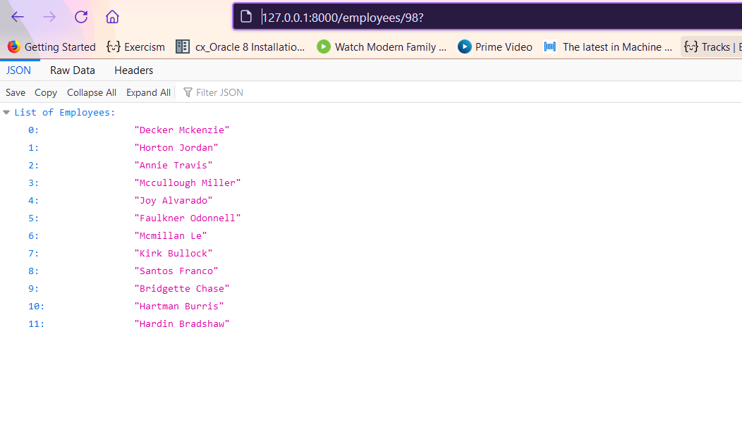

**Use Case 02-** Given 2 people, provide their information (Name, Age, Address, phone) and the list of their friends in common who have brown eyes and

are still alive.

**URL:** <http://127.0.0.1:8000/people/?name_01=Bonnie%20Bass&name_02=Rosemary%20Hayes>

**Screenshot:**

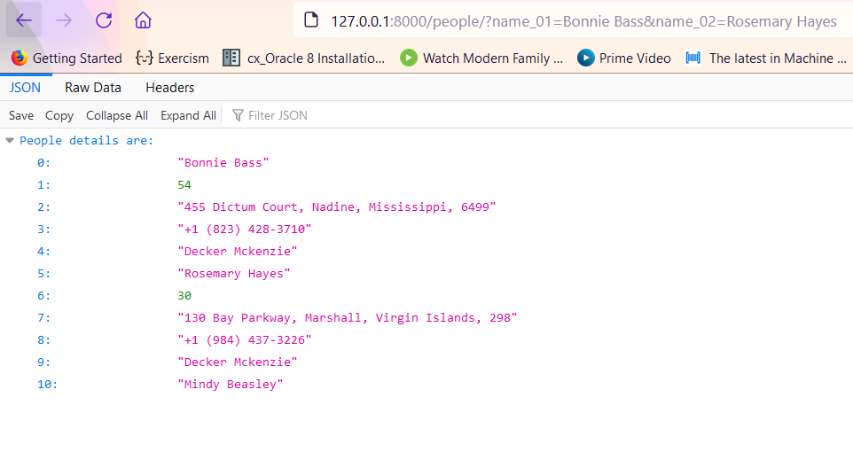

**Use Case 03:** Given 1 people, provide a list of fruits and vegetables they like. This endpoint must respect this interface for the output: {"username":

"Ahi", "age": "30", "fruits": ["banana", "apple"], "vegetables": ["beetroot", "lettuce"]}

**URL:** <http://127.0.0.1:8000/food/921>?

**Screenshot:**

