Sales Funnel Analysis SQL Queries

1. Defining Sales Funnel Stages
Counts unique users at each milestone in the purchasing pipeline over the last 30 days to measure baseline audience volume across every step of the sales funnel.

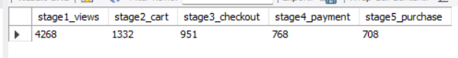

2. Conversion Rate Analysis
Calculates the step-by-step progression percentages between consecutive funnel stages to pinpoint friction points and user drop-off rates across the purchase journey.

3. Marketing Channel Effectiveness
Evaluates user acquisition channels (Organic, Paid Ads, Email, Social) across traffic volume, cart additions, and final purchases to identify which traffic sources generate the highest conversion efficiency.

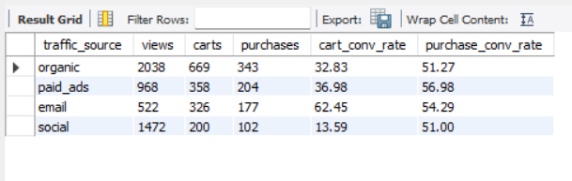

4. Time to Conversion Analysis
Measures the average duration in minutes taken by users to move from product view to cart addition, and from cart addition to final purchase completion.

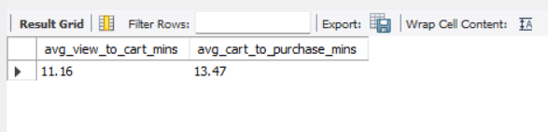

5. Revenue Funnel Metrics
Aggregates overall financial performance and purchasing behavior to calculate key commercial KPIs, including total buyers, total revenue, completed orders, and Average Order Value (AOV).

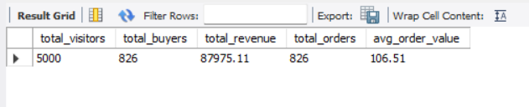

Executive Summary & Key Insights

1. Website Optimization (UX)
Our final payment-to-purchase conversion rate is exceptionally strong at 92%, showing that users who enter payment details complete their transactions with minimal friction. This indicates that the lower end of the checkout flow is technically sound and user-friendly. Because this stage is already operating near peak efficiency, no major UX changes or redesigns are recommended for the final payment pages, as tweaking this step risks introducing unnecessary friction.
2. Marketing Channel Effectiveness
- Social Media (High Volume, Low Intent): Social media drives significant top-of-funnel traffic (1,472 views), but yields a low cart-addition rate (13.59%) and an overall view-to-purchase rate of just 6.93%. High view volume on social acts primarily as a vanity metric rather than a revenue driver. We recommend auditing ad creative and potentially shifting budget away from broad social targeting toward higher-converting channels.
- Email Marketing (Low Volume, High Efficiency): Email drives lower total volume (522 views), but achieves an outstanding 62.45% view-to-cart rate and a 33.91% overall purchase conversion rate. Because email subscribers demonstrate much higher buying intent, the business should double down on email marketing by allocating resources toward list building, lead capture pop-ups, and automated retention sequences.
3. Financial Performance & Margins
With a calculated Average Order Value (AOV) of $106.51, acquisition efforts must be carefully benchmarked against Customer Acquisition Cost (CAC). Paid traffic campaigns (Paid Ads and Social Ads) must keep CAC well below $106.51—after factoring in product cost of goods sold (COGS)—to maintain positive unit economics. Reallocating capital from low-intent social ads into high-ROI email campaigns will lower overall blended CAC and protect net profitability.

