**Assignment-2 Name- Yashvant Yadav RollNo- 220290120200**

**OUTPUT:**

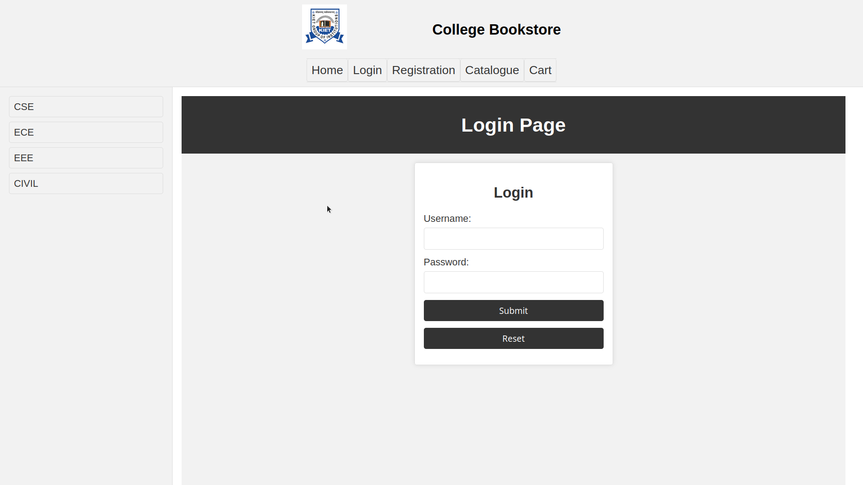

**CODE:**

**<!DOCTYPE html>**

<html lang="en">

<head>

<meta charset="UTF-8">

<meta name="viewport" content="width=device-width, initial- scale=1.0">

<title>Login /title>

<style> body { margin: 0;

padding: 0;

font-family: Arial, sans-serif; background-color: #f2f2f2;

}

header {

background-color: #333; color: white;

text-align: center; padding: 10px;

}

main {

max-width: 400px; margin: 20px auto; background-color: #fff; padding: 20px;

border: 1px solid #ddd; border-radius: 5px;

box-shadow: 0 0 10px rgba(0, 0, 0, 0.1);

}

h2 {

text-align: center; color: #333;

}

label { display: block;

margin-bottom: 8px; color: #333;

}

input { width: 100%;

padding: 10px; margin-bottom: 15px;

box-sizing: border-box; border: 1px solid #ddd; border-radius: 5px; font-size: 16px;

}

input[type="submit"], input[type="reset"] { background-color: #333;

color: #fff; padding: 10px 15px; border: none; border-radius: 5px; cursor: pointer;

transition: background-color 0.3s;

}

input[type="submit"]:hover, input[type="reset"]:hover { background-color: #555;

}

/style>

/head>

<body>

<header>

<h1>Login Page /h1>

/header>

<main>

<h2>Login /h2>

<form action="#" method="post">

<label for="username">Username: /label>

<input type="text" id="username" name="username" required>

<label for="password">Password: /label>

<input type="password" id="password" name="password" required>

<input type="submit" value="Submit">

<input type="reset" value="Reset">

/form>

/main>

/body>

/html>