use SQLDataExploration;

Select * from CovidDeaths

WHERE continent IS NOT NULL;

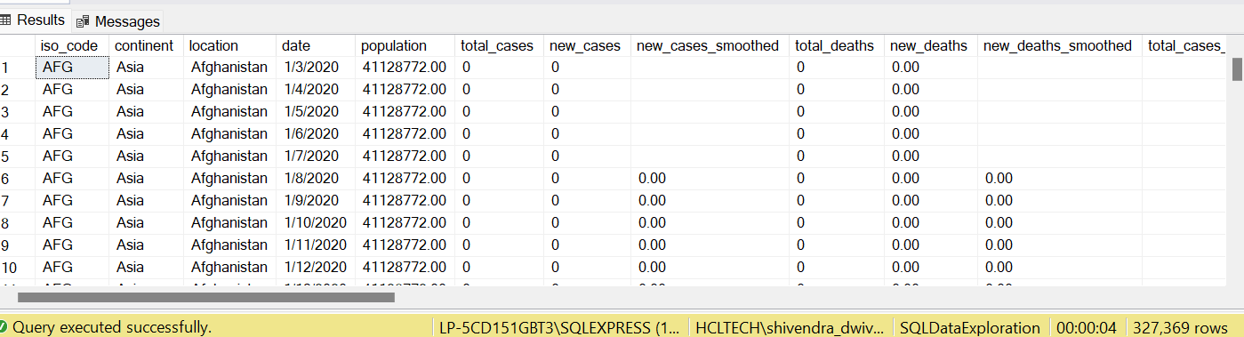

select location, date, total_cases, new_cases, total_deaths, population

from CovidDeaths order by 1,2;

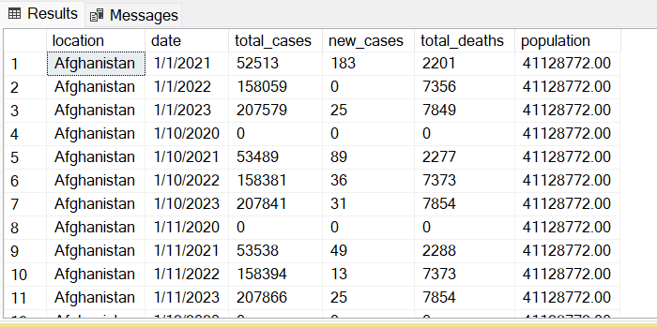

--Death Ratio

select location, date, total_cases, total_deaths, (total_deaths/total_cases)*100 as Death_Ratio

from CovidDeaths

where total_cases != 0

order by 1,2;

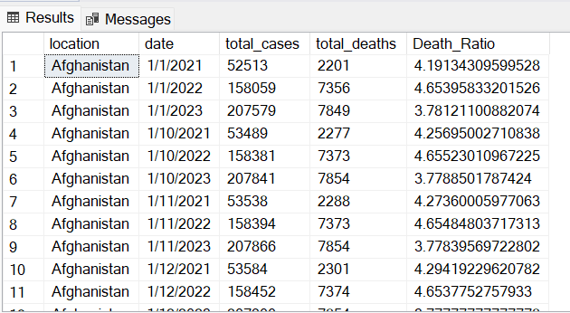

--Death Ratio for India

select location, date, total_cases, total_deaths, (total_deaths/total_cases)*100 as Death_Ratio

from CovidDeaths

where total_cases != 0

and location like '%India%'

order by 1,2;

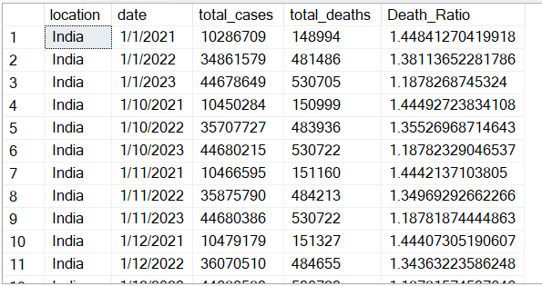

--Cases per population date wise

select location, date, total_cases, population, (total_cases/population)*100 as Active_Rate

from CovidDeaths

WHERE continent IS NOT NULL

order by 1,2;

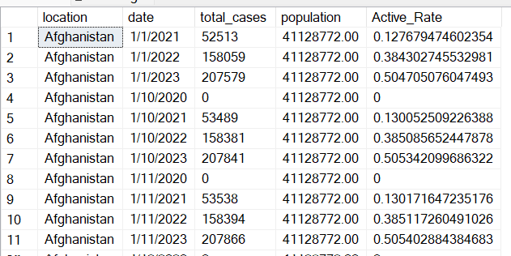

select population, total_cases, (total_cases/population)*100 as Case_Rate

from CovidDeaths

WHERE continent IS NOT NULL

order by 1,2;

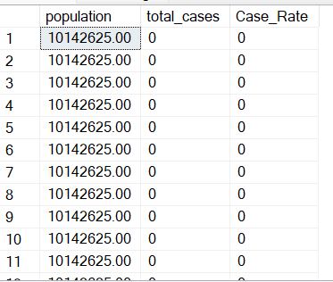

--Infection Rate of each country

select location, population, MAX(total_cases) as HighestInfectionCount, MAX(total_cases/population)*100 as InfectionRate

from CovidDeaths

WHERE continent IS NOT NULL

Group by location, population

order by InfectionRate desc;

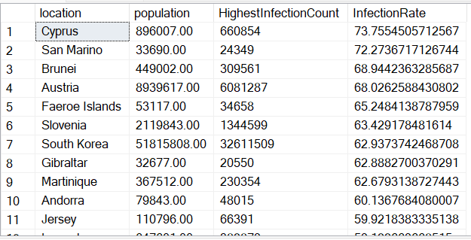

--Death count of each country

select location, MAX(CAST(total_deaths as int)) as TotalDeathCount

from CovidDeaths

WHERE continent IS NOT NULL

Group by location, population

order by 1;

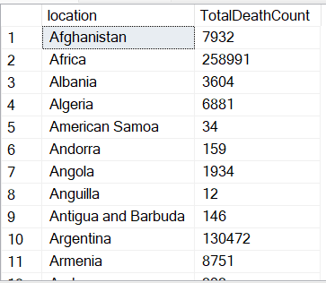

select location,continent, max(CAST(total_deaths as int)) as TotalDeathCount, MAX(total_deaths/population)*100 as DeathRate

from CovidDeaths

WHERE continent != ''

Group by location, continent

order by TotalDeathCount desc;

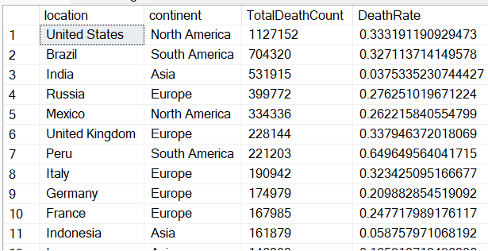

--Death count by continent

select continent, max(cast(total_deaths as int)) as TotalDeathCount

from CovidDeaths

where continent != '' and continent not in ('High%', 'Upper%', 'Lower%')

Group by continent

order by TotalDeathCount desc;

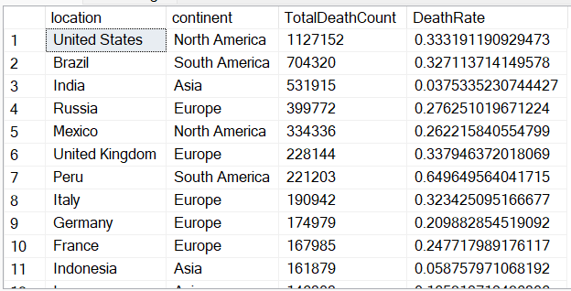

--Global Numbers

select date, SUM(total_cases) as PerDayCases, SUM(cast(new_deaths as float)) as NewDeaths, SUM(cast(new_deaths as float))*100/SUM(new_cases) as NewDeathPercentage

--,total_deaths,(total_deaths), (total_deaths/total_cases)*100 as DeathPercent

from CovidDeaths

where continent != '' and new_cases != 0

Group by date

order by 1,2;

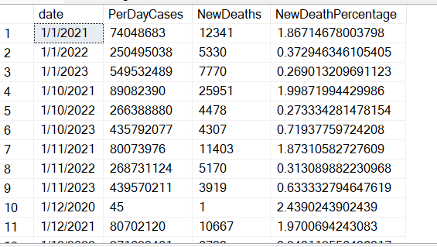

-- Total Deaths and Cases

select SUM(new_cases) as Total_Cases, SUM(cast(new_deaths as float)) as NewDeaths, SUM(cast(new_deaths as float))/SUM(new_cases)*100 as NewDeathPercentage

--,total_deaths,(total_deaths), (total_deaths/total_cases)*100 as DeathPercent

from CovidDeaths

where continent != '' and new_cases != 0

order by 1,2;

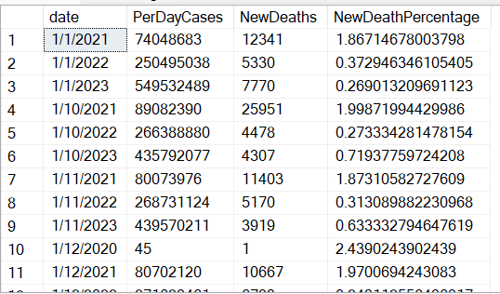

select * from CovidVccinations;

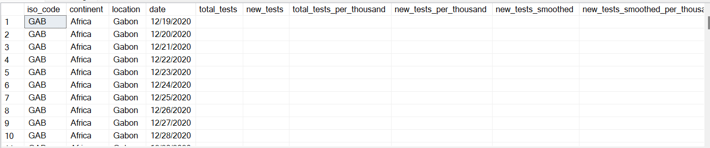

--Joining Tables on date and location

select * from CovidDeaths D

join CovidVccinations V

on d.location = v.location

and d.date = v.date;

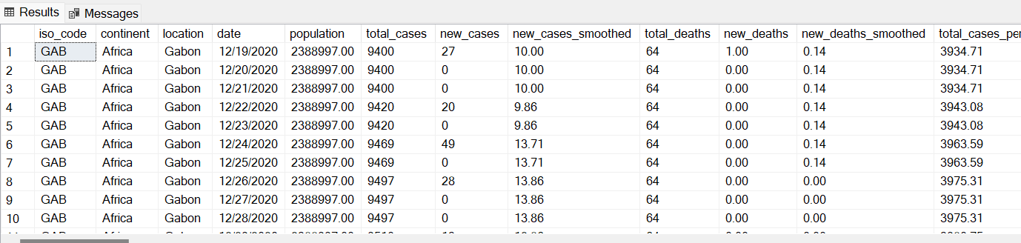

-- Total population vs Vaccinations

Select d.continent , d.location , d.date, d.population, v.new_vaccinations

from CovidDeaths D

join CovidVccinations V

on d.date = v.date

and d.location = v.location

where d.continent != ''

order by 2,3;

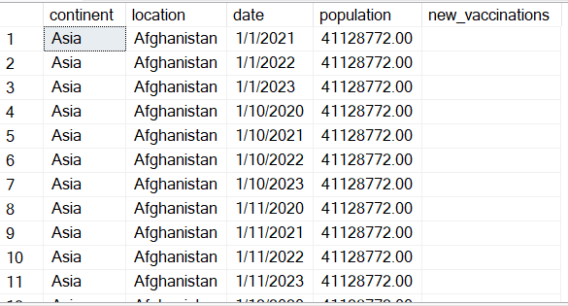

select d.continent, d.location, d.date, d.population, v.new_vaccinations,

Sum(cast(v.new_vaccinations as float)) over (partition by d.location order by d.location, d.date) as RollingPeopleVaccinated

from CovidDeaths D

join CovidVccinations V

on d.location = v.location

and d.date = v.date

where d.continent != ''

order by 2,3;

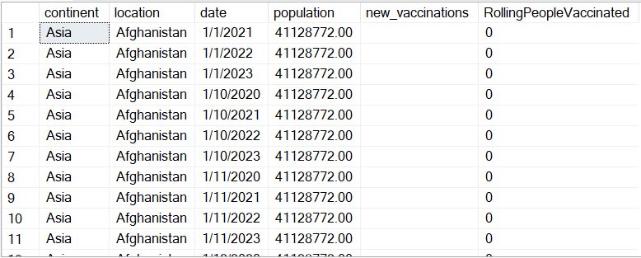

--USE CTE

WITH PopvsVac (Continent, location,date, population, New_Vaccinations, RollingPeopleVaccinated)

as

(

Select d.continent, d.location, d.date, d.population, v.new_vaccinations,

Sum(cast(v.new_vaccinations as float)) over (partition by d.location order by d.location, d.date) as RollingPeopleVaccinated

from CovidDeaths D

join CovidVccinations V

on d.location = v.location

and d.date = v.date

where d.continent != ''

--order by 2,3

)

select *,(RollingPeopleVaccinated/population)*100

from PopvsVac;

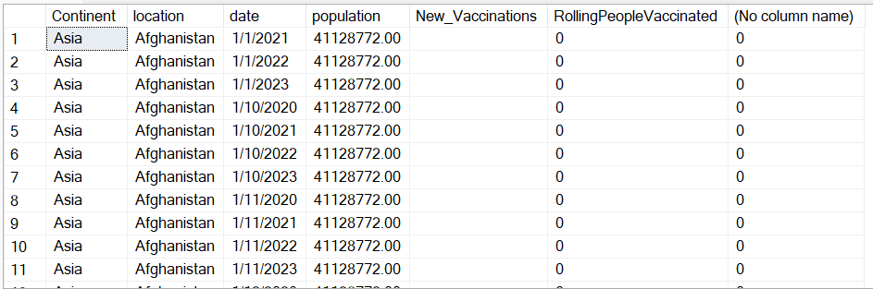

--Temp Table

Drop table if exists #PercentPopulationVaccinated

Create Table #PercentPopulationVaccinated

(Continet nvarchar(255),

Location nvarchar(255),

Date datetime,

Population float,

New_Vaccinations float,

RollingPeopleVaccinated float

)

insert into #PercentPopulationVaccinated

Select d.continent, d.location, d.date, d.population, v.new_vaccinations,

Sum(cast(v.new_vaccinations as float)) over (partition by d.location order by d.location, d.date) as RollingPeopleVaccinated

from CovidDeaths D

join CovidVccinations V

on d.location = v.location

and d.date = v.date

where d.continent != ''

--order by 2,3

select *, (RollingPeopleVaccinated/population)*100

from #PercentPopulationVaccinated

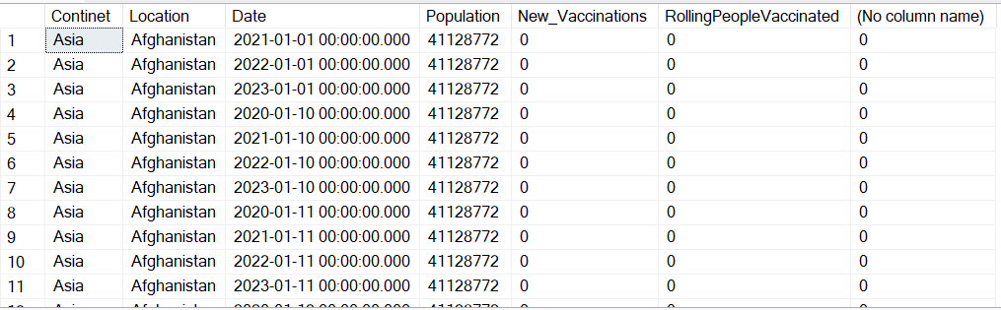

--Creating view to store data for visualization

Create view PercentPeopleVaccinated as

Select d.continent, d.location, d.date, d.population, v.new_vaccinations,

Sum(cast(v.new_vaccinations as float)) over (partition by d.location order by d.location, d.date) as RollingPeopleVaccinated

from CovidDeaths D

join CovidVccinations V

on d.location = v.location

and d.date = v.date

where d.continent != ''

--order by 2,3

select * from PercentPeopleVaccinated

