ARDUINO PHYSICAL AI CHALLENGE INDIA 2026
Project Report
Organised by Robu.in × Arduino · Submit as PDF · Max 10 MB
Project Title | AI Garbage Segregator - Colour-Based Waste Sorting Robotic Arm using Arduino UNO Q
Team Name
Registration / Team ID | APC-2026-MH-24834
Contest Track | Robotics & Gaming
Institution & City | PUNE

Team Members (1–4)
Name | Email | Role
Shiven | guptarashmi3@rediffmail.com | Team Leader - Hardware & Software Integration

1. Project Overview

Problem Statement
Manual segregation of recyclable waste at the point of collection is inconsistent, unhygienic and labour-intensive. Small-scale recycling centres, schools and homes often lack an affordable, automated way to separate waste into categories. This project addresses that gap with a low-cost robotic arm that automatically detects colour-coded waste objects (red and blue) using computer vision and sorts them into their correct bins, reducing manual handling and making segregation more consistent.

How Your Project Works
The project is a 3D-printed 4-DOF robotic arm (base, shoulder, elbow, gripper) driven by four servo motors and controlled by an Arduino UNO Q. A camera connected to a PC continuously watches the workspace, and OpenCV (HSV colour thresholding) detects red or blue objects placed in front of the arm. When an object is detected, the PC sends a single command ('R' or 'B') over a WiFi TCP socket to main.py running on the UNO Q's Linux (MPU) side. main.py calls Bridge.call("pick_and_place", colorCode), which invokes the pick_and_place() function on the UNO Q's real-time STM32U585 (MCU) side. The MCU smoothly drives the four servos through a pick sequence and a place sequence - rotating the base left for red objects or right for blue objects - before returning to the home position, ready for the next object.

Why Arduino UNO Q?
The UNO Q's dual-processor design is central to this project: the STM32U585 MCU gives precise real-time PWM control for smooth servo motion, while the Qualcomm QRB2210 MPU runs full Linux for networking and, in future iterations, on-device AI/vision processing. The Bridge (RPC) library lets the two sides exchange a single function call instantly, so a command received over WiFi reaches the servo-control code with minimal delay. This removes the need for two separate boards. Currently, colour detection runs on a PC; since the QRB2210 MPU can run Python/AI workloads on-device, a natural next step is to move OpenCV detection onto the UNO Q itself using its own camera, removing the dependency on an external PC.

2. Components Used (BOM)

Component | Qty
Arduino UNO Q (ABX00087) | 1
Servo Motors (MG90s) - Base, Shoulder, Elbow, Gripper | 4
3D-Printed 4-DOF Robotic Arm Chassis | 1
USB-C Power Supply / Adapter | 1
PC / Laptop with Webcam (runs OpenCV vision processing) | 1
Jumper Wires / Connecting Wires | As needed

3. System Architecture & Circuit

Step-by-Step Workflow
1) Webcam on the PC continuously captures frames of the sorting area.
2) object_sort_client.py converts each frame to HSV and applies colour masks to detect red and blue objects, locating the centre of the largest valid contour.
3) When a red or blue object is confirmed (with a 3-second cooldown to avoid repeat triggers), the PC opens a TCP socket to the UNO Q's WiFi IP address (port 5005) and sends 'R' or 'B'.
4) main.py on the UNO Q's Linux/MPU side receives the command and calls Bridge.call("pick_and_place", colorCode).
5) The Bridge relays the call to pick_and_place() in sketch.ino on the STM32U585 MCU.
6) The MCU moves the base, shoulder, elbow and gripper servos to pick the object and place it in the red (left) or blue (right) bin, then returns to the home position.
7) A result code (1 = success) is returned through the Bridge to main.py and back to the PC over the same socket, confirming the cycle is complete.

Block Diagram & Circuit Schematic
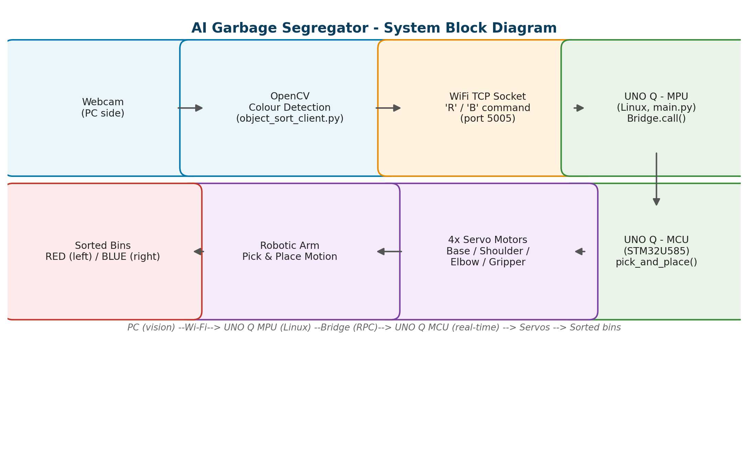
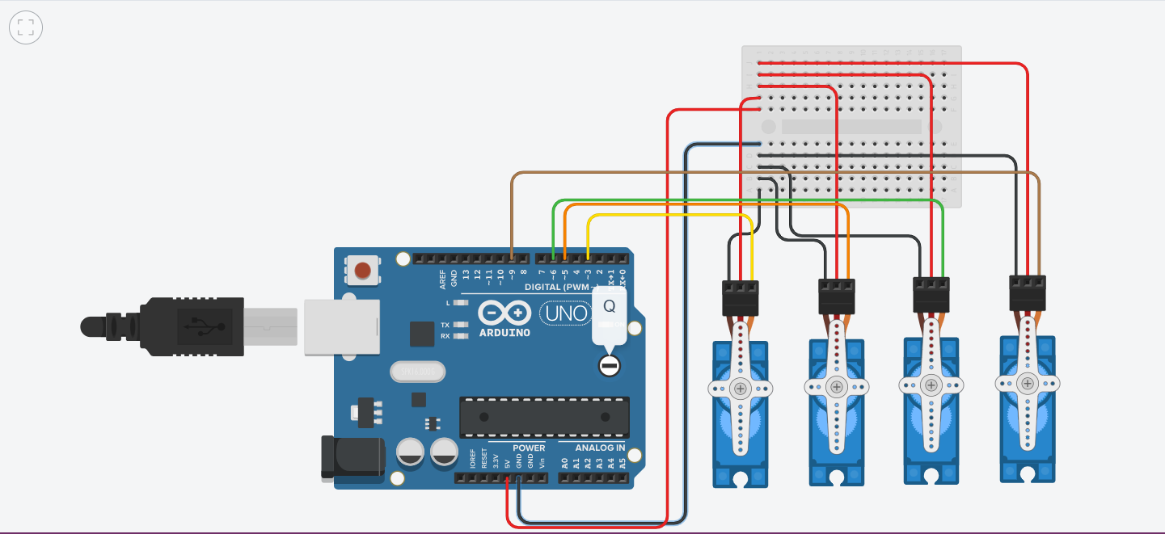

4. AI / ML Model Details
Model Used | Not a trained model - classical rule-based Computer Vision (HSV colour thresholding) using OpenCV
Training Platform | Not Applicable - no training involved; HSV colour ranges for red and blue were tuned manually
Accuracy | Qualitative only - reliably detected red/blue test objects under normal indoor lighting; not benchmarked with a formal accuracy metric
Dataset | Not Applicable - no image dataset was used; detection relies on manually tuned HSV colour ranges, not a trained model

Brief Description & Limitations
Each frame is converted from BGR to HSV. Two hue ranges are combined for red (which wraps around the HSV hue axis) and one range for blue; a morphological opening removes small noise. The largest contour above a minimum area is treated as the target object, and its centroid decides which colour label ('R' or 'B') is sent to the arm. Because this is colour-based, not shape/material-based, detection can be confused by any other red or blue item in frame, and accuracy degrades under poor or changing lighting. It also does not classify actual waste material (plastic, metal, paper). A planned improvement (Section 7) is a trained lightweight image-classification model so the system can sort by material rather than colour alone.

5. Code Structure
sketch.ino (STM32U585 MCU): setup() attaches the 4 servos and starts Bridge; smoothMove() steps a servo one degree at a time for smooth motion; pickObject() opens the gripper, lowers the arm, grips and lifts the object; placeLeft()/placeRight() rotate the base to the correct bin, release the object, and return home; pick_and_place(colorCode) is the function exposed via Bridge.provide() and called remotely from main.py (1=red/left, 2=blue/right). main.py (UNO Q Linux/MPU, via App Lab): start_server() opens a TCP socket on port 5005; handle_client() reads the 'R'/'B' command, calls Bridge.call("pick_and_place", colorCode), and returns the result to the PC. object_sort_client.py (PC/VS Code): get_largest_contour_center() finds the largest red/blue contour; main() captures frames, builds HSV masks, applies the cooldown, and calls send_command() to transmit 'R'/'B' to the UNO Q over WiFi.

GitHub Repository | https://github.com/Shivenhack/Arduino_UNO_Q_Robotic_Arm
Demo Video Link | https://youtu.be/GKL3kyJKa7I

6. Testing & Results
The system was tested by placing red and blue objects individually and in sequence in front of the camera under normal indoor lighting. Each detection correctly triggered the matching socket command, and the arm consistently placed red objects in the left bin and blue objects in the right bin before returning home. End-to-end response time was dominated by servo motion time (smoothMove() step delay) rather than network latency. The 3-second cooldown was necessary to stop a stationary object re-triggering repeated commands. Edge cases observed: both colours in frame at once (red is checked first); low light causing missed detections; and a new command arriving while the arm is busy, which is safely ignored by the armBusy flag.

Project Images (2–3)

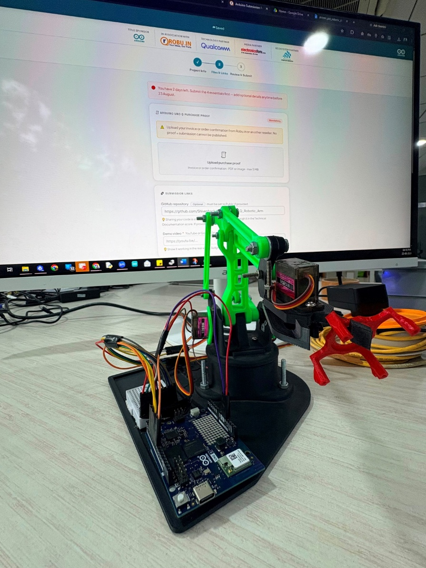
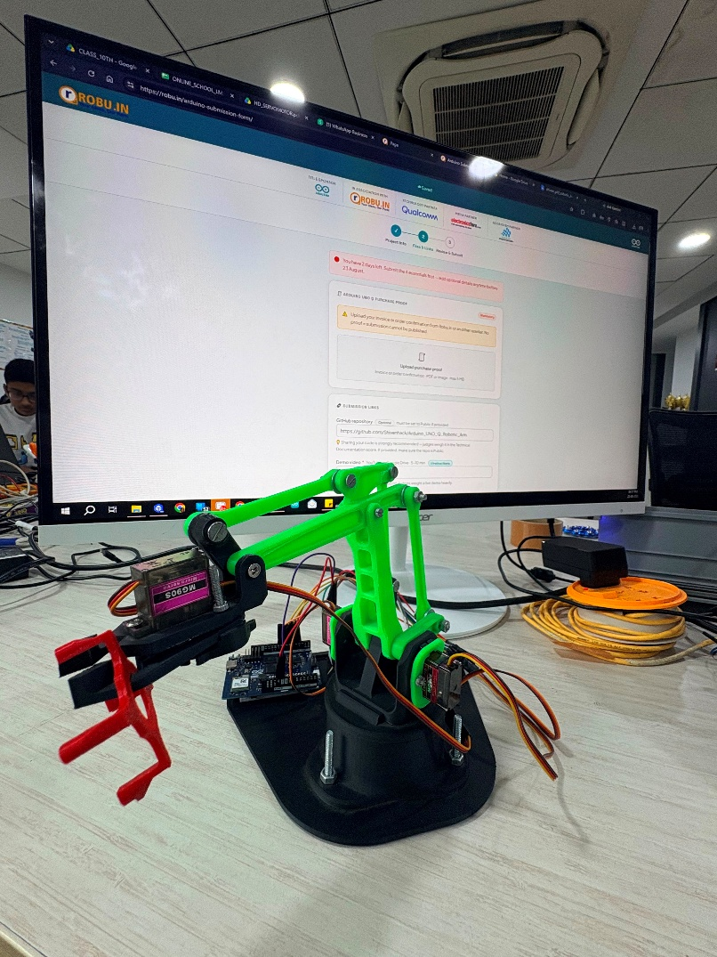

7. Challenges, Learnings & Future Improvements

Challenges Faced
Getting smooth, non-jerky servo motion (solved with the smoothMove() stepping function); establishing reliable PC-to-UNO Q communication over WiFi (matching the socket port and the board's IP address); coordinating the MCU (real-time control) and MPU (networking) sides correctly using Bridge.provide()/Bridge.call(); avoiding false or repeated triggers from one stationary object (added a cooldown timer and an armBusy flag); and tuning HSV colour thresholds to work reliably under different lighting conditions.

What You Learned & What’s Next
Summarise what you built, what you learned, and 2–3 future improvements.
I learned how the UNO Q's dual processor architecture separates real-time hardware control (MCU) from networking/vision processing (MPU), and how Bridge (RPC) lets Arduino sketches and Python applications on the same board work together. We also learned practical robotics skills - servo calibration, smooth interpolated motion, and building a closed-loop pick-and-place sequence plus classical computer-vision technique such as HSV colour segmentation and contour detection.
Future improvements:
1)Integrate an ESP32-CAM module to move image capture and detection closer to the arm itself, reducing dependency on a PC-side webcam.
2) Move OpenCV detection from the PC onto the UNO Q itself using its own camera, removing the need for an external laptop.
3) Switch from colour-based detection to object/material-based detection using a trained lightweight image-classification model (e.g. TensorFlow Lite), so the system sorts by actual waste type rather than colour.
4) Add more sorting categories/bins and a sensor to confirm successful pickup before placing.

8. Declaration
We confirm this is our original, unpublished work. The Arduino® UNO™ Q is the primary board in this project. All team members have reviewed and agree to this report.
Date | 23-August-2026
Arduino Physical AI Challenge India 2026 · Robu.in × Arduino · contest@robu.in

