EX:No.4 221501701

Implement programs for estimating & eliminating trend in time series data- aggregation, smoothing.
Aim:
Write a program to estimating & eliminating trend in time series data- aggregation, smoothing.

Algorithm:
Import Libraries
- Load required libraries: numpy, pandas, matplotlib, and statsmodels.
Load the Dataset
- Read the weather dataset (weather_data.csv) and set the 'Date' column as the index.
Select a Time Series Column
- Choose a column for analysis (e.g., Temperature).
Apply Aggregation (Rolling Mean)
- Compute a 7-day rolling mean to smooth fluctuations in the data.
Apply Smoothing Techniques:
- Moving Average Smoothing: Compute a centered 7-day moving average.
- Exponential Smoothing: Apply Holt-Winters Exponential Smoothing to capture trends.
Extract Trend using Seasonal Decomposition
- Decompose the time series into trend, seasonal, and residual components using additive decomposition.
Visualize the Data
- Plot the original time series.
- Overlay the rolling mean, moving average, and exponential smoothing for comparison.
- Plot the trend component extracted from decomposition.
Output the Results
- Display the smoothed series and extracted trend.
- If needed, detrend the series by subtracting the estimated trend.

Code:
import numpy as np
import pandas as pd
import matplotlib.pyplot as plt
from statsmodels.tsa.seasonal import seasonal_decompose
from statsmodels.tsa.holtwinters import ExponentialSmoothing
# Load the dataset
df = pd.read_csv(r"C:\Users\harsh\Downloads\cleaned_weather.csv", parse_dates=['date'], index_col='date')
# Selecting the time series column
time_series = df['Tdew']
# 1. Aggregation - Rolling Mean
rolling_mean = time_series.rolling(window=7).mean()
# 2. Smoothing - Moving Average
moving_avg = time_series.rolling(window=7, center=True).mean()
# 3. Exponential Smoothing
exp_smooth = ExponentialSmoothing(time_series, trend='add', seasonal=None, damped_trend=False).fit().fittedvalues
# 4. Seasonal Decomposition (Trend Extraction)
decomposition = seasonal_decompose(time_series, model='additive', period=30)
trend = decomposition.trend
# Plot the results
plt.figure(figsize=(12, 6))
plt.plot(time_series, label='Original', color='blue', alpha=0.5)
plt.plot(rolling_mean, label='Rolling Mean (7-day)', color='red')
plt.plot(moving_avg, label='Moving Average (7-day)', color='green')
plt.plot(exp_smooth, label='Exponential Smoothing', color='purple')
plt.title('Trend Estimation & Smoothing')
plt.legend()
plt.show()
# Plot decomposed trend
plt.figure(figsize=(12, 4))
plt.plot(trend, label='Extracted Trend', color='brown')
plt.title('Trend Component from Seasonal Decomposition')
plt.legend()
plt.show()

Output:
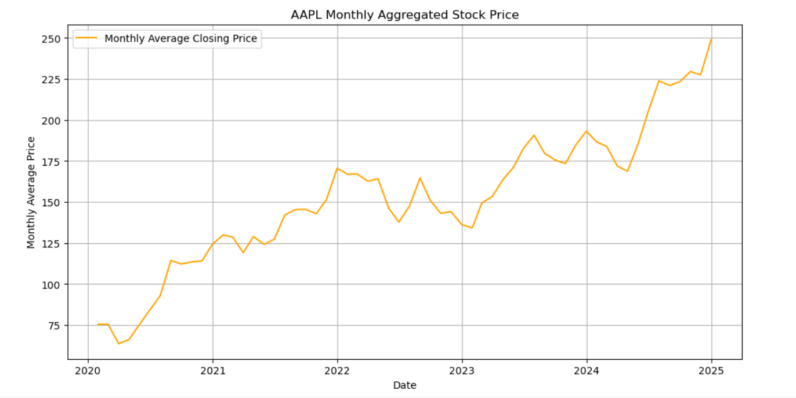
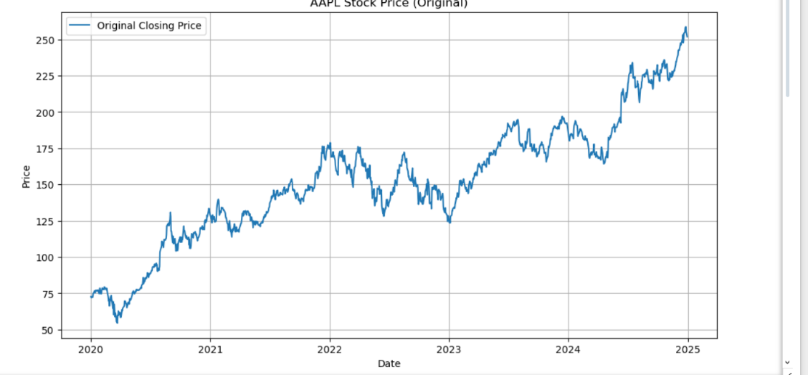

Result:
Thus, the program to estimating & eliminating trend in time series data- aggregation, smoothing was done.

