Implement programs to check stationary of a time series data

EX:No.3
DATE:22/03/25

AIM:
Write a program to Implement programs to check stationary of a time series data

ALGORITHM:
Step 1: Install required libraries (if not already installed).
Step 2: Import necessary libraries (pandas, numpy, matplotlib).
Step 3: Load air pollution data, parse dates, and set 'date' as the index.
Step 4: Remove duplicate timestamps and fill missing values.
Step 5: Select the 'pollution_today' column.
Step 6: Remove outliers using the IQR method.
Step 7: Ensure daily data frequency.
Step 8: Resample to weekly average (optional, not used in the plot).
Step 9: Create a figure and plot daily pollution levels as a line graph.
Step 10: Set labels, title, and legend for the plot.
Step 11: Show the plot.

CODE:

from statsmodels.tsa.stattools import adfuller
import pandas as pd
# Load the time series data
accident_df = pd.read_csv("C:\Users\hemhe\Downloads\archive\symbols_valid_meta.csv", parse_dates=["Date"], index_col="Date")
# Select the "Total Accidents" column for stationarity testing
time_series = accident_df["Total Accidents"]

# Compute rolling statistics
rolling_mean = time_series.rolling(window=12).mean()
rolling_std = time_series.rolling(window=12).std()

# Perform Augmented Dickey-Fuller test
adf_test = adfuller(time_series, autolag="AIC")
adf_result = {
"ADF Statistic": adf_test[0],
"p-value": adf_test[1],
"Critical Values": adf_test[4],
"Stationary": adf_test[1] < 0.05 # If p-value < 0.05, data is stationary}
# Visualization of rolling statistics
plt.figure(figsize=(12, 5))
plt.plot(time_series, label="Original Time Series", alpha=0.5)
plt.plot(rolling_mean, label="Rolling Mean", color="red", linestyle="dashed")
plt.plot(rolling_std, label="Rolling Std Dev", color="green", linestyle="dotted")
plt.xlabel("Date")
plt.ylabel("Total Accidents")
plt.title("Rolling Mean & Standard Deviation for Stationarity Check")
plt.legend()
plt.grid(True)
plt.show()

# Display ADF test results
adf_result

OUTPUT: 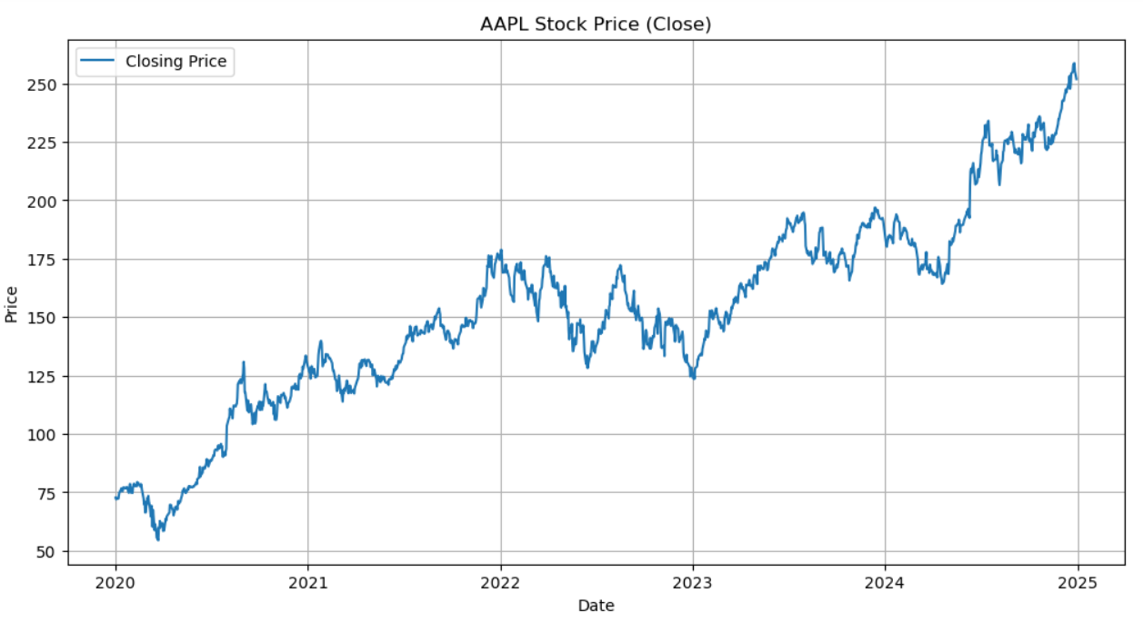

RESULT:
Thus, the program using the time series data implementation has been done successfully.

