#include<iostream>

#include<conio.h>

#include<string.h>

using namespace std;

class BankAccount

{

int acctno;

char name[30],acttype,address[100];

float balance;

public:

void readdetails()

{

cout<<"\n Enter the Fisrt name: ";

cin>>name;

cout<<"\n Enter the account number: ";

cin>>acctno;

cout<<"\n Enter the account Type: ";

cin>>acttype;

cin.ignore();

cout<<"\n Enter the address: ";

cin.getline(address,30);

cout<<"\n Enter the balance: ";

cin>>balance;

}

void printdetails()

{

cout<<endl<<"Name: "<<name;

cout<<endl<<"Account number: "<<acctno;

cout<<endl<<"Account number: "<<acttype;

cout<<endl<<"Address: "<<puts(address);

cout<<"\n the reqiured Balance: "<<balance<<endl;

}

void deposit()

{

float x;

cout<<"\n Enter the amount to be deposited: "<<endl;

cin>>x;

balance+=x;

}

void withdraw()

{

float x;

cout<<"\n Enter the amount to be withdrawn: ";

cin>>x;

if(x<balance)

cout<<"\n No sufficient balance";

else

balance=balance-x;

cout<<endl<<"Balance: "<<balance;

}

};

int main()

{

cout<<"-----------------------------------------------------------------------";

cout<<"\n\t\t To display bank account using classes: ";

cout<<"\n------------------------------------------------------------------------";

BankAccount accnt1;

int x, n;

do

{

cout<<"\n1]Read Details \n2]Print details \n3]Deposit \n4]Withdraw \n5]Exit"<<endl<<"Enter the option: ";

cin>>n;

switch(n)

{

case 1: accnt1.readdetails();break;

case 2: accnt1.printdetails();break;

case 3: accnt1.deposit();break;

case 4: accnt1.withdraw();break;

case 5: break;

default: cout<<endl<<"Enter a valid number!! ";

}

}while(n!=5);

getch();

}

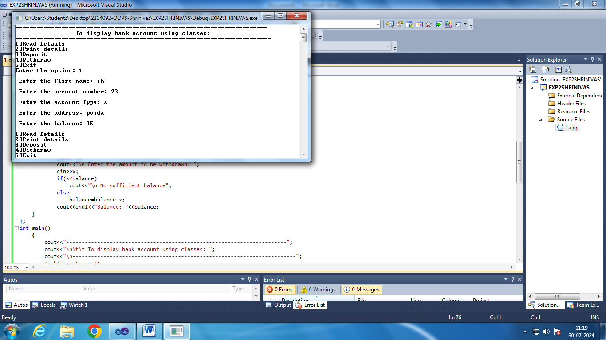

#include<iostream>

#include<conio.h>

#include<string.h>

using namespace std;

class Employee

{

int empid;

char empname[30],designation[100],address[100];

float salary;

public:

void readdetails()

{

cin.ignore();

cout<<"\n Enter the Fisrt name: ";

cin.getline(empname,30);

cout<<"\n Enter the Employee id : ";

cin>>empid;

cout<<"\n Enter the address: ";

cin>>address;

cout<<"\n Enter the designation: ";

cin>>designation;

cout<<"\n Enter the salary:";

cin>>salary;

}

void printdetails()

{

cout<<"\n Name: ";

cout<<"\n Employee id: ";

cout<<"\n address: ";

cout<<"\ designation: ";

cout<<"\n salary: ";

}

};

int main()

{

cout<<"-----------------------------------------------------------------------";

cout<<"\n\t\t To Display Employee details using classes: ";

cout<<"\n------------------------------------------------------------------------";

Employee accnt1;

int x, n;

do

{

cout<<"\n1]Read Details \n2]Print details \n3]Exit"<<endl<<"Enter the option: ";

cin>>n;

switch(n)

{

case 1: accnt1.readdetails();break;

case 2: accnt1.printdetails();break;

case 3: break;

default: cout<<endl<<"Enter a valid number!! ";

}

}while(n!=3);

getch();

}

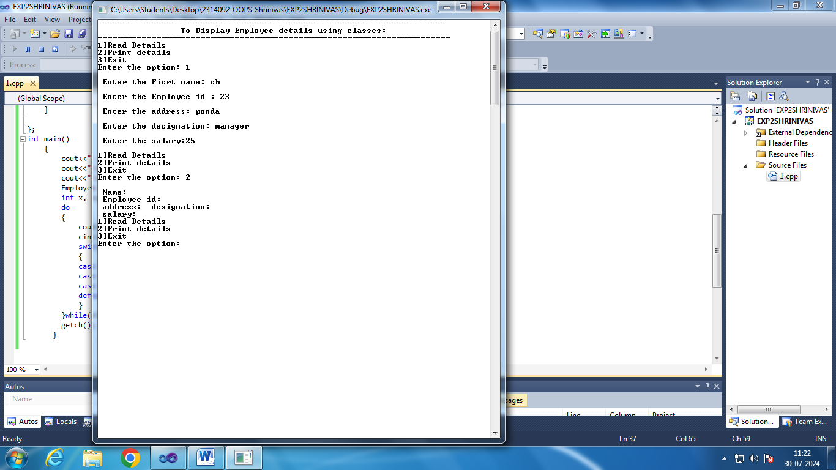

#include<iostream>

#include<conio.h>

using namespace std;

class Distance

{

int meter,inches;

public:

void readdistance()

{

cout<<"\n Enter in meters: ";

cin>>meter;

cout<<"\n Enter in inches: ";

cin>>inches;

}

void printdistance()

{

cout<<"\n Meters: "<<meter<<" Inches: "<<inches;

}

void addDistance()

{

float x,y;

cout<<"\n Enter in meters: ";

cin>>x;

cout<<"\n Enter in inches: ";

cin>>y;

meter+=x;

if((inches+y)>=(39.37))

{meter++;

inches=inches+y-39.37;}

else

inches=inches+y;

}

};

int main()

{

Distance D;

int n;

cout<<"-----------------------------------------------------------------------";

cout<<"\n\t\t To Display Employee details using classes: ";

cout<<"\n------------------------------------------------------------------------";

do{

cout<<"\n1)Read Distance \n2) Print Distance \n3) Add distanance \n4)Exit\nEnter Appropriate option: ";

cin>>n;

switch(n)

{

case 1: D.readdistance();break;

case 2: D.printdistance();break;

case 3: D.addDistance();break;

case 4: break;

default: cout<<"\nEnter Appropriate option!";

}

}while(n!=4);

}

