**Question_1:**

The election is conducted in a city and everyone can vote for one or more candidates, or choose not to vote at all. Each person has 1 vote so if they vote for multiple candidates, their vote gets equally split across these candidates. For example, if a person votes for 2 candidates, these candidates receive an equivalent of 0.5 vote each.

Find out who got the most votes and won the election. Output the name of the candidate or multiple names in case of a tie. To avoid issues with a floating-point error you can round the number of votes received by a candidate to 3 decimal places.

**Table_Details:**

Voting_details ---> Voter,Candidates

**Solution**

select candidate

from

(select candidate,

round(sum(vote_value),3) n_votes,

dense_rank()over(order by round(sum(vote_value),3)DESC) place

from

(select candidate,voter, round(1.0 /count(*) over(partition by voter),3) vote_value

from voting_results

where candidate is not null) a

group by candidate) results

where place = 1

**Solution_Answer**

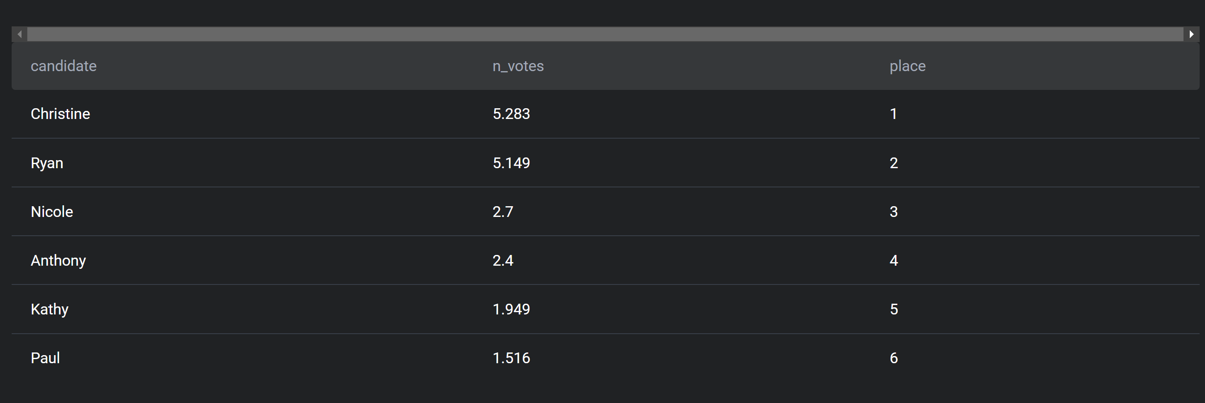

**Question_2:** Find the 3 most profitable companies in the entire world. Output the result along with the corresponding company name. Sort the result based on profits in descending order.

Table_Details:

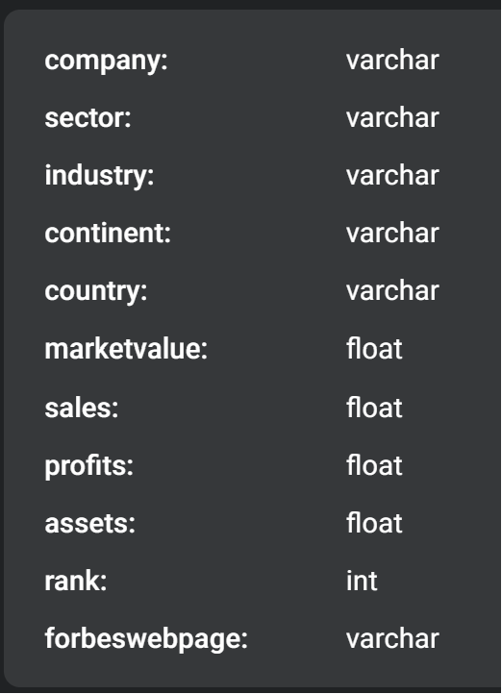

**Query_That_Solved_Question**:

select company,profits,`rank`

from forbes_global_2010_2014

order by profits desc;

limit 3;

or

select company,sum(profits) as Total_profits

from forbes_global_2010_2014

group by company

order by Total_profits desc;

**Result**:

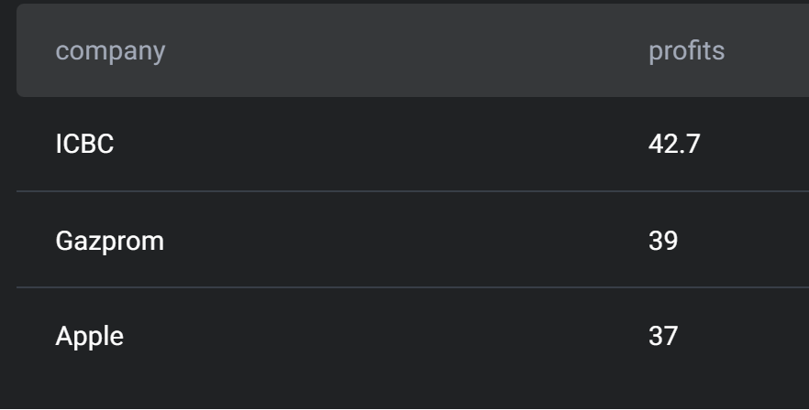

**Question_3: Worker with highest salaries**

You have been asked to find the job titles of the highest-paid employees.

Your output should include the highest-paid title or multiple titles with the same salary.

**Table_Details:**

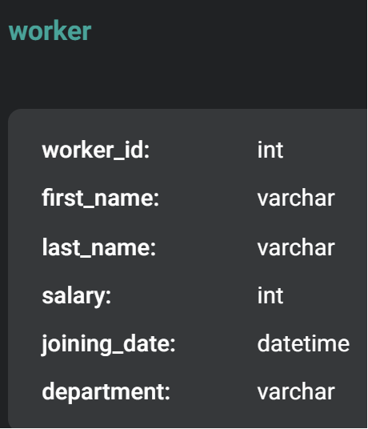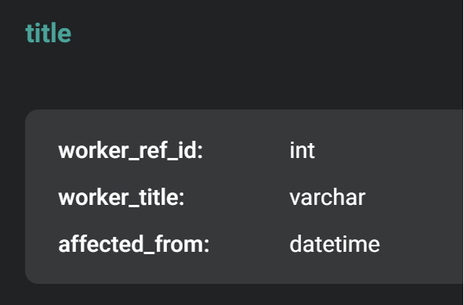

**Query_That_Solved_Question:**

select worker_id,concat(first_name," ",last_name) as name,worker_title,salary

from worker as w

join title as t

on w.worker_id = t.worker_ref_id

where salary = (select max(salary) from worker)

**Result:**

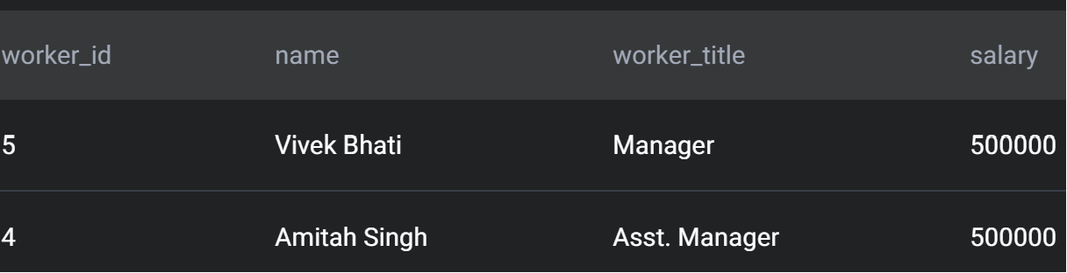

**Question_3: Users by Average Usage Time**

Calculate each user's average session time. A session is defined as the time difference between a page_load and page_exit. For simplicity, assume a user has only 1 session per day and if there are multiple of the same events on that day, consider only the latest page_load and earliest page_exit, with an obvious restriction that load time event should happen before exit time event . Output the user_id and their average session time.

**Table_Details:**



**Solution_Query:**

select A.user_id , avg(timestampdiff(second,Late_load,Early_exit)) as Average_session

from

(select user_id,date(timestamp) as Date, max(timestamp) as Late_load

from facebook_web_log

where action = 'page_load'

group by 1,2) as A

join

(select user_id,date(timestamp) as Date, min(timestamp) as Early_exit

from facebook_web_log

where action = 'page_exit'

group by 1,2) as B

on A.user_id = B.user_id

group by 1;

Or

with temp as (

select user_id, date(timestamp) as date,

max(case when action = 'page_load' then timestamp else null end)

as late_load,

min(case when action = 'page_exit' then timestamp else null end)

as early_exit

from facebook_web_log

group by user_id, date

)

select user_id, avg(timestampdiff(second,late_load,early_exit)) as avg_time

from temp

where early_exit is not null and late_load is not null

group by user_id;

**Result:**

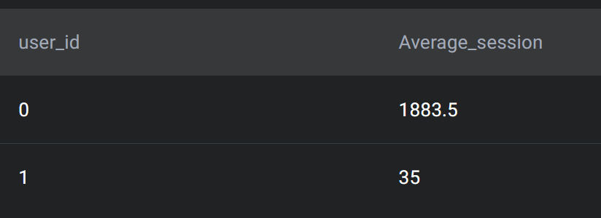

**Question_4: Salaries Difference**

Write a Query that calculates that in difference between the highest salaries found in marketing, engineering departments. Output must be absolute difference in salaries

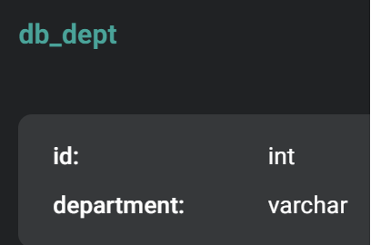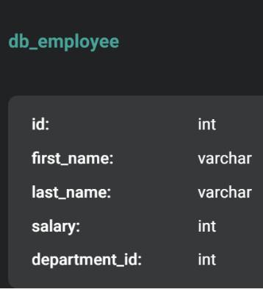**Tables_Details:**

**Solution_Query_to_Question:**

with A as

(select max(salary) as marketing_high

from db_employee as de

join db_dept as dd

on de.department_id = dd.id

where dd.department like "marketing"

group by de.department_id),

B as

(select max(salary) as engineering_high

from db_employee as de

join db_dept as dd

on de.department_id = dd.id

where dd.department like "engineering"

group by de.department_id)

select abs(marketing_high-engineering_high) as salary_difference from A,B;

select

abs(max(case when dd.department = 'marketing' then de.salary

else 0

end ) -

max(case when dd.department = 'engineering' then de.salary

else 0

end)) as Salary_difference

from db_employee as de

join db_dept as dd

on de.department_id = dd.id

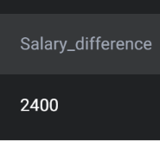**Result**

**Question_5: Risky Projects**

Identify projects that are at risk for going overbudget. A project is considered to be overbudget if the cost of all employees assigned to the project is greater than the budget of the project.

You'll need to prorate the cost of the employees to the duration of the project. For example, if the budget for a project that takes half a year to complete is $10K, then the total half-year salary of all employees assigned to the project should not exceed $10K. Salary is defined on a yearly basis, so be careful how to calculate salaries for the projects that last less or more than one year.

Output a list of projects that are overbudget with their project name, project budget, and prorated total employee expense (rounded to the next dollar amount).

HINT: to make it simpler, consider that all years have 365 days. You don't need to think about the leap years.

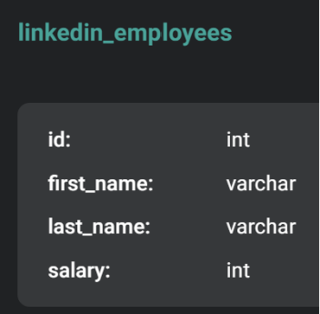**Table_Details:**

**Solution_Query_to_question:**

with project_details as

(select id,title,budget,timestampdiff(day,start_date,end_date) as project_duration

from linkedin_projects),

employee_details as

(select id,salary/365 as salary_per_day from linkedin_employees)

select pd.title,budget, ceiling(sum(project_duration * salary_per_day))

as Total_cost_pay_employee

from project_details as pd

join linkedin_emp_projects as emp

on pd.id = emp.project_id

join employee_details as ed

on ed.id = emp.emp_id

group by pd.id

having budget < Total_cost_pay_employee

order by pd.title ASC

select lp.title,lp.budget,

ceiling((datediff(lp.end_date,lp.start_date)*sum(le.salary)/365)) as prorated_value

from linkedin_projects as lp

join linkedin_emp_projects as lep on lp.id = lep.project_id

join linkedin_employees as le on le.id = lep.emp_id

group by lp.id

having prorated_value > budget;

**Result:**

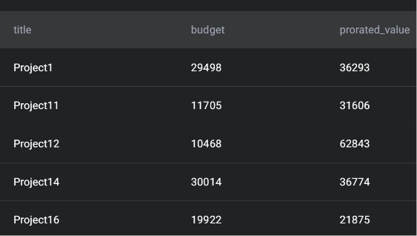**This table shows only 5 rows because of space constraints**

**Question_6: Top percentile Fraud**

ABC Corp is a mid-sized insurer in the US and in the recent past their fraudulent claims have increased significantly for their personal auto insurance portfolio. They have developed a ML based predictive model to identify propensity of fraudulent claims. Now, they assign highly experienced claim adjusters for top 5 percentile of claims identified by the model. Your objective is to identify the top 5 percentile of claims from each state. Your output should be policy number, state, claim cost, and fraud score.

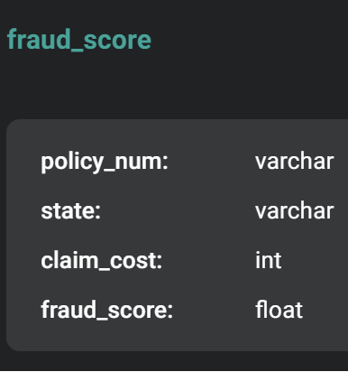**Table_Details:**

**Solution_Query_to_Quesiton:**

with row_num as

(select *,percent_rank()over(partition by state order by fraud_score desc) as rn

from fraud_score),

ntilee as

(select *,count(policy_num)over(partition by state) as nt

from fraud_score),

rnakk as

(select *,row_number()over(partition by state order by fraud_score asc) as rnk

from fraud_score)

select r.policy_num,r.state,r.fraud_score,r.rn,(k.rnk/n.nt)*100 as percnt from row_num as r

join ntilee as n on r.policy_num = n.policy_num

join rnakk as k on r.policy_num = k. policy_num

having percnt > 95 or r.rn < 0.05;

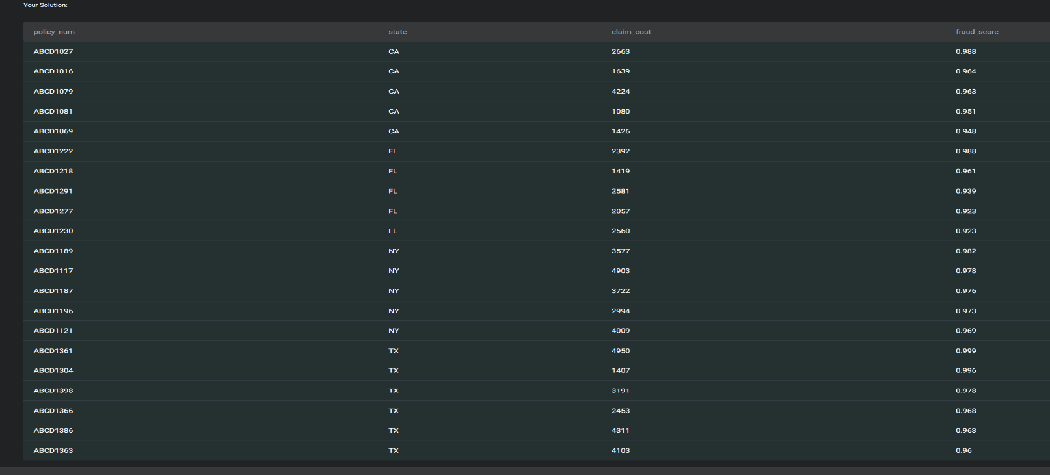**Result:**