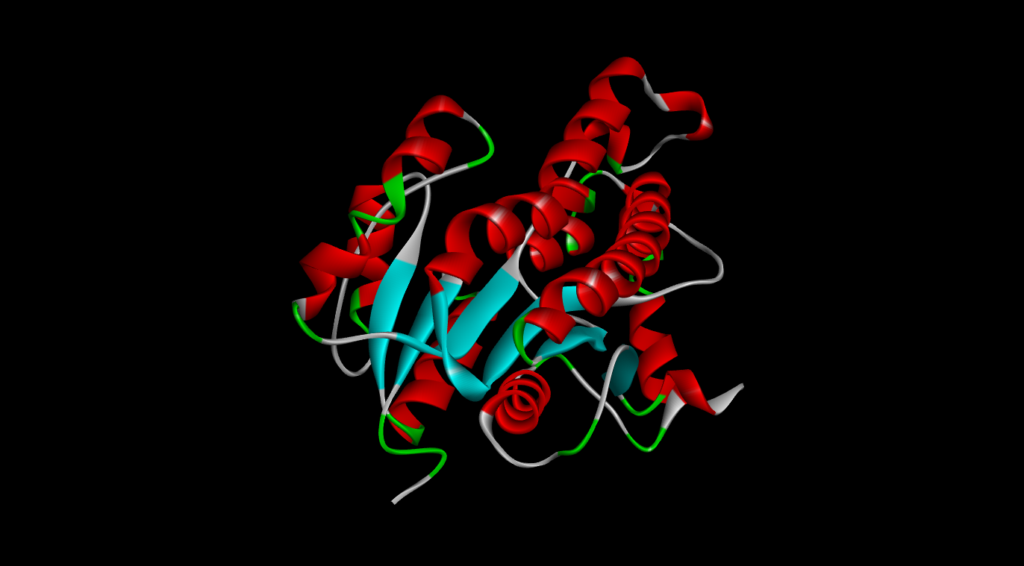

In-Silico Analysis of Mycobacterium tuberculosis InhA Mutants and Their Interaction with Isoniazid (INH)

BIOINFORMATICS PROJECT
By:
- Shivangi Singh
- Anushreeya Khati

In-Silico Analysis of Mycobacterium tuberculosis InhA Mutants and Their Interaction with Isoniazid (INH)

OVERVIEW:
Isoniazid (INH) is a first-line anti-tubercular drug. It is a pro-drug and is activated by the catalase-peroxidase enzyme KatG, which converts INH to an isonicotinoyl acyl radical that combines with NAD(H) to form an active isonicotinoyl-NAD (INH-NAD) adduct. The adduct binds competitively at the NADH-binding pocket of InhA. This causes the inactivation of the enoyl-acyl carrier protein reductase of the FAS-II pathway, blocking mycolic acid biosynthesis. Point mutations in the inhA gene (e.g. S94A, I21V, T2A, Y158F, D148G) have been reported in resistant clinical isolates.
This project uses a structure-based in-silico workflow (structure retrieval, receptor and ligand preparation, molecular docking, pose analysis) to compare how wild-type InhA and selected variants interact with isoniazid and with the INH-NAD adduct, and to relate predicted binding to the known mechanism of INH resistance.

QUESTION?

How do substitutions (S94A, I21V, T2A, Y158F, D148G) in InhA change the predicted binding affinity, residues participation, and ligand-contacting residues of the INH-NAD adduct relative to wild-type InhA?

OBJECTIVES:
- 3D structure retrieval and preparation of the structures of wild-type InhA and the S94A, I21V, T2A, Y158F and D148G mutant variants from the RCSB Protein Data Bank.
- Structure retrieval of isoniazid drug and the isonicotinoyl-NAD adduct and preparation as docking-ready ligand files.
- Molecular docking of protein and its variant against isoniazid and/or the INH-NAD adduct using AutoDock vina / PyRx.
- Compare binding affinities and ligand-interacting residues across wild-type and mutant structures and relate them to isoniazid resistance.

DATA:

Item | Details
Protein source | RCSB Protein Data Bank (downloaded as .cif)
Organism / target | Mycobacterium tuberculosis InhA (enoyl-ACP reductase, ENR)
Structures | 1 wild type + 5 mutants (S94A, I21V, D148G, Y158F, T2A), each a separate .cif file.
  Mutants | PDB ID
  S94A | 2IEB
  T2A | 5OIN
  I21V | 2IE0
  D148G | 4DQU
  Y158F | 6EP8
Ligand 1 | Isoniazid (INH), 3-D SDF from PubChem
Ligand 2 | INH-NAD adduct, extracted from a co-crystallised InhA-INH-NAD structure
Chain used | Chain A only (reduces docking run-time, as INH is a homo-tetramer;)

METHODOLOGY:
Stage | Tool | What was done | Output
1. Structure retrieval | RCSB PDB | Downloaded wild-type InhA and 5 mutant structures (PDB.cif) | 6 receptor structures
2. Protein preparation | DSV | Removed waters/ligands/heteroatoms; kept chain A; added polar H and Kollman charges | Receptor PDBQT files
3. Ligand preparation | PubChem; DSV | INH from PubChem (SDF); INH-NAD adduct extracted from co-crystallised complex; saved as PDB/PDBQT | Ligand PDBQT files
4. Docking | AutoDock Vina (vina --config config.txt) or PyRx | Grid box centred on the NADH/INH pocket; 9 poses per run ranked by affinity (kcal/mol), with RMSD. relative to best pose | 9 ranked poses per complex
5. Pose analysis | DSV (PyMOL) | Best-scoring (most negative) pose visualised with receptor; contacting residues recorded | Contact residues; figures
6. Comparison | Tabulation | Docking against INH-NAD repeated for each mutant; top affinities and contact residues compared with wild type | Comparison table (6.2)

Preparation: For docking in AutoDock vina, water molecules, crystallographic ligands and other non-protein heteroatoms were removed in Discovery Studio Visualizer (DSV); partial charges and polar hydrogens were added; proteins were saved in PDB format and converted to PDBQT.
But for PyRx, only water molecules and ligand are removed from protein then in saved in PDB format. This protein can be used directly for docking no other preparation is required. Similarly, ligands in SDF can be added directly without preparation, PyRx prepare protein and ligand and convert to PDBQT format before docking.
Docking scope: INH (parent drug) was docked to wild type only; the INH-NAD adduct was docked to wild type and all five mutants.

Tools and resources:
Step | Tool | Source
Protein / mutant structure download | RCSB PDB | www.rcsb.org
Protein preparation | Discovery Studio Visualizer, AutoDock Tools | biovia.com
Ligand structure | PubChem | pubchem.ncbi.nlm.nih.gov
Molecular docking | AutoDock Vina / PyRx | autodock.scripps.edu
Visualisation | Discovery Studio Visualizer / PyMOL | pymol.org

RESULTS:

Wild-type InhA:
The INH-NAD adduct bound more strongly than parent INH drug, consistent with the fact that adduct being the species that actually engages the NADH pocket.

Complex | Best affinity (kcal/mol) | Contact residues (best pose)
WT + INH | -5.8 (9 poses range: -5.8 to -4.6) | Val65, Leu63, Ile95, Ile122, Phe41, Gly96
WT + INH-NAD adduct | -10.2 (9 poses range: -10.2 to -9.2) | Phe149, Met199, Lys165, Gly14, Phe97, Ser94, Gly96, Ile122, Phe41, Ile95, Val65, Met147, Ile21, Ala191, Gly192

Wild-type Vs Mutants (with INH-NAD adduct):
Variant | Best affinity (kcal/mol) | 2nd-best affinity (kcal/mol) | Lowest-scoring pose (kcal/mol)
WT | -10.5 | -10.3 | -9.7
D148G | -11.1 | -11.1 | -10.4
I21V | -10.5 | -10.4 | -9.6
S94A | -10.1 | -10 | -8.9
T2A | -10 | -9.7 | -8.4
Y158F | -9.5 | -9.4 | -8.8

*Negative Binding Affinity means stronger binding of ligand with receptor
*Negative Δ = stronger predicted binding than WT.
*Top-pose ranking (strongest to weakest): D148G > I21V= WT >S94A > T2A >Y158F.

Pose observations (from the docking tables):
- D148G: the top pose (-11.1) is better than the next pose (-10.5).
- I21V: the top two poses are equal (-10.5, -10.1) and the top four lie within -11.0 to -9.5 kcal/mol.
- Y158F: weakest and most dispersed result; several poses have RMSD > 18 Å from the best pose.

FIGURES AND VISUALIZATION:
Figures are the DSV docking-pose and interaction images from the final report.
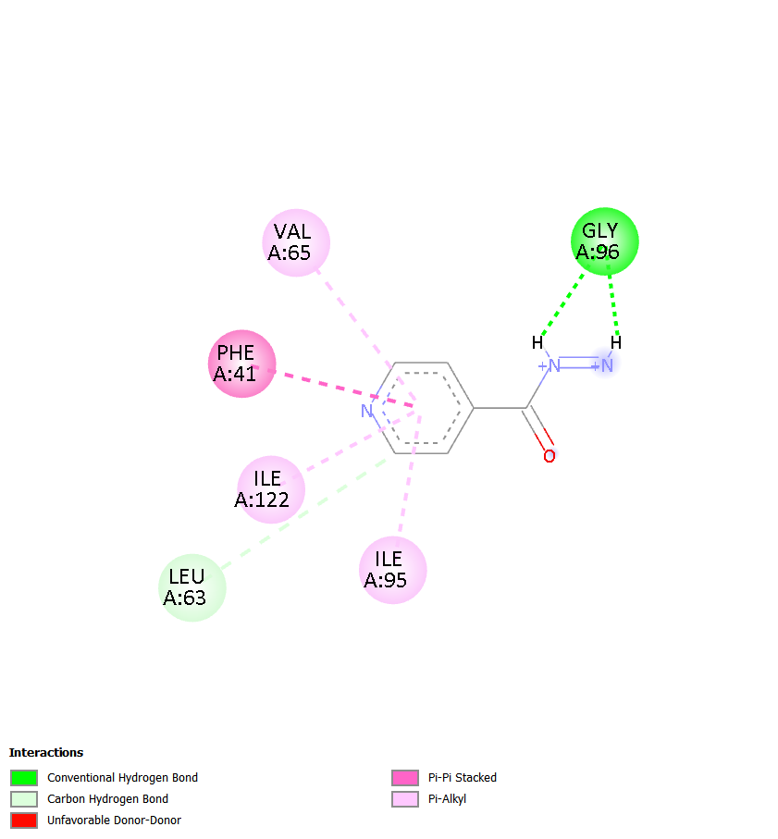
Figure 1. Wild-type InhA docked with isoniazid (INH). Best pose (-5.8 kcal/mol) in the binding pocket; contacting residues: Val65, Leu63, Ile95, Ile122, Phe41, Gly96.
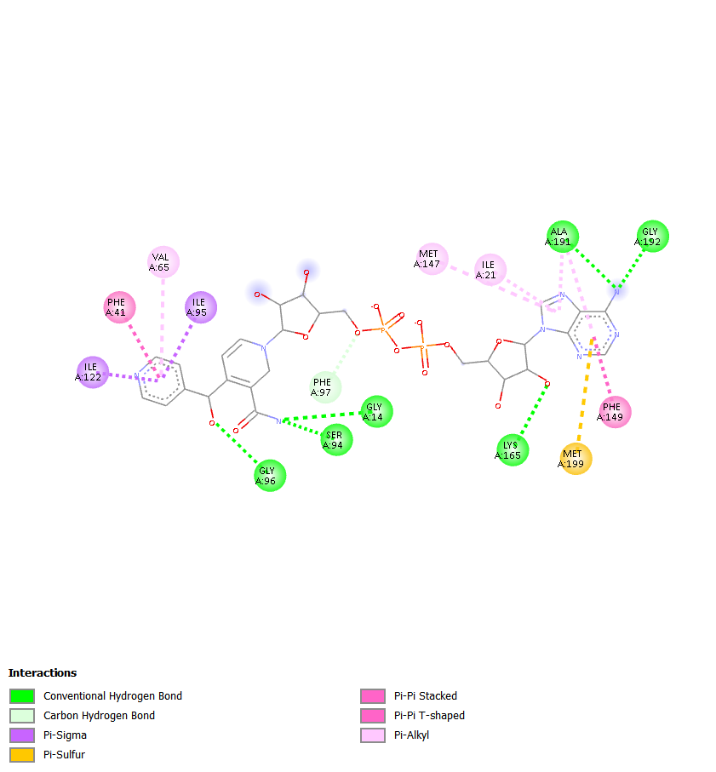
Figure 2. Wild-type InhA docked with the INH-NAD adduct. Best pose (-10.2 kcal/mol) with the 15 contacting residues listed in Section 6.1.
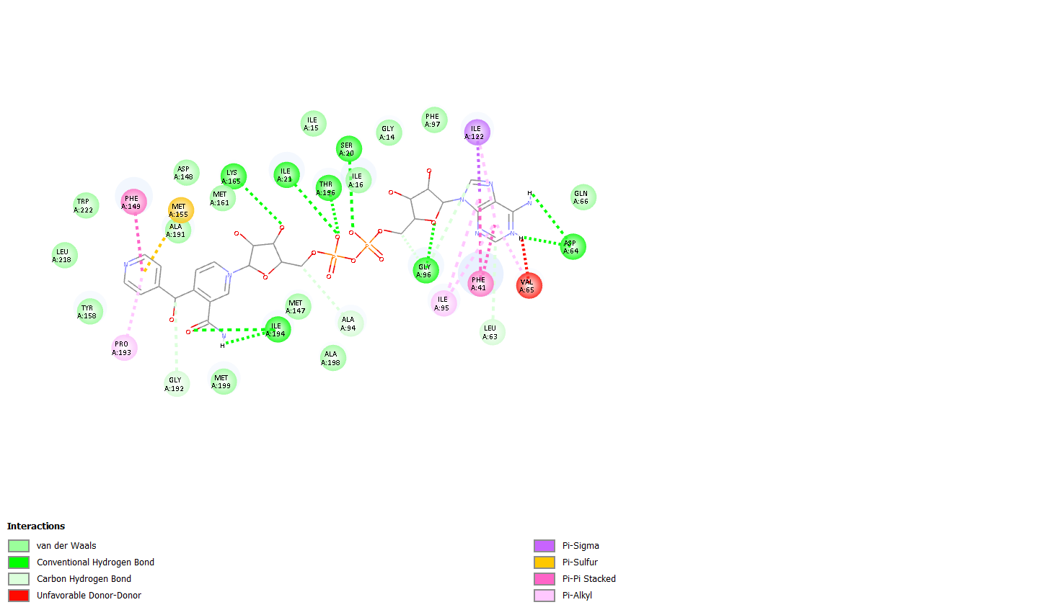
Figure 3. S94A mutant docked with the INH-NAD adduct. Best pose (-10.1 kcal/mol), the strongest predicted binding among all variants.
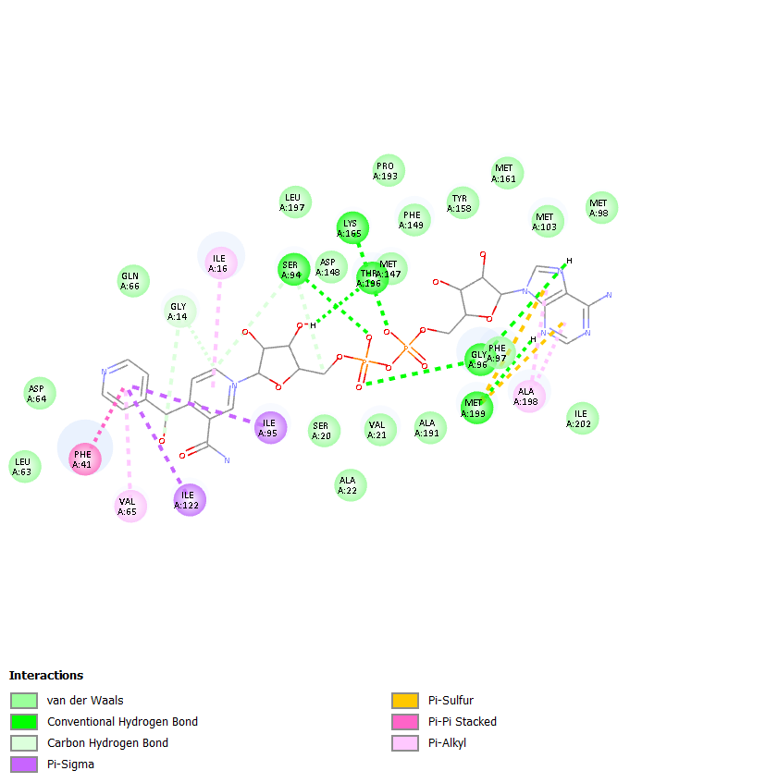
Figure 4. I21V mutant docked with the INH-NAD adduct. Best pose (-10.5 kcal/mol).
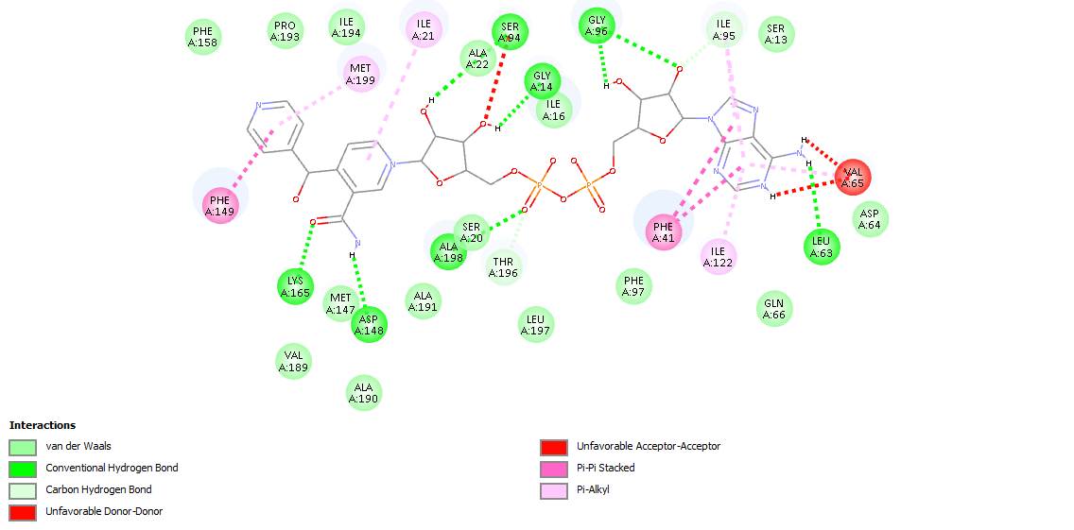
Figure 5. Y158F mutant docked with the INH-NAD adduct. Best pose (-9.5 kcal/mol), equal to wild type.
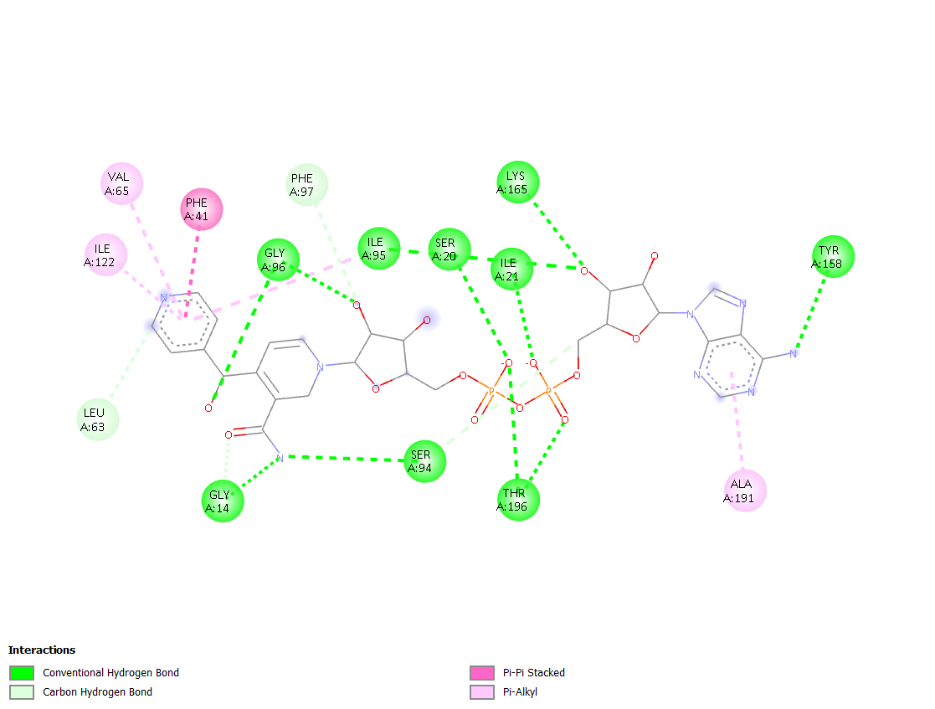
Figure 6. D148G mutant docked with the INH-NAD adduct. Best pose (-11.1 kcal/mol).
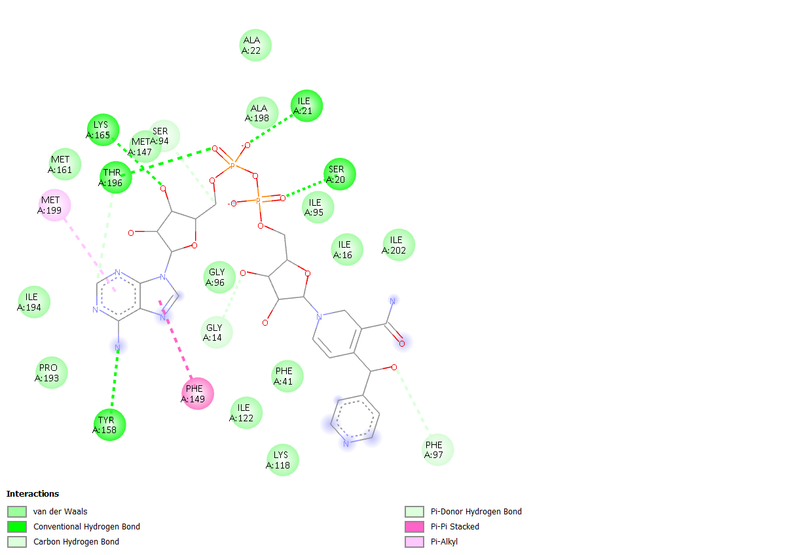
Figure 7. T2A mutant docked with the INH-NAD adduct. Best pose (-10 kcal/mol), the weakest among all variants.

CONCLUSION:
Using a Vina/PyRx docking workflow, this project showed that the INH-NAD adduct binds wild-type InhA far more strongly than isoniazid itself, and compared the adducts predicted binding across five resistance-associated variants. Predicted affinities ranged from -9.5 (T2A) to -11.8 kcal/mol (S94A), and no uniform loss of affinity was seen across mutants. The results provide a structural starting point for understanding InhA-adduct interactions; establishing their relevance to resistance would require validated docking, dynamics-based analysis and experimental data.

- FUTURE PERSPECTIVE:

This project provides a basic understanding of molecular docking, showing how changes in the ligand and point mutations in the protein sequence can cause a shift in binding affinity. There is much more that can be done in the future. Molecular dynamics simulation using GROMACS (or AMBER/NAMD) can be performed to explain the stability of this protein-ligand interaction. In-silico mutagenesis using PyMOL Mutagenesis Wizard (or Chimera/FoldX) can be done to create new mutant variants targeting different amino acids present in the active site, i.e., the NADH binding site. Different derivatives of the ligand can be retrieved from databases such as PubChem to prepare a ligand library, which can be docked against the protein to find similar molecules that bind more efficiently. The ligand structure can also be modified using tools such as ChemDraw to improve its binding with the receptor.

