Task 1

- Step‑by‑Step Solution Explanation
- Import into Power Query: Load the raw posts dataset into the Power Query Editor.
- Remove duplicates: Select the Post ID column, choose Remove Rows → Remove Duplicates to keep only unique posts.
- Standardize date & platform: Convert the Date column to the Date data type and format all platform names consistently (e.g., “Youtube” instead of “youtube”).
- Format numeric fields: Set columns like Likes, Shares, Comments, Impressions, Reach, and Ad Spend to Whole Number or Decimal as appropriate.
- Split hashtags: Use Split Column → By Delimiter (,) on the hashtags column to separate tags into Rows.
- Load cleaned data: Click Close & Load to output the cleaned table to a new worksheet

Task 2 – Engagement Analysis

Step‑by‑step solution
Task 2.1 Calculate engagement rate per platform : I have used Post data to find out the engagement rate per post. I created a worksheet named Task 2 in which I have mention solution for the task.
Approach: To find engagement rate, I used the formula SUM(F2:H2)/I2 where F,G & H columns are Likes, shares and comments which divide by the impressions with column I.
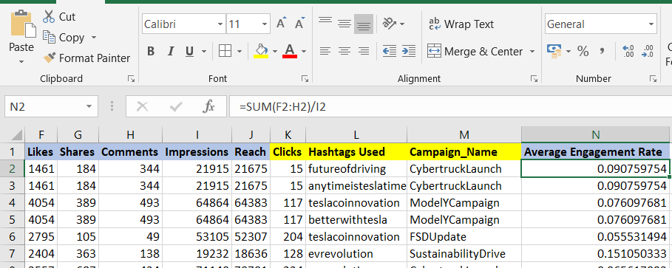

Then, for each platform, I find out the average engagement rate per platform using formula AVERAGEIF($B$1:$B$301,$Q4,N:N). Here B is the platform column range, Q4 containing the platform name and N:N refers to engagement rate.

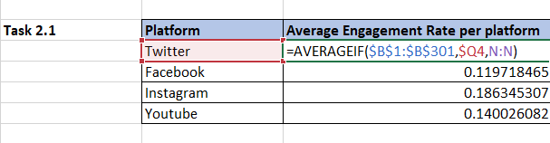

Task 2.2 Identify Top 10 Tesla Posts with Highest Engagement :
Sort the Engagement Rate column in descending order. Select the top 10 rows and copy their Post ID and Platform into a summary table titled “Top 10 Tesla Posts with Highest Engagement Rate”

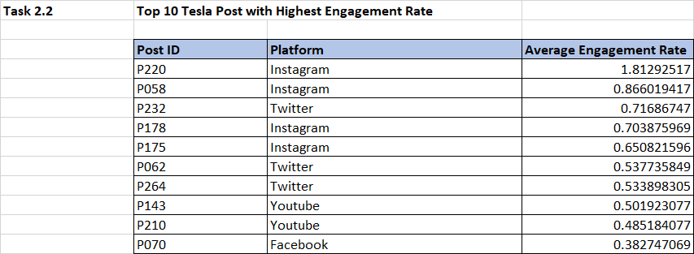

Task 2.3 Create a Pivot Table showing
Total Likes, Shares, Comments by Content Type & Platform
- Insert a Pivot Table using Posts data.
- Drag Content Type to the Rows area and Platform to the Columns area.
- Drag Likes, Shares and Comments to the Values area and set each to “Sum.” This produces a matrix showing total likes, shares and comments for each combination of content type and platform.

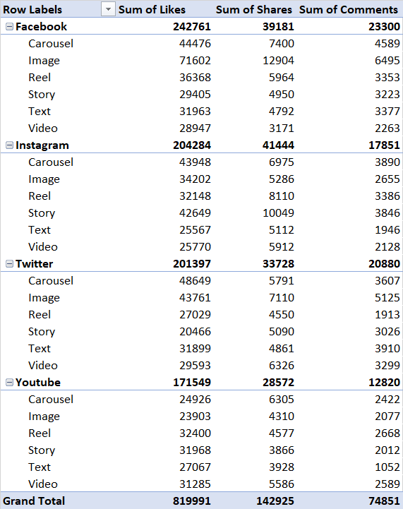

Average Clicks per post by Hashtag

- Insert a Pivot Table using Posts data.
- Drag Hashtag Used to the Rows area.
- Drag clicks to the Values area and set to “Average.”

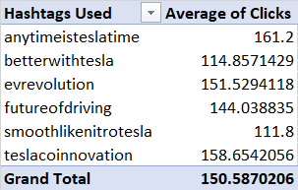

Task 2.4 Highlight top-performing hashtags (#Cybertruck, #ModelY, #EVAdoption, etc.).

Sort the average clicks as per Task 2.3 in descending order to find the hashtags with the highest average clicks. Used conditional Formatting.
Home Tab -> Conditional Formatting -> Top/Bottom Rules -> Top 10 Items
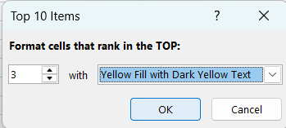

Result :

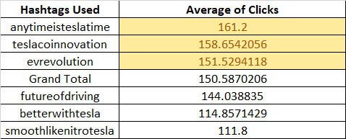

Task 3 – Platform Analysis

Task 3.1 Identify the platform with highest engagement (e.g., Twitter for announcements vs. YouTube for product demos).

Firstly, select Platform,Like, shares, comments,Impressions,reach, Clicks from the Posts sheet and paste it to another worksheet named Task 3.
Using Sum formula on likes shares and comments to find out the Total Engagemet.
SUM(B2:D2) where B,C and D columns refers to Likes,Shares and Comments.
Then, find the total engagement per platform by using SUMIF($A$1:$A$301,$K6,$H$1:$H$301) in which A refers to Platform Column, K refers to the cell where Platform name is written against which I have to find total Engagement, also H refers to the column having Total Engagememt Value.

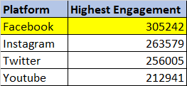
Task 3.2 Compare follower growth rates across platforms

Use the weekly engagement dataset . Add a column named Growth Rate with the formula =(New_Followers – Unfollows) / Total Followers. Then compute the average growth rate for each platform with AVERAGEIF($B:$B,Q4, $V:$V) where B is Platform Column, Q4 is the cell where Platform is mentioned, V is the Growth Rate Column.

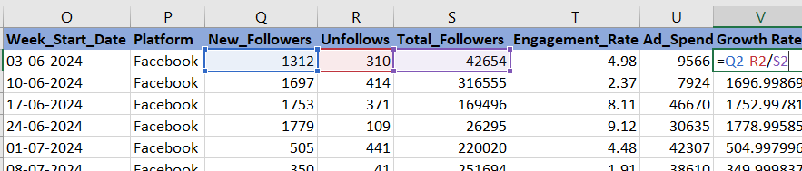

Result

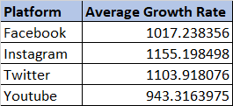

Task 3.3 Visualize Engagement vs. Ad Spend per platform

Tesla should follow a multi-platform strategy.
Twitter works best for quick product updates, YouTube for detailed demos, while Instagram gives the highest engagement and Facebook helps reach wider audiences. Combining all four keeps Tesla visible, drives awareness fast, and builds long-term brand connection.

Step 1. Firstly find out the average ad spend for each platform by using formula
AVERAGEIF($P$1:$P$201,$X19,$U$1:$U$201) in which P refers to Column having Platform , X refers to the cell where platform name has been mentioned and U refers to Ad spend. Simultaneously, get average engagement rate against each platform by using AVERAGEIF($P$1:$P$201,$X19,$T$1:$T$201), where T is engagement Rate.

Task 4 Hashtag & Content Strategy
Firstly, used Post data in Power query and split the Hashtag Column with the help of delimiter ( ,) in row, so that data will be separated in rows by delimiter. (used only for Task 4.1 & Task 4.2)
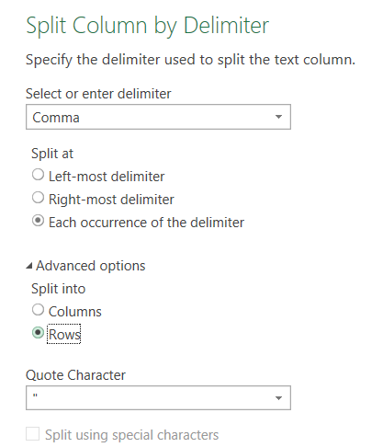

Task 4.1 Identify most frequently used Tesla hashtags.
1. Create a Pivot table, drag Hashtag Used in rows and values and set value field in count. This will give the count of each hashtag.
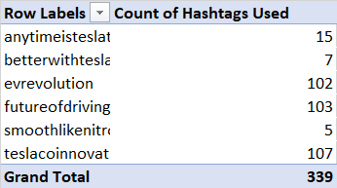
Task 4.2 Compare average performance of posts containing each hashtag.
1. Insert a column named Engagement Rate and find the engagement rate by using
Engagement Rate = (Likes + Shares + Comments) / Impressions.
2. Created a pivot table, drag Hashtag Used in rows and engagement rate in values and set to average.
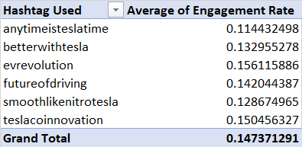

Also created a Clustered Column Chart to show the Average performance per Hashtag
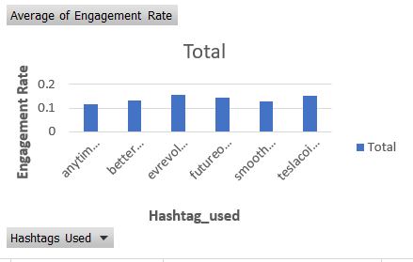

Task 4.3 Compare Content Performance
Find the engagement rate by using
Engagement Rate = (Likes + Shares + Comments) / Impressions and insert a pivot in which set Content Types in Row area and engagement rate in Value and set to average.
Format the average engagement rate into Percentage and create Clustered Column Chart showing Content Type in X asix and average engagement rate in Y axix.
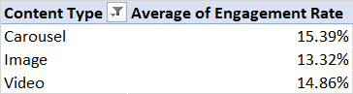
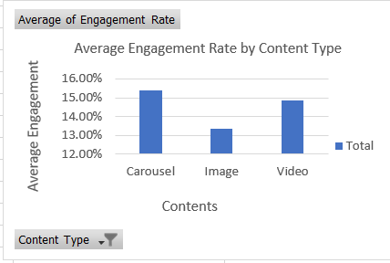

Task 4.4 Recommend content type priorities per platform (e.g., videos on YouTube, car images on Instagram).
Used Posts data and insert a column named Engagement Rate and find the engagement rate against Platform.
Insert a pivot table using platform in Row area , Content type in column area and the engagement rate in Values and set to average. Hence, find greatest value among the content types for each platform by using Max function MAX(F30:K30) .
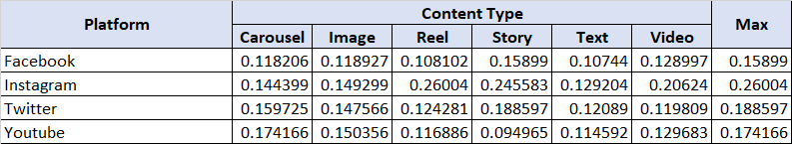

Task 5 Campaign Effectiveness
Task 5.1 Total & Average Impressions, Likes, Clicks per Campaign
Create a pivot table with Campaign_Name in the Rows area. Drag Impressions, Likes and Clicks to the Values area twice: set the first instance to “Sum” and the second instance to “Average.” Rename the columns accordingly (“Total Impressions”, “Average Impressions”, etc.). The pivot table now shows total and average impressions, likes and clicks for each campaign.
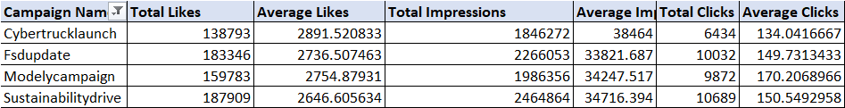

Task 5.2 Engagement uplift during vs. before campaigns (e.g., Cybertruck launch spike).

Insights
Task 5.3 Which campaign had the highest ROI (engagement vs. spend)?
Firstly, select Post data and find Total engagement by addition of Likes ,share and comments.
Using Pivot, Drag campaign Name in Row area and Total engagement at value field. Also combine the values to the campaign meta data and find ROI using (Total Engagement/Total Budget.
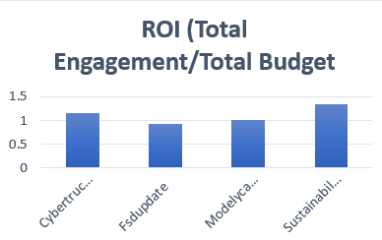

Hence, find out that Sustainability Drive delivered the highest ROI.
Task 5.4 Which campaign drove the strongest follower growth?

Task 6 : Follower Retention & Loyalty
Task 6.1 : Visualize weekly follower growth per platform (line chart)
Firstly used Engagement Summary Data and find Net growth by (New_Followers – Unfollows) and Create a pivot table with Week_start_date in the Rows area. Drag Platform in the column area. Drag Net growth to the Values area and set to the sum. Hence created a line chart.
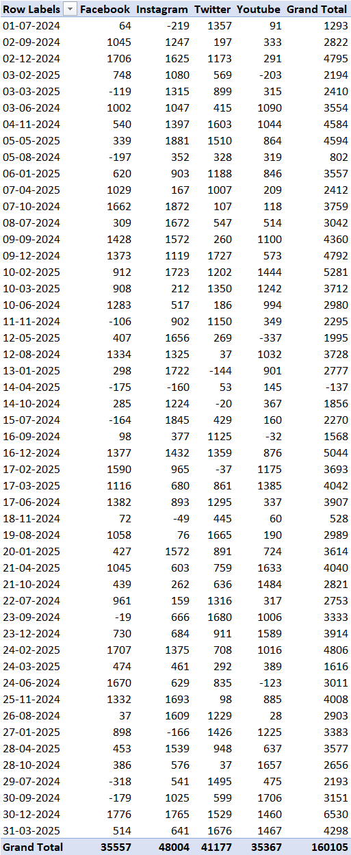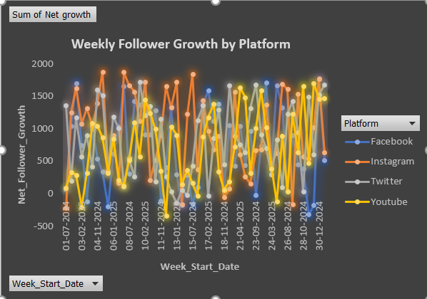

Task 6.2 Identify the peak week of follower gain
In previous task, I found the value for Net Growth and basis on this, I found out the week start date against the maximum net growth by using INDEX($A$1:$A$201,MATCH(MAXIFS(H1:H201,B1:B201,$J64),$H$1:$H$201,0)) where A refers to the week start date, H refers to the Net growth and B refers to the platform. Hence, Peak week of follower gain is 05-05-2025.
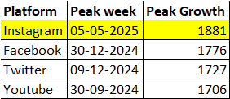

Task 6.3
Task 6.4 Correlate ad spend vs. follower growth using scatter plots.
Used Engagement Summary data and plot a scatter graph to show the comparison between Add spend or Follower growth.
