**Assignment – 3**

1. **AdventureWorks (OLTP) - what is the total sales by country sorted in descending order?  
     
   Query:**

select cr.Name,

SUM(sod.LineTotal) as TotalSales from

Sales.SalesOrderHeader soh

INNER JOIN Sales.SalesTerritory st ON soh.TerritoryID = st.TerritoryID

INNER JOIN Person.CountryRegion cr ON st.CountryRegionCode = cr.CountryRegionCode

INNER JOIN [Sales].[SalesOrderDetail] sod on sod.SalesOrderID= soh.SalesOrderID

group by cr.Name  
order by 2 desc

**Screenshot:**

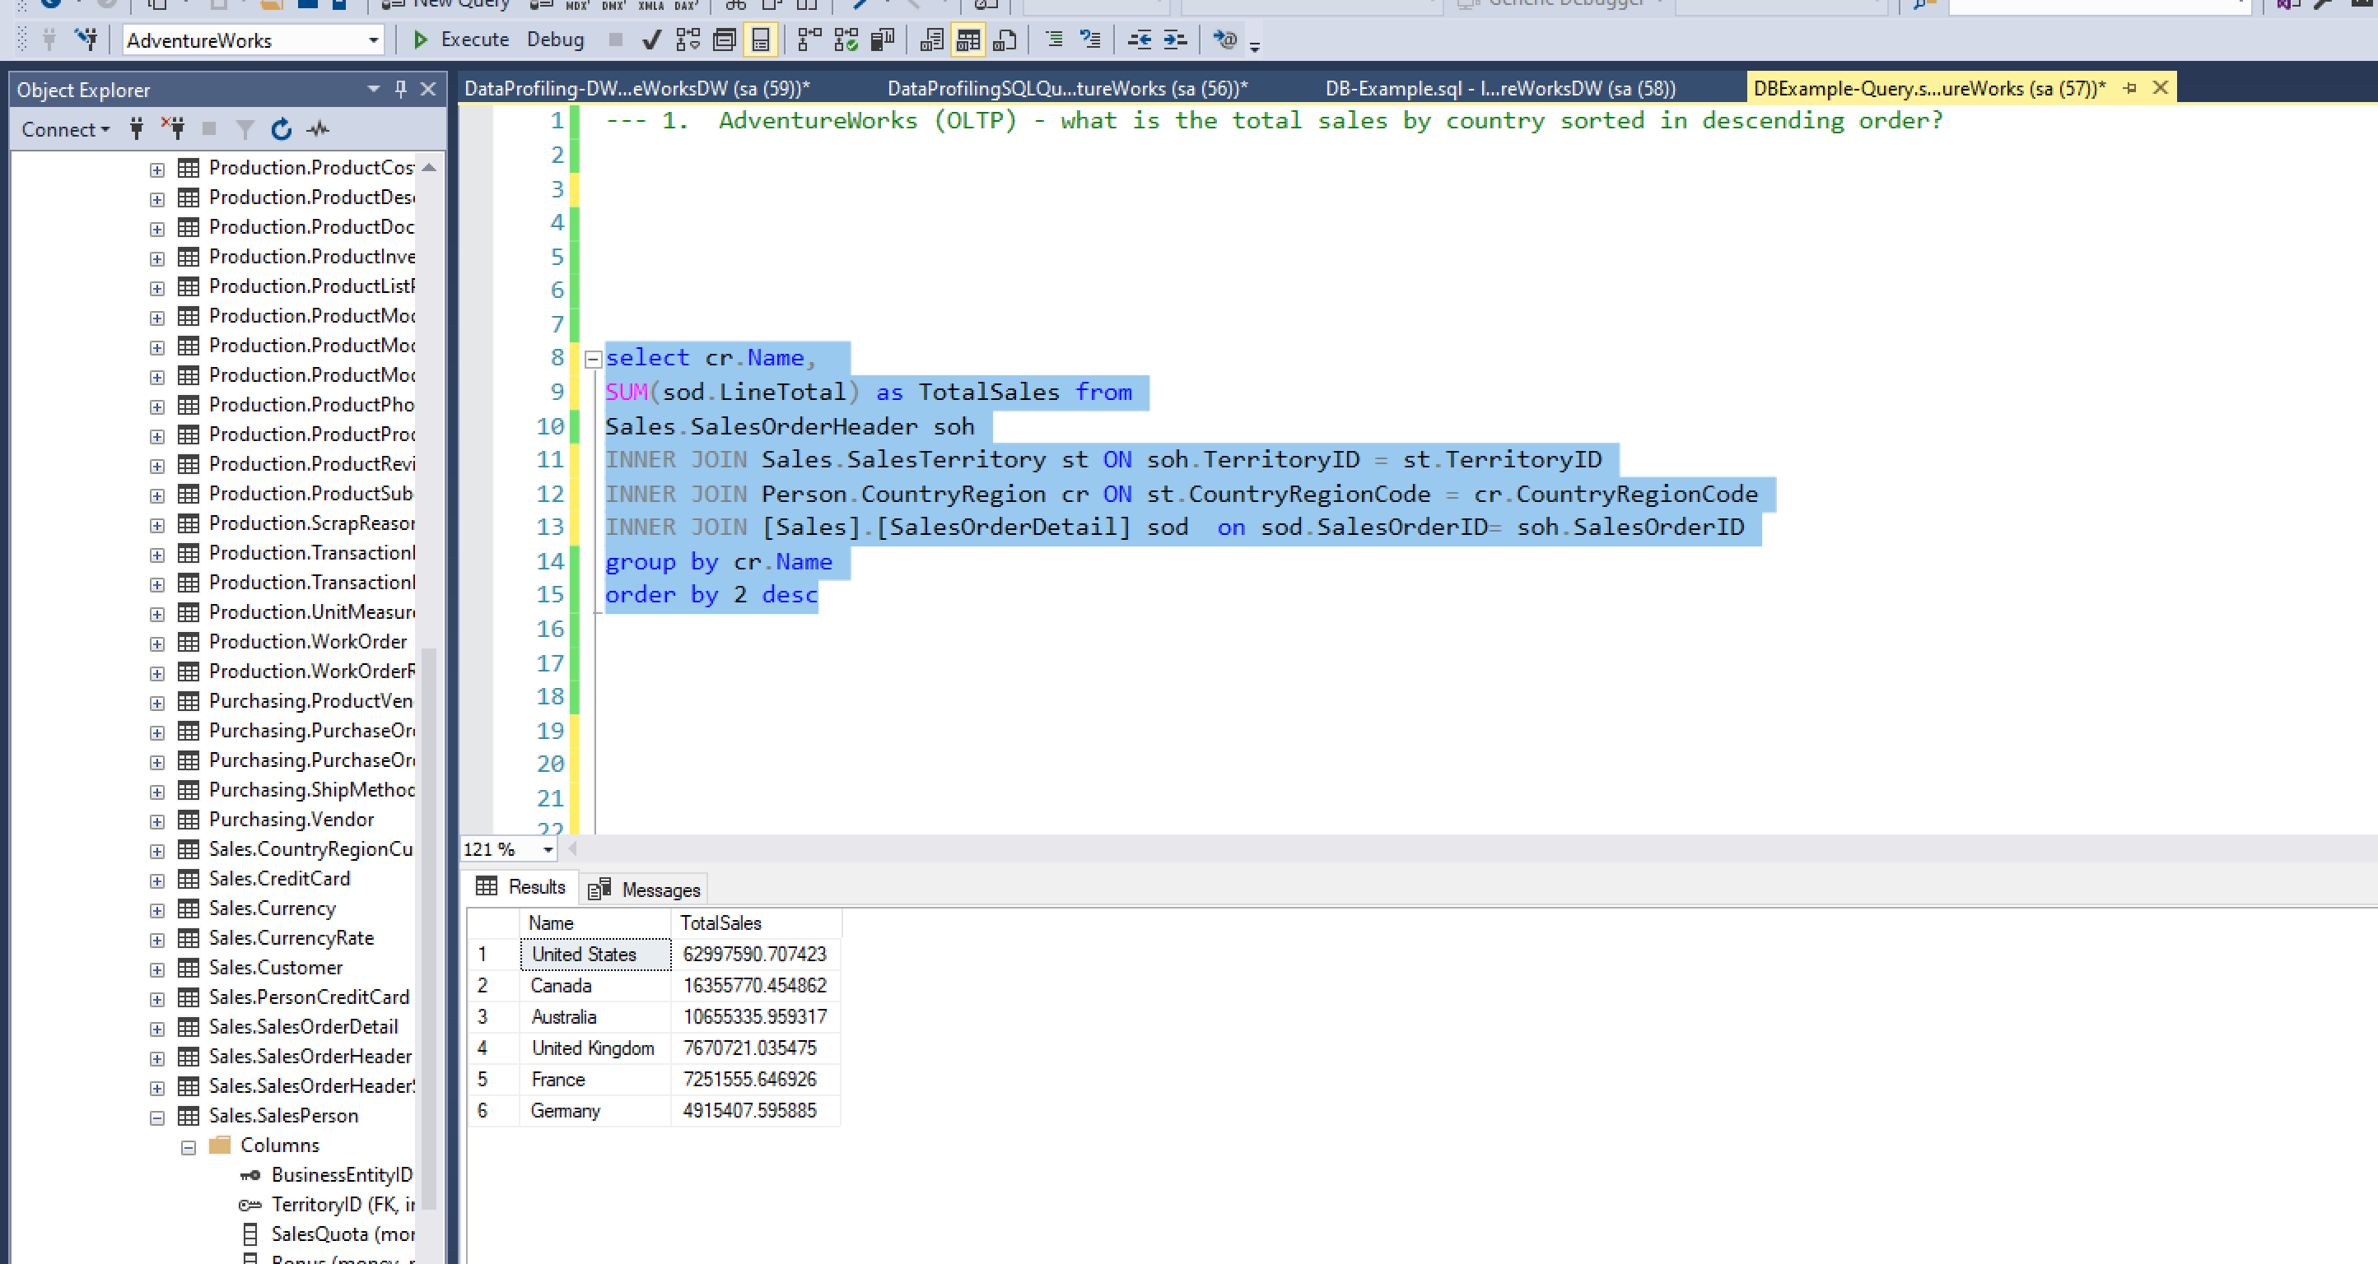

1. **AdventureWorksDW (Data Warehouse) - what is the Internet sales by year?**

SELECT SUM(salesamount) AS TotalSales, YEAR(OrderDate) AS [YEAR] FROM FactInternetSales

GROUP BY YEAR(OrderDate)  
  
