# Data Structures and Algorithms

# INFO 6205

# Homework 7

Due: June 27, 2020

1. Consider the following data:

a) Draw the undirected graph that is represented as follows:

Vertices: 1, 2, 3, 4, 5, 6, 7, 8, 9

Edges:  (5, 6), (4, 6), (3, 7), (6, 7), (5, 7), (1, 4), (2, 4), (2, 3), (4, 7), (4, 8), (5, 9)

b) Is graph connected? Is it complete? Explain.

c) Draw Undirected graph using the same data as above.

d) Is the directed graph connected? Is it complete? Explain.

e) Write Adjacency lists representation for data in (a)

f) Write Java code implementation of Adjacency lists representation.

Note: you need to use Bag data structure.

g) What is the space and running time complexity of Adjacency Lists algorithm?

2. For graph 1.aperform:

a) Depth-First Search traversal algorithm starting at vertex 1

b) Write Java code for the algorithm

c) What is the running time complexity of the algorithm?

3. For graph 1.a perform:

a) Breadth-First Search traversal starting at Vertex 1.

b) Write Java code for the algorithm.

c) What is the running time complexity of the algorithm?

4. Consider Graph data structures for Adjacency-Lists for both Directed graph

and Undirected Graph, What are the differences (data structures, methods)?

5. Consider data the following Graph perform:

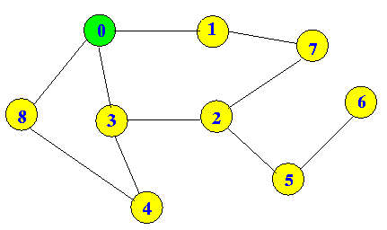

a) Depth-First Search, Show Data structure step-by-step,

b) Breadth-First Search show step-by-step

c) What is time complexity for each case?

d) Write Java code, what is the termination for recursive calls

e) Build a graph from the following Matrix :

f) Build Adjacency List

adjacencymatrix.png

6. Consider this Directed graph: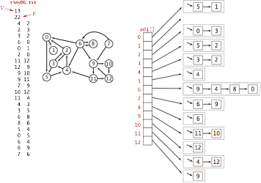

a) Construct Adjacency List for Graph

b) Write Java code to iterate through Graph and print connection for each Vertex.

8. Consider this binary tree:

a) Print in-order, post-order, pre-order Tree Traversal

b) Write Java code, compile and run.

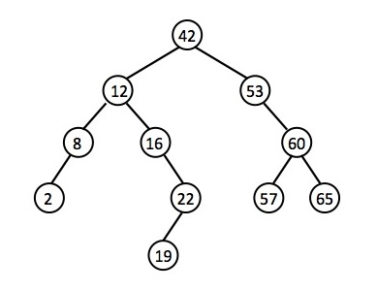

7. Consider a disk with a sector size of 512 bytes, 1,000 tracks per surface, 100 sectors per track, five double-sided platters and a block/page size of 1024 bytes. Suppose that the average seek time is 5 msec, the average rotational delay is 5 msec, and the transfer rate is 100 MB per second. Suppose that a file containing 1,000,000 records of 100 bytes each is to be stored on such a disk and that no record is allowed to span two blocks.

a) How many records fit into a block?

b) How many blocks are required to store the entire file?

8. Consider data: {3, 7, 9, 23, 45, 1, 5, 14, 5, 24, 13, 11, 8, 19, 4, 31, 35, 56, 17, 29, 6, 22}

a) Construct a B-Tree order of t=4

b) Delete elements 45, 11, 31, 4, Construct new BTree, and Describe the delete algorithm

step(s) for each element.

c) Write the Java code for (a) and (b).

d) Perform InOrder traversal and PostOrder traversal on B-Tree

e) Class Record is described below. Write Java code to build the B-Tree you constructed in (a)

public class Record {

private int key

private Node leftNode;

private Node rightNode;

public Record(int key, Node leftNode, Node rightNode) {

this.key = key;

this.leftNode = leftNode;

this.rightNode = rightNode;

}

public Record(int key){

this.key = key;

}

public int getKey() {

return key;

}

public Node getLeftNode() {

return leftNode;

}

public Node getRightNode() {

return rightNode;

}

public void setKey(int key) {

this.key = key;

}

public void setLeftNode(Node leftNode) {

this.leftNode = leftNode;

}

public void setRightNode(Node rightNode) {

this.rightNode = rightNode;

} }

9. Consider the following sequence of letters:

‘A’G’F’B’K’D’H’M’J'E'S'I'R'X'C'L'N'T'U'P'

a) Build BTree with order of t=5

b) What is minimum degree for this BTree?

c) Write Java code to Insert into BTree

d) Consider 3-cases for deleting from B-tree,

Select delete element for each of 3-cases to delete from BTree in (a)

D) Delete E, F, M,

e) Write Java code for all 3 deletion cases

f) Test Java code for (c) and (e) for BTree you constructed in (a)

g) Discuss height, time and space complexity

10. Consider this BTree, Delete L, K, G

