Readings:

• https://en.wikipedia.org/wiki/Database_normalization

Homework:

Quiz Week 3

Chapter 4 (Hoffer, Ramesh, & Topi)

Problems and Exercises 12,13,14

12. Transform Figure 2-15b, attribute version, to 3NF relations. Transform Figure 2-15b, relationship version, to 3NF relations. Compare these two sets of 3NF relations with those in Figure 4-10. What observations and conclusions do you reach by comparing these different sets of 3NF relations? Conversion of attribute and relation ship

**Observation and Conclusions:**

* **Primary key for each entity is clearly defined**
* **Functional dependencies are clearly defined**
* **Multi valued and composite values are stated precisely with forming a relation using foreign keys.**
* **As per the relationship diagram there is no anomalies therefore, any changes to skill or department will not have any effects.**

13. The Public Safety office at Millennium College maintains a list of parking tickets issued to vehicles parked illegally on the campus. Table 4-6 shows a portion of this list for the fall semester. (Attribute names are abbreviated to conserve space.)

a. Convert this table to a relation in first normal form by entering appropriate data in the table. What are the determinants in this relation?  
b. Draw a dependency diagram that shows all functional dependencies in the relation, based on the sample data shown.  
c. Give an example of one or more anomalies that can result in using this relation.  
d. Develop a set of relations in third normal form. Include a new column with the heading Violation in the appropriate table to explain the reason for each ticket. Values in this column are expired parking meter (ticket code 1), no parking permit (ticket code 2), and handicap violation (ticket code 3).  
e. Develop an E-R diagram with the appropriate cardinality notations.

a)

**Determinants in this relation: Key Identifiers is nothing but primary key on which other attributes are dependent**

**State_ID-> Last_Name, First_Name, Phone_No, State_License, License_Number, Ticket, Date,  
Code, Fine.**

b) Functional Dependencies

c) Example of one or more anomalies

**- Insertion of one attribute is dependent on other attribute, in such scenario insertion anomalies occurs.**

**-Deletion of one attribute effect other attribute, means if one attribute is deleted other attribute will also be deleted, in this scenario delete anomalies will occur.**

**-Updating of one attribute effects another attribute, means if one attribute is updated other attribute will also be updated.**

**For example, if we delete State License other data will also be deleted.**

d)

* **Non key attributes are fully functional dependent on primary key or no partial functional dependencies, this partial dependency exist in above table because State_ID and License_Number have become composite key.**
* **Some attribute depends on State_ID and some are License_Number so that is why partially exist  
  Below is the diagram for same**.

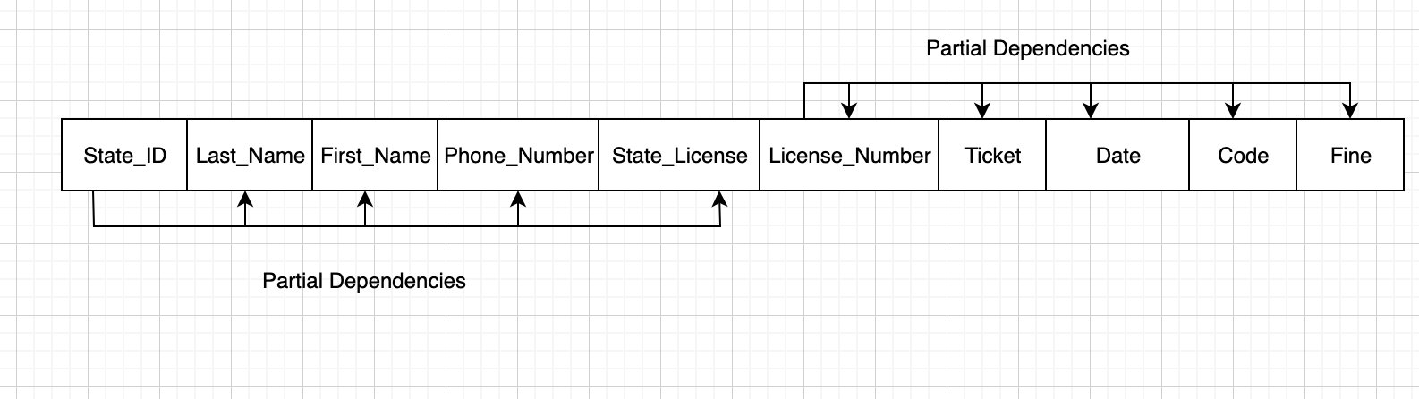

**A table has to be in 3-NF form it has to have no transitive dependency.  
Transitive dependency we need to remove from the diagram, below is the one with no transitive dependency.  
- to remove transitive dependency we divided parking ticket in two parts   
- License_Number, Date, Fine, Code and Ticket_no, Violation.**

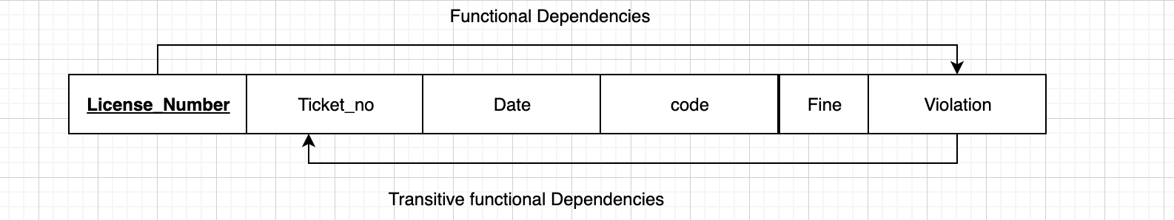

e)   
1:1 relationship with Student and License   
1:M relationship with License and ticket

14. The materials manager at Pine Valley Furniture Company maintains a list of suppliers for each of the material items purchased by the company from outside vendors. Table 4-7 shows the essential data required for this application.

a. Draw a dependency diagram for this data. You may assume the following:

• Each material item has one or more suppliers. Each supplier may supply one or more items or may not supply any items.

• The unit price for a material item may vary from one vendor to another.

• The terms code for a supplier uniquely identifies the terms of the sale (e.g., code 2 means 10 percent net 30 days, etc.). The terms for a supplier are the same for all material items ordered from that supplier.

b. Decompose this diagram into a set of diagrams in 3NF.

c. Draw an E-R diagram for this situation.

1. Dependency Diagram for This data is below where an attribute is dependent on another attribute.

* Material_ID - > Material_Name, Unit_Of_Measure, Standard_Cost
* Vendor_ID->Vendor_Name, Terms_Code, Terms
* Material_ID, Vendor_ID -> Unit_Price
* Terms_Code-> Terms

1. 3NF relation diagram

Entity: Material, Supplied By, Vendor, Terms  
Key Attribute: Material_ID, Vendor_ID, Terms_Code – Primary Attributes

1. E-R Diagram

Mandatory one to Optional one

