*TRIVIM*

(Version: alpha)

User manual

**Introduction:**

Trivim is a R&D application for non-commercial use in training and capacity building for close range photogrammetry developed at the Indian Institute of Remote Sensing (IIRS), Indian Space Research Organization (ISRO), Dehradun India.

This open source freeware application enables generation of 3D street scenarios using a set of 2D images based on the principles of close range photogrammetry. Users can acquire a sequence of overlapping photographs (minimum being 60%) using DSLR’s /consumer grade camera/mobile phone camera. The application comprises of a series of simple steps which generates a photo textured 3D model that can be imported as KML for 3D visualization in an earth explorer such as Google Earth, Bing 3D, ISRO Bhuvan 3D etc. The product would provide a visualization and decision support tool by creating georeferenced, photorealistic models attached with attribute database for a variety of applications (e.g. urban planners).

The Application comprises of the following modules:

* **Camera Calibration:** Calibrates the camera and estimates the interior orientation parameters.
* **Field Planning:** Lets the user estimate the time required for image acquisition.
* **Point Cloud Generation:** Creates 3D point cloud from set of overlapping 2D images.
* **Image Segmentation:** The image segmentation tab allows the user to create building segments to be used as units for database creation and query.
* **3D model Generation:** Compiles the planimetry, elevation and attribute information related to the building segment and creates a 3D model.
* **Database Query:** Provides options for simple query related to the user defined database.

**Key features of the product:**

* One stop solution for generating 3D street views.
* Provides real world coordinates.
* Images collected using wide range of cameras/mobile phones can be processed.
* Semi-automatic segmentation of features.
* 3D database creation and simple query options.

**STEPS TO GENERATE 3D MODEL**

* **Executing the Software**
* Execute the given exe file ‘*Trivim.exe*’ (inside given *Trivim* folder) to run the application.
* Here RED colour indicates that the process needs to be completed, BLUE colour shows the optional process.
* Once a process is finished, the text colour of that button becomes green.

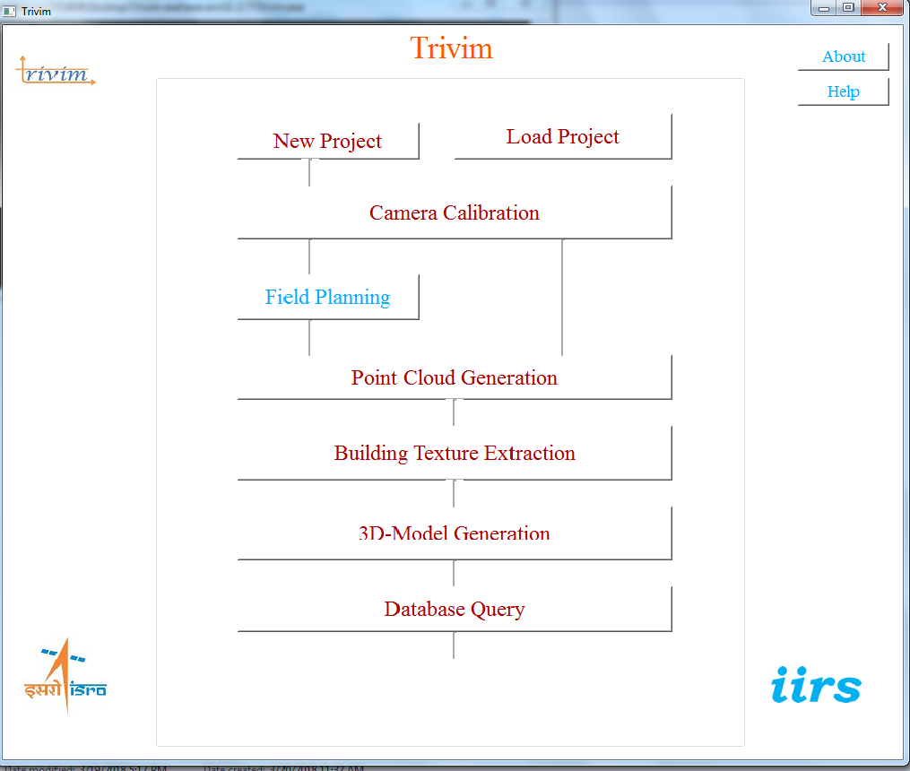

Fig1: Main Menu

* **Creating a new project**
* Click on *New Project* in main menu to create a new project

(Fig 2).

* A window asking the name of project folder will appear. Create a new folder. The created Folder will the Project folder.

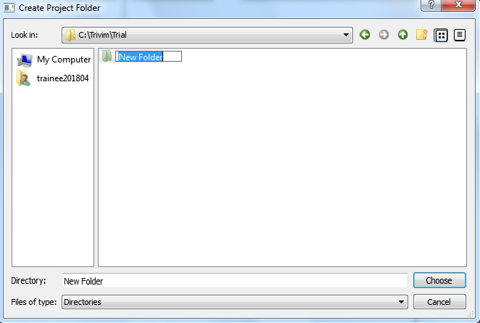

Fig2: Creating a new project

* Enter the database attributes as per user’s requirement. (These attributes will be used for Database querying)
* Enter the variable name and choose variable type (Fig 3).
* Click on Add Variable to add the attributes to the database.
* Click on Remove Variable to delete an attributes from the database.

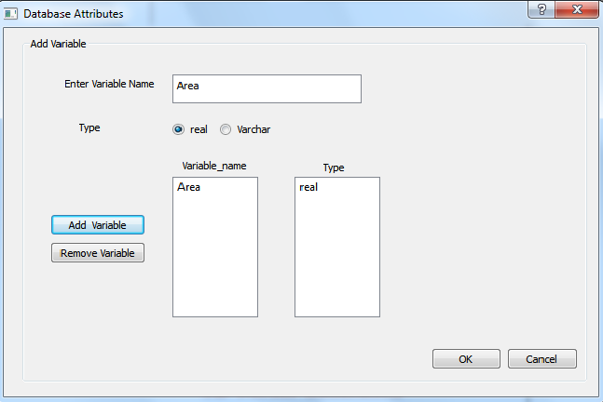

Fig3: Database structure

* Load an existing project
* For loading the existing project click on *Load Project* in main menu and choose the project Folder.

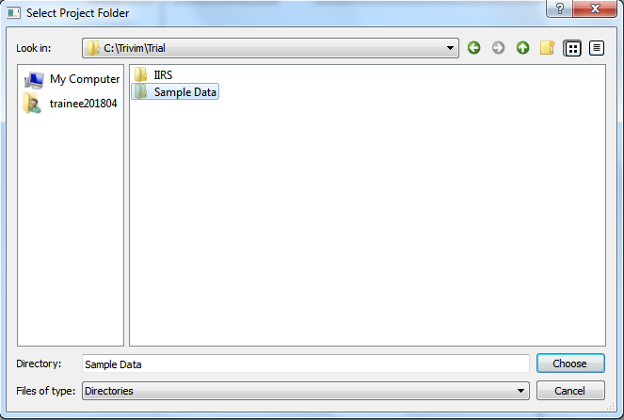

Fig 4: Loading an Existing Project

* **Camera Calibration**

The first process for 3-D Model generation is Camera Calibration. Camera Calibration is a necessary step in 3D computer vision in order to extract metric information from 2D images. Purpose of camera calibration is to establish projection from 3D world coordinates to 2D image coordinates. The camera calibration module calibrates the camera and estimates the interior orientation parameters.

1. Print the chessboardfinal.jpg (*Trivim/Sample Data/ChessboardImage*) on A4 size paper and paste it on a hard, flat surface.
2. Acquire at least 6 to 8 photographs of chessboard from different orientations with the focal length required for the project (the same focal length has to be used for field data acquisition). For clarifications refer to the sample chessboard images provided in the Sample Data (*Trivim/Sample Data*).There is no specific sequence required of photos.
3. Convert chessboard images into greyscale.
4. Click on *Camera Calibration* in main menu to open the Camera Calibration window (Fig 5).
5. Select camera name from the drop down menu.
6. Click on *Browse* to locate the directory of chessboard images (or directly enter path of directory of chess board images in the provided text field). (*In the sample data, images for calibration are provided in the “gry” folder*)
7. Click on the *Calculate Parameters* to perform Camera Calibration.
8. If the camera is not listed in the *Camera Type*, then enter the details of new camera in *Add New Camera* section and after filling the details click on *Add New Camera* button.
9. Perform step f and g.
10. If the result of Camera Calibration has already been saved in the computer, then click on *Load Camera Parameters* and load the camera file.
11. Once the process is finished, results are displayed in the *Camera Parameters* tab (Fig 6). If the results are not satisfactory then click on *Recalculate Parameters* to perform the camera calibration again. (*If required, camera name and chessboard image directory can be chosen again*).

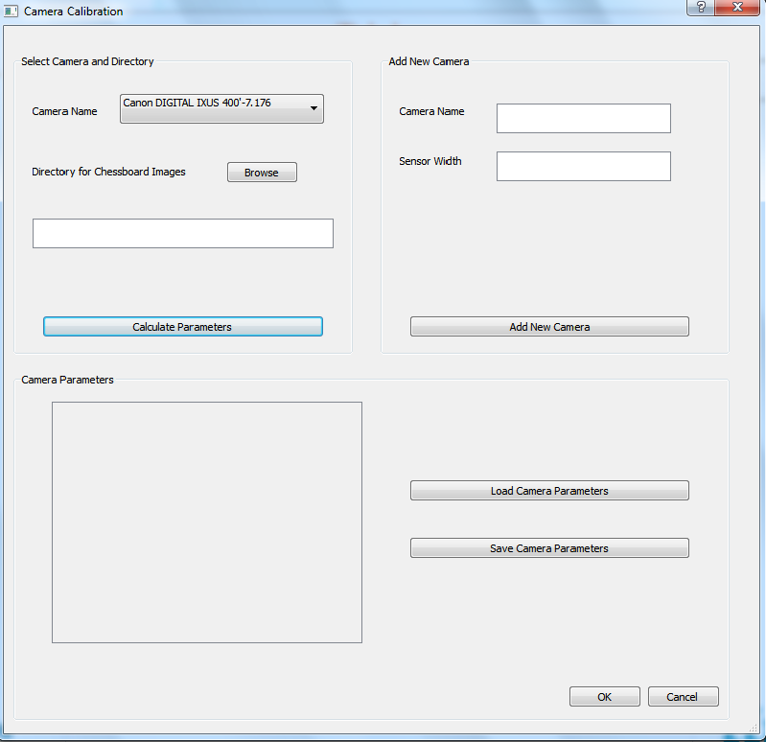

Fig 5: Camera Calibration Window

l) The camera parameters can also be saved for further use from *Save Camera Parameters*.

m) Click on *OK* to complete the process.

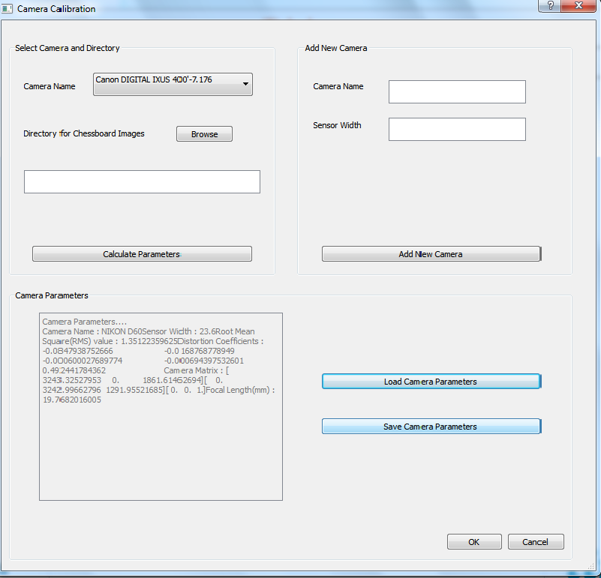

Fig 6: Camera Calibration Results

 **Field Planning** (Optional)

In order to find out the approximate number of photos required and the approximate time required, the following steps are to be performed:

* Click on *Field Planning* in main menu to open the Field Planning window. (Fig 8)
* Provide approximate *Length of Path (meters).*
* Provide approximate *Distance from Building (meter).*
* Provide approximate *Overlap of photos.*
* Provide *approximate time for one photograph.*
* Click *calculate.*
* Click on *OK* to complete the process.

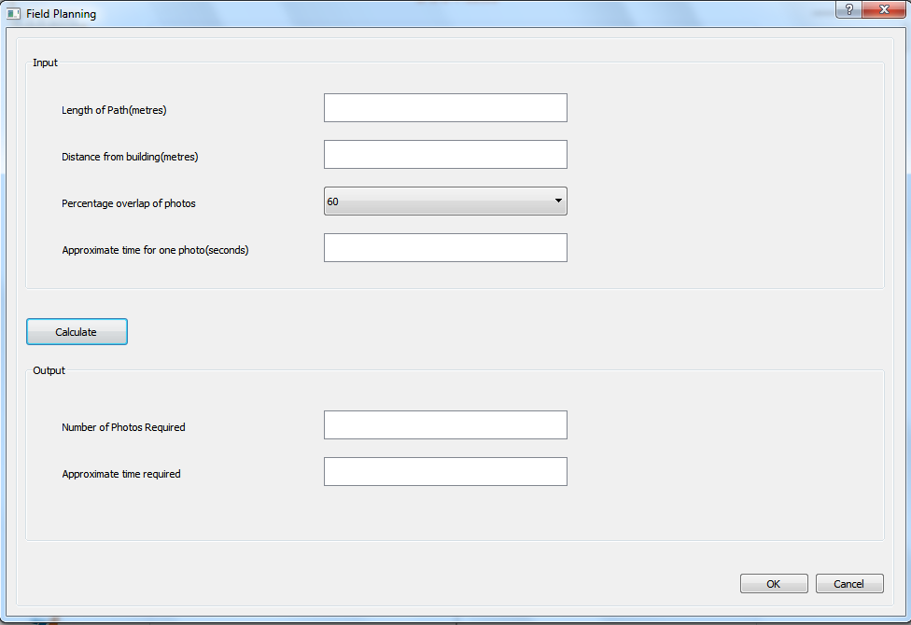Fig 7: Field planning window

**Calculations:** The software uses the following formula to calculate the number of photographs required:

( 𝐿𝑒𝑛𝑔𝑡ℎ 𝑜𝑓 𝑃𝑎𝑡ℎ/𝐷𝑖𝑠𝑡𝑎𝑛𝑐𝑒 𝐹𝑟𝑜𝑚 𝐵𝑢𝑖𝑙𝑑𝑖𝑛𝑔 )= (𝐶𝐶𝐷 𝑖𝑛 𝑚𝑚/𝐹𝑜𝑐𝑎𝑙 𝐿𝑒𝑛𝑔𝑡ℎ 𝑖𝑛 𝑚𝑚)×{1+(𝑛−1)(𝑃𝑒𝑟𝑐𝑒𝑛𝑡𝑎𝑔𝑒 𝑜𝑓 𝑂𝑣𝑒𝑟𝑙𝑎𝑝)},where, *n* is the number of photographs required.

 Point Cloud Generation 

A **point cloud** is a set of data points in some coordinate system. In a three-dimensional coordinate system, these points are usually defined by (X, Y, Z) coordinates, and often are intended to represent the external surface of an object. The *Point Cloud Generation* creates 3D point cloud from set of overlapping 2D images.

* Click on *Point Cloud Generation* in main menu to open the Point Cloud Generation window (Fig 8).
* Select the directory of images whose point cloud is to be generated. Then click on *Generate Point Cloud* button.

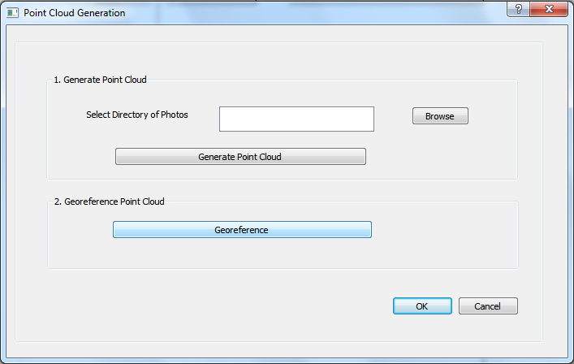

Fig 8: Point Cloud Generation and Georeferencing window

Note: The processing time depends on number of images and size of photos chosen for point cloud generation.

The point cloud files are formed in the *Point Cloud* folder inside the projects folder.

* Now, Click on *Georeference* button for georeferencing the generated point cloud.
* If the images are already geo-tagged then a file named *georeffile.txt* will be automatically created in the *PointCloud* folder inside the project folder otherwise a browsing window will appear asking to browse the file containing the global coordinates of the exposure station points(*User should provide the coordinates file if the images are not geotagged*). The format of the coordinates text file should be same as shown below:

cam_x cam_y cam_z descriptor

1.122 2.335 0.363 photo_1

0.204 34.24 8.929 photo_2

9.324 5.252 3.443 photo_3

NOTE: The georeferenced file will be saved inside the *PointCloud* folder with the name “georeffile.txt”.

 Building Texture Extraction

The building texture extraction/segmentation option allows the user to create building segments to be used as units for database creation and query.

The Image Segmentation window appears as shown below in Fig 9

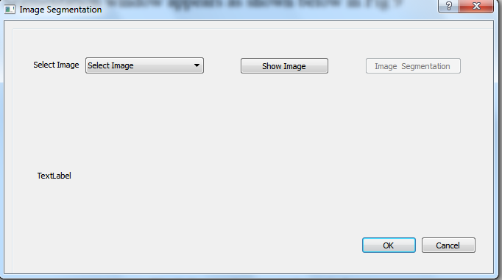

Fig 9: Image Segmentation window

To start image segmentation click on the *Image Segmentation* button in main menu of Trivim.

* To start segmentation, select the desired image from the *Select Image* dropdown menu.
* Then click on Show Image button to view the selected image. The selected image will be displayed on the *Image Preview* tab.fig(10)

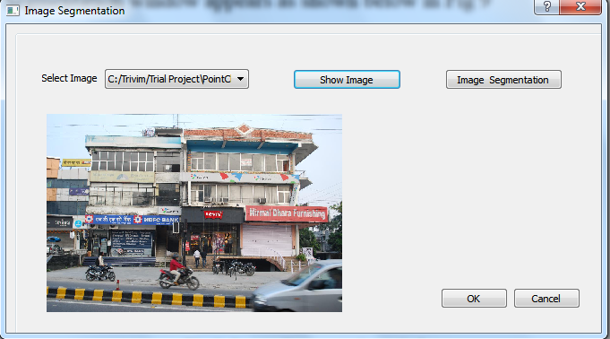  
Fig 10: *Image Preview* tab

* Click on *Image Segmentation* button to perform segmentation.
* A Dialog with image pops up. (Fig 11).

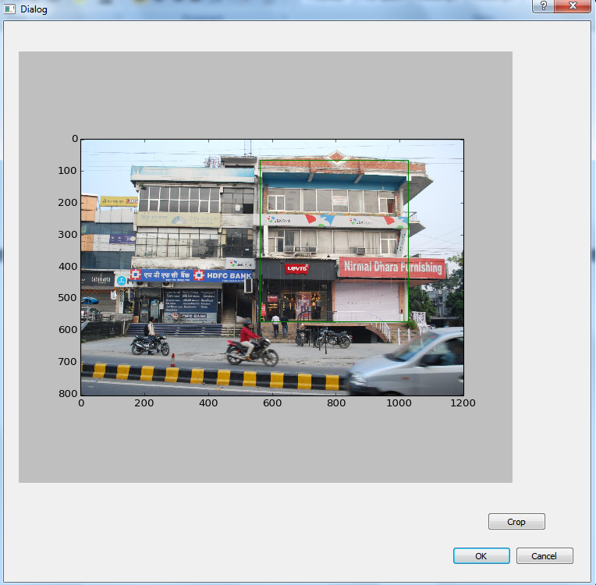

Fig 11: Segmentation window

* With this click on one corner of the desired segment and draw complete segment while holding the left click button (don’t release the button before completing the quadrant and ensure that the segment is closed). The segment is drawn in 'white' colour. An example image is shown in Fig 10 to draw segments.
* Once a segment is drawn, click on *Crop* button in the Segmentation window to save the drawn segment. A window will pop up to enter the database details of the building segments shown in Fig12.

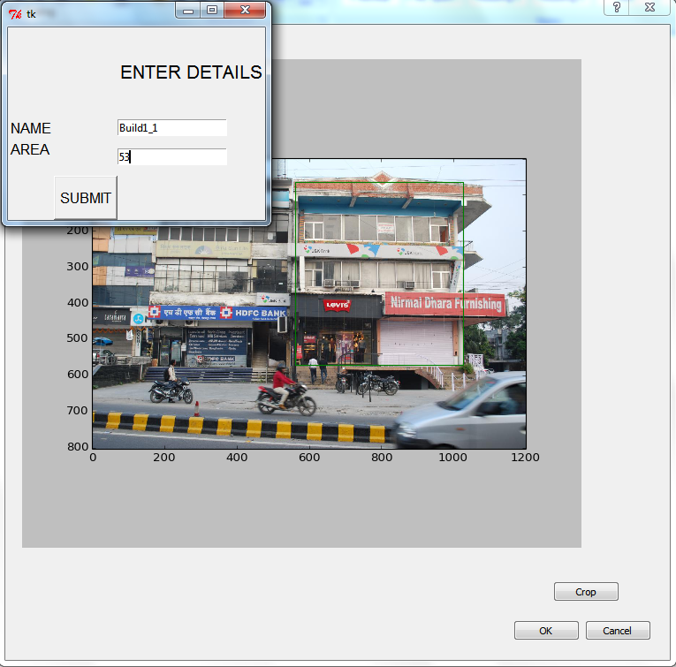  
Fig 12: Saving a segment in Database

*Follow the following nomenclature strictly for naming the segment:*

**buildM_N.png**

Where M is the number of building and N is the floor number of that particular building taking N=1 for ground floor and increase the value of N for upper floors. For example, build2_4 implies to 3rd floor of 2nd building. Then click Submit button after each entry.

* Repeat the same procedure for all desired segments in the image.
* Once all the segments are drawn in the selected image, click on *OK* button to complete the segmentation process for the selected image.
* Repeat the above steps for another image.
* Click on *OK* to complete the process.

***CHECK****: DO CHECK YOUR PROJECT'S "INPUT" FOLDER TO SEE WEATHER YOUR BUILDINGS (BUILD1, BUILD2...) HAVE BEEN CREATED OR NOT.*

* **3D Model Generation**

It compiles the planimetry, elevation and attribute information related to the building segment and creates a 3D model

* To generate a 3D model of the building, click on ‘*3D Model Generation*’ in main menu to open the 3D-Model Generation window. (See Fig 13).

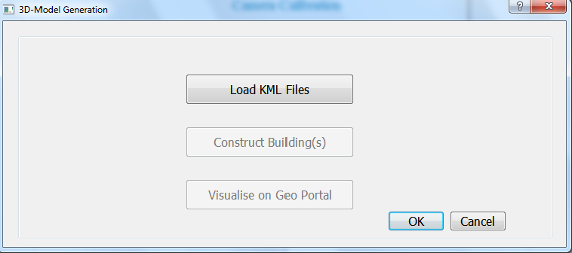

Fig 13: 3D Model Generation window

* Click on *Load KML Files* to import the footprint (in KML file format) of the building to the project folder. A new window will open (see Fig 14) that will allow the user to select the footprint files (in .kml file format).

*{KML files for two buildings are given in the Sample Data}.*

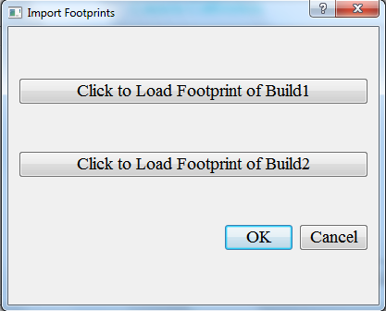

Fig 14: Import Footprints window

* Select the footprint files for respective buildings.

Note*: Here footprint is the polygon of the area where the building is located. It should be in the “.kml” file format. The name of the footprint files should be as per the name of the building. For example: The footprint of the first building should be names as “build1.kml”, “build2.kml” for second building.*

CAUTION: *Draw the Polygon where the 3D-Model is to be placed. Draw the polygon as mentioned below:*

* *Assume yourself in front of the building location, take bottom-left point as the first point, and bottom-right as second and successively complete the polygon.*
* Click on *Construct Building(s)* Button. It opens Google SketchUp for 3D model construction of buildings from the data and closes it automatically once the model generation is finished.
* Click on *Visualise on GeoPortal* button to visualise the 3D-Model.
* Click on *OK* to complete the process.



Fig 15: Final output displaying the 3d model with database

 **Database Query**

This tab is used for querying the database containing information of all the floors of the buildings.

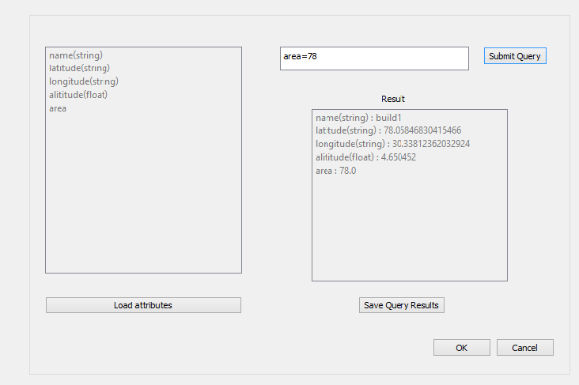Fig 21: Database Query Tab

* *Load Attributes* button will display the attributes of the database of the current loaded project.
* *Submit Query* button will process the query entered by the user and display the results.
* *Save Query Results* button will enable the user to save the query results in a “.txt” file in a directory.
* Click on *OK* to complete the process.