EX No:1 | EDA-DATA CLEANING
Aim:
To perform Exploratory Data Analysis (EDA) and data cleaning on the City Day Air Quality dataset using Pandas, NumPy, and Matplotlib by handling missing values, removing duplicates, converting data types, and analyzing air quality patterns.
Algorithm:
- Import pandas, numpy, and matplotlib.pyplot.
- Load city_day.csv and inspect the dataset structure, missing values, and duplicates.
- Remove duplicate records and handle missing values in the dataset.
- Convert the Date column into datetime format.
- Perform EDA on AQI, AQI_Bucket, City, and pollutant columns.
- Plot frequency distributions and a correlation heatmap.
- Summarize the air quality insights and end execution.
Program:
import pandas as pd
import numpy as np
import matplotlib.pyplot as plt
# ============================================================
# CRISP-DM FRAMEWORK
# ============================================================
# 1. BUSINESS UNDERSTANDING
# Objective:
# Analyze air quality patterns, AQI levels,
# pollutant concentrations and city-wise trends.
# 2. DATA UNDERSTANDING
df = pd.read_csv("city_day.csv")
print(df.head())
print(df.shape)
print(df.info())
print(df.describe())
print(df.isnull().sum())
print(df.duplicated().sum())
# 3. DATA PREPARATION
df.drop_duplicates(inplace=True)
df['Date'] = pd.to_datetime(df['te'])
# Fill numerical missing values using median
num_cols = df.select_dtypes(include=np.number).columns
df[num_cols] = df[num_cols].fillna(df[num_cols].median())
# Fill categorical missing values using mode
cat_cols = df.select_dtypes(include='object').columns
for col in cat_cols:
df[col] = df[col].fillna(df[col].mode()[0])
# 4. MODELING (EDA)
df['City'].value_counts().head(10).plot(kind='bar')
plt.title("Top Cities in Dataset")
plt.show()
df['AQI_Bucket'].value_counts().plot(kind='bar')
plt.title("AQI Category Distribution")
plt.show()
df['AQI'].plot(kind='hist', bins=30)
plt.title("AQI Distribution")
plt.xlabel("AQI")
plt.show()
df['PM2.5'].plot(kind='hist', bins=30)
plt.title("PM2.5 Distribution")
plt.xlabel("PM2.5")
plt.show()
corr = df.select_dtypes(include='number').corr()
plt.figure(figsize=(10,8))
plt.imshow(corr)
plt.colorbar()
plt.xticks(range(len(corr.columns)), corr.columns, rotation=90)
plt.yticks(range(len(corr.columns)), corr.columns)
plt.title("Correlation Heatmap")
plt.show()
# 5. EVALUATION
print("Air quality patterns and trends identified successfully.")
# 6. DEPLOYMENT
print("Insights can be deployed through dashboards."
# ============================================================
# SEMMA FRAMEWORK
# ============================================================
# SAMPLE
df = pd.read_csv("city_day.csv")
# EXPLORE
print(df.head())
print(df.info())
print(df.describe())
print(df.isnull().sum())
# MODIFY
df.drop_duplicates(inplace=True)
df['Date'] = pd.to_datetime(df['Date'])
num_cols = df.select_dtypes(include=np.number).columns
df[num_cols] = df[num_cols].fillna(df[num_cols].median())
cat_cols = df.select_dtypes(include='object').columns
for col in cat_cols:
df[col] = df[col].fillna(df[col].mode()[0])
# MODEL
df['AQI_Bucket'].value_counts().plot(kind='bar')
plt.title("AQI Category Distribution")
plt.show()
df['AQI'].plot(kind='hist', bins=30)
plt.title("AQI Distribution")
plt.show()
df['City'].value_counts().head(10).plot(kind='bar')
plt.title("Top Cities")
plt.show()
corr = df.select_dtypes(include='number').corr()
plt.figure(figsize=(10,8))
plt.imshow(corr)
plt.colorbar()
plt.xticks(range(len(corr.columns)), corr.columns, rotation=90)
plt.yticks(range(len(corr.columns)), corr.columns)
plt.title("Correlation Heatmap")
plt.show()
# ASSESS
print("Patterns and trends successfully identified.")
# ============================================================
# KDD FRAMEWORK
# ============================================================
# SELECTION
df = pd.read_csv("city_day.csv")
# PREPROCESSING
print(df.info())
print(df.isnull().sum())
print(df.duplicated().sum())
df.drop_duplicates(inplace=True)
# TRANSFORMATION
df['Date'] = pd.to_datetime(df['Date'])
num_cols = df.select_dtypes(include=np.number).columns
df[num_cols] = df[num_cols].fillna(df[num_cols].median())
cat_cols = df.select_dtypes(include='object').columns
for col in cat_cols:
df[col] = df[col].fillna(df[col].mode()[0])
# DATA MINING
df['AQI_Bucket'].value_counts().plot(kind='bar')
plt.title("AQI Category Distribution")
plt.show()
df['AQI'].plot(kind='hist', bins=30)
plt.title("AQI Distribution")
plt.show()
df['City'].value_counts().head(10).plot(kind='bar')
plt.title("Top Cities")
plt.show()
corr = df.select_dtypes(include='number').corr()
plt.figure(figsize=(10,8))
plt.imshow(corr)
plt.colorbar()
plt.xticks(range(len(corr.columns)), corr.columns, rotation=90)
plt.yticks(range(len(corr.columns)), corr.columns)
plt.title("Correlation Heatmap")
plt.show()
# INTERPRETATION
print("Knowledge discovered from the dataset has been interpreted to support air quality analysis.")
Output:
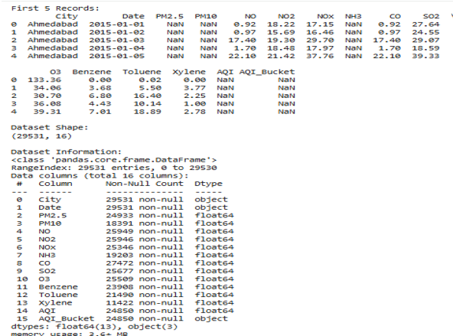

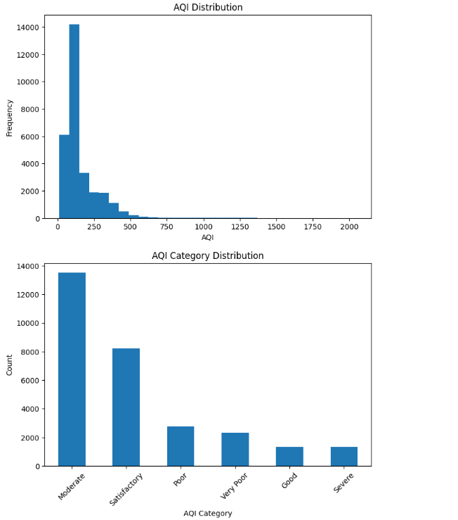
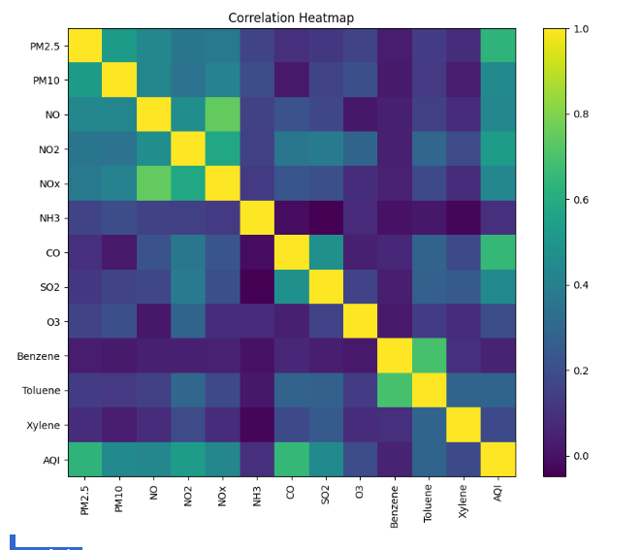

AQI Analysis
Average AQI = 158.78155158985473
Maximum AQI = 2049.0
Minimum AQI = 13.0
Most Common AQI Category:
Moderate
CRISP-DM: Data understanding, preparation, modeling and evaluation completed.
SEMMA: Sample, Explore, Modify, Model and Assess completed.
KDD: Selection, Preprocessing, Transformation, Data Mining and Interpretation completed.
Air quality patterns and trends identified successfully.

Result:

