16X2 LCD DRIVER

1st Level Implementation.

EXPECTIATION:

- Display 32 charachters in sequence. Take a charachter or a string with string length less than 32 from user space program and Display.
- If String is more than 32 charachters just ignore the exceeding charachter.

OPERATION AVAILABLE TO USER PROGRAM:
- Open
This Function should initialise the LCD hardware. LCD should blink its back light twice and show string “INIT DONE !!”

- Write
This Function should accept string less than 32 chars, If user enter more charachter than it should not fail, It should show the 32 chars and ignore rest.

- Close
This function should display “PWR OFF !!” blink back light and power off the device.

INTERFACES:
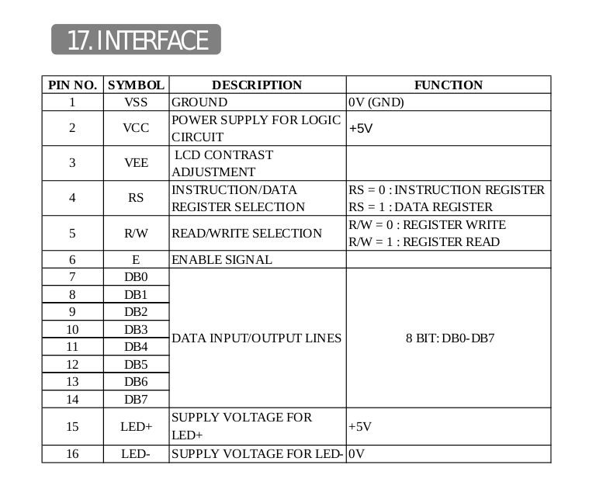

SET OF API’s:

- LCD_Init()
Register LCD device in kernel
Set the LCD in 8 bit mode
Blink the back light and display “INIT DONE !!”

- LCD_Exit()
Unallocate the resources
Blink the back light and display “PWR OFF”
Unregister the LCD device from kernel

- LCD_Send_Command(Command)
Set the LCD in command by following the below steps
Reset the RS pin of LCD i.e (RS = 0, Instruction Register)
Put the command on DB line
Set E pin as 1 wait 5 sec and than set as 0

- LCD_Send_Data(string)
Set the LCD in command by following the below steps
Reset the RS pin of LCD i.e (RS = 1, Data Register)
Put the char on DB line
Set E pin as 1 wait 5 sec and than set as 0
till the last char in string if it is less than 32 or till 32 char.
`
- LCD_Blink()
- LCD_Delay(seconds)

