Evidence Report

Evidence Id - ER_01

Test Scenario Id - TS_NAV_02

Test Case Id - TC_NAV_BAR_04

Title - To Validate Resources Menu

Expected Result - Resources Page should be displayed

Actual Result - Not Displaying Resources Page on clicking

Evidence - Screenshot

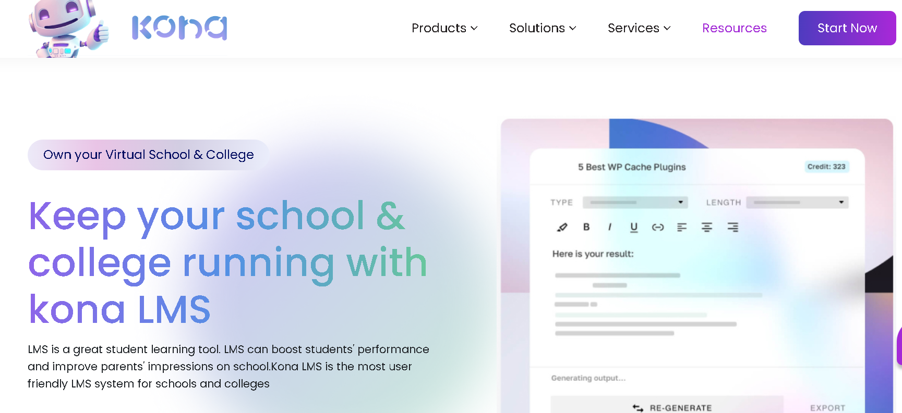

Evidence Id - ER_02

Test Scenario Id - TS_DRPDWN_03

Test Case Id - TC_DRDN_04

Title - To Validate "Resources" menu dropdown visibility

Expected Result - The dropdown menu should become visible

Actual Result - Not Displaying Dropdowns

Evidence - Screenshot

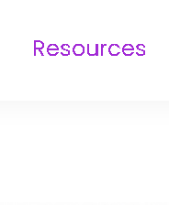

Evidence Id - ER_03

Test Scenario Id - TS_DRPDWN_03

Test Case Id - TC_DRDN_05

Title - To Validate "LMS" option in "Products" dropdown

Expected Result - User should be navigated to the LMS page

Actual Result - User is not able to navigate to the LMS Page, it is navigating to the CRM page

Evidence - Screenshot

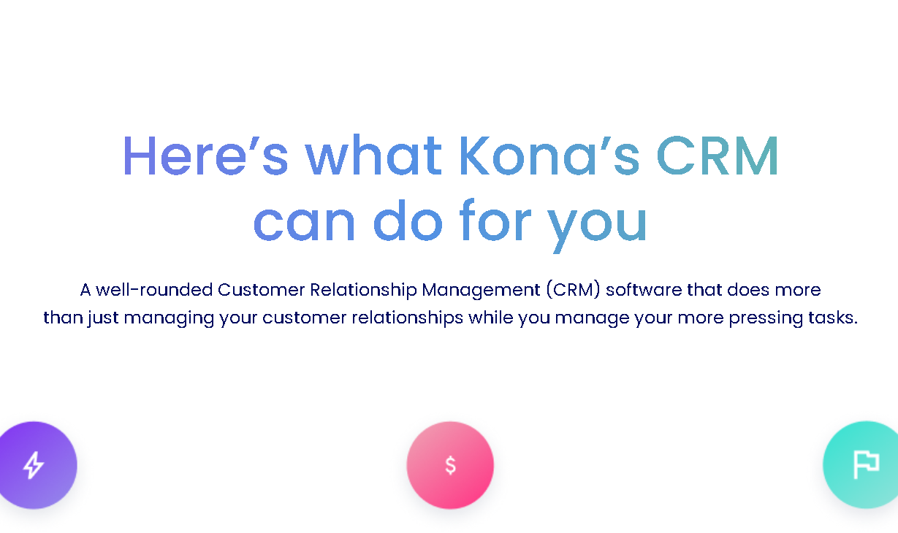

Evidence Id - ER_04

Test Scenario Id - TS_DRPDWN_03

Test Case Id - TC_DRDN_07

Title - To Validate "HRMS" option in "Products" dropdown

Expected Result - User should be navigated to the HRMS page

Actual Result - User is not able to navigate to the HRMS Page, it is navigating to CRM Page

Evidence - Screenshot

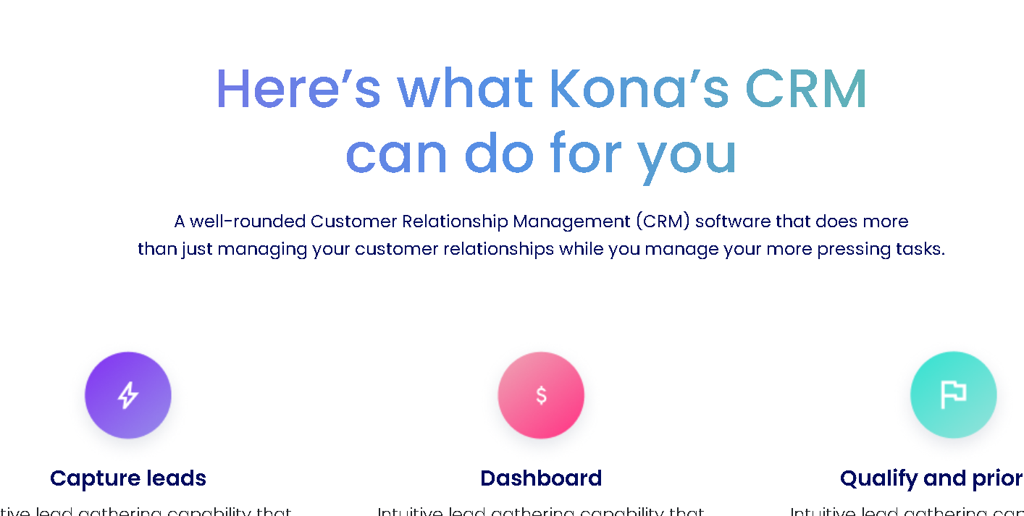

Evidence Id - ER_05

Test Scenario Id - TS_DRPDWN_03

Test Case Id - TC_DRDN_08

Title - To Validate "Educational Institutions" option in "Solutions" dropdown

Expected Result - User should be navigated to the Educational Institutions page

Actual Result - Navigating to the LMS Page

Evidence - Screenshot

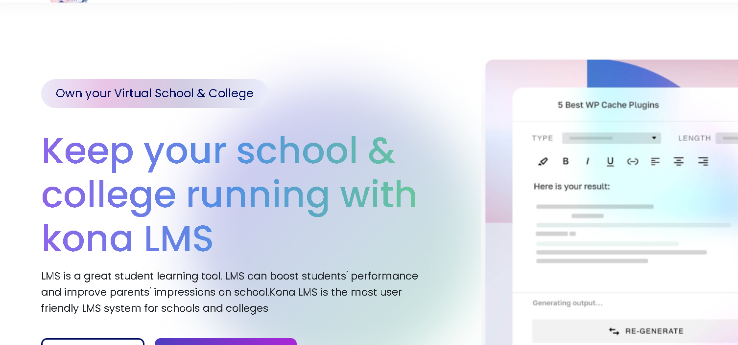

Evidence Id - ER_06

Test Scenario Id - TS_DRPDWN_03

Test Case Id - TC_DRDN_09

Title - To Validate "Finance" option in "Solutions" dropdown

Expected Result - User should be navigated to the Finance page

Actual Result - Navigating to the LMS Page

Evidence - Screenshot



Evidence Id - ER_07

Test Scenario Id - TS_DRPDWN_03

Test Case Id - TC_DRDN_10

Title - To Validate "Sales" option in "Services" dropdown

Expected Result - User should be navigated to the Sales page

Actual Result - Navigating to Services Page

Evidence - Screenshot

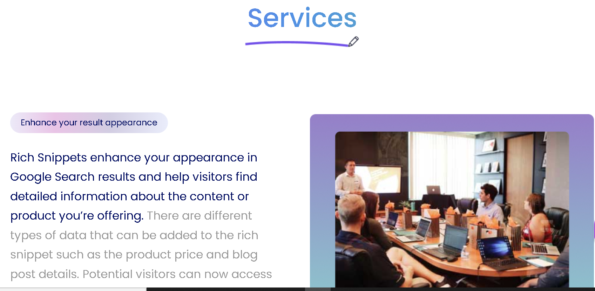

Evidence Id - ER_08

Test Scenario Id - TS_DRPDWN_03

Test Case Id - TC_DRDN_12

Title - To Validate "Marketing" option in "Services" dropdown

Expected Result - User should be navigated to the Marketing page

Actual Result - Navigating to Services Page

Evidence - Screenshot



Evidence Id - ER_09

Test Scenario Id - TS_BUTTONS_05

Test Case Id - TC_BUTTONS_04

Title - To Validate form fields after clicking "Know More" button

Expected Result - All form fields should be displayed correctly after clicking the "Know More" button

Actual Result - Form is not displaying as per expectation, it is opening same as "Start Now" Form

Evidence - Screenshot

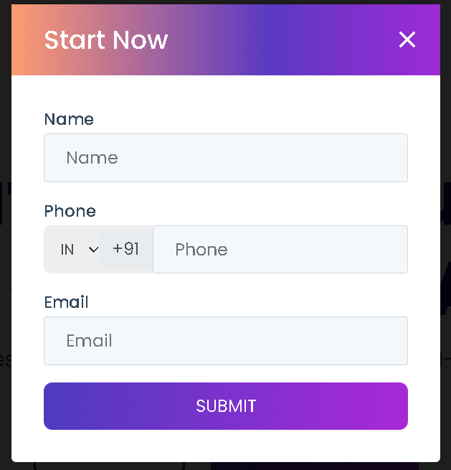

Evidence Id - ER_10

Test Scenario Id - TS_BUTTONS_05

Test Case Id - TC_BUTTONS_05

Title - To Validate form fields after clicking "Ask For Free Demo" button

Expected Result - All form fields should be displayed correctly after clicking the "Ask For Free Demo"

Actual Result - Form is not displaying as per expectation, it is opening same as "Start Now" Form

Evidence - Screenshot



Evidence Id - ER_11

Test Scenario Id - TS_FORM_06

Test Case Id - TC_FORMS_04

Title - To Validate form submission with invalid Name

Expected Result - Form should not submit and should display a validation message for the Name field

Actual Result - Form Submitted Successfully, and it navigated to the Nexa Design Page

Evidence - Data tried while testing

Data - Name:123456

Phone:7795791832

Email:shivleelakumari@gmail.com

Evidence Id - ER_12

Test Scenario Id - TS_CONTENT_09

Test Case Id - TC_LMS_CONTENT_01

Title - To Validate LMS Section Navigation

Expected Result - Navigate to LMS details page

Actual Result - Navigating to CRM page instead of LMS

Evidence - Screenshot



Evidence Id - ER_13

Test Scenario Id - TS_CONTENT_09

Test Case Id - TC_LMS_CONTENT_04

Title - To Validate "Know More" Link in LMS

Expected Result - Navigate to more details about LMS

Actual Result - Navigating to more details but to CRM page instead of LMS

Evidence - Screenshot

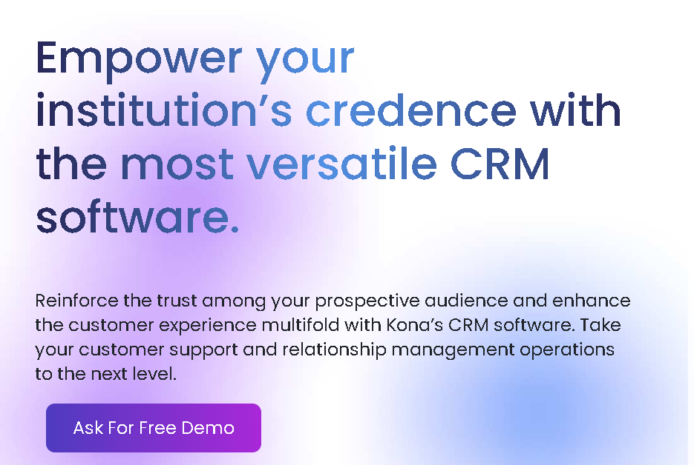

Evidence Id - ER_14

Test Scenario Id - TS_CONTENT_09

Test Case Id - TC_HRMS_CONTENT_04

Title - To Validate "Know More" Link in HRMS

Expected Result - Navigate to more details about HRMS

Actual Result - Navigating to more details but to CRM page instead of HRMS

Evidence - Screenshot



Evidence Id - ER_15

Test Scenario Id - TS_TEST_10

Test Case Id - TC_TEST_04

Title - To Validate User Details in Testimonials

Expected Result - User details should be correctly displayed

Actual Result - User details are not correctly displayed

Evidence - Screenshot

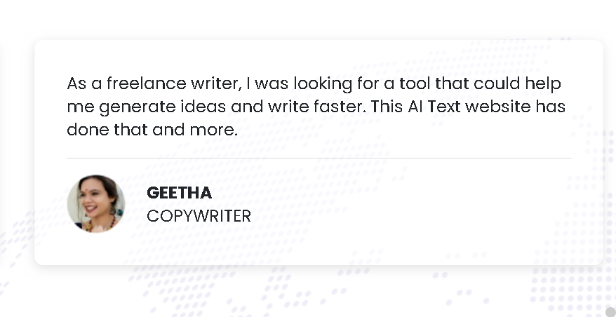

Evidence Id - ER_16

Test Scenario Id - TS_FOOTER_12

Test Case Id - TC_FOOTER_05

Title - To Validate the "Products" section links

Expected Result - Each link should navigate to the respective products page

Actual Result - Links are not navigating to the respected page, except CRM

Evidence - Screenshot on clicking LMS and HRMS



Evidence Id - ER_17

Test Scenario Id - TS_FOOTER_12

Test Case Id - TC_FOOTER_06

Title - To Validate the "Solutions" section links

Expected Result - Each link should navigate to the respective Solutions page

Actual Result - Links are not navigating to the respected pages, except LMS

Evidence - Screenshot on clicking CRM and HRMS

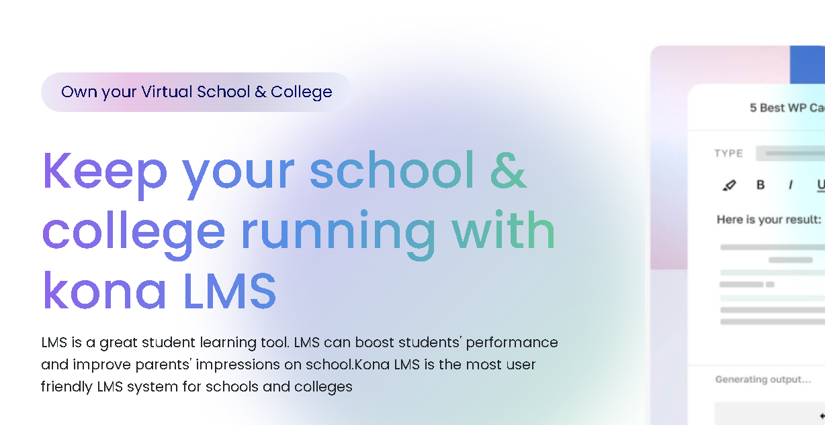

Evidence Id - ER_18

Test Scenario Id - TS_FOOTER_12

Test Case Id - TC_FOOTER_07

Title - To Validate the "Services" section links

Expected Result - Each link should navigate to the respective Services page

Actual Result - Links are not navigating to the respected pages, but redirecting to Services Page

Evidence - Screenshot on clicking LMS, CRM and HRMS

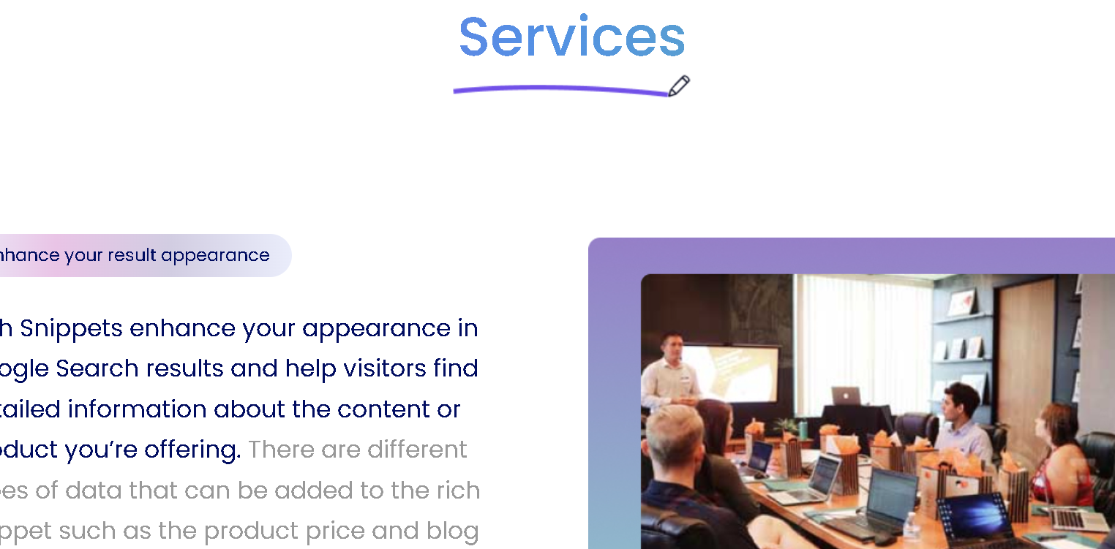

Evidence Id - ER_19

Test Scenario Id - TS_FOOTER_12

Test Case Id - TC_FOOTER_08

Title - To Validate the presence of "Resources" in footer

Expected Result - "Resources" Section should be visible with LMS, CRM, HRMS listed under it

Actual Result - Resources section does not contains any links

Evidence - Screenshot of Footer

