Design Plan
Assured Financials Loan Management System Design Plan
Shivnarine Chaitram
Shivshankar Chaitram
Emily Bookram
Anyootookeeuh Warde
Laiza Percy

Tables of Content
Content Page Number
- System Models:
  - Context Model 3
  - Activity Diagram 4
  - Use Case Diagram 10
  - Sequence Diagram 13
  - Class Diagram 15
- System Architecture:
  - MVC Architecture 19

Context Model
A context model or (external perspective model) illustrates how the system that needs to be constructed will communicate with other systems in its surroundings. It displays the limits of an environment's system, which consists of multiple automated systems.
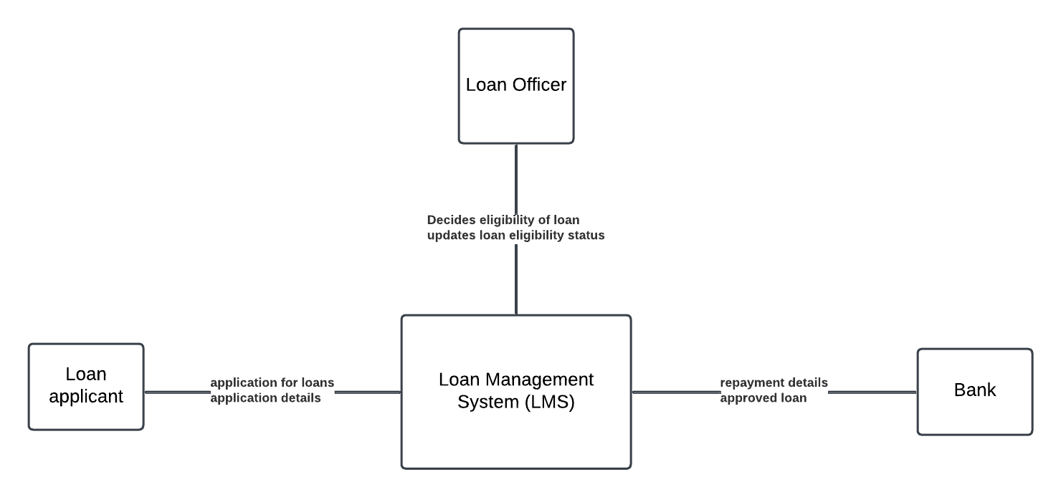
Figure 1: The context model of the Loan Management System
Components:
- Loan officer: The personnel responsible for verifying loan applications, making approval decisions, and updating status on loan process.
- Loan applicant: The individual seeking a loan who interacts with the Loan management system to fill out the application and provide supporting documentation.
- Bank: The external entity that provides the monetary loan from the loan management system and through which repayment can be made.
- Loan management system (LMS): The core system that automates the loan application process, manages the data, and tracks the loan status.
Activity Diagram
An activity diagram illustrates how a system or process moves from one activity to another. It's called a 'behaviour diagram' because it outlines what should occur in the modeled system and is used to depict the various dynamic characteristics of a system.
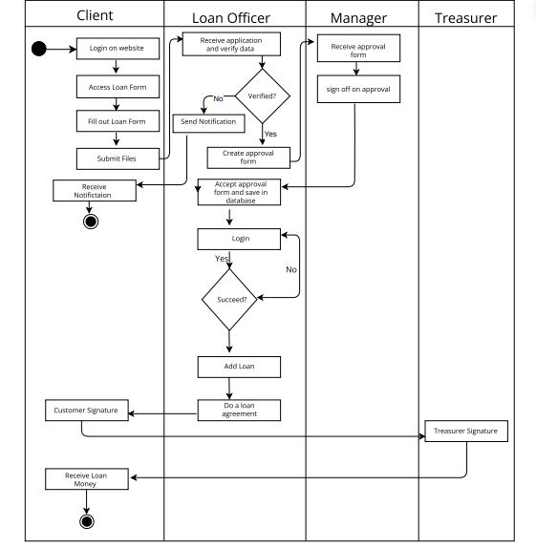
Figure 2: Activity Diagram of the Loan management system
This diagram represents the order for loan application processing involving four key participants: Client, Loan Officer, Manager, and Treasurer. It breaks down the loan approval process into a series of ordered and conditional activities.
Participants and Their Roles
- Client: The individual seeking a loan is responsible for initiating the process by submitting the necessary forms and supporting documents.
- Loan Officer: The administrator who verifies the client’s data, ensures compliance with internal policies, and prepares the application for managerial review.
- Manager: Responsible for higher-level approval of the loan application and ensures that all risks are reduced and that the loan meets the standards of the organization.
- Treasurer: Oversees the final stage of the process by ensuring that approved loans are disbursed securely and appropriately.
Process:
- Client Activities:
  - Login on Website: The client begins by logging into the loan application portal. This step ensures that only registered clients can access the system.
  - Access Loan Form: After logging in, the client finds the loan application section to access the necessary forms.
  - Fill Out Loan Form: The client provides critical information (e.g., personal details, loan purpose, requested amount) in the loan application form.
  - Submit Files: The client uploads supporting documents (e.g., proof of income, identification, credit history) alongside the completed loan form. Successful submission relies on accurate and complete information provided by the client.
  - Receive Notification: Notifications keep the client informed of the progress, such as application receipt, additional document requests, or approval status.
- Loan Officer Activities:
  - Receive Application and Verify Data: The loan officer reviews the application and verifies that all required information is accurate and meets eligibility criteria.
    - Decision Point: Verified?
      - No: If the application is incomplete, contains errors or not approved, the loan officer sends a notification to the client.
      - Yes: The application moves to the next step for further processing.
  - Create Approval Form: The loan officer drafts an internal approval form summarizing the application details for managerial review. This step is conditional on successful verification of client data.
  - Accept Approval Form and Save in Database: The approved form is stored in the system to maintain records.
  - Login: The loan officer logs into the system to finalize the application processing.
    - Decision Point: Succeed?
      - No: If login or system processing fails, the officer resolves the issue or retries.
      - Yes: The officer proceeds to add the loan to the system.
  - Add Loan: The loan is officially recorded in the system as an approved and active loan.
  - Do a Loan Agreement: The loan officer facilitates the signing of the loan agreement by the client, ensuring that all terms and conditions are acknowledged and agreed upon. This step serves as the legal binding between the financial institution and the client.
- Manager Activities:
- Receive Approval Form: The manager receives the loan officer’s approval form and evaluates the application. This step can only occur after the loan officer completes their processing and prepares the approval form.
- Sign Off on Approval: The manager confirms the application if it satisfies all risk, compliance, and organizational criteria. Once approved, the application is forwarded to the treasurer for the disbursement process.
- Treasurer Activities:
- Receive Approval Form: The treasurer ensures that the approved application is complete and in order. This step depends on managerial approval and proper documentation by the loan officer.
- Treasurer Signature: The treasurer signs off to confirm the readiness of the loan for disbursement. This step acts as the final authorization needed to release funds.
- Final Steps:
- Customer Signature: Before disbursement, the client provides their signature on the finalized agreement, indicating their acceptance of the loan terms.
- Receive Loan Money: The client receives the loan funds, completing the process.
Dependencies
- The Loan Officer’s verification is critical as it ensures that only eligible and well-documented applications proceed to the approval stage.
- Managerial approval is essential to reduce risk and ensure that loans align with the objectives of the institution.
- The Treasurer’s signature serves as a control point to prevent unauthorized disbursements.
Parallel Activities
- While the Loan Officer processes the application, the Manager can prepare for a review once data is submitted, reducing wait times.
- The Treasurer’s review process can run in parallel with the Loan Agreement signing.
This process ensures a secure and efficient flow for loan management. Clear roles and checkpoints minimize errors, reduce risks and enhance transparency. The diagram outlines a balance between automation (notifications, data verification) and human oversight (approval, disbursement) to provide a seamless experience for all members.

Use Case Diagram
A Use-case diagram outlines a system's scope and high-level operations. The relationships between the system and its actors are also depicted in these diagrams. Use-case diagrams' actors and use cases explain the functions of the system and how its users interact with it, but they don't explain how the system’s internal functions.
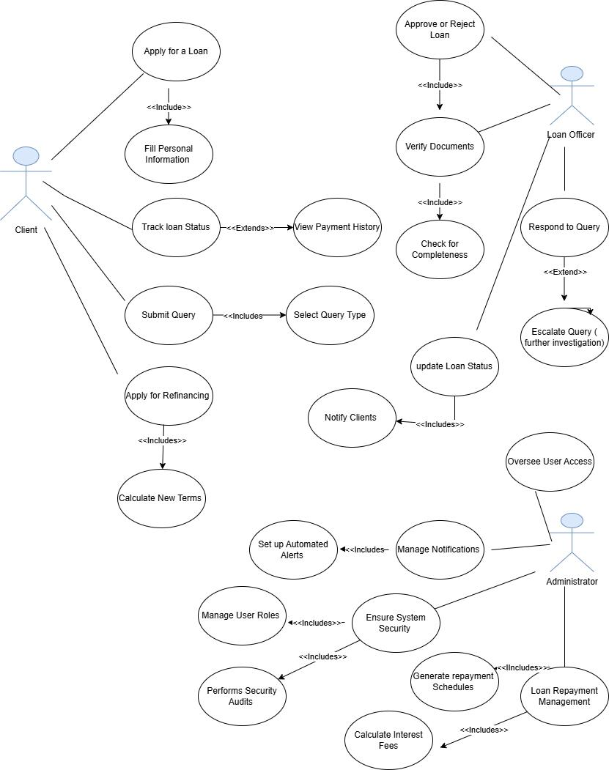
Figure 3: Use-Case Diagram of the Loan management system

Description of diagram:
Actors:
- Client: Borrowers that apply for loans, officials who put in loan requests, monitor loan processes, handle repayments, and communicate through queries and applications for refinancing.
- Loan Officer: Workers who evaluate credentials of loan seekers and prepare documents for loans, manage loans for customers, and answer inquiries from customers.
- Administrator: Administrators are responsible for guarding the data, controlling the users’ access, handling the notifications and are in charge of the overall performance and compliance of the system.
Use Cases:
- Apply for Loan:
  - Description: A client fills in a loan application that provides the necessary information about the person and his/her financial abilities.
  - Includes: Writing down their details and providing their financial data.
- Track Loan Status:
  - Description: Clients check the status of their borrowed loans and their history.
  - Extends: Like features such as payment history in detailed form can also be included.
- Apply for Refinancing:
  - Description: Existing loans are adjusted through a refinancing application wherein clients ask for modifications to their current loan package.
  - Includes: Determining of new loan terms through client information input.

- Submit Query:
  - Description: Loan customers provide questions or concerns related to the loans.
  - Includes: Choosing of the type of query and perhaps the supporting documents to attach to the query.
- Approve/Reject Loan:
  - Description: Firms’ loan officers consider such applications and make a final decision to accept or decline the loan.
  - Includes: Using the documents in decision making process as a data authentication technique.
- Verify Documents:
  - Description: Make sure all required other documentation is proper and all needed complementary details are incorporated.
  - Includes: Revision in terms of documents’ fill in and confirming data entered on the tables with the assistance of the external databases.
- Respond to Query:
  - Description: Loan officers respond to questions from the clients.
  - Extends: Referring queries if he or she feels that such concerns demand further probe or if their answer needs the authorization of a higher official.
- Update Loan Status:
  - Description: Loan officers change the status of the loans after they have been undergone through by the organization
  - Includes: Informs clients of the new status of the application.
- Manage Notifications:
  - Description: Clients and staff create and monitor system alerts through admin control.
  - Includes: The ability to employ surveillance to key changes /reminders.
- Ensure System Security
  - Description: Managers keep the system and data secure and accurate The real-world account of how managers maintain the security and integrity of the system is described below.
  - Includes: This involves implementing, administering and modifying roles for user accounts, undertaking security reviews and check on access-authority settings.
- User Access:
  - Description: The access to the system is conducted and controlled by administrators.
  - Extends: Auditing of access logs whenever there occurs any strange behavior or and inspection.
- Loan Repayment Management:
  - Description: Oversee all the matters of collection of loan repayments and record payments received.
  - Includes: The preparation of repayment schedules, as well as calculation of interest as well as fees is another area that can benefit from the use of the systems.

Sequence Diagram
A sequence diagram shows the order in which messages are sent back and forth between objects during an interaction. Lifelines are used to represent a set of objects in a sequence diagram, along with the messages that are exchanged between them over time.
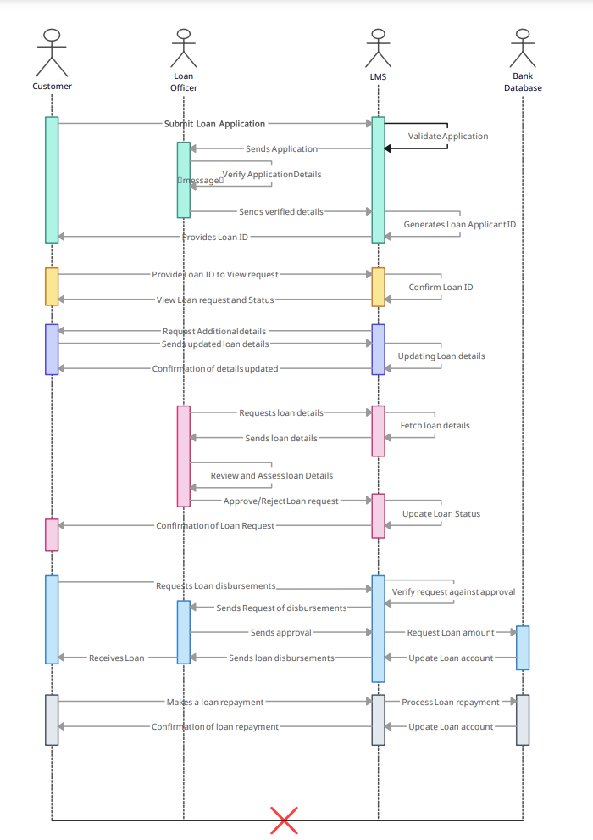
Figure 3: Sequence Diagram for Loan management system

Description:
- Apply for a loan: The customer sends the filled loan application to the Loan management system (LMS). It validates it and sends it to the loan officer who verifies the application details then allows the LMS to store the data and generate an ID to allow the user to enter their account which is provided to them.
- Viewing Loan: The customer logs in with his/her ID to view their loan status as a result of the system confirming their ID.
- Updating loan details: the system sends a notification to the customer about the need for additional information, the customer sends the additional information which the LMS uses to update the loan request application and send a conformation to the customer.
- Loan approval: The loan officer requests the loan details from the LMS which sends it to him to assess and review. They then approve or reject the request which updates the loan status in the LMS and send the loan confirmation notification to the customer.
- Loan disbursements: The customer requests the disbursements, which the LMS send to the loan officer to approve after which the money is updated in the back database and the loan account in the LMS. The money is then sent to the loan officer who sends it to the customer.
- Loan Repayment: The customer makes a loan repayment to the LMS which updates the bank database and the loan account and sends a repayment confirmation notification to the customer.

Class Diagram
A class diagram is a graphic representation of a system's structure that displays its classes, characteristics, methods, and connections between them. It facilitates comprehension of the system's structure and component interactions by all project participants, including developers and designers.
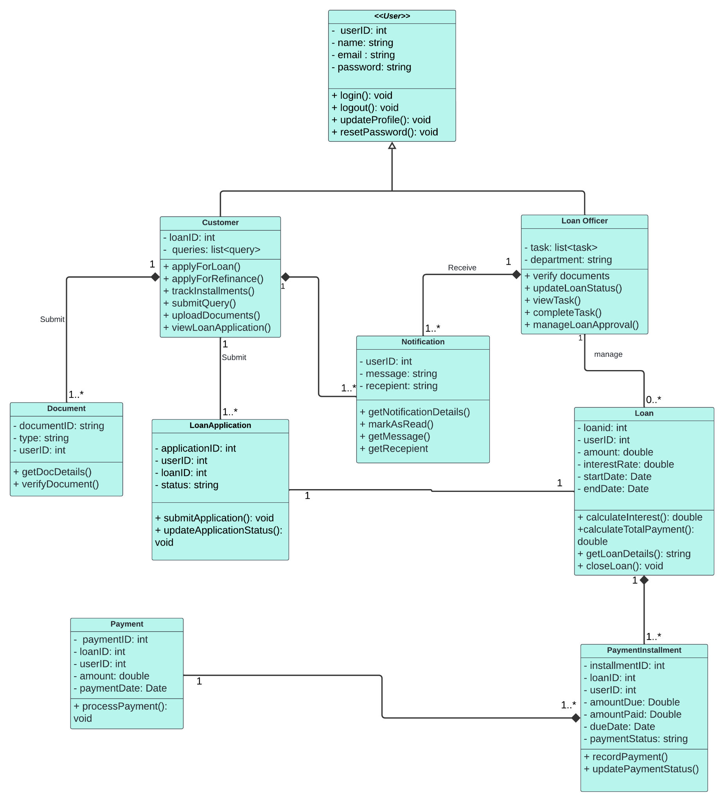
Figure 5: Class Diagram of the Loan management system

Brief Description:
This UML class diagram represents the structure of the Loan Management System, it is designed to manage user interactions, loan related activities, and provide essential functions to its users.
The classes are:
- User: this is the base class for the customer and loan officer classes.
- Customer: applies for loan, track installments, submit queries and documents.
- Loan Officer: processes loan applications, verifies documents and other actions.
- Loan: manages loan details such as payment and calculations.
- Payment: records payment and processes payment related activities.
- Loan Application: manages application details, and updates the application status.
- Notification: handles notification for both users.
- Document: stores and handles loan related documents.
- Payment Installments: tracks individual loan payments.
The three types of relationship used in the class diagram are:
- Inheritance: Inheritance establishes a hierarchical relationship where the user class acts as the parent and the customer and loan officer classes are the child classes. The child classes inherit attributes from the user class such as UserID, name, email, and password; these are common attributes to all types of users in the system, so defining them once in the parent class avoids redundancy. The child classes also inherit shared behaviors such as login, logout, reset password, and update profile; these methods are fundamental operations that apply to all users regardless of their role in the system.
- Association: represents a relationship between two classes where one interacts with another but there is no ownership involved. For example, an association relationship exists between the customer and Loan Application classes. A Loan Application exists independently of the customer, even if the customer's account is deleted or deactivated the application will still exist for record keeping purposes. Similarly, if the application is deleted it does not necessarily affect the existence of the customer.
- Composition: represents a relationship between two classes. In this type of relationship, a child class cannot exist without the parent class. For example, Loan is the parent class and PaymentInstallment is the child class, a PaymentInstallment cannot exist without a loan, if the loan is closed the PaymentInstallment will be removed, as there will be no reason to have a loan installment without an active loan.
Multiplicities:
- Customer $→$ LoanApplication (1 – 1..*)
  - A customer can have multiple Loan Applications, but each Loan Application is linked to one customer.
- LoanApplication $→$ Loan (1 – 1)
  - A Loan Application leads to one loan, and each loan is associated with one Loan Application.
- Loan $→$ PaymentInstallment (1– 1..*)
  - A loan can have multiple PaymentInstallments, but each PaymentInstallment belongs to one loan.
- LoanOfficer $→$ Notification (1– 1..*)
  - A LoanOfficer can receive multiple notifications, each notification is linked to one LoanOfficer.
- Customer $→$ Document (1– 1..*)
  - A customer can submit multiple documents, and each document is linked to one customer.

- Payment $→$ PaymentInstallment (1– 1..*)
  - A Payment is linked to one PaymentInstallment, and each PaymentInstallment can have multiple Payments.
- LoanOfficer $→$ Loan (1 – 0..*)
  - One LoanOfficer can be associated with zero or many loans, but each loan is associated with one LoanOfficer.

Model-View-Controller Architecture
The Model-View-Controller (MVC) framework divides an application into three primary logical components: the Model, View, and Controller. Every architectural element is designed to manage application development facets. It separates the presentation layer from the business logic layer.

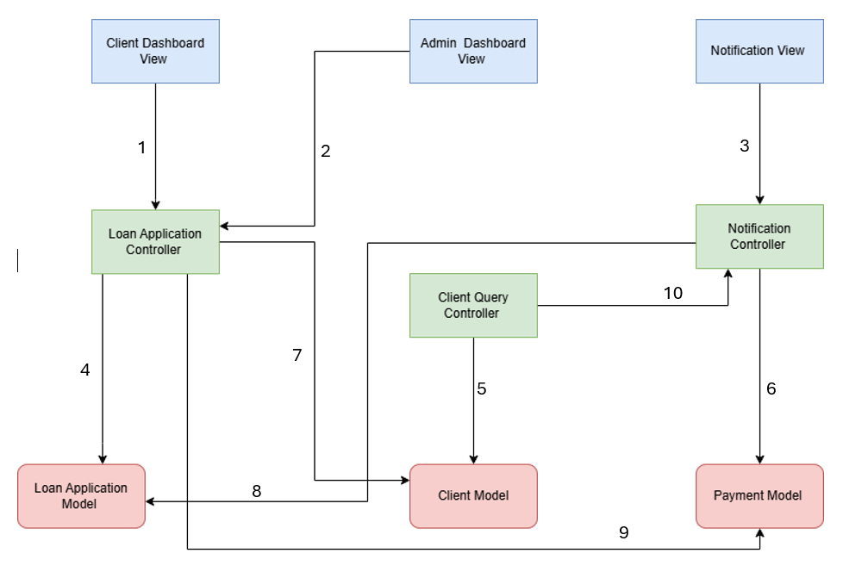
Figure 6: MVC architecture of Loan management system
- Model:
  - Description: The Model shows the data layer and business logic of LMS. Some of the data structures that it holds are loan application, client details, loans details, repayment plan, and so on.
  - Components:
    - Loan Application Model: Concerns include receiving applications for a loan, approving, or denying the application among others.
    - Client Model: Handles information specific to the client; name and surname, previous loans, and current account status.
    - Payment Model: Responsible for managing payment, balances and payment terms governing the loans.
- View:
  - Description: The View layer is implemented by the View component. It provides the interface for the client as well as the administrator through the later in charge of the management of the application.
  - Components:
    - Client Dashboard View: Awards to the clients the status of their loan, application forms and other repayment schedules.
    - Admin Dashboard View: Decides upcoming applications, clients’ management tools, and reporting system for the administrators.
- Controller:
  - Description: The Controller deals with the requested data from the user, queries the Model and uses the result to update the View.
  - Components:
    - Loan Application Controller: Provides inputs by the loan application forms to the model.
    - Client Query Controller: Responds to queries from the clients and changes the View.
    - Notification Controller: Handles the communication to the users that are affected by state changes on the Model.

Relatives in Architecture:
- Client Dashboard View to Loan Application Controller:
  - Purpose: Interfaces with the clients as much as the processing of loans is concerned.
  - Functionality: Whenever a client completes a loan application or enters the website to check the status of the loan, the Client Dashboard View relays all the information to the Loan Application Controller.
- Admin Dashboard View to Loan Application Controller:
  - Purpose: Enables the administrators to handle loan applications.
  - Functionality: Loan applicants either get approved or rejected by administrators. Admin Dashboard View transmits these inputs to Loan Application Controller that modify the Model in consideration to admin actions performed.
- Notification View to Notification Controller:
  - Purpose: Controls the showing and handling of notifications.
  - Functionality: The Notification View is used to notify users of status change of their loans or to remind them about payment while the Notification Controller operates on data from the Model to propagate these notifications.
- Loan Application Controller to Loan Application Model:
  - Purpose: Manages and revises the data on loans’ application.
  - Functionality: The Controller cross-checks with the View and sends loan data to the Loan Application Model to update the system with new or changed loan data.
- Client Query Controller to Client Model:
  - Purpose: Handles all the other requests and communicates with the clients regarding their accounts or loans.
  - Functionality: When a client sends a query, the Client Query Controller for the quote interacts with the Client Model to either get or set certain client details. This could include verification of account details, applications, and other specifics of a certain client who may require an answer to his/her query.
- Notification Controller to Payment Model:
  - Purpose: Oversees payment related notifications.
  - Functionality: It makes a call to the Payment Model to get the due dates, payment confirmation, or if any is overdue, and sends notifications to the clients and administrators on such occurrences.
- Loan Application Controller to Client Model:
  - Purpose: Submits changes to the client’s information during the issuance of the loan.
  - Functionality: Whenever a loan application is made or modified the details of the client such as credit scores or other personal information may also be changed in the Client Model.
- Notification Controller to Loan Application Model :
  - Purpose: Notifications on the status of loan applications is also done.
  - Functionality: When a client needs to be informed about approval or rejection of the loan application, the Notification Controller turns to the Loan Application Model.
- Loan Application Controller to Payment Model:
  - Purpose: Disburses payments when it has approved a loan.
  - Functionality: After a loan is approved, the Controller determines the payment in the Payment Model.
- Client Query Controller to Notification Controller:
  - Purpose: Serves to integrate cooperation between the client and system administrators.
  - Functionality: Therefore, in case a certain client query has been accounted for, the Client Query Controller may engage the Notification Controller to return responses to the client. It makes sure that the client gets acknowledgment or response to their inquiries at the right time.
Data Flow Summary:
- Views communicate with Controllers to manage user actions.
- Such inputs go through a controller who filters such inputs and feeds the appropriate Models with the new data.
- Models are the data keepers therefore serving as repositories of data that are usable by the Controllers and the Views.
- Controllers also employ data from Models for invoking appropriate actions such as sending of notifications with the Notification Controller.
Scenario: Client Inquiry about the status of loan
- Background:
  - Jane Doe, a client of Assured Financials took an online loan management system recently to apply for a personal loan. She needs to know how to monitor the application of her loan and some questions concerning the conditionalities of the loan.
- Step-by-step Process:
  - Client Interaction:
    - Action: Jane opens a Client Dashboard View and goes to the Submit Query tab.
    - Input: She puts in a query seeking to know her current status of her loan and also enquires on the interest rates being offered.
  - Client Query Controller Processing:
    - Action: Jane’s query is received in the system at the Client Query Controller.
    - Model Access:
      - The Controller then checks the status of Jane’s current loan application in the Client Model, and she also checks Jane’s profile.
      - It checks the loan application details such as the loan application number, whether the loan application is active or not, and checks the interest from the Loan Application Model.
  - Response Preparation:
    - Action: The Client Query Controller determines a response from the received data.
    - Output: This way it drafts a message summarizing her loan application status and detailing the interest rate terms.
  - Notification to Client:
    - Action: The Notification controller forwards the response from the Client Query Controller.
    - Output: Jane gets an email and a notification on the dashboard stating her loan status “Under Review”, and the outline of the interest rates offered.
  - Client Follow-Up:
    - Action: On getting satisfied with the system, Jane makes use of the Client Dashboard to track the progress of the application and/or upload other documents if needed.

