SCHOOL OF COMPUTER APPLICATION
PREDICTIVE ANALYTICS

BCADS1501

Submitted By:
Name: Shivneet Mishra
Section: BCA DS 36
University Roll No: 1230258410
Semester: 5th
Submitted To:
Mr. Ayushman Bhadauria
Babu Banarasi Das University, Lucknow
BBD City, Ayodhya Road, Lucknow Uttar Pradesh- 226028 Bharat

Case Study
“ACME, a company selling sports products, wants to promote its new product: the XL Original Orange Baseball Cap. To test customer interest, ACME sent a test mailing to 10,000 randomly selected customers and recorded their responses.”
Agenda/Definition:
- The agenda is to build a predictive model using the specified dataset to estimate an unknown or future value (the target/output variable).
- To apply a suitable machine learning algorithm (e.g., Linear Regression, Decision Tree, Neural Network) to the ACME dataset within SPSS Modeler to establish a relationship between input variables (predictors) and a target variable, and then use that established relationship (the model) to predict the output for new, unseen data.

Outcomes/Learning:
- Proficiency in data importation and pre-processing (e.g., data auditing, missing value handling, variable type setting) within SPSS Modeler.
- Ability to select and deploy appropriate modeling nodes (algorithms) for the specific prediction task (e.g., classification or regression).
- Skills in evaluating model performance using appropriate graphs and statistics (e.g., gain charts, accuracy matrices, $\text{R}^2$, RMSE).
- Understanding the end-to-end CRISP-DM (Cross-Industry Standard Process for Data Mining) process within a visual environment.

Required Tool:
The specific software required to perform the modeling and prediction is:

- IBM SPSS Modeler: This is the primary tool. It's a graphical workbench for building models without needing to write code.
- ACME Dataset: The required data source (in a format compatible with Modeler, like a flat file .csv,.txt, or a database connection).

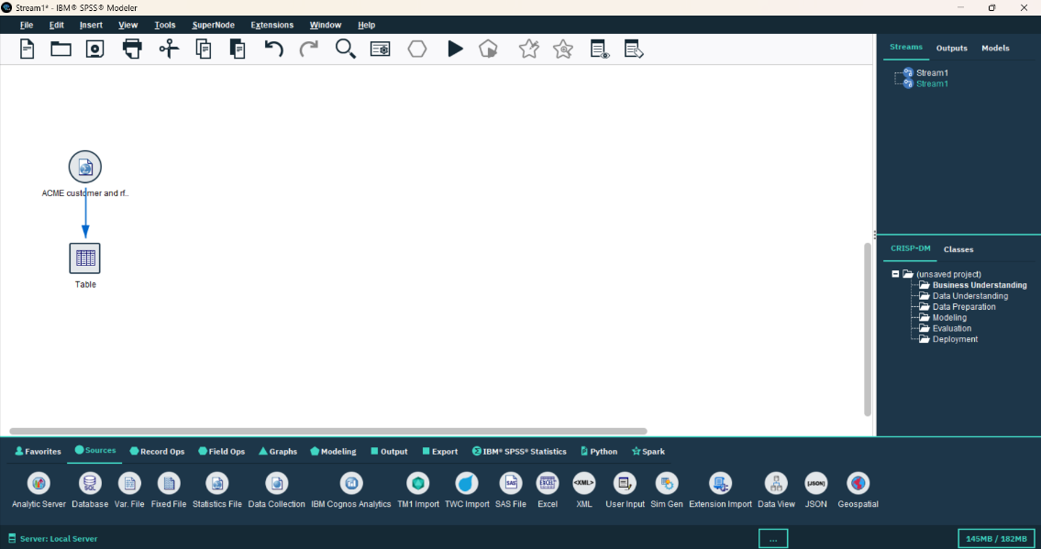
Steps:

- Import the dataset, use the table to get all the data (12 columns and 30000 rows)

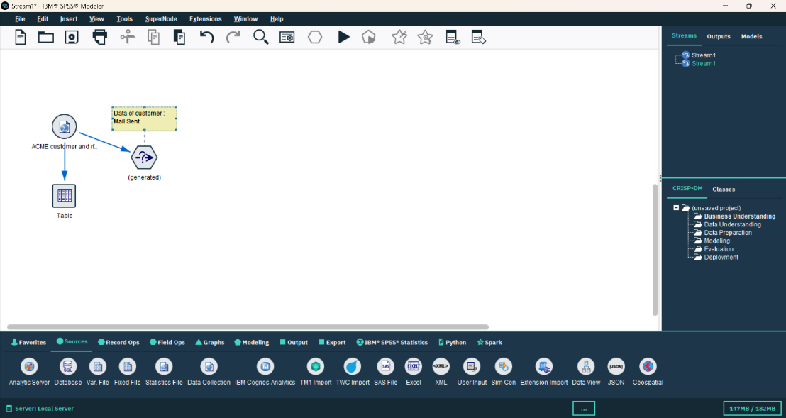
- Filter the data for the “YES” value and generate the node, rename as training data.

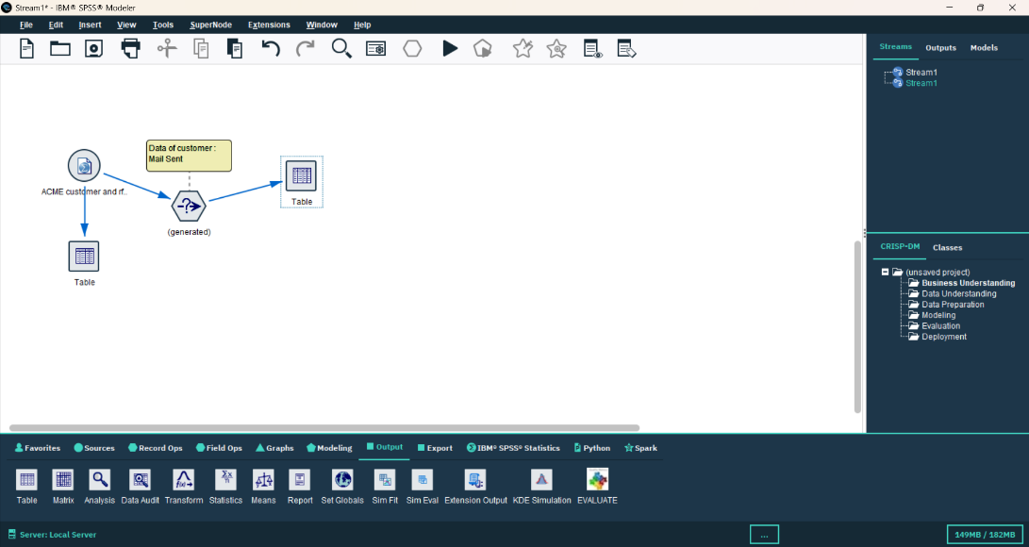

- Connect that node with table to get the desired output. (10000 rows)

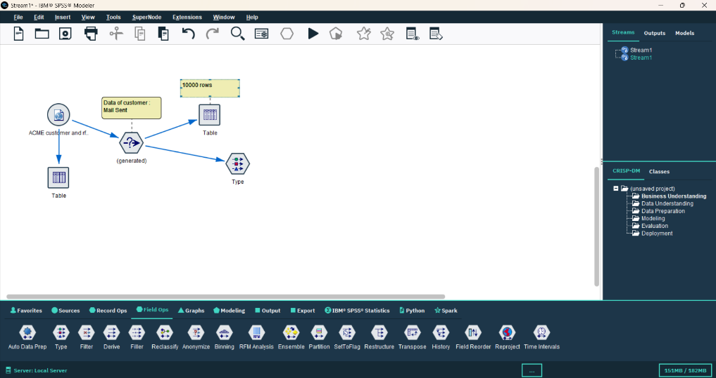
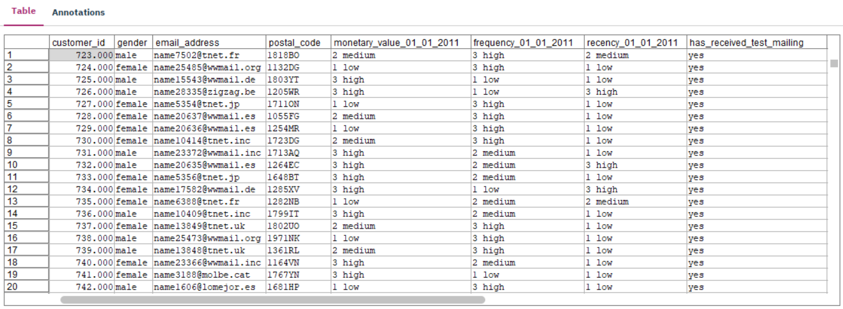

- Drag and drop the type node and connect with the training data node.

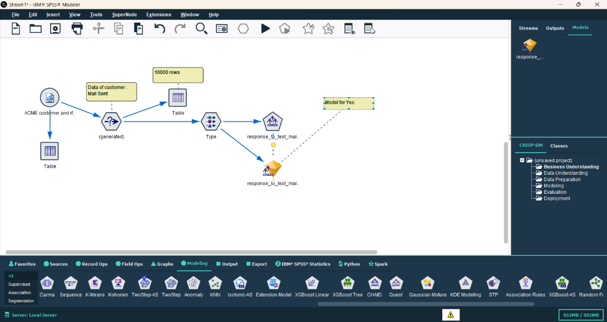

- Use the CHAID model and train the model with data.

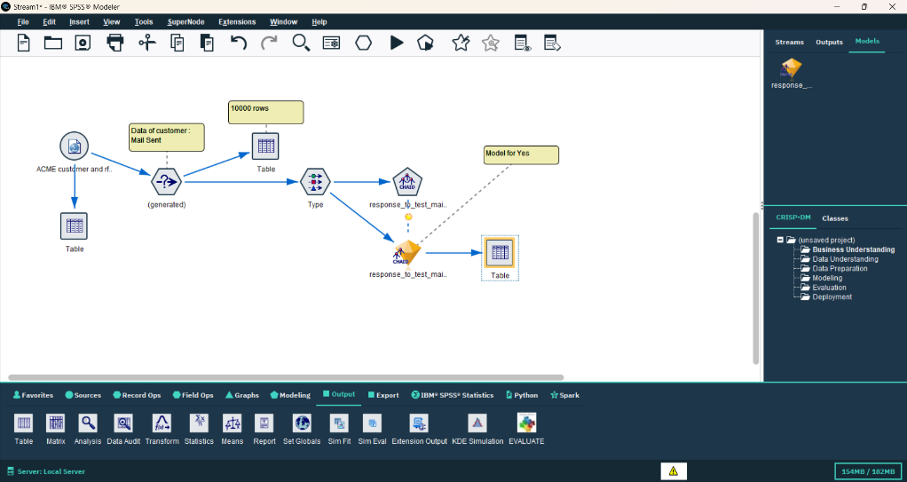
- Use the table to get the result after the model is trained.

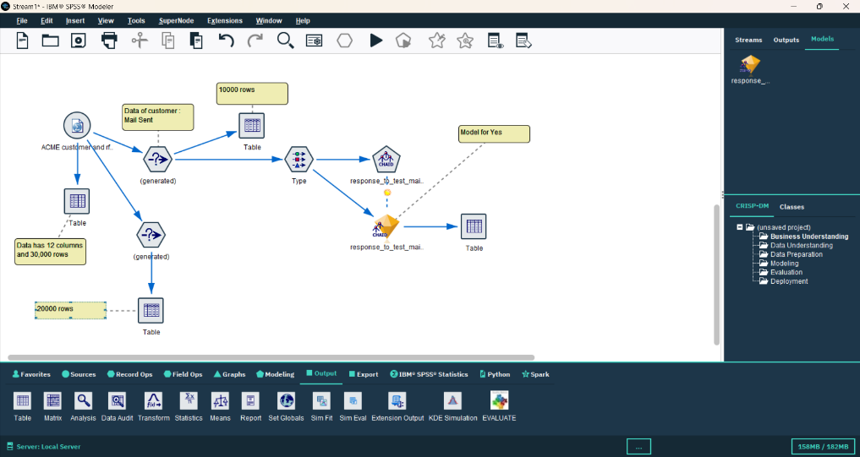
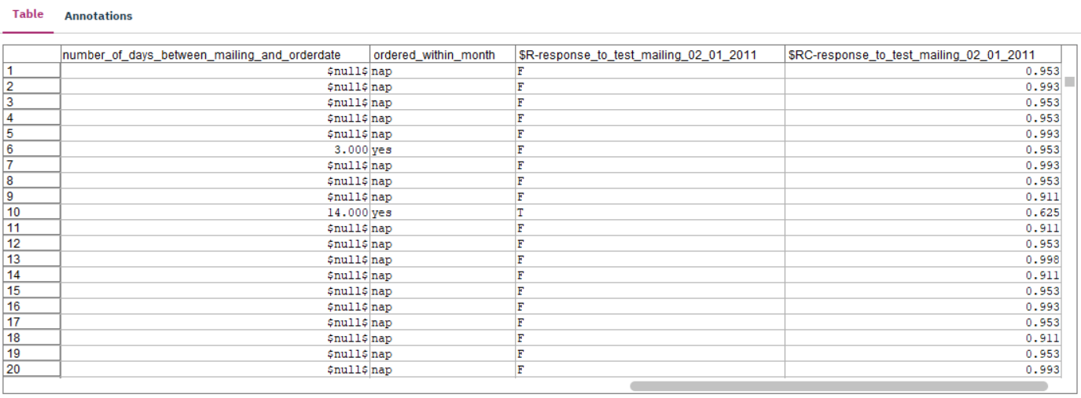

- Go back and filter the data for the “NO” value and generate the node, rename as test data for testing out model.

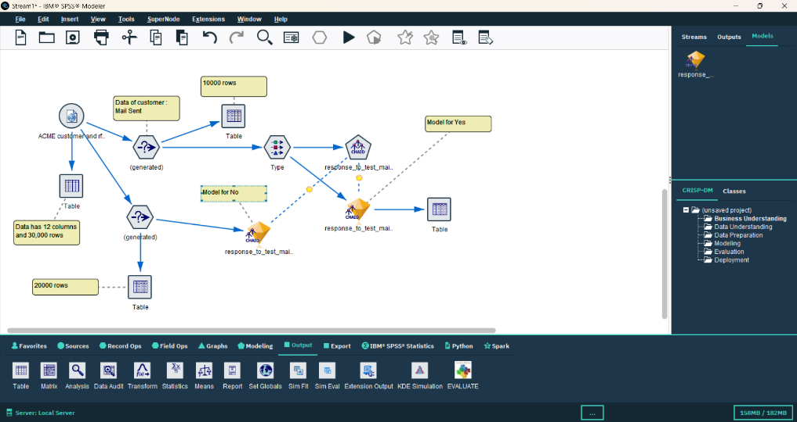

- Make the copy of the model and connect with the test data.

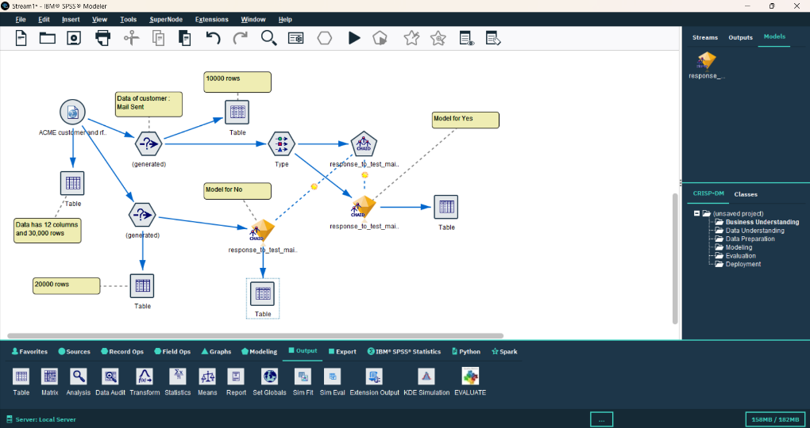

- Use the table along with all nodes to get the result.

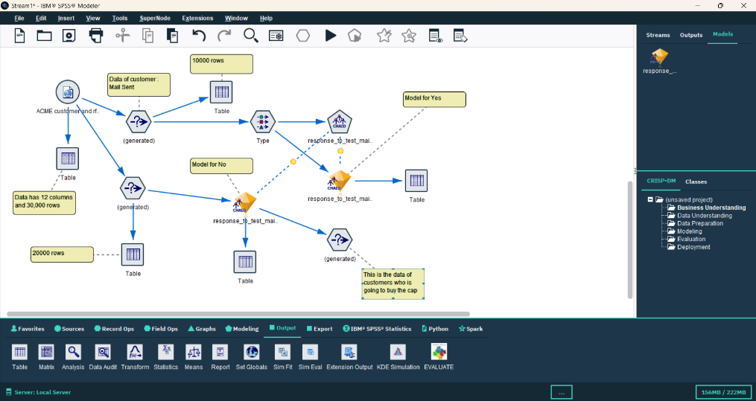

- Again generate a new node for the “TRUE” data in the model. (Data of customers who are going to buy the cap)

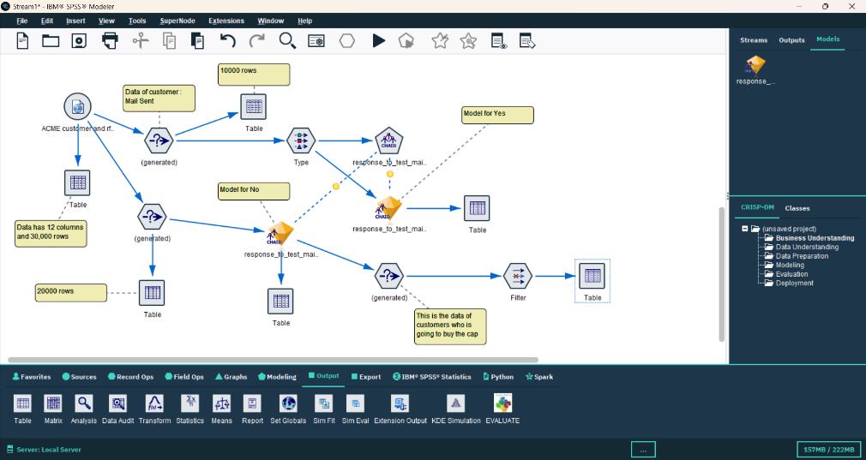

- Use the filter node to rename the specific columns and filter the data that we
needed.

- After all export the data to your local file with choosing the flat file node and
specify the path where you want to save.
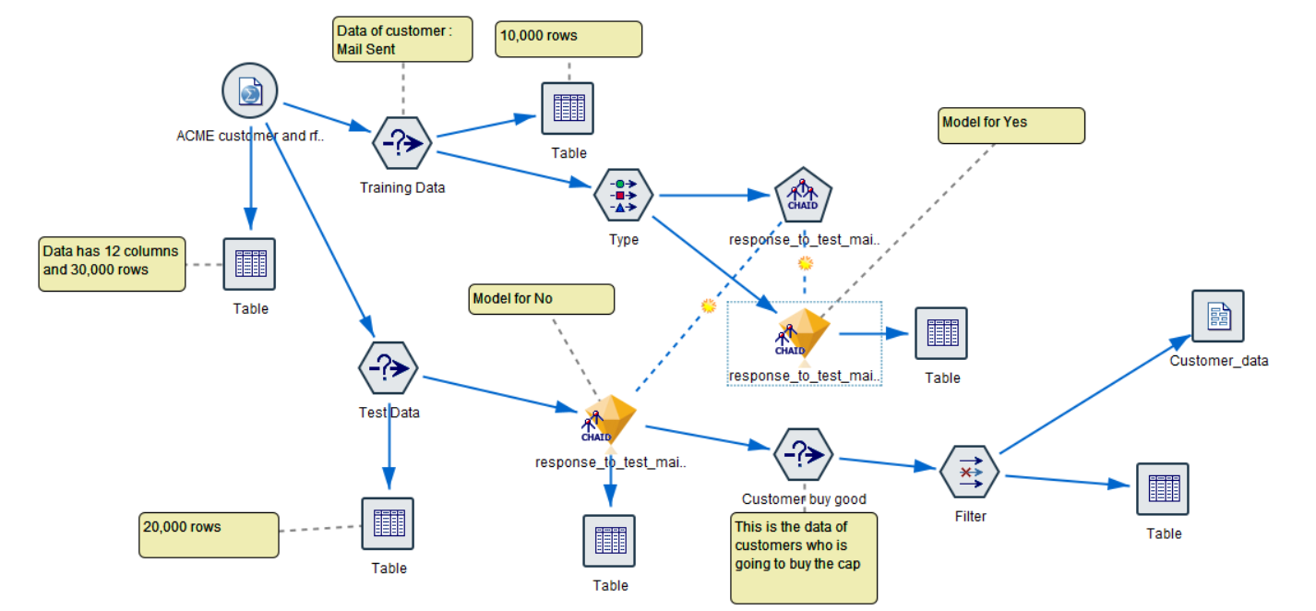

Q 1. How many records are in the training dataset?
Ans. There are 30000 Rows in the dataset.
Q 2. How many fields are in the training dataset?
Ans. There are 12 Columns in the dataset.
Q 3. How many customers were included in the test mailing?
Ans. There are 20000 customers are included in the test mailing.
Q 4. Which field is used as the first split?
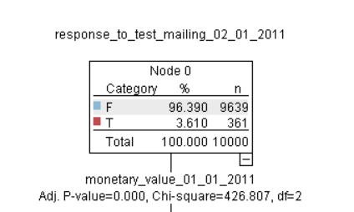
Ans. monetary_value_01_01_2011 fields is used as the first split.

Q 5. Which group shows the highest response rate? What is the probability of responding for this group?
Ans. recency_01_01_2011 shows the highest response rate and the probability of responding for this group is 62.548 %
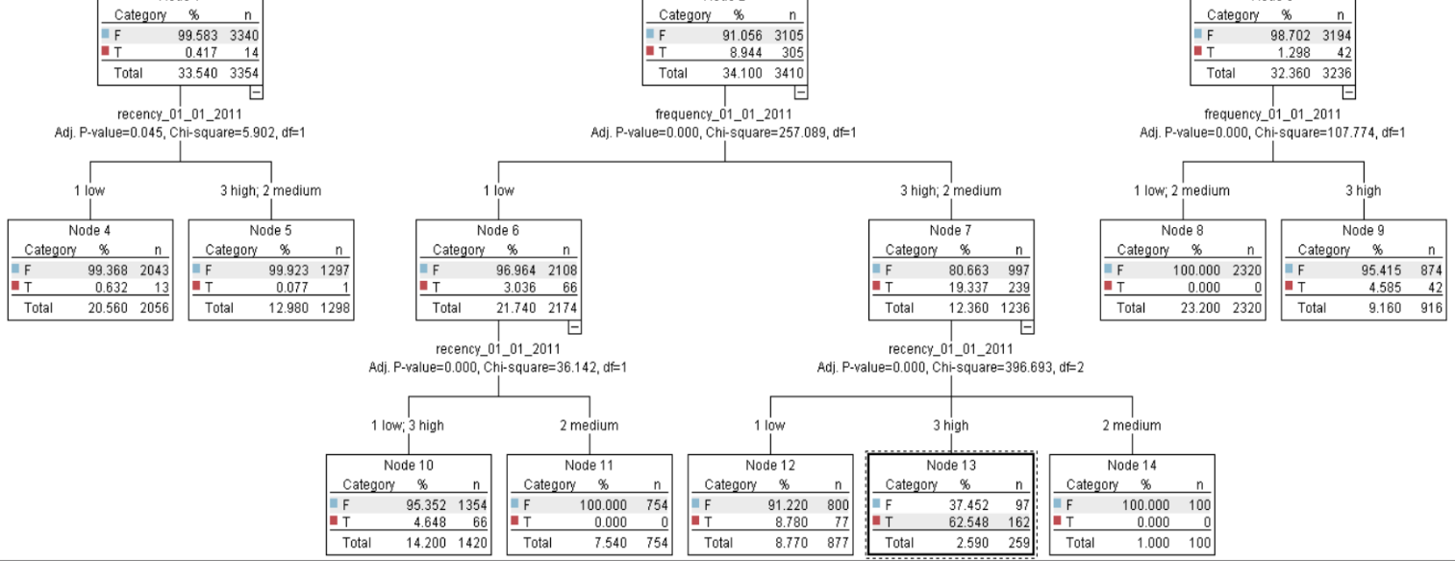

Q 6. Identify the two new fields added by the model.
Ans. $R-response_to_test_mailing_02_01_2011 and
$RC-response_to_test_mailing_02_01_2011 are two new fields added by the model.
Q 7. What do these fields represent?
Ans. The first fields represents the True/False value for the customers who are going to buy the cap or not. The second fields represents the probability of that condition is going to true.
Q 8. How many customers are predicted to respond positively (predicted = T )?
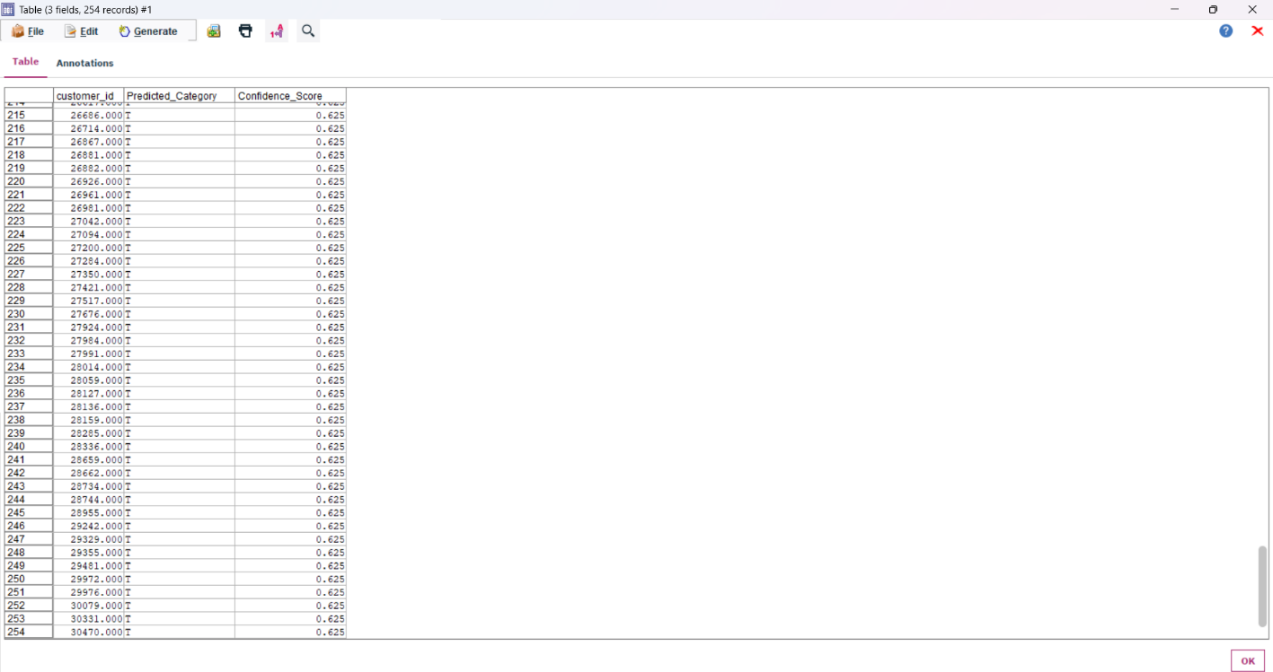
Ans. There are 254 customers are predicted to respond positively (predicted = T).
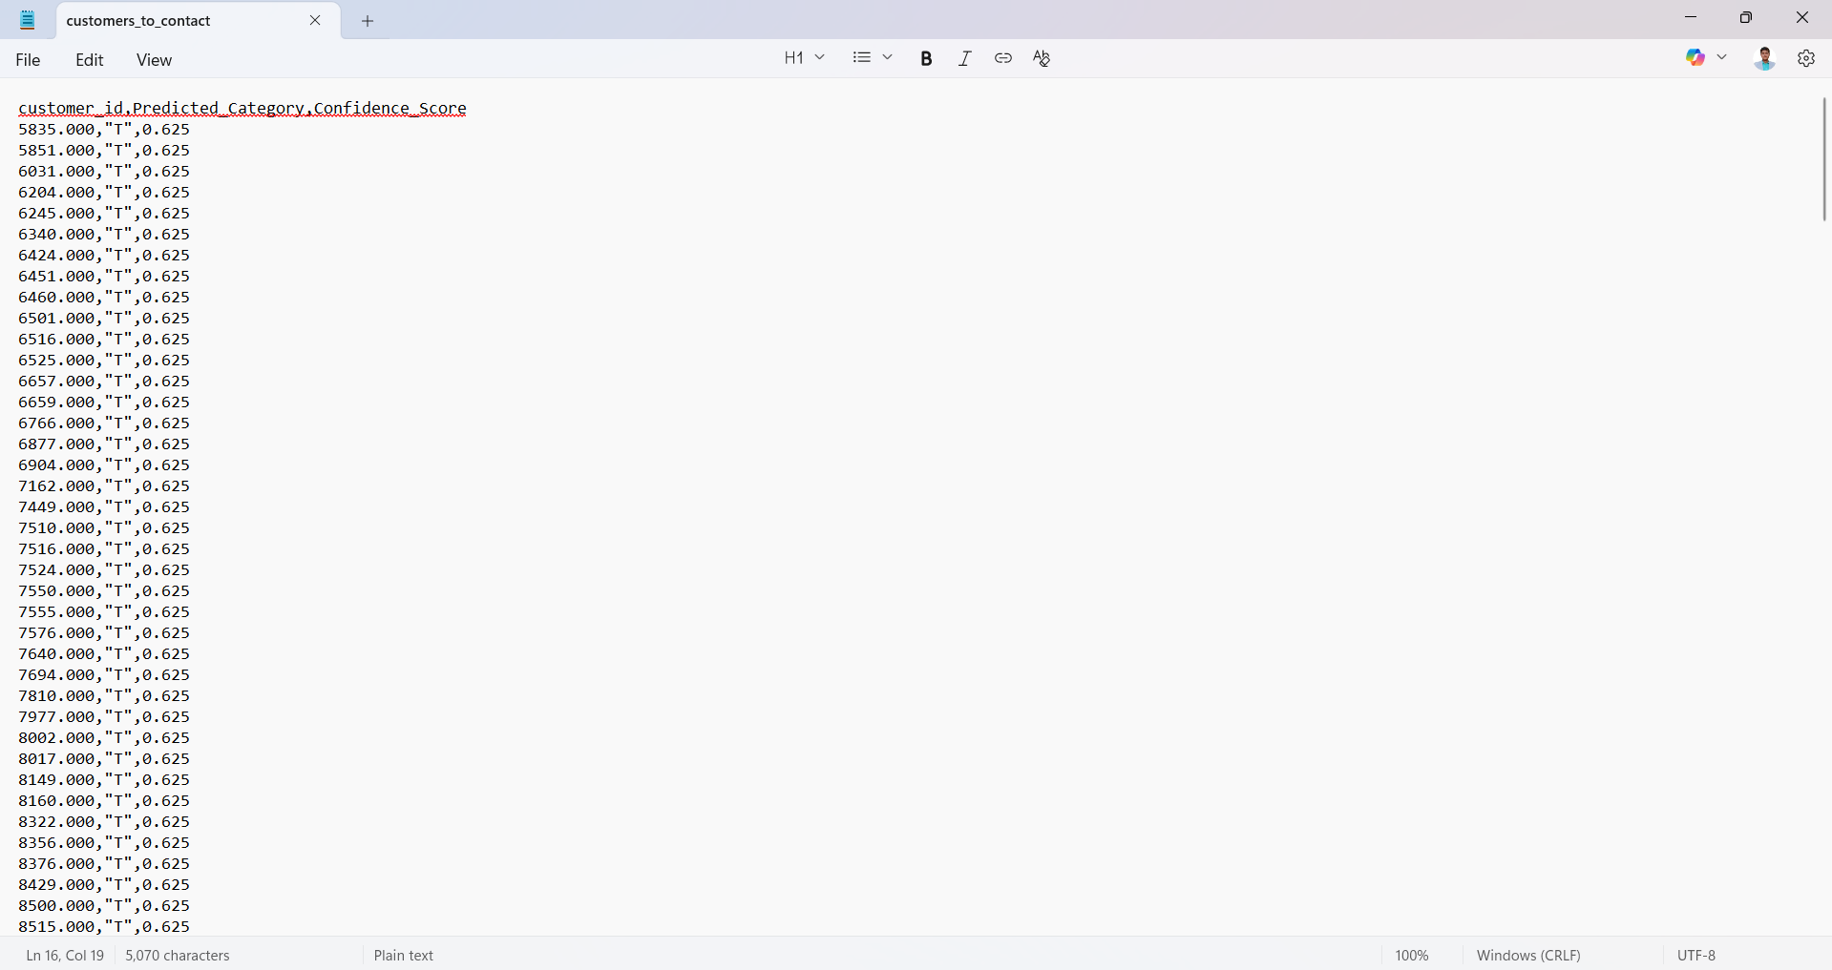
After exporting -
5

