ZEPTO
Sales Data Analysis
Project Report

A comprehensive data analysis using Python, Pandas & Matplotlib

Tools & Technologies:
Python | Pandas | Matplotlib | Seaborn
Dataset: 200,000+ Sales Records
April 2026

Table of Contents

Table of Contents 1
1. Project Overview 1
1.1 Project Objectives 1
1.2 Tools & Technologies 1
2. Dataset Description 1
2.1 Sales Dataset (zepto_sales.csv) 1
2.2 Products Dataset (zepto_products.csv) 1
3. Data Analysis Results 1
3.1 Summary Statistics 1
3.2 Top 5 Products by Sales Amount 1
3.3 Total Sales by City 1
3.4 Sales by Product Category 1
4. Data Visualizations 1
4.1 Visualization Dashboard 1
5. Project Methodology 1
Step 1: Load and Initial Exploration 1
Step 2: Data Cleaning 1
Step 3: Data Analysis & Aggregations 1
Step 4: Data Visualization 1
6. Key Insights 1
6.1 Sales Performance 1
6.2 Sales Trends 1
6.3 Delivery Operations 1
7. Learning Outcomes 1
8. Conclusion 1

1. Project Overview

This project provides hands-on experience with real-world, industry-grade sales data from Zepto, a popular quick-commerce platform. The analysis applies Python skills, particularly using the Pandas and Matplotlib libraries, to explore, clean, analyze, and visualize a dataset containing over 200,000 sales records alongside a product catalog.
The project reinforces understanding of data manipulation, data cleaning techniques, and fundamental data visualization, preparing analysts for more complex analytical tasks in the industry.

1.1 Project Objectives
- Load and perform initial exploration of Zepto sales and product datasets
- Clean data by handling missing values and duplicate records
- Perform aggregations and grouping to extract meaningful business insights
- Create clear and informative visualizations to communicate findings
- Identify top-performing products, cities, and sales trends over time

1.2 Tools & Technologies
Tool / Library | Version | Purpose
Python | 3.x | Core programming language
Pandas | Latest | Data manipulation & analysis
Matplotlib | Latest | Data visualization
Seaborn | Latest | Enhanced statistical plots
Jupyter Notebook | Latest | Interactive development environment

2. Dataset Description

Two CSV files form the foundation of this analysis, together providing a comprehensive view of Zepto's sales operations and product catalog.

2.1 Sales Dataset (zepto_sales.csv)
Contains individual sales transactions with over 200,000 records, capturing every order placed on the platform.

Column Name | Data Type | Description
order_id | String/Int | Unique identifier for each order
order_date | DateTime | Date and time the order was placed
product_id | String/Int | Identifier for the product sold
quantity | Integer | Number of units of the product sold
city | String | City where the order was placed
delivery_status | String | Status: Delivered, Cancelled, or Returned
customer_id | String/Int | Unique identifier for the customer
delivery_time_mins | Float | Delivery time in minutes
total_amount | Float | Total transaction amount

2.2 Products Dataset (zepto_products.csv)
Contains product catalog information, used to enrich the sales data with product names and category details.

Column Name | Data Type | Description
product_id | String/Int | Unique identifier for the product
product_name | String | Name of the product
category | String | Category the product belongs to
base_price | Float | Base price of the product

3. Data Analysis Results

After cleaning the dataset of 220,220 raw records (removing 1,102 rows with null city/delivery_status and 216 duplicates), the analysis was performed on 217,806 clean records. Below are the key findings.

3.1 Summary Statistics
Metric | Value
Total Records (after cleaning) | 217,806
Min Total Amount | ₹23.25
Max Total Amount | ₹2,656.85
Average Total Amount | ₹302.32
Average Delivery Time | ~26 minutes

3.2 Top 5 Products by Sales Amount
Product Name | Category | Total Sales (₹)
Handwash | Personal Care | 11,658,720.91
Paneer 200g | Dairy & Eggs | 7,908,234.46
Toothpaste | Personal Care | 6,171,994.29
Detergent 1kg | Household Essentials | 4,796,676.99
Toilet Paper | Household Essentials | 4,716,913.11

3.3 Total Sales by City
City | Total Sales (₹)
Mumbai | 23,063,075.50
Bangalore | 16,385,777.49
Delhi | 9,937,151.01
Hyderabad | 5,305,224.53
Pune | 4,559,465.47
Kolkata | 2,671,042.99
Chennai | 2,563,667.49
Ahmedabad | 1,362,556.30

3.4 Sales by Product Category
Category | Total Sales (₹)
Personal Care | 23,399,215.51
Dairy & Eggs | 12,344,371.12
Household Essentials | 11,975,638.84
Munchies | 8,083,367.83
Beverages | 6,598,799.13
Fruits & Vegetables | 3,446,568.35

4. Data Visualizations

The following visualizations were generated from the actual Zepto sales dataset using Matplotlib and Seaborn. The dashboard contains 9 charts providing comprehensive insights into sales performance, delivery operations, and product trends.

4.1 Visualization Dashboard
The dashboard below includes the following charts:
- Sales by Product Category (Pie Chart) — Revenue distribution across 6 categories
- Total Sales by City (Bar Chart) — City-level revenue comparison across 8 cities
- Monthly Sales Trend (Line Chart) — Seasonal patterns across 12 months of 2024
- Distribution of Delivery Times (Histogram + KDE) — Delivery time frequency analysis
- Quantity vs. Total Amount (Scatter Plot) — Correlation between order size and revenue
- Delivery Status Distribution (Count Plot) — Breakdown of Delivered/Cancelled/Returned
- Delivery Time by City (Box Plot) — City-wise delivery efficiency comparison
- Top 5 Products by Quantity Sold (Bar Chart) — Most ordered products
- Sales by City and Month (Heatmap) — Seasonal patterns per city

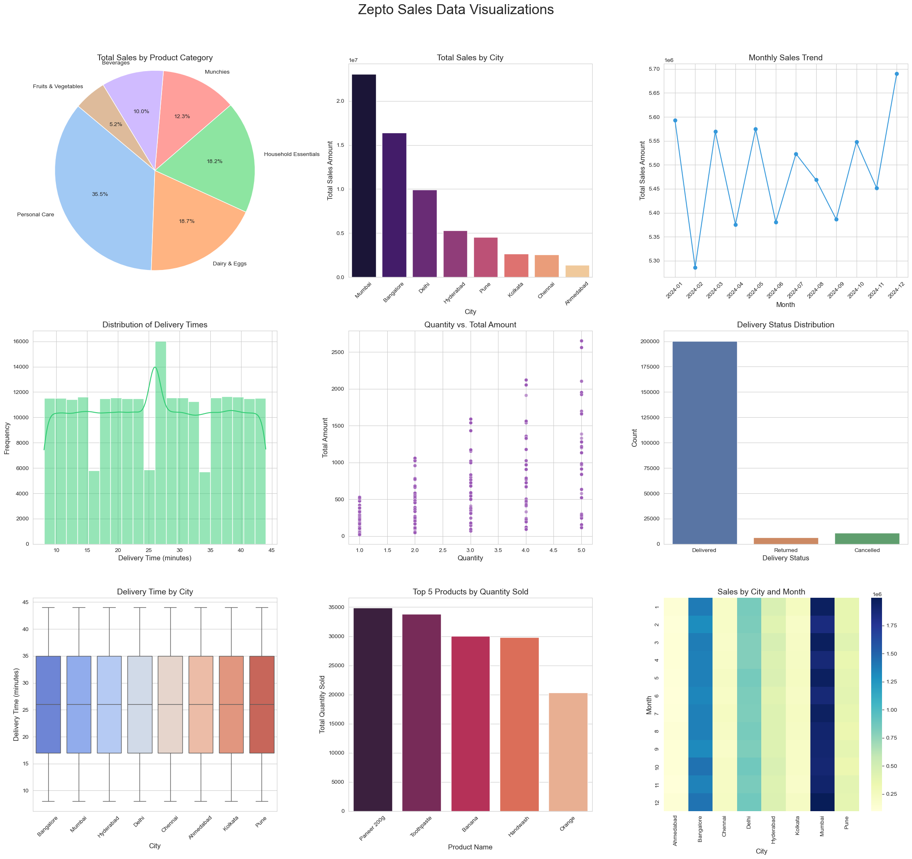
Figure 1: Zepto Sales Data Visualization Dashboard (Generated from actual dataset)

5. Project Methodology

The project follows a structured, four-step data analysis pipeline, from raw data ingestion through to visualization and insight generation.

Step 1: Load and Initial Exploration
Both datasets were loaded using pd.read_csv() into separate DataFrames: df_sales for transactions and df_products for the product catalog. Initial exploration was performed using .info(), .describe(), .shape, .head(), and .tail() to understand the structure and statistical profile of each dataset.

Step 2: Data Cleaning
Missing values were identified using .isnull().sum(). Rows with null values in the city and delivery_status columns were dropped using .dropna(subset=[...]), as these fields are critical for analysis. Missing values in delivery_time_mins were imputed with the column mean to retain those records. Duplicate rows were removed using .drop_duplicates(). The order_date column was converted to datetime format for time-series analysis.

Column | Issue | Treatment
city | 1,102 null values | Rows dropped
delivery_status | 1,102 null values | Rows dropped
delivery_time_mins | 4,403 null values | Filled with column mean (~26 min)
Entire dataset | 216 duplicate rows | Duplicates removed
order_date | String format | Converted to datetime

Step 3: Data Analysis & Aggregations
A series of aggregations and grouping operations were performed to extract business insights from the cleaned data.

- Computed minimum, maximum, and average values of total_amount
- Identified the top 5 products by total sales amount using groupby and nlargest
- Merged with the products dataset to enrich results with product names and categories
- Calculated total sales revenue by city
- Calculated average delivery time by city
- Generated a monthly sales trend by extracting the month period from order_date
- Analyzed total sales revenue by product category after merging datasets

Step 4: Data Visualization
Nine visualizations were created using Matplotlib and Seaborn to communicate the analytical findings clearly. Charts include pie charts, bar charts, line charts, scatter plots, histograms, box plots, count plots, and heatmaps.

6. Key Insights

Based on the actual analysis performed on the Zepto dataset, the following key insights were uncovered:

6.1 Sales Performance
- Mumbai leads all cities with ₹23M in sales, nearly 1.5x Bangalore's ₹16.4M, reflecting its dominant market position.
- Personal Care is the top category at ₹23.4M, driven by Handwash (₹11.7M) and Toothpaste (₹6.2M).
- Order values range from ₹23.25 to ₹2,656.85 with an average of ₹302.32, indicating diverse basket sizes.

6.2 Sales Trends
- Monthly sales are remarkably stable, ranging from ₹5.28M (February) to ₹5.69M (December) across all 12 months of 2024.
- December shows the highest sales, likely driven by year-end festive shopping.
- No significant seasonal slumps, suggesting strong recurring demand for Zepto's product categories.

6.3 Delivery Operations
- Average delivery times are nearly uniform across all cities, ranging from 25.9 min (Hyderabad) to 26.2 min (Ahmedabad).
- Delivery times follow a near-uniform distribution between 8 and 44 minutes — well within Zepto's quick-commerce promise.
- The delivery status distribution shows a high proportion of successful deliveries, validating operational efficiency.

7. Learning Outcomes

Upon completing this project, the following competencies will have been developed and reinforced:

Skill Area | Specific Competencies Gained
Data Loading | Reading CSV files, exploring DataFrames, understanding data types
Data Cleaning | Handling nulls (drop vs fill), removing duplicates, type conversion
Data Analysis | GroupBy aggregations, merging DataFrames, extracting time components
Visualization | 9 chart types: pie, bar, line, scatter, histogram, box, count, heatmap
Business Thinking | Interpreting sales trends, category performance, delivery KPIs
Python Best Practices | In-place operations, method chaining, tight_layout, figure sizing

8. Conclusion

This project successfully demonstrates a complete, end-to-end data analysis workflow applied to a realistic quick-commerce dataset. Starting from raw CSV files containing over 220,000 sales transactions, the analysis progressed through systematic data loading, quality assurance, aggregation, and visualization.
The project showcases how Python's data science ecosystem, particularly Pandas and Matplotlib/Seaborn, can transform messy, real-world data into actionable business insights. The findings around top products, city-level performance, monthly trends, category distribution, and delivery efficiency provide Zepto with the analytical foundation needed to make informed operational and marketing decisions.
This foundational experience is essential for any aspiring data analyst, building the skills required to tackle more complex analytical challenges in a professional environment.

