SMART WEARABLE FOR THE BLIND
Shivom Sehgal
Objective:
The aim of the project is to
- Design a smart wearable for the blind based on home automation and ultrasonic mechanism.

Circuit/Block Diagram:
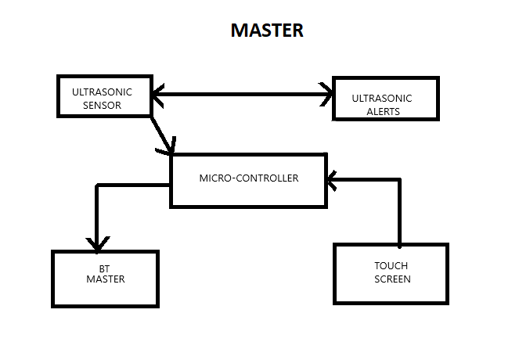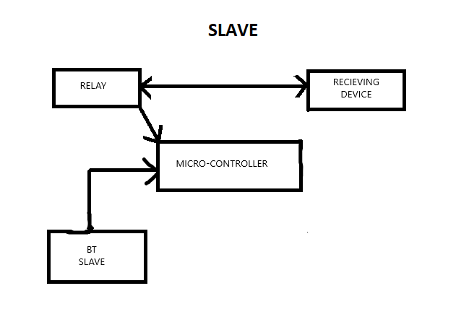
In this project we made a smart wearable for the blind which could provide independence in day-to-day works like walking on a street or switching on the air conditioner without the help of another individual and tried our level best to break the myth that Most of the members of the non-blind community believe that the blind people cannot do their work or live a normal life. Through this wearable the individual can have the leisure of doing normal things (like walking Etc) without diluting his confidence.

Summary:
- We have made a smart wearable for the blind which is subdivided into two parts(master side and slave side).
- On the master side the ultrasonic sensor and vibrating motor is attached which detect the obstacles in the path of the individual and direct the information to the microcontroller which indeed is connected to the Bluetooth master and touch screen for reception of information.
- On the slave side Bluetooth slave receives the signal from the Bluetooth master and feeds it to the microcontroller which is connected to the relay for home automation

