

Business Analytics

# Worksheet 3.3

## Student Name: Aman Sharma UID: 22MCA20026

|  |  |
| --- | --- |
| **Branch: MCA** | **Section/Group: 22MCA5-B** |
| **Semester: 3rd** | **Date of Performance: 06-11-23** |
|  | **Subject Code: 22CAH-703** |

**AIM of The Practical**

## Q. Implementation of dashboard in Tableau.

A Tableau dashboard is a collection of different views or visualizations that show different types of data at the same time. It allows users to get a holistic view of all the data on one screen. Dashboards are a type of data visualization, and often use common visualization tools such as graphs, charts, and tables.

**Step-1.** Create a new dashboard by clicking on the dashboard option from the task bar.

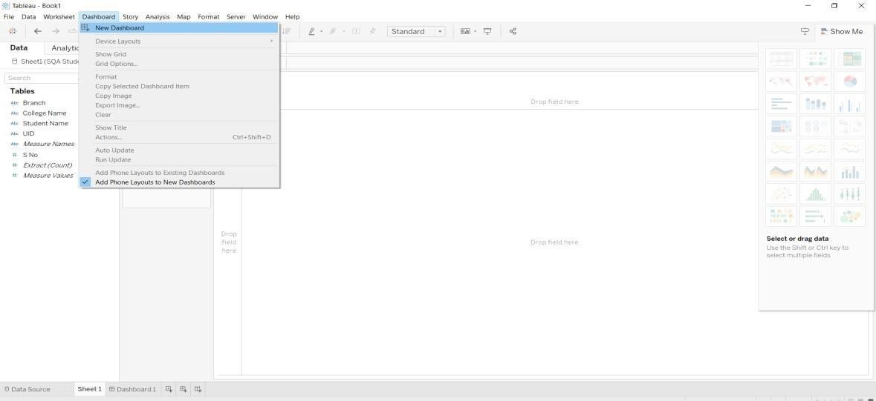

* The dashboard will look like this.



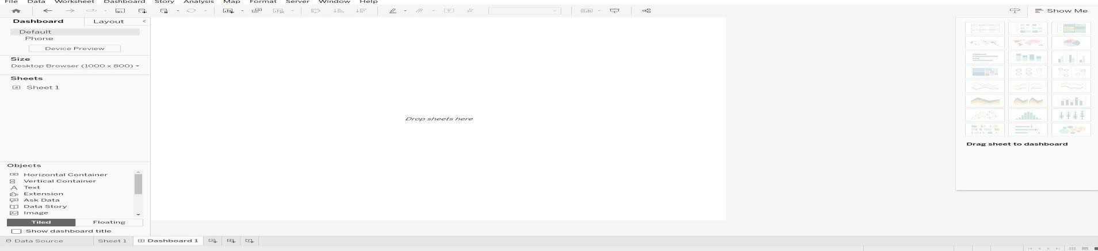

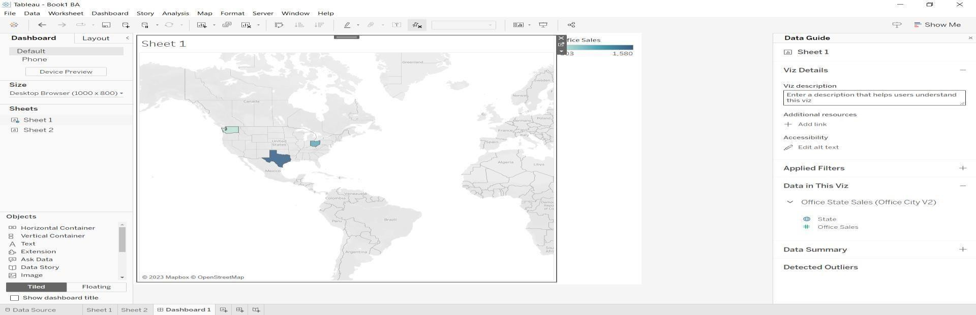**Step 2** : Now, drop the sheets from the Sheets options on the screen.

**Step-3.** To create Floating sheets, click on the arrow provided on the top right of the sheet and select the option as shown below.



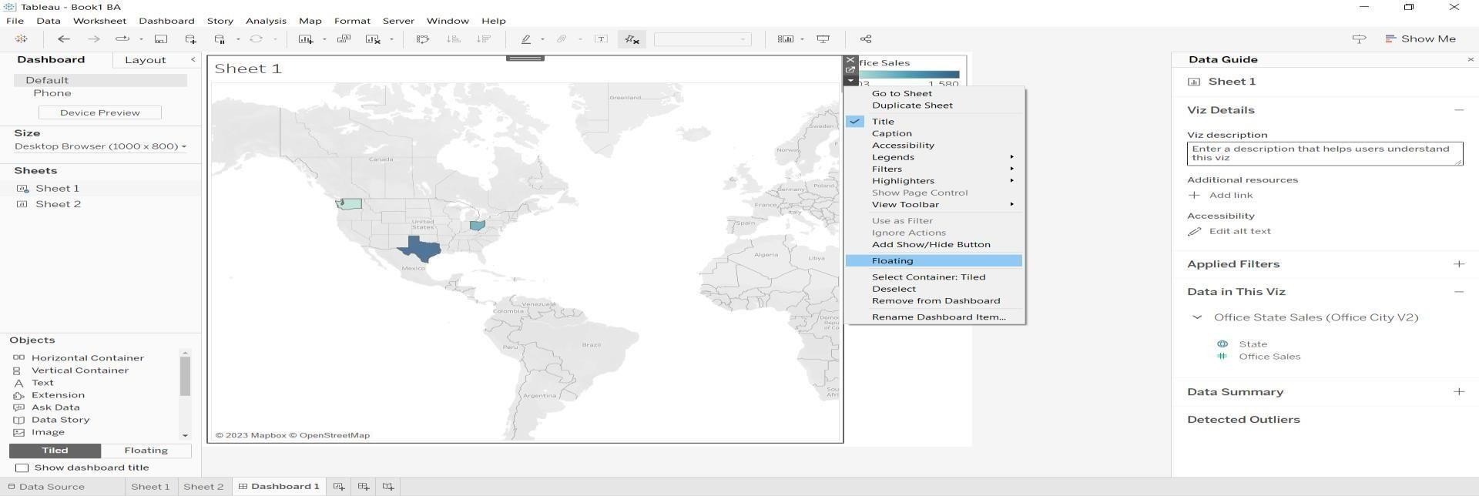

**Step-4**. The floating sheets will be created which will look like this in the dashboard.

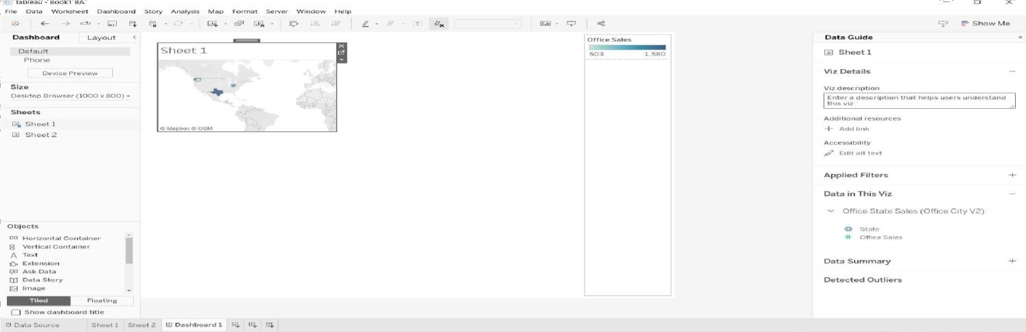

**Step-5.** You can resize these sheets according to your need to get a clear view of the data.

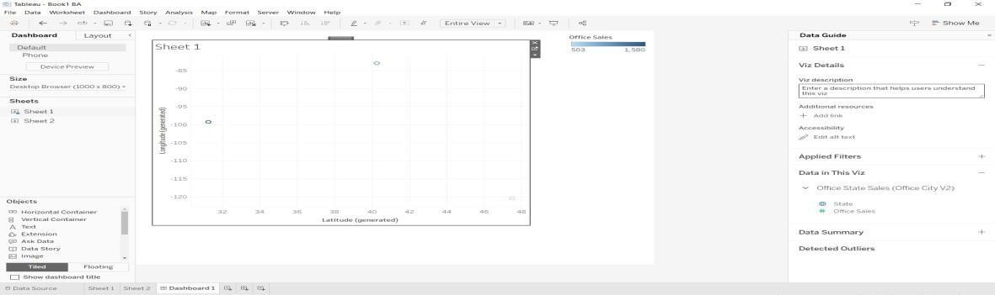



**Step 7:** Publish the Dashboard Publish the dashboard to Tableau Server, Tableau Online, or Tableau Public (if applicable). Choose the appropriate permissions and access controls to share the dashboard securely .

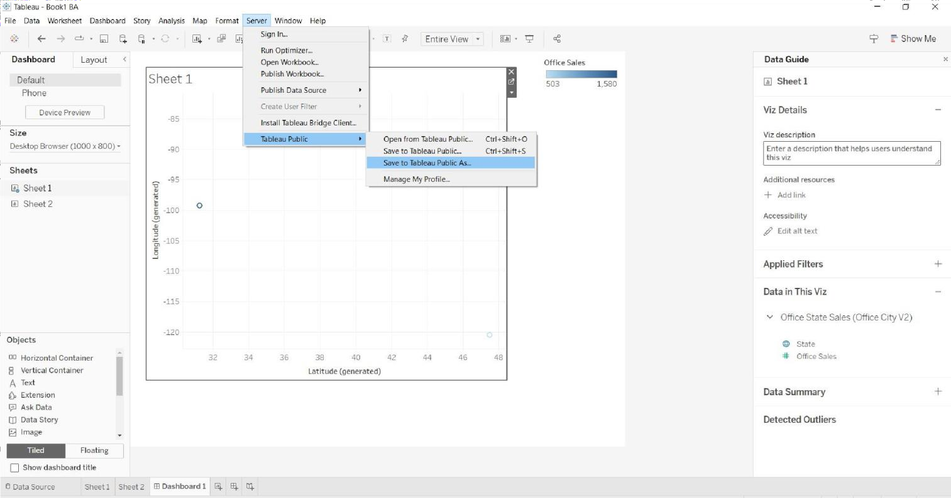

# Learning Outcomes: -

1. Learn about Tableau and how to implement dashboard in Tableau.
2. Design Principles and User Experience. 3.Learn about Visualization Techniques.

4. Sharing and Collaboration**.**