SAP_RPA_LR (RAP-Rapid Automation of placeholders)
Introduction: -
I am making a project that will automate the manual extraction of the part description from the SAP dashboard mainly tcodes=MD04/MD06. For this project I need to make an RPA-Robotic process Automation bot that will sit inside your windows PC and work as an executable .exe

Stage 1.: - (MD04)
Normal steps for extracting the part Description
- Step 1 – open SAP Logon inside your pc by clicking on the logo on the taskbar (highlighted box in the image)

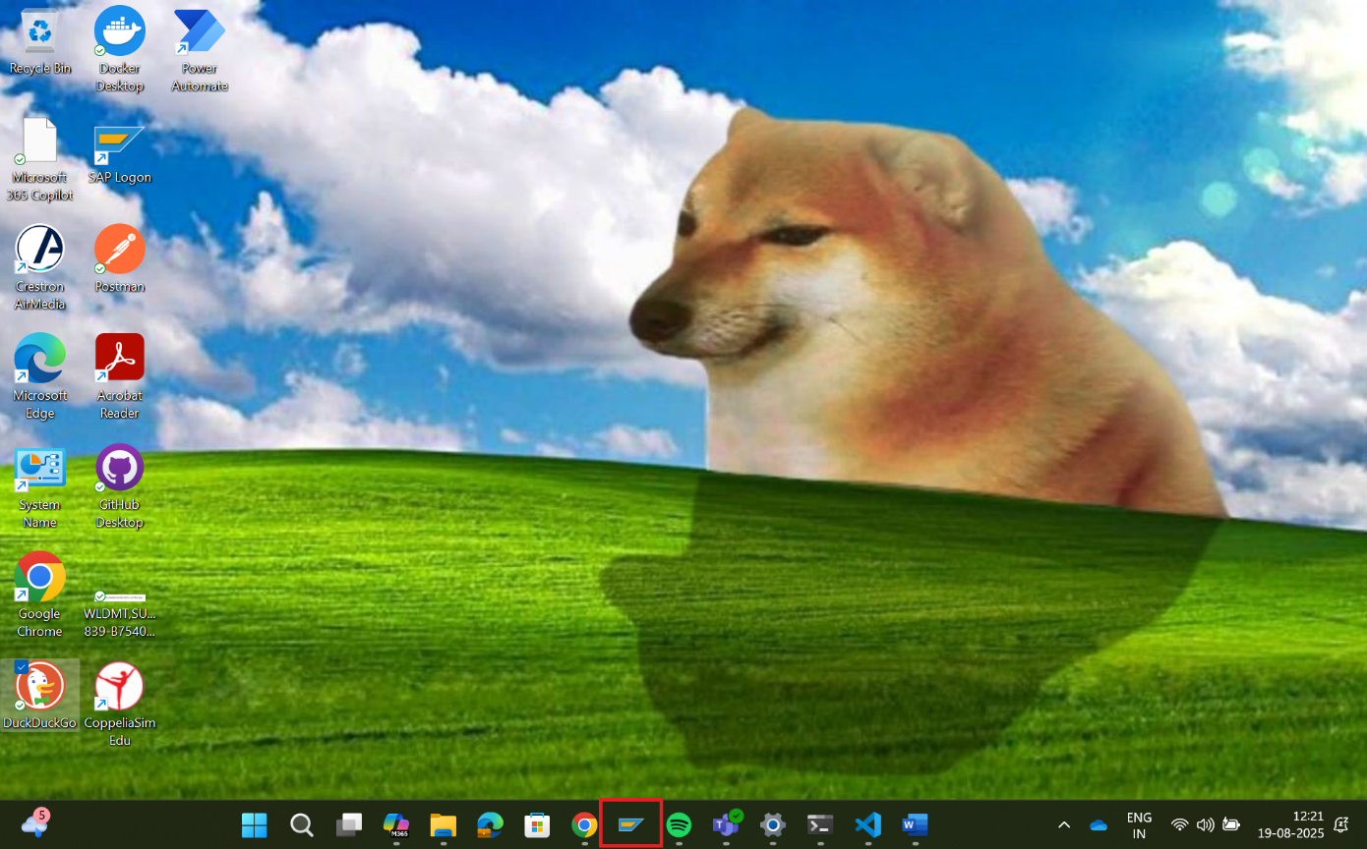

- Step 2 – Wait for few seconds until this window opens up and the click on the maximize icon (highlighted box in the image)

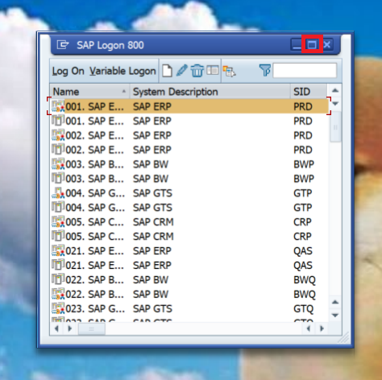

- Step 3 – click on the first option and you should check for the variables like
{
Name == “001. SAP ECC Production (PRD)”,
System Description == “SAP ERP”,
SID == “PRD”,
Group/Server == “Production PRD”,
Instance No. == NULL,
Message Server == “pdtcprd01.fermont.lamrc.net”,
Router(s) == NULL,
Connection == NULL,
Type == NULL,
Function == NULL,
Client == NULL,
User Name == NULL,
Language == NULL,
Working Directory == NULL,
Window Size == NULL,
Trace Level == NULL,
SAP GUI Parameter == NULL,
Connection Reuse == NULL
}

(highlighted box in the image)

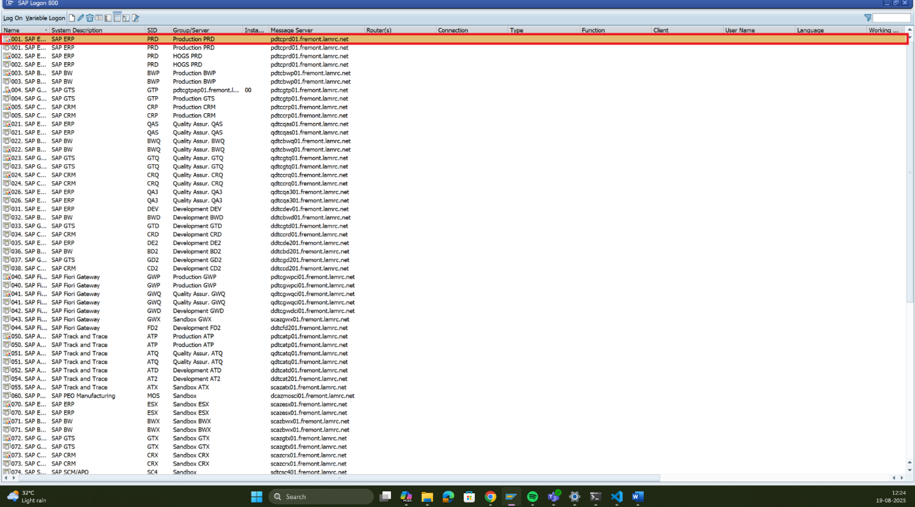
- Step 4 – After peforming the previous step you have to wait for few seconds, so that the screen below can open then find the search bar (highlighted box in the image) then, because we are working on MD04 right now so you must put MD04 on that search bar and then press enter

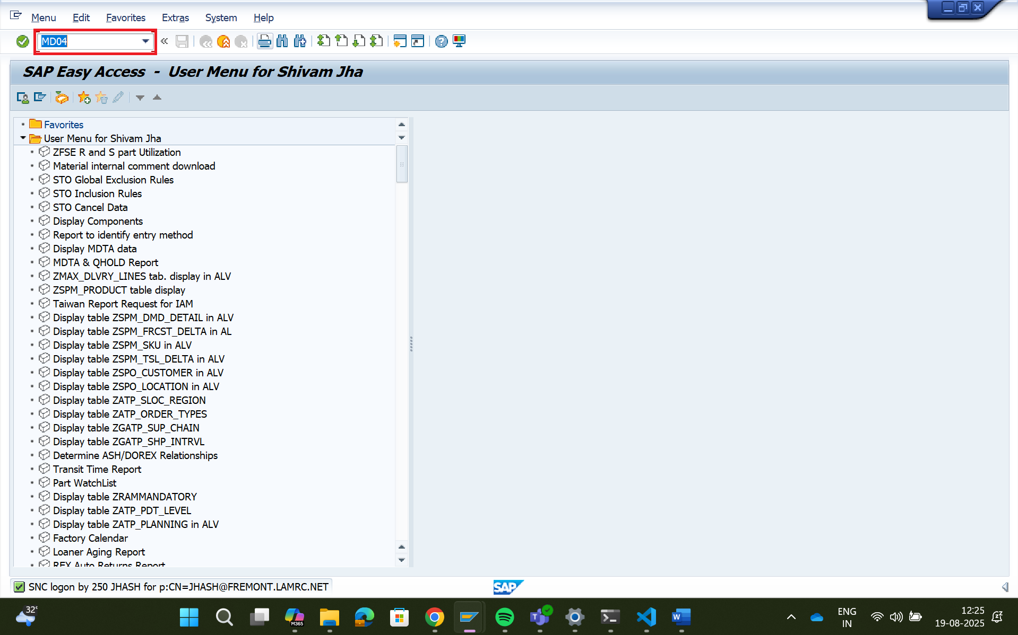
- Step 5 – write the part no that would be provided to you and enter the MRP Area as 1000 and then Click Enter
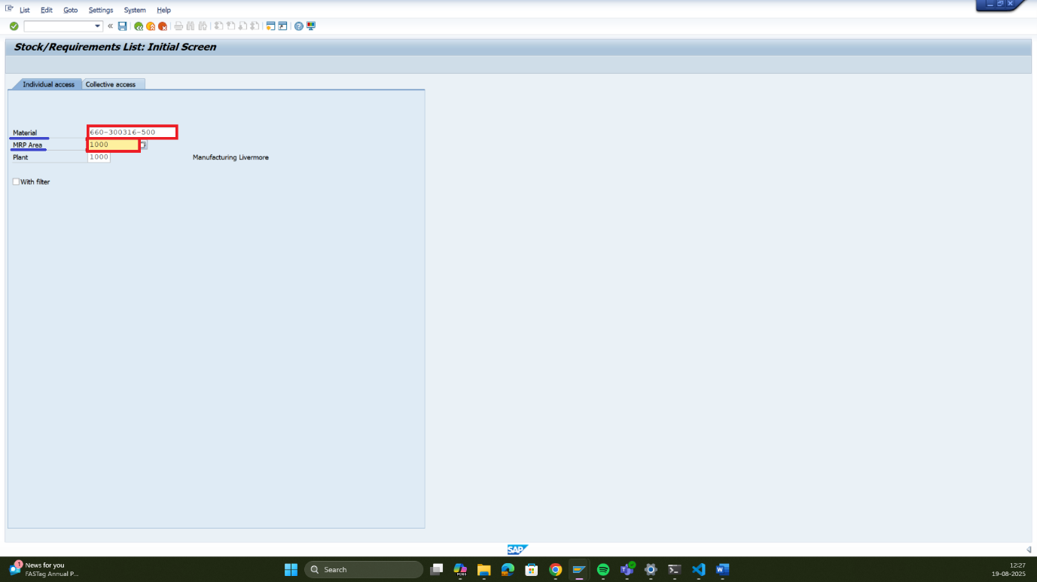
- Step 6: From the window, double click on the number present in front of MatRes.
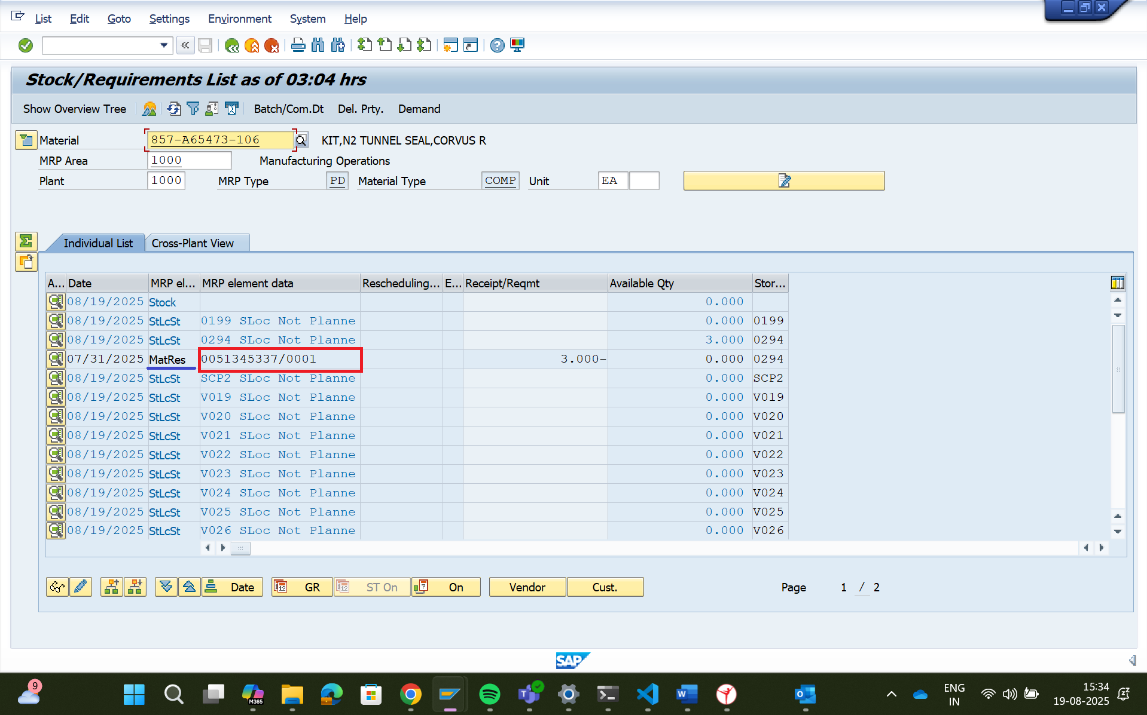
- Step 7: After performing the previous step this new screen will appear to you to maximize this screen click on the button which is highlighted

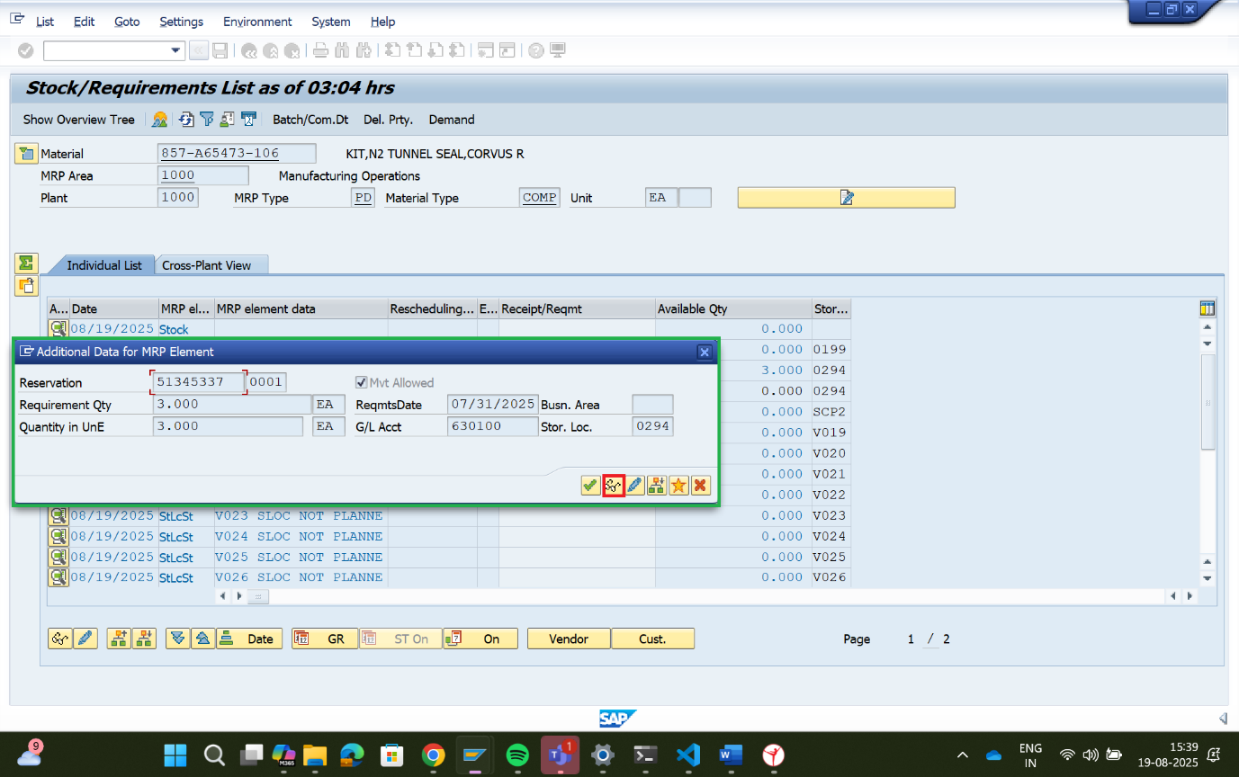

- Step 8 – Although all the information on the screen is important which reside inside the green box I need you to make an excel with 2 columns in its first is part no and the second one is of description so that will you extract from this whindow
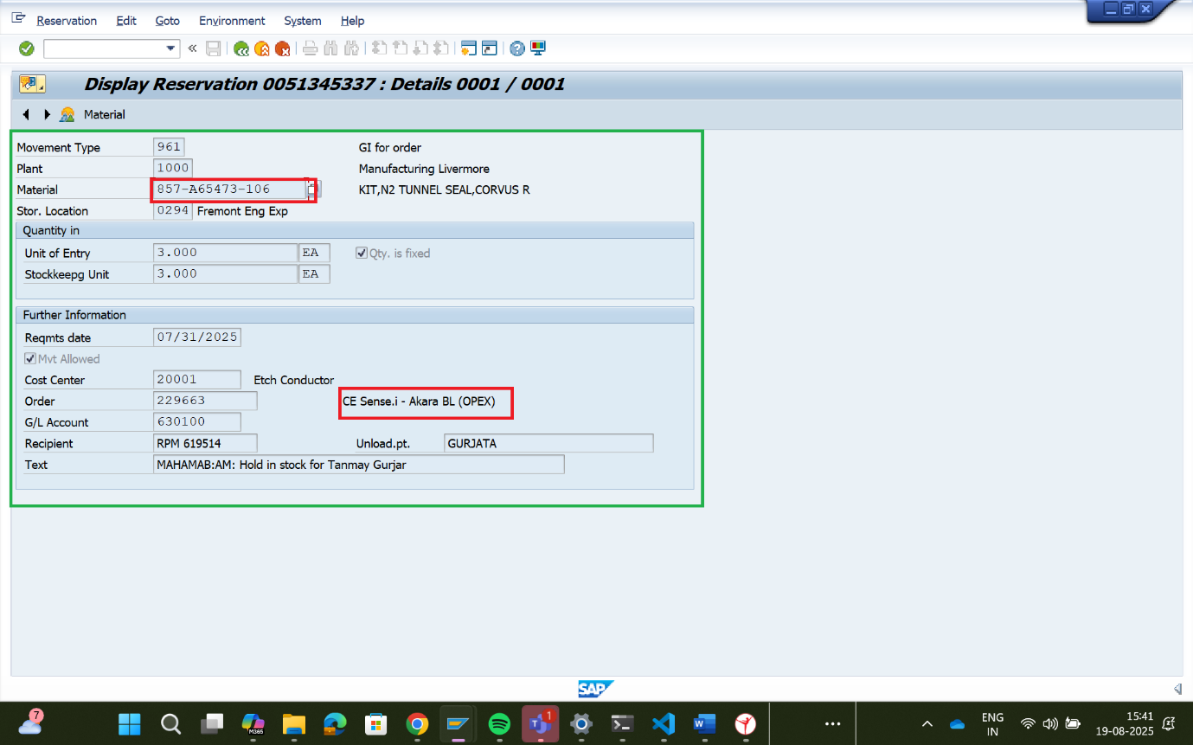

For more then one part No. we will create a tkinter exe file that will take part no as input for now and when the person will click on the start button all the above automation process will start ….

