Name: Shivprasad CP

Roll No: 9696

Batch: A

Experiment 2

**Implement SQL queries for OLAP operations:**

**Part 1**

**Part 1**

create table *dim_time*(time_key *serial* primary key, days *date*, weeks *int*, months *int*, quarter *int*, years *int*);

select * from dim_time;

insert into dim_time(days, weeks, months, quarter, years)

values  ('2016-03-08', 33, 8, 3, 2016),

('2018-06-27', 27, 26, 6, 2018),

('2019-04-30', 30, 18, 4, 2019),

('2015-06-01', 1, 22, 6, 2015),

('2015-12-06', 6, 49, 12, 2015),

('2012-12-21', 21, 51, 12, 2012);

create table *dim_location*(location_key *serial* primary key, street *varchar*, city *varchar*, states *varchar*, country *varchar*);

select * from dim_location;

insert into dim_location(street, city, states, country)

values ('gully chowl', 'Navi Mumbai', 'Maharashtra', 'India'),

('Film city road', 'Mumbai', 'Maharashtra', 'India'),

('Sector 24', 'Noida', 'U.P', 'India'),

('Aul market road', 'Patamundi', 'Orrisa', 'India'),

('Shivaji Chowk', 'Pune', 'Maharashtra', 'India');

insert into dim_location(street, city, states, country)

values ('New market', 'Noida', 'U.P', 'India');

create table *dim_treatment*(treatment_key *serial* primary key, treatment_name *varchar*, costs *int*, medicine_info *varchar*);

select * from dim_treatment;

insert into dim_treatment(treatment_name, costs, medicine_info)

values('Root Canal', 2000, 'Yes'),

('Braces', 2500, 'No'),

('Teeth whitening', 3000, 'Yes'),

('Root Canal', 2500, 'Yes'),

('Wisdom extract', 4000, 'No'),

('Root Canal', 3000, 'Yes');

create table *dim_diagonse*(diagonse_key *serial* primary key, diagonse_info *varchar*, Doctor_key *int*);

select * from dim_diagonse;

insert into dim_diagonse(diagonse_info, Doctor_key)

values('Root Canal', 20),

('Braces', 21),

('Teeth whitening', 40),

('Root Canal', 72),

('Wisdom extract', 34),

('Root Canal', 40);

create table *fact_revenue*(time_key *int* references dim_time(time_key),

                          location_key *int* references dim_location(location_key),

                          treatment_key *int* references dim_treatment(treatment_key),

                          diagonse_key *int* references dim_diagonse(diagonse_key),

                          net_revenue *decimal*(19,4), total_diagonse *int*,

                          primary key(time_key, location_key, treatment_key, diagonse_key)

                         );

insert into fact_revenue values(1,1,1,1,20000.50, 10),

(2,2,2,2,10000.50, 5),

(3,3,3,3,15000.50, 8),

(4,4,4,4,22000.50, 12),

(5,5,5,5,24000.50, 15),

(6,6,6,6,18000.50, 9);

select * from fact_revenue;

drop table fact_revenue;

*-- Roll Up Operations*

select city, states, sum(net_revenue) from dim_location inner join

fact_revenue on dim_location.location_key *=* fact_revenue.location_key

group by rollup(states, city) order by states,city;

*--Cube operations*

select years, quarter, total_diagonse, sum(net_revenue) from fact_revenue natural inner join dim_time

group by cube(years, quarter, total_diagonse);

*--Slice Operations*

select states, city, sum(net_revenue) from dim_location inner join fact_revenue on

fact_revenue.location_key *=* dim_location.location_key where states *=* 'Maharashtra' group by states, city;

*--Dice Operations*

select states, city, sum(net_revenue) from dim_location inner join fact_revenue on

fact_revenue.location_key *=* dim_location.location_key where states *=* 'Maharashtra' and city *=* 'Mumbai'

group by states, city;

Part 2:

Perform data analysis with visualization for the following:

a)To view monthly, quarterly, yearly profit, sales of each category, region wise

b) Comparison of sales and profit on various years.

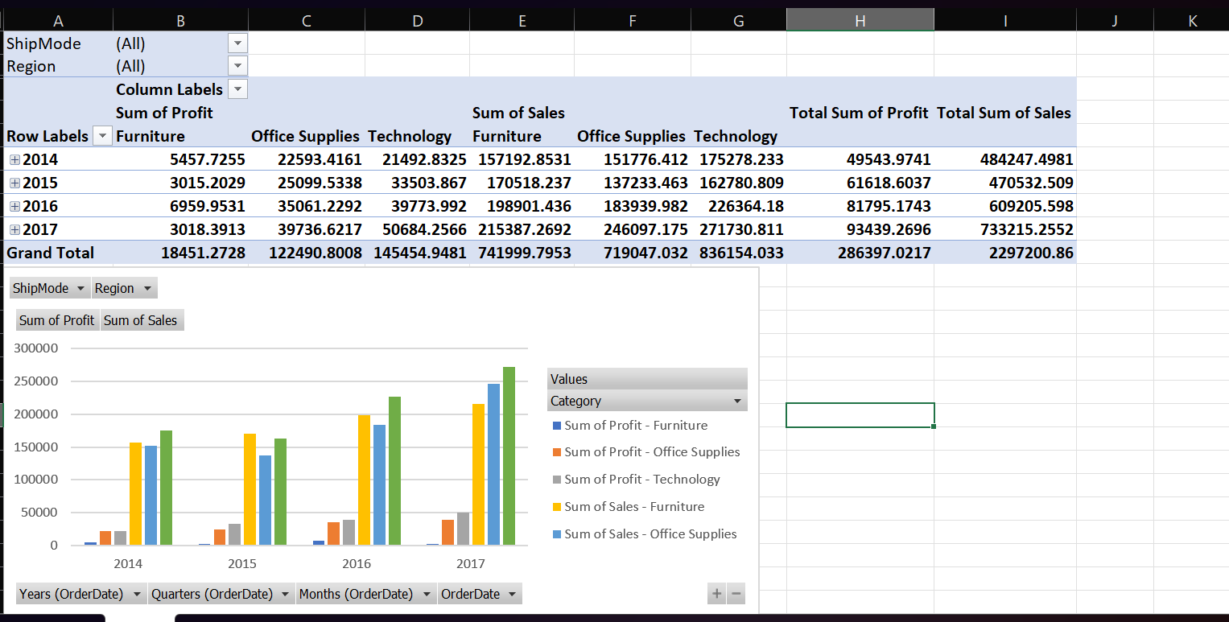

c) Comparison of sales in various months for product category =furniture.

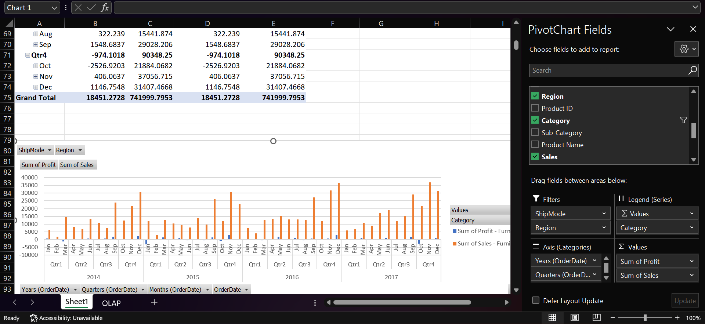

d) Need to know which product has more demand on which location?

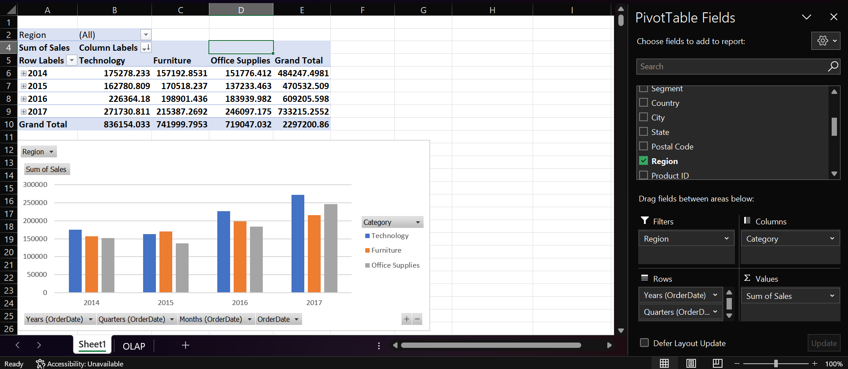

e) What is sale of product category wise, city wise for year=2015 ?

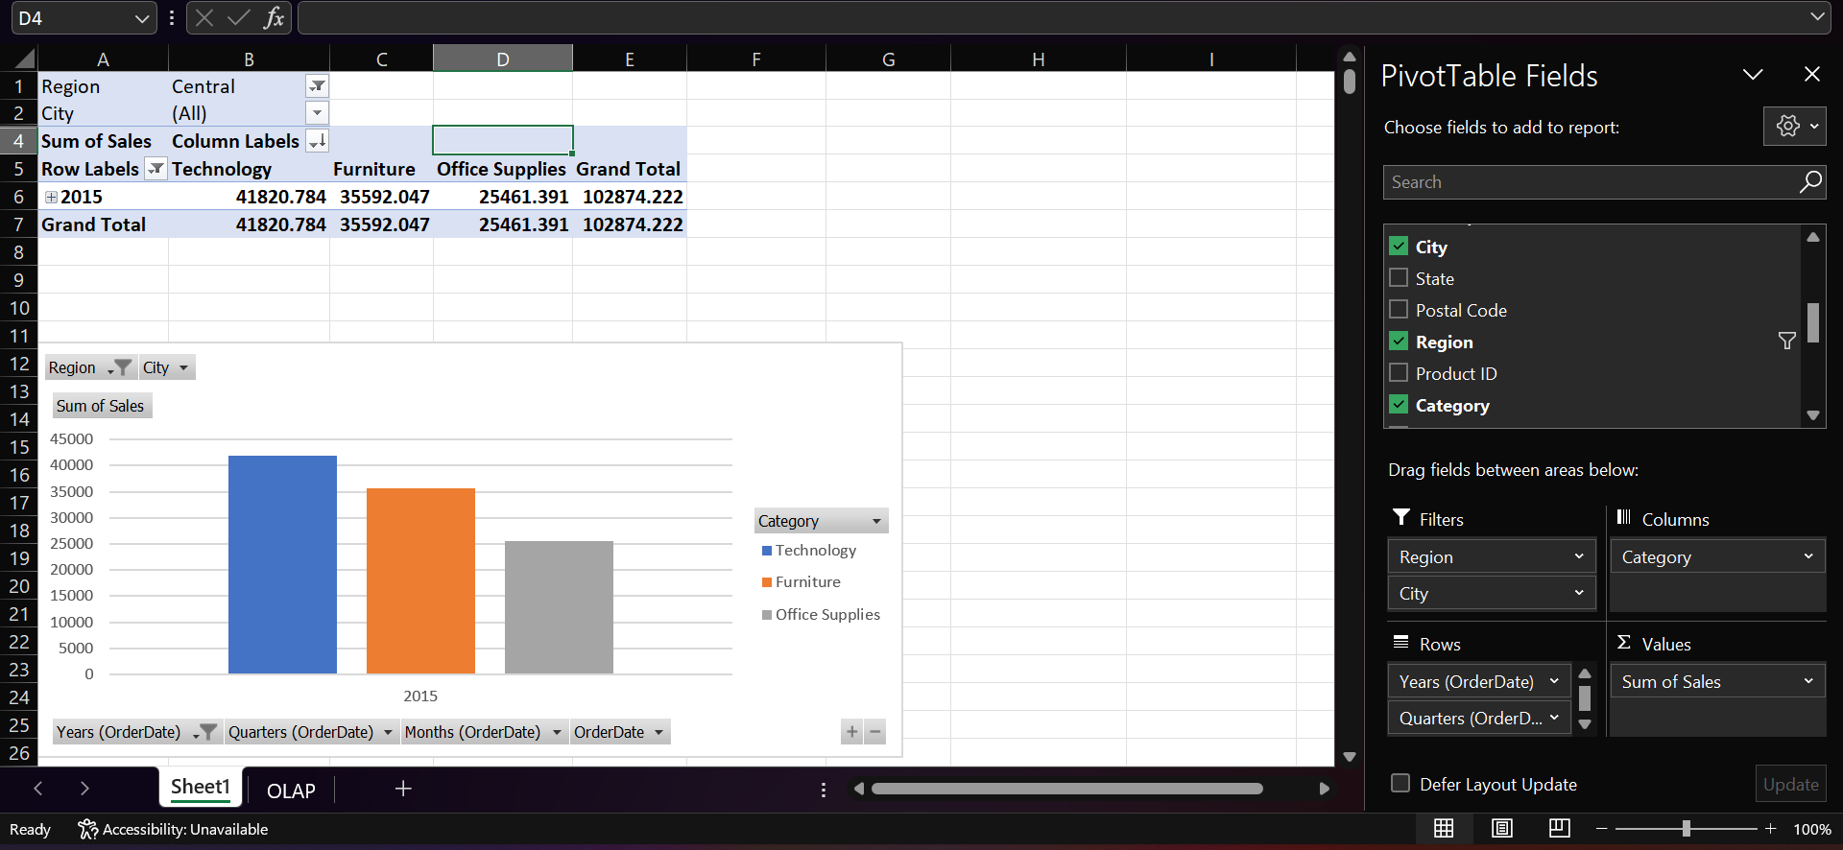

f) What is sales of product categories of Jan month of each year?

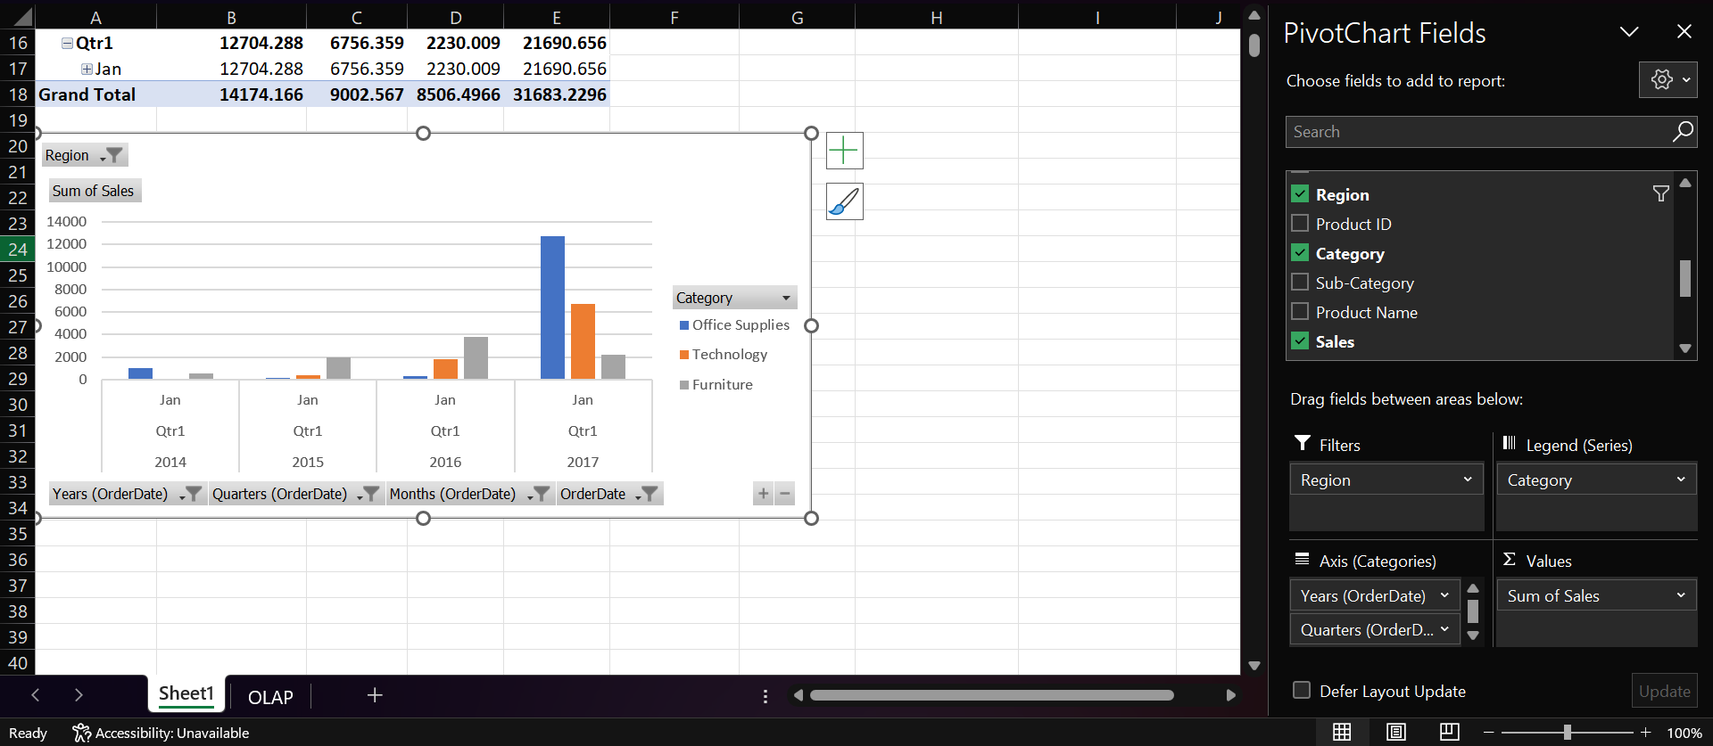

g) What is trend of sales on year 2014 and 2015 for product category furniture and technology?

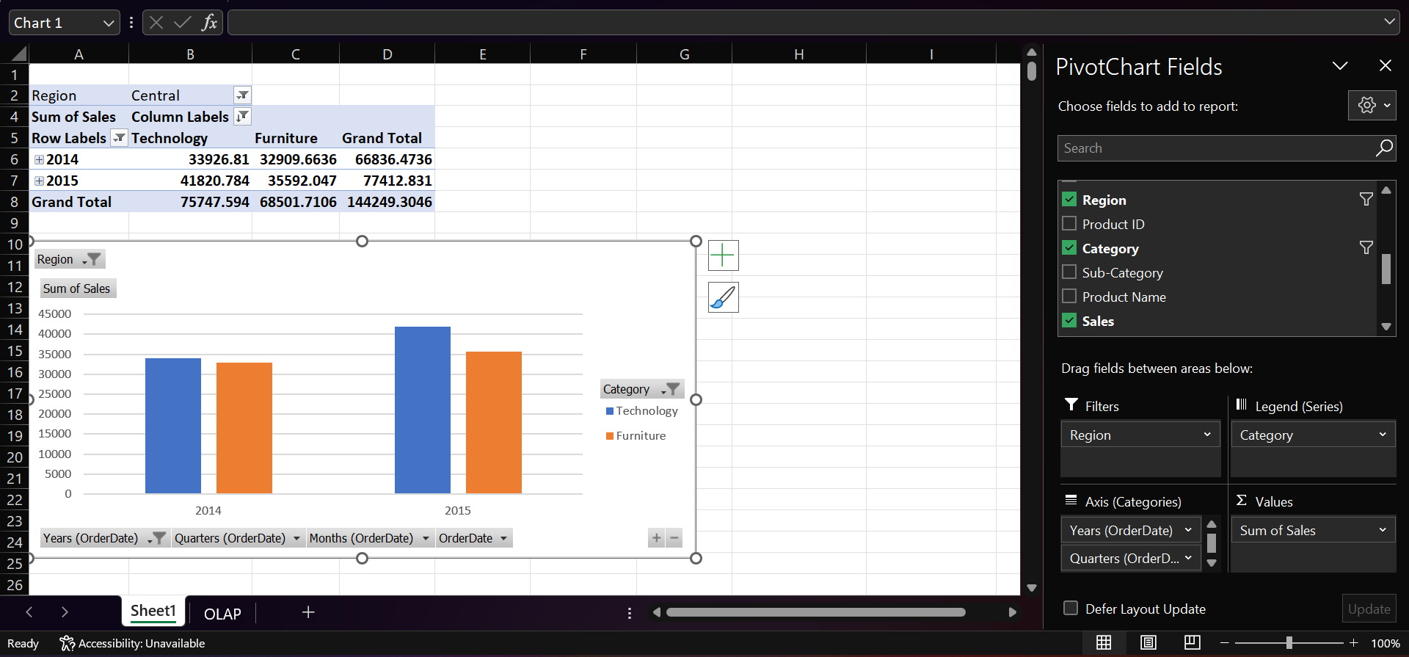

Part 3:

List down the data Extraction Transformation and Loading processes applicable for your DW system.

Extract:

* Data Source Identification: Different sources of dental clinical data, which could include electronic health records, appointment systems, billing systems, patient information, etc.
* Data Extraction: Extract relevant data from the identified sources using appropriate methods, such as database queries, flat file exports, etc.
* Data Profiling: Analyze and profile the extracted data to understand its quality, structure, and potential issues.

Transform:

* Data Cleansing: Cleaning the extracted data by identifying missing values, inconsistencies, errors, and duplicates.
* Data Transformation: Convert data into a common format and standardize units, terminologies, and codes to ensure consistency.
* Data Integration: Integrate data from various sources into a unified format, considering data types, relationships, and hierarchies.
* Data Validation: Validate the transformed data to ensure that it meets the defined quality standards and business rules.

Loading:

* Staging: Store the cleaned and transformed data in a staging area, separate from the data warehouse, to facilitate further validation.
* Data Warehouse Loading: Load the validated and transformed data into the data warehouse.