|  |  |  |  |  |  |  |  |  |
| --- | --- | --- | --- | --- | --- | --- | --- | --- |
| **Experiment No:** | 07 |  |  |  |  |  | TE AI&DS | |
| Date of Performance: | |  |  |  |  |  | Roll No: 9696 | |
| **Aim**: To Implement K-mean clustering algorithm to group similar data objects | | | | | | | | |
| **Related CO4:** Implement Classification, Clustering and Association mining techniques to extract knowledge | | | | | | | | |
| **Objective:**  To learn clustering techniques | | | | | | | | |
| **Rubrics for assessment of Experiment:** | | | |  |  |  |  |  |
|  |  |  |  |  |  |  |  |  |
| **Sr. No** | **Parameters** | **Exceed** | |  | **Meet** | | **Below** | |
|  |  | **Expectations(EE)** | | | **Expectations** | | **Expectations** | |
|  |  |  |  |  | **(ME)** | | **(BE)** | |
| 1 | Timeline (2) | Early or on time | | | One session late | | More than one | |
|  |  | (2) |  |  | (1) |  | session late (0) | |
| 2 | Preparedness (2) | Knows the basic | | | Managed to | | Not aware of the | |
|  |  | theory related to | | | explain the | | theory to the | |
|  |  | the experiment | | | theory related to | | point. (1) | |
|  |  | very well. (2) | |  | the experiment. | |  |  |
|  |  |  |  |  | (1) |  |  |  |
| 3 | Effort (3) | Done expt on their | | | Done expt with | | Just managed. | |
|  |  | own. (3) | |  | help from other. | | (1) |  |
|  |  |  |  |  | (2) |  |  |  |
| 4 | Documentation(2) | Lab experiment is | | | Documented in | | Experiments not | |
|  |  | documented in | | | proper format | | written in | |
|  |  | proper format and | | | but some | | proper format | |
|  |  | maintained neatly. | | | formatting | | (0.5) |  |
|  |  | (2) |  |  | guidelines are | |  |  |
|  |  |  |  |  | missed. (1) | |  |  |
| 5 | Result (1) | Specific | |  | Partially | | Not specific at | |
|  |  | conclusion.(1) | | | specific | | all. (0) | |
|  |  |  |  |  | conclusion. | |  |  |
|  |  |  |  |  | (0.5) |  |  |  |
| **Assessment Marks:** | |  |  |  |  |  |  |  |
|  |  |  |  |  | |  | |  |
| Timeline(2) | Preparedness(2) | Effort(3) |  | Documentation(2) | | Result(1) | | Total(10) |
|  |  |  |  |  |  |  |  |  |

## Theory:

## What is Clustering?

Clustering is dividing data points into homogeneous classes or clusters:

* Points in the same group are as similar as possible
* Points in different group are as dissimilar as possible

When a collection of objects is given, we put objects into group based on similarity.

## Application of Clustering:

Clustering is used in almost all the fields. You can infer some ideas from Example 1 to come up with lot of clustering applications that you would have come across.

Listed here are few more applications, which would add to what you have learnt.

* Clustering helps marketers improve their customer base and work on the target areas. It helps group people (according to different criteria’s such as willingness, purchasing power etc.) based on their similarity in many ways related to the product under consideration.
* Clustering helps in identification of groups of houses on the basis of their value, type and geographical locations.
* Clustering is used to study earth-quake. Based on the areas hit by an earthquake in a region, clustering can help analyse the next probable location where earthquake can occur.

## Clustering Algorithms:

A Clustering Algorithm tries to analyse natural groups of data on the basis of some similarity. It locates the centroid of the group of data points. To carry out effective clustering, the algorithm evaluates the distance between each point from the centroid of the cluster.

The goal of clustering is to determine the intrinsic grouping in a set of unlabelled data.

## K-Means Clustering Algorithm-

K-Means Clustering Algorithm involves the following steps-

### Step-01:

* Choose the number of clusters K.

### Step-02:

* Randomly select any K data points as cluster centers.
* Select cluster centers in such a way that they are as farther as possible from each other.

### Step-03:

* Calculate the distance between each data point and each cluster center.
* The distance may be calculated either by using given distance function or by using euclidean distance formula.

### Step-04:

* Assign each data point to some cluster.
* A data point is assigned to that cluster whose center is nearest to that data point.

### Step-05:

* Re-compute the center of newly formed clusters.
* The center of a cluster is computed by taking mean of all the data points contained in that cluster.

### Step-06:

Keep repeating the procedure from Step-03 to Step-05 until any of the following stopping criteria is met-

* Center of newly formed clusters do not change
* Data points remain present in the same cluster
* Maximum number of iterations are reached

**Implementation:**

**Part 1: WAP in Python/java to implement K-means clustering algorithm**

Suppose That The Data Mining Task Is To Cluster Points (With .*X*, *Y*/ Representing Location)

Into Three Clusters, Where The Points Are

*A*(2,10),B(2,5),C(8,4),D(5,8),*E(*7,5),*F(*6,4),G(1,2),*H(*4,9).

**Read No of Objects**

**Read all Object Details**

**Read K**

**Give Output In Step Wise/Iteration Wise (distance matrix with cluster assignment )**

**Part 2: using standard libraries / packages**

[K-Means Clustering with scikit-learn - DataCamp](https://www.datacamp.com/community/tutorials/k-means-clustering-python)

Post lab:

1. Differentiate K-means and K-medoid algorithms with one example
2. List the packages/ libraries of python used in experiments.

Other resources:

[sklearn.cluster.KMeans — scikit-learn 0.24.1 documentation (scikit-learn.org)](https://scikit-learn.org/stable/modules/generated/sklearn.cluster.KMeans.html)

[Build K-Means from scratch in Python | by Rishit Dagli | Medium](https://medium.com/@rishit.dagli/build-k-means-from-scratch-in-python-e46bf68aa875)

[K-Means Clustering Algorithm from Scratch - ML+ (machinelearningplus.com)](https://www.machinelearningplus.com/predictive-modeling/k-means-clustering/)

[10 Clustering Algorithms With Python (machinelearningmastery.com)](https://machinelearningmastery.com/clustering-algorithms-with-python/)

**Code with output:**

Part 1:

import matplotlib.pyplot as plt

import numpy as np

from matplotlib import style

# Points

# A(2,10),B(2,5),C(8,4),D(5,8),E(7,5),F(6,4),G(1,2),H(4,9).

style.use('ggplot')

X = np.array([[2, 10], # A

[2, 5], # B

[8, 4], # C

[5, 8], # D

[7, 5], # E

[6, 4], # F

[1, 2], # G

[4, 9] # H

])

plt.scatter(X[:,0], X[:,1], s=150)

plt.show()

#defining functions

class K_Means:

def __init__(self, k=2, tol=0.001, max_iter=300):

# Initialize K-Means parameters: number of clusters (k), tolerance, and maximum iterations

self.k = k

self.tol = tol

self.max_iter = max_iter

def fit(self, data):

# Initialize centroids for each cluster

# Randomly assign the first k data points as centroids

self.centroids = {}

for i in range(self.k):

self.centroids[i] = data[i]

# Iterate to update centroids and cluster assignments

for i in range(self.max_iter):

self.classifications = {} # Assignments of data points to clusters

# Initialize classifications

for i in range(self.k):

self.classifications[i] = []

# Assign each data point to the nearest centroid

for featureset in data:

distances = [np.linalg.norm(featureset - self.centroids[centroid]) for centroid in self.centroids]

classification = distances.index(min(distances))

self.classifications[classification].append(featureset)

prev_centroids = dict(self.centroids)

# Update centroids based on the mean of points in each cluster

for classification in self.classifications:

self.centroids[classification] = np.average(self.classifications[classification], axis=0)

# Calculate the distance matrix for each centroid

dist_matrix = np.zeros((self.k, len(data)))

for centroid_idx in range (self.k):

for i, feature_set in enumerate(data):

dist_matrix[centroid_idx][i] = np.linalg.norm(feature_set - self.centroids[centroid_idx])

print(f"Distance Matrix for Iteration {i + 1}:")

print(dist_matrix)

# Print the distance matrix

# print(f"Distance Matrix for Iteration {i + 1}:")

# print(dist_matrix)

# Check for convergence based on centroid movement

optimized = True

for c in self.centroids:

original_centroid = prev_centroids[c]

current_centroid = self.centroids[c]

if np.sum((current_centroid - original_centroid) / original_centroid * 100.0) > self.tol:

optimized = False

# Break if centroids have converged

if optimized:

break

def predict(self, data):

# Predict the cluster for a given data point (find the nearest centroid)

distances = [np.linalg.norm(data - self.centroids[centroid]) for centroid in self.centroids]

classification = distances.index(min(distances))

return classification

#main function

model = K_Means() # Create a K-Means model instance

model.fit(X) # Fit the model to the data

# Plot the centroids of each cluster

for centroid in model.centroids:

plt.scatter(model.centroids[centroid][0], model.centroids[centroid][1],

marker="o", color="k", s=150, linewidths=5)

# Plot the data points for each cluster

for classification in model.classifications:

# Assign a different color to each cluster

color = 'r' if classification == 0 else 'b'

for featureset in model.classifications[classification]:

plt.scatter(featureset[0], featureset[1], marker="x", color=color, s=150, linewidths=5)

plt.show()

# Output:

# distance matrix calculation for each iterations

Distance Matrix for Iteration 1:

[[1.94365063 0. 0. 0. 0. 0.

0. 0. ]

[0. 0. 0. 0. 0. 0.

0. 0. ]]

Distance Matrix for Iteration 2:

[[1.94365063 4.33333333 0. 0. 0. 0.

0. 0. ]

[0. 0. 0. 0. 0. 0.

0. 0. ]]

Distance Matrix for Iteration 3:

[[1.94365063 4.33333333 6.61647775 0. 0. 0.

0. 0. ]

[0. 0. 0. 0. 0. 0.

0. 0. ]]

Distance Matrix for Iteration 4:

[[1.94365063 4.33333333 6.61647775 1.66666667 0. 0.

0. 0. ]

[0. 0. 0. 0. 0. 0.

0. 0. ]]

Distance Matrix for Iteration 5:

[[1.94365063 4.33333333 6.61647775 1.66666667 5.20683312 0.

0. 0. ]

[0. 0. 0. 0. 0. 0.

0. 0. ]]

Distance Matrix for Iteration 6:

[[1.94365063 4.33333333 6.61647775 1.66666667 5.20683312 5.51764845

0. 0. ]

[0. 0. 0. 0. 0. 0.

0. 0. ]]

Distance Matrix for Iteration 7:

[[1.94365063 4.33333333 6.61647775 1.66666667 5.20683312 5.51764845

7.49073502 0. ]

[0. 0. 0. 0. 0. 0.

0. 0. ]]

Distance Matrix for Iteration 8:

[[1.94365063 4.33333333 6.61647775 1.66666667 5.20683312 5.51764845

7.49073502 0.33333333]

[0. 0. 0. 0. 0. 0.

0. 0. ]]

Distance Matrix for Iteration 1:

[[1.94365063 4.33333333 6.61647775 1.66666667 5.20683312 5.51764845

7.49073502 0.33333333]

[6.62117814 0. 0. 0. 0. 0.

0. 0. ]]

Distance Matrix for Iteration 2:

[[1.94365063 4.33333333 6.61647775 1.66666667 5.20683312 5.51764845

7.49073502 0.33333333]

[6.62117814 2.97321375 0. 0. 0. 0.

0. 0. ]]

Distance Matrix for Iteration 3:

[[1.94365063 4.33333333 6.61647775 1.66666667 5.20683312 5.51764845

7.49073502 0.33333333]

[6.62117814 2.97321375 3.2 0. 0. 0.

0. 0. ]]

Distance Matrix for Iteration 4:

[[1.94365063 4.33333333 6.61647775 1.66666667 5.20683312 5.51764845

7.49073502 0.33333333]

[6.62117814 2.97321375 3.2 4.00499688 0. 0.

0. 0. ]]

Distance Matrix for Iteration 5:

[[1.94365063 4.33333333 6.61647775 1.66666667 5.20683312 5.51764845

7.49073502 0.33333333]

[6.62117814 2.97321375 3.2 4.00499688 2.41660919 0.

0. 0. ]]

Distance Matrix for Iteration 6:

[[1.94365063 4.33333333 6.61647775 1.66666667 5.20683312 5.51764845

7.49073502 0.33333333]

[6.62117814 2.97321375 3.2 4.00499688 2.41660919 1.2

0. 0. ]]

Distance Matrix for Iteration 7:

[[1.94365063 4.33333333 6.61647775 1.66666667 5.20683312 5.51764845

7.49073502 0.33333333]

[6.62117814 2.97321375 3.2 4.00499688 2.41660919 1.2

4.29418211 0. ]]

Distance Matrix for Iteration 8:

[[1.94365063 4.33333333 6.61647775 1.66666667 5.20683312 5.51764845

7.49073502 0.33333333]

[6.62117814 2.97321375 3.2 4.00499688 2.41660919 1.2

4.29418211 5.06359556]]

Distance Matrix for Iteration 1:

[[1.94365063 0. 0. 0. 0. 0.

0. 0. ]

[0. 0. 0. 0. 0. 0.

0. 0. ]]

Distance Matrix for Iteration 2:

[[1.94365063 4.33333333 0. 0. 0. 0.

0. 0. ]

[0. 0. 0. 0. 0. 0.

0. 0. ]]

Distance Matrix for Iteration 3:

[[1.94365063 4.33333333 6.61647775 0. 0. 0.

0. 0. ]

[0. 0. 0. 0. 0. 0.

0. 0. ]]

Distance Matrix for Iteration 4:

[[1.94365063 4.33333333 6.61647775 1.66666667 0. 0.

0. 0. ]

[0. 0. 0. 0. 0. 0.

0. 0. ]]

Distance Matrix for Iteration 5:

[[1.94365063 4.33333333 6.61647775 1.66666667 5.20683312 0.

0. 0. ]

[0. 0. 0. 0. 0. 0.

0. 0. ]]

Distance Matrix for Iteration 6:

[[1.94365063 4.33333333 6.61647775 1.66666667 5.20683312 5.51764845

0. 0. ]

[0. 0. 0. 0. 0. 0.

0. 0. ]]

Distance Matrix for Iteration 7:

[[1.94365063 4.33333333 6.61647775 1.66666667 5.20683312 5.51764845

7.49073502 0. ]

[0. 0. 0. 0. 0. 0.

0. 0. ]]

Distance Matrix for Iteration 8:

[[1.94365063 4.33333333 6.61647775 1.66666667 5.20683312 5.51764845

7.49073502 0.33333333]

[0. 0. 0. 0. 0. 0.

0. 0. ]]

Distance Matrix for Iteration 1:

[[1.94365063 4.33333333 6.61647775 1.66666667 5.20683312 5.51764845

7.49073502 0.33333333]

[6.62117814 0. 0. 0. 0. 0.

0. 0. ]]

Distance Matrix for Iteration 2:

[[1.94365063 4.33333333 6.61647775 1.66666667 5.20683312 5.51764845

7.49073502 0.33333333]

[6.62117814 2.97321375 0. 0. 0. 0.

0. 0. ]]

Distance Matrix for Iteration 3:

[[1.94365063 4.33333333 6.61647775 1.66666667 5.20683312 5.51764845

7.49073502 0.33333333]

[6.62117814 2.97321375 3.2 0. 0. 0.

0. 0. ]]

Distance Matrix for Iteration 4:

[[1.94365063 4.33333333 6.61647775 1.66666667 5.20683312 5.51764845

7.49073502 0.33333333]

[6.62117814 2.97321375 3.2 4.00499688 0. 0.

0. 0. ]]

Distance Matrix for Iteration 5:

[[1.94365063 4.33333333 6.61647775 1.66666667 5.20683312 5.51764845

7.49073502 0.33333333]

[6.62117814 2.97321375 3.2 4.00499688 2.41660919 0.

0. 0. ]]

Distance Matrix for Iteration 6:

[[1.94365063 4.33333333 6.61647775 1.66666667 5.20683312 5.51764845

7.49073502 0.33333333]

[6.62117814 2.97321375 3.2 4.00499688 2.41660919 1.2

0. 0. ]]

Distance Matrix for Iteration 7:

[[1.94365063 4.33333333 6.61647775 1.66666667 5.20683312 5.51764845

7.49073502 0.33333333]

[6.62117814 2.97321375 3.2 4.00499688 2.41660919 1.2

4.29418211 0. ]]

Distance Matrix for Iteration 8:

[[1.94365063 4.33333333 6.61647775 1.66666667 5.20683312 5.51764845

7.49073502 0.33333333]

[6.62117814 2.97321375 3.2 4.00499688 2.41660919 1.2

4.29418211 5.06359556]]

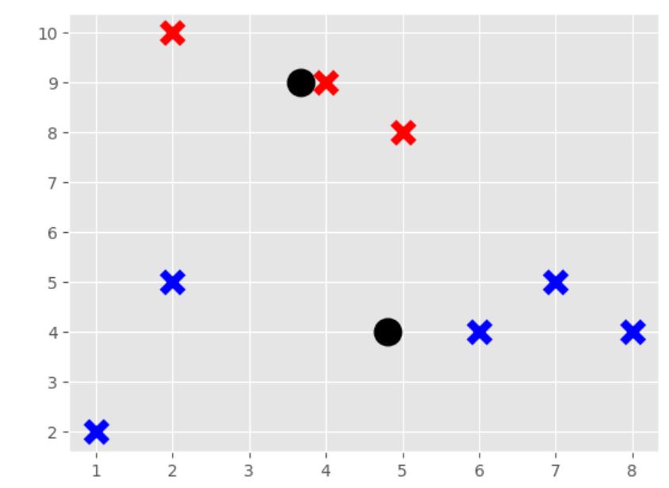

Part 2:

# Code:

# Using scikit-learn's KMeans

kmeans = KMeans(n_clusters=2)

kmeans.fit(X)

centroids = kmeans.cluster_centers_

labels = kmeans.labels_

# Plot the centroids of each cluster

plt.scatter(centroids[:, 0], centroids[:, 1], marker="o", color="k", s=150, linewidths=5)

# Plot the data points for each cluster

for cluster_num in range(kmeans.n_clusters):

color = 'r' if cluster_num == 0 else 'b'

plt.scatter(X[labels == cluster_num][:, 0], X[labels == cluster_num][:, 1],

marker="x", color=color, s=150, linewidths=5)

plt.xlabel('X1')

plt.ylabel('X2')

plt.title('KMeans Clustering')

plt.show()

# Output:  
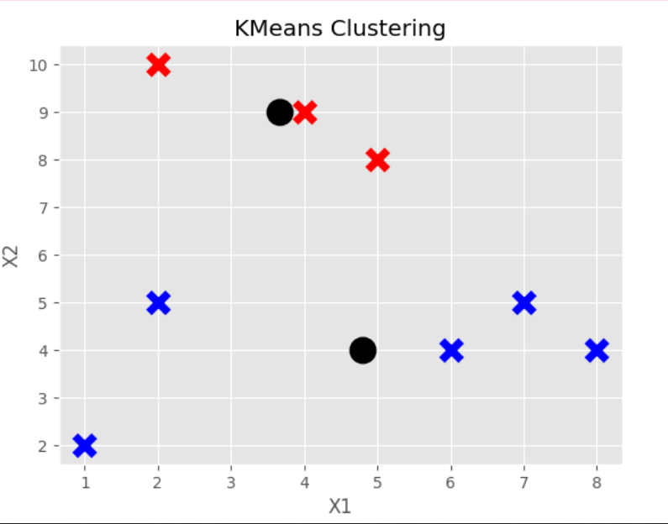

Post lab:

1. Differentiate K-means and K-medoid algorithms with one example

Ans:

**1. K-Means:**

• Centroid-Based Clustering: In order to reduce the sum of squared distances, K-Means divides data into K clusters according to the centroids.

• Centroid as Representative: The centroid of each cluster—which might not actually be a data point—serves as its representative.

• Sensitive to Outliers: Because squared distances are used, it is sensitive to outliers. • Computational Efficiency: For large datasets, generally faster and more scalable. One example would be to identify market segments by classifying customers based on their past purchases.

1. **K-Medoid:**

• Medoids-Based Clustering: Using real data points (medoids) as cluster representatives, K-Medoid clusters data into K groups.

• Using a Medium as a Representative: Real data points, which are more resilient to outliers, are used to represent each cluster.

• Robust to Outliers: Because absolute distances are used, it is less susceptible to outliers.

• Computational Complexity: When dealing with large datasets, computational complexity is higher than with K-Means.

• As an illustration, consider grouping cities according to travel times, with the medoid designating the location with the shortest overall distance to other cities.

1. List the packages/ libraries of python used in experiments.

Ans:

The following packages and libraries for Python were used in the code that you submitted: 1. matplotlib.pyplot: This programme is used to create plots and data visualisations, including scatter plots. 2. numpy (np): Used to manipulate arrays and perform numerical operations.

3. matplotlib.style: This specifies the plot style, which is 'ggplot' in this example. 4. KMeans from sklearn.cluster: This K-Means clustering tool was imported from Scikit-Learn.

**Conclusion:**

We learnt to Implement K-mean clustering algorithm to group similar data objects.