**MODULE – 4**

1. Write a program to demonstrate different Window handling events.

**CODE:**

import javax.swing.*;

import java.awt.*;

import java.awt.event.*;

public class Question1 extends Frame implements WindowListener {

Question1() {

addWindowListener(this);

setSize (400, 400);

setLayout (null);

setVisible (true);

}

public static void main(String[] args) {

new Question1();

}

public void windowActivated (WindowEvent arg0) {

System.out.println("activated");

}

public void windowClosed (WindowEvent arg0) {

System.out.println("closed");

}

public void windowClosing (WindowEvent arg0) {

System.out.println("closing");

dispose();

}

public void windowDeactivated (WindowEvent arg0) {

System.out.println("deactivated");

}

public void windowDeiconified (WindowEvent arg0) {

System.out.println("deiconified");

}

public void windowIconified(WindowEvent arg0) {

System.out.println("iconified");

}

public void windowOpened(WindowEvent arg0) {

System.out.println("opened");

}

}

**OUTPUT:**

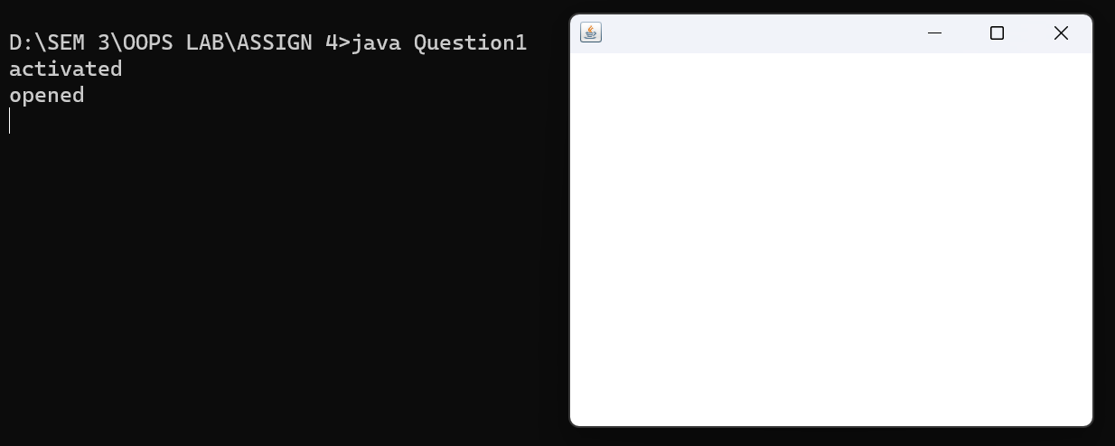

activated

opened

closing

deactivated

closed

2. Write a program to demonstrate different mouse handling events like mouseClicked(), mouseEntered(), mouseExited(), mousePressed, mouseReleased() and mouseDragged().

**CODE:**

import java.awt.*;

import java.awt.event.*;

import javax.swing.*;

public class Question2 extends JFrame implements MouseListener{

Label l;

Question2(){

addMouseListener(this);

setDefaultCloseOperation(EXIT_ON_CLOSE);

l=new Label();

l.setBounds(20,50,100,20);

add(l);

setSize(300,300);

setLayout(null);

setVisible(true);

}

public static void main(String[] args) {

new Question2();

}

public void mouseClicked(MouseEvent e) {

l.setText("Mouse Clicked");

System.out.println("Mouse clicked");

}

public void mouseEntered(MouseEvent e) {

l.setText("Mouse Entered");

System.out.println("Mouse entered");

}

public void mouseExited(MouseEvent e) {

l.setText("Mouse Exited");

System.out.println("Mouse exited");

}

public void mousePressed(MouseEvent e) {

l.setText("Mouse Pressed");

System.out.println("Mouse pressed");

}

public void mouseReleased(MouseEvent e) {

l.setText("Mouse Released");

System.out.println("Mouse released");

}

}

**OUTPUT:**

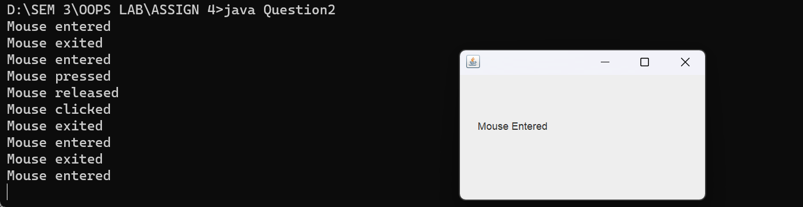

Mouse entered

Mouse exited

Mouse entered

Mouse pressed

Mouse released

Mouse clicked

Mouse exited

Mouse entered

Mouse exited

Mouse entered

Mouse exited

Mouse entered

Mouse exited

3. Write a program to demonstrate different keyboard handling events.

**CODE:**

import javax.swing.*;

import java.awt.*;

import java.awt.event.*;

class Question3 implements KeyListener, ActionListener {

static JFrame frame;

static JTextField input, output;

public static void main(String[] args) {

frame = new JFrame("Question 3");

frame.setSize(500, 500);

frame.setLayout(null);

output = new JTextField();

output.setBounds(0, 0, 500, 50);

frame.add(output);

input = new JTextField();

input.setBounds(0, 400, 500, 50);

frame.add(input);

JButton exit = new JButton("Exit");

exit.setBounds(220, 200, 60, 30);

frame.add(exit);

Question3 obj = new Question3();

input.addKeyListener(obj);

exit.addActionListener(obj);

frame.setVisible(true);

}

public void actionPerformed(ActionEvent ae) {

frame.dispose();

}

public void keyReleased(KeyEvent e) {

output.setText("");

output.setText("Key Released : "+e.getKeyCode());

if(Character.isLetter(e.getKeyChar()))

keyTyped(e);

if(Character.isDigit(e.getKeyChar()))

keyTyped(e);

}

public void keyPressed(KeyEvent e) {

output.setText("");

output.setText("Key Pressed : "+e.getKeyCode());

if(Character.isLetter(e.getKeyChar()))

keyTyped(e);

if(Character.isDigit(e.getKeyChar()))

keyTyped(e);

}

public void keyTyped(KeyEvent e) {

output.setText("");

output.setText("Key Typed : "+e.getKeyChar());

}

}

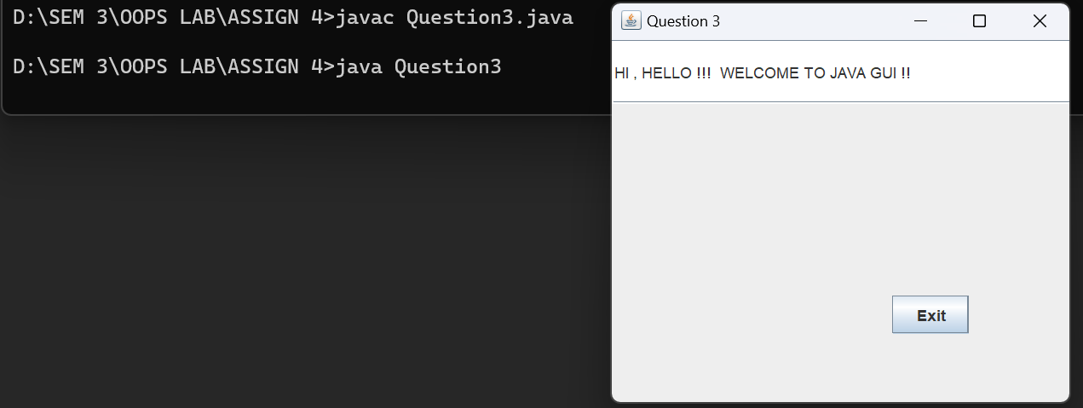**OUTPUT:**

4. Write a program to generate a window without an applet window using main() function.

**CODE:**

import javax.swing.*;

class Question4 {

public static void main(String[] args) {

JFrame frame = new JFrame("Question 4");

frame.setSize(300, 300);

frame.add(new JTextField("Hello, World"));

frame.setVisible(true);

frame.setDefaultCloseOperation(JFrame.EXIT_ON_CLOSE);

}

}

**OUTPUT:**

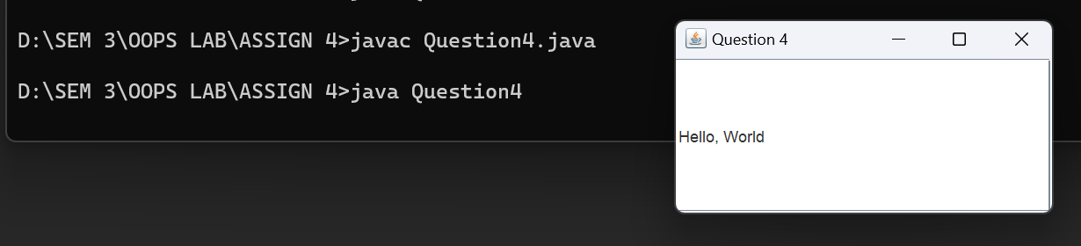

5. Write a program to demonstrate the use of push buttons.

**CODE:**

import javax.swing.*;

import java.awt.*;

import java.awt.event.ActionEvent;

import java.awt.event.ActionListener;

class Question5 {

public static void main(String[] args) {

new Question5();

}

ActionListener e=new ActionListener() {

public void actionPerformed(ActionEvent e) {

JOptionPane.showMessageDialog(null,"You have clicked the button");

}

};

public Question5() {

JFrame f = new JFrame();

JButton b1 = new JButton();

b1.setText("CLICK ME");

b1.addActionListener(e);

f.add(b1);

f.setLayout(new FlowLayout());

f.setVisible(true);

f.setSize(400, 400);

f.setDefaultCloseOperation(JFrame.EXIT_ON_CLOSE);

}

}

**OUTPUT:**

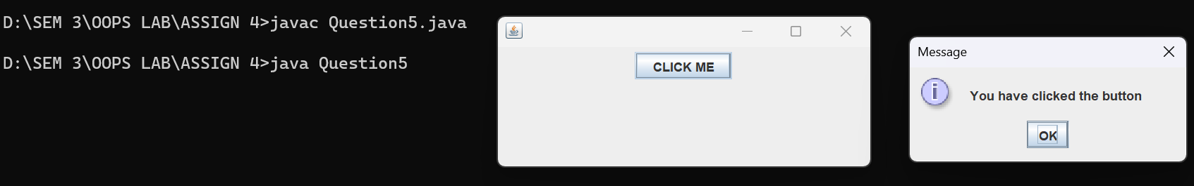

6. WAP to create a Menu using the frame.

**CODE:**

import javax.swing.*;

import java.util.*;

import java.awt.*;

public class Question6 {

public Question6() {

JFrame f = new JFrame("Checkbox Example");

String[] langs = {"WRAP", "PIZZA", "COKE", "TEA"};

int xDisp = 100, yDisp = 30, width = 75, height = 75;

ArrayList<JCheckBox> checkBoxes = new ArrayList<JCheckBox>();

for(int i = 0; i < langs.length; i++) {

checkBoxes.add(new JCheckBox(langs[i], false));

checkBoxes.get(i).setBounds(xDisp, yDisp, width, height);

yDisp += 50;

}

for(JCheckBox checkBox: checkBoxes)

f.add(checkBox);

JButton btn = new JButton("Submit");

btn.setBounds(xDisp, yDisp + 50, 100, 50);

f.add(btn);

f.setLayout(null);

f.setSize(400, 400);

f.setVisible(true);

f.setDefaultCloseOperation(JFrame.EXIT_ON_CLOSE);

}

public static void main(String[] args) {

new Question6();

}

}

**OUTPUT:**

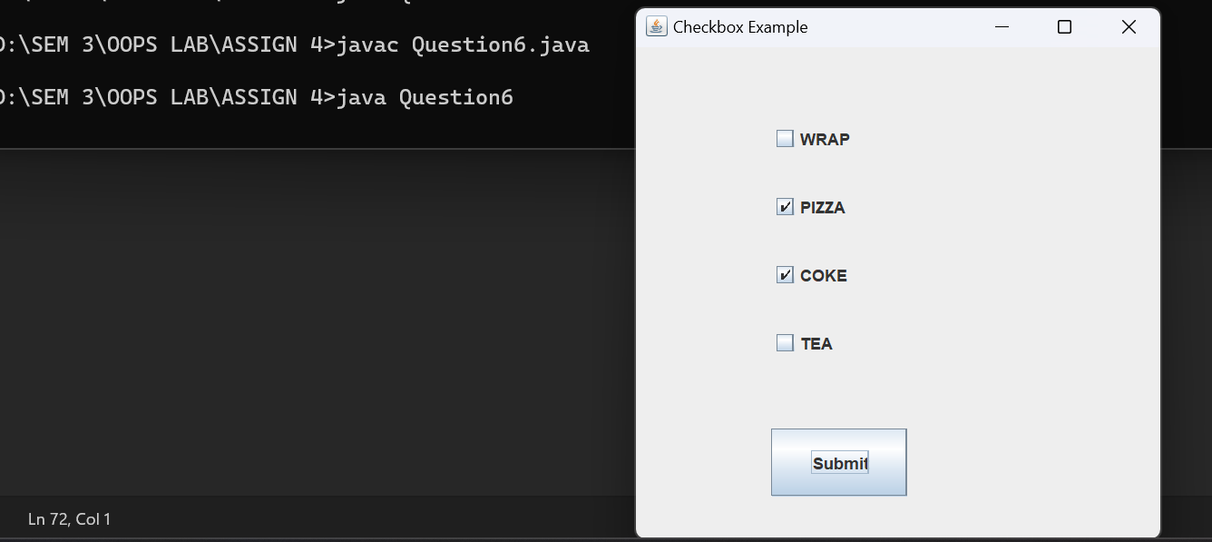

7. WAP to create a Frame that display the student information.

**CODE:**

import javax.swing.*;

import java.awt.*;

import java.util.*;

class Student {

JLabel L1, L2, L3;

JTextField tf1, tf2, tf3;

public Student() { initGui(); }

public void initGui() {

Scanner sc = new Scanner(System.in);

JFrame frame = new JFrame("Student Information");

this.L1 = new JLabel("Roll Number: ");

this.L2 = new JLabel("Name of the student: ");

this.L3 = new JLabel("Branch: ");

this.tf1 = new JTextField(20);

this.tf2 = new JTextField(20);

this.tf3 = new JTextField(20);

System.out.print("Enter roll number: ");

String rollNumber = sc.nextLine();

System.out.print("Enter name: ");

String name = sc.nextLine();

System.out.print("Enter branch: ");

String branch = sc.nextLine();

this.tf1.setText(rollNumber);

this.tf2.setText(name);

this.tf3.setText(branch);

Container container = frame.getContentPane();

container.setLayout(new GridLayout(3, 2));

// container.setLayout(null);

container.add(this.L1);

container.add(this.tf1);

container.add(this.L2);

container.add(this.tf2);

container.add(this.L3);

container.add(this.tf3);

frame.setSize(350, 300);

frame.setVisible(true);

frame.setDefaultCloseOperation(JFrame.EXIT_ON_CLOSE);

}

}

public class Question7 {

public static void main(String[] args) {

new Student();

}

}

**OUTPUT:**

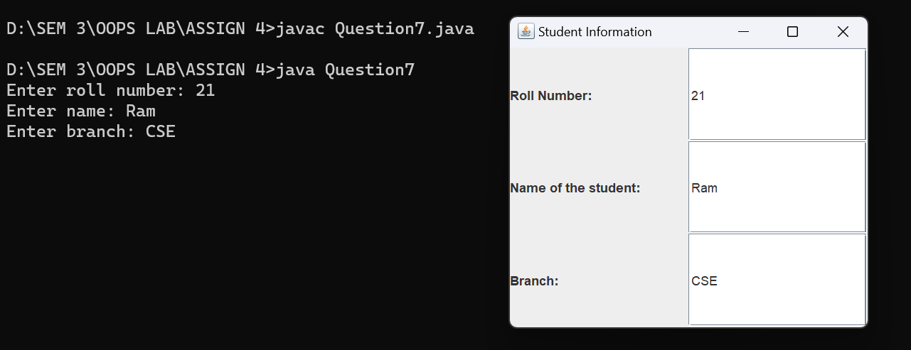

8. WAP to create a Dialogbox.

**CODE:**

import javax.swing.*;

public class Question8 {

Question8() {

JFrame frame = new JFrame();

String name = JOptionPane.showInputDialog(frame, "Enter your name: ");

JOptionPane.showMessageDialog(frame, "Hello " + name);

frame.setDefaultCloseOperation(JFrame.EXIT_ON_CLOSE);

}

public static void main(String[] args) {

new Question8();

System.exit(0);

}

}

**OUTPUT:**

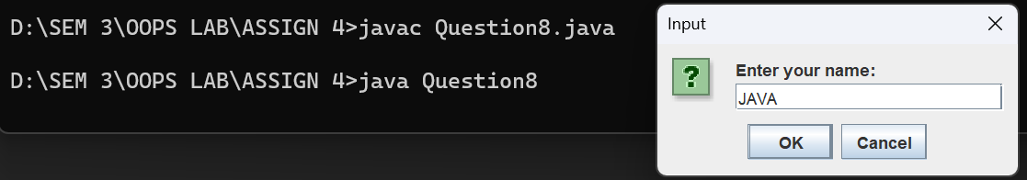

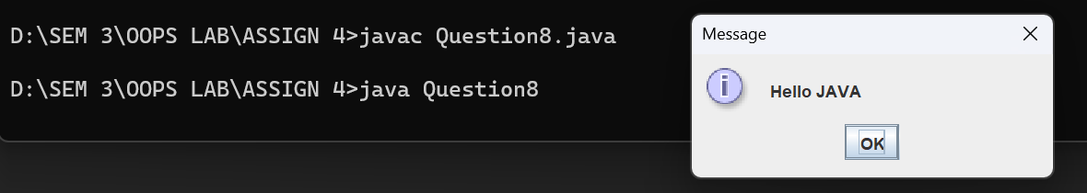

9. WAP to implement the FlowLayout and BorderLayout.

**CODE:**

import javax.swing.*;

import java.awt.*;

class Question9 {

private static void buildButton(String value, Color color, JPanel toAdd) {

JButton button = new JButton(value);

button.setForeground(color);

toAdd.add(button);

}

public static void main(String[] args) {

JFrame frame = new JFrame("Question 9");

frame.setSize(600, 600);

JPanel buttonPanel = new JPanel(new FlowLayout());

buildButton("BLUE", Color.BLUE, buttonPanel);

buildButton("ORANGE", Color.ORANGE, buttonPanel);

buildButton("RED", Color.RED, buttonPanel);

buildButton("GREEN", Color.GREEN, buttonPanel);

buildButton("PINK", Color.PINK, buttonPanel);

JPanel mainPanel = new JPanel(new BorderLayout());

mainPanel.add(buttonPanel, BorderLayout.SOUTH);

mainPanel.add(new JButton("NORTH"), BorderLayout.NORTH);

mainPanel.add(new JButton("WEST"), BorderLayout.WEST);

mainPanel.add(new JButton("EAST"), BorderLayout.EAST);

mainPanel.add(new JLabel("CENTER"), BorderLayout.CENTER);

frame.setContentPane(mainPanel);

frame.setVisible(true);

frame.setDefaultCloseOperation(JFrame.EXIT_ON_CLOSE);

}

}

**OUTPUT:**

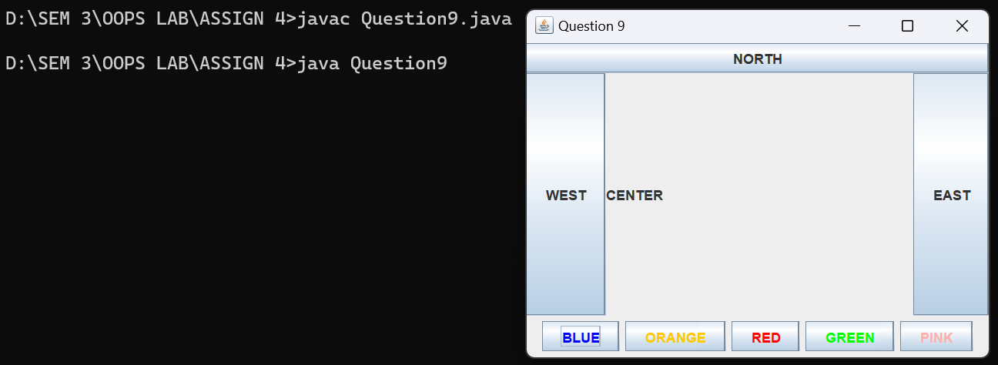

10. WAP to implement the GridLayout and CardLayout.

**CODE:**

import javax.swing.*;

import java.awt.*;

class Question10 {

public static void main(String[] args) {

JFrame frame = new JFrame("Question 10");

JPanel panel = new JPanel();

panel.setLayout(new GridLayout(3, 3));

JButton button;

for(int i = 1; i < 10; i++) {

button = new JButton(i+"");

panel.add(button);

}

JPanel main = new JPanel();

main.setLayout(new CardLayout(10, 10));

main.add("Numbers", panel);

frame.setContentPane(main);

frame.setSize(300, 300);

frame.setVisible(true);

frame.setDefaultCloseOperation(JFrame.EXIT_ON_CLOSE);

}

}

**OUTPUT:**

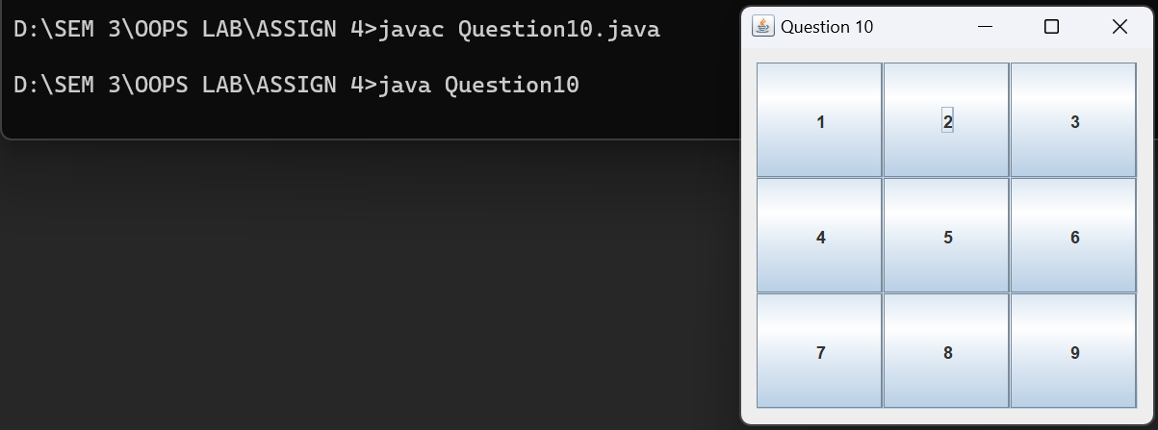

11. WAP to implement the GroupLayout and BoxLayout.

**#GROUPLAYOUT:**

**CODE:**

import javax.swing.*;

import java.awt.*;

import static javax.swing.GroupLayout.Alignment.*;

class GroupLayoutTest {

public static void main(String[] args) {

JFrame frame = new JFrame("GroupLayout Implementation");

frame.setDefaultCloseOperation(JFrame.EXIT_ON_CLOSE);

Container myPanel = frame.getContentPane();

GroupLayout groupLayout = new GroupLayout(myPanel);

groupLayout.setAutoCreateGaps(true);

groupLayout.setAutoCreateContainerGaps(true);

myPanel.setLayout(groupLayout);

JButton b1 = new JButton("Button One");

JButton b2 = new JButton("Button Two");

JButton b3 = new JButton("Button Three");

groupLayout.setHorizontalGroup(groupLayout.createSequentialGroup()

.addGroup(groupLayout.createParallelGroup(LEADING).addComponent(b1).addComponent(b3))

.addGroup(groupLayout.createParallelGroup(TRAILING).addComponent(b2)));

groupLayout.setVerticalGroup(groupLayout.createSequentialGroup()

.addGroup(groupLayout.createParallelGroup(BASELINE).addComponent(b1).addComponent(b2))

.addGroup(groupLayout.createParallelGroup(BASELINE).addComponent(b3)));

frame.pack();

frame.setVisible(true);

}

}

**OUTPUT:**

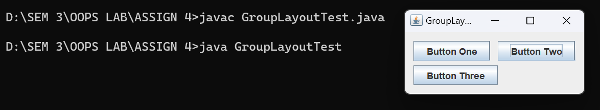

**# BOXLAYOUT:**

**CODE:**

import javax.swing.*;

import java.awt.*;

class BoxLayoutTest{

public static void main(String[] args) {

JFrame frame = new JFrame("Box Layout Implementation");

frame.setDefaultCloseOperation(JFrame.EXIT_ON_CLOSE);

JButton jb1 = new JButton("Button 1 -");

JButton jb2 = new JButton("Button 2 --------");

JButton jb3 = new JButton("Button 3 -");

JButton jb4 = new JButton("Button 4 --------");

JButton jb5 = new JButton("Button 5 -");

JButton jb6 = new JButton("Button 6 --------");

JPanel panel1 = new JPanel();

JPanel panel2 = new JPanel();

JPanel panel3 = new JPanel();

panel1.setBorder(BorderFactory.createTitledBorder("LEFT"));

panel2.setBorder(BorderFactory.createTitledBorder("CENTER"));

panel3.setBorder(BorderFactory.createTitledBorder("RIGHT"));

BoxLayout layout1 = new BoxLayout(panel1, BoxLayout.Y_AXIS);

BoxLayout layout2 = new BoxLayout(panel2, BoxLayout.Y_AXIS);

BoxLayout layout3 = new BoxLayout(panel3, BoxLayout.Y_AXIS);

panel1.setLayout(layout1);

panel2.setLayout(layout2);

panel3.setLayout(layout3);

jb1.setAlignmentX(Component.LEFT_ALIGNMENT);

jb2.setAlignmentX(Component.LEFT_ALIGNMENT);

panel1.add(jb1);

panel1.add(jb2);

jb3.setAlignmentX(Component.CENTER_ALIGNMENT);

jb4.setAlignmentX(Component.CENTER_ALIGNMENT);

panel2.add(jb3);

panel2.add(jb4);

jb5.setAlignmentX(Component.RIGHT_ALIGNMENT);

jb6.setAlignmentX(Component.RIGHT_ALIGNMENT);

panel3.add(jb5);

panel3.add(jb6);

frame.setLayout(new FlowLayout());

frame.add(panel1);

frame.add(panel2);

frame.add(panel3);

frame.pack();

frame.setVisible(true);

}

}

**OUTPUT:**

