PROJECT AND TEAM INFORMATION
Project Title
AI DRIVEN SMART TRAFFIC MANAGEMENT
Student / Team Information
Team Name:  Team # | STAT-IV-T041
Team member 1 (Team Lead) | Bisht, Aditya – 230213801 aadityabisht34@gmail.com  
Team member 2 | Pun, Shivraj – 23011680 @gmail.com  

Team member 3 | Iris Rana, Hanul – 230221555 Hanulirisranal@gmail.com  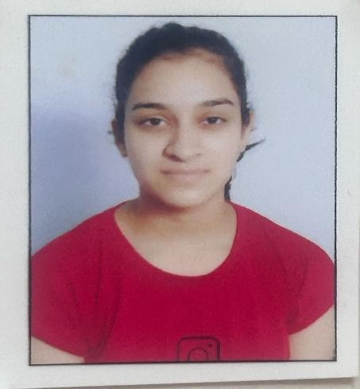
Team member 4 | Kimothi, Aditya – 23021776 adityakimothi31@gmail.com  

PROPOSAL DESCRIPTION
Motivation (1 pt)
Urban areas suffer from unpredictable traffic congestion, leading to delays, fuel waste, and frustration. Current traffic signals operate on fixed timers, which fail to account for real-time congestion levels. We aim to create a machine learning-based system that predicts traffic congestion at major intersections using historical data (time, day, vehicle count), enabling dynamic traffic light adjustments and better planning for peak times. Our system focuses on prediction, not hardware deployment, making it simple, cost-effective, and student-project-friendly.

State of the Art / Current solution (1 pt)
Traditional systems use static timers for traffic lights. Some advanced systems rely on sensors, cameras, and IoT devices to dynamically adapt signal timings. However, such systems are expensive and require significant physical infrastructure and maintenance.
In contrast, our approach utilizes the R programming language to build a flexible, efficient, and data-driven traffic analysis system based entirely on historical and user-fed traffic data. R’s powerful data manipulation, statistical modelling, and visualization capabilities make it ideal for analysing complex traffic patterns and making accurate predictions.
This software-first approach ensures greater accessibility, especially for educational, research, or pilot-level deployments, where infrastructure budgets are limited but data insights are still crucial. R enables rapid development of predictive models—from data cleaning and preprocessing to statistical analysis—within a robust and well-supported ecosystem.
The system is also designed to be extensible, allowing potential future integration with IoT-based infrastructure if needed, while keeping the core solution lightweight and cost-effective.
Project Goals and Milestones (2 pts)
(Describe the project general goals. Include initial milestones as well any other milestones. Max 300 words).
Goal 1: Gather and preprocess publicly available or simulated traffic data

Goal 2: Build a regression-based ML model to predict congestion based on day/time Goal 3: Train and test the model for accuracy
Goal 4: Create a web-based visualization (Streamlit) showing congestion predictions

Goal 5: Allow user to input data and receive traffic level prediction
Milestones will be tracked weekly with deliverables like cleaned datasets, trained models, and frontend integration. responsiveness of predictions.
Project Approach (3 pts)
We will use Python, Pandas, Scikit-learn, and Streamlit. The traffic dataset (simulated or public) will contain fields like time of day, day of week, and vehicle count.

R programing language for entire pipelining: Linear regression, via packages. Target: Predict congestion level as a numeric index
Frontend: Streamlit for visual interaction with the model
The model will be trained and validated, then wrapped with an interface where users can input day/time to see predicted congestion.

System Architecture (High Level Diagram)(2 pts)
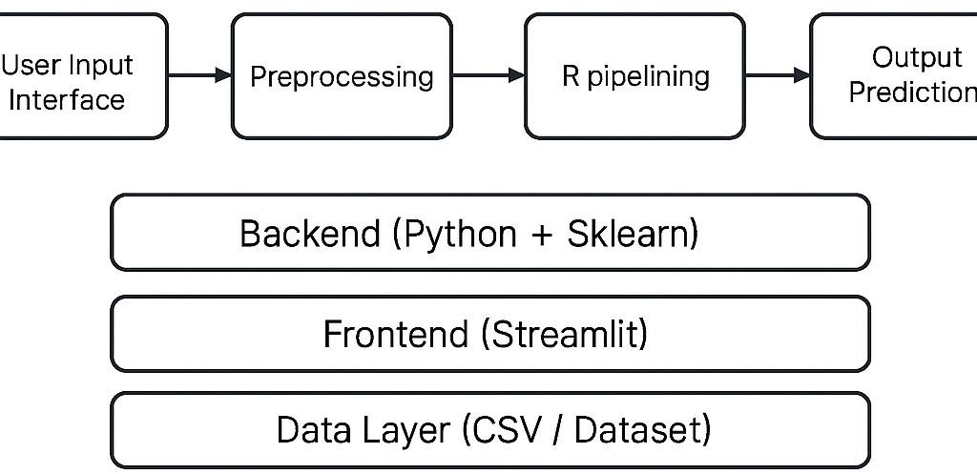

Project Outcome / Deliverables (1 pts)
- An R-based engine for traffic congestion prediction
- A web-based app interface (Streamlit)
- Documentation of implementation, dataset, and performance metrics
- Future scope section for IoT extension (optional)

Assumptions
Historical traffic data is available or can be reasonably simulated Traffic patterns follow predictable trends based on time and day
References
1 GeeksforGeeks:
GeeksforGeeks is a computer science portal providing tutorials, algorithms, coding challenges, and programming articles.
URL: https://www.geeksforgeeks.com/ 2 Wikipedia:
Wikipedia is a free online encyclopaedia offering detailed information on a wide range of topics including traffic management and congestion.
URL: https://www.wikipedia.org/
3 The R Project for Statistical Computing
R is a programming language and environment widely used for statistical computing, data analysis, and machine learning.
Official Site: https://www.r-project.org/

