Assignment 7

**Aim:** Design and develop custom Application (Mini Project) using Salesforce Cloud.

**Objective:** To create an custom application on Salesforce Lightning platform.

**Software / Hardware Requirements:** OS - Windows / Ubuntu, Google Chrome.

**Theory:**

1. Salesforce:

Salesforce is a cloud computing service as a software (SaaS) company that specializes in customer relationship management (CRM). Salesforce's services allow businesses to use cloud technology to better connect with customers, partners and potential customers. The software has become the number one for customer success and helps businesses track customer activity, market to customers and many more services. Salesforce is a [customer relationship management](https://www.salesforce.com/eu/learning-centre/crm/what-is-crm/) solution that brings companies and customers together. It is one integrated CRM platform that gives all your departments — including marketing, sales, commerce, and service — a single, shared view of every customer.

1. Salesforce Lightning Experience:

Salesforce Lightning Experience is simply referred to as *“*Lightning*”*. When working with lightning Salesforce we will learn about different Salesforce lightning topics like Lightning Login, Lightning App Builder, Lightning for Outlook, Salesforce Lightning Components, Lightning Sync and many more. Some of them are applicable in Lightning Experience only, but some others will work in both Lightning Experience and older Classic user interfaces. Lightning Sync is used to sync your user contacts and events between your email server with Salesforce.

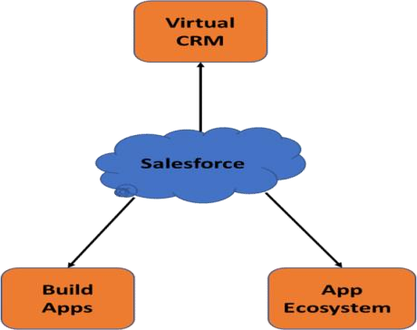

Step 1: Log into Salesforce Developer account.

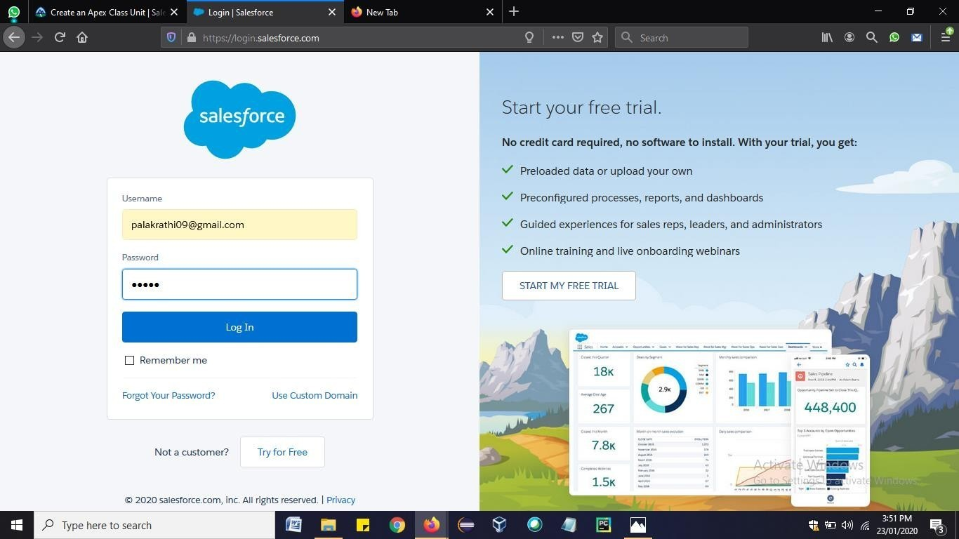

Step 2: Open Salesforce Lightning platform and click on Object Manager => Create => Custom Object.

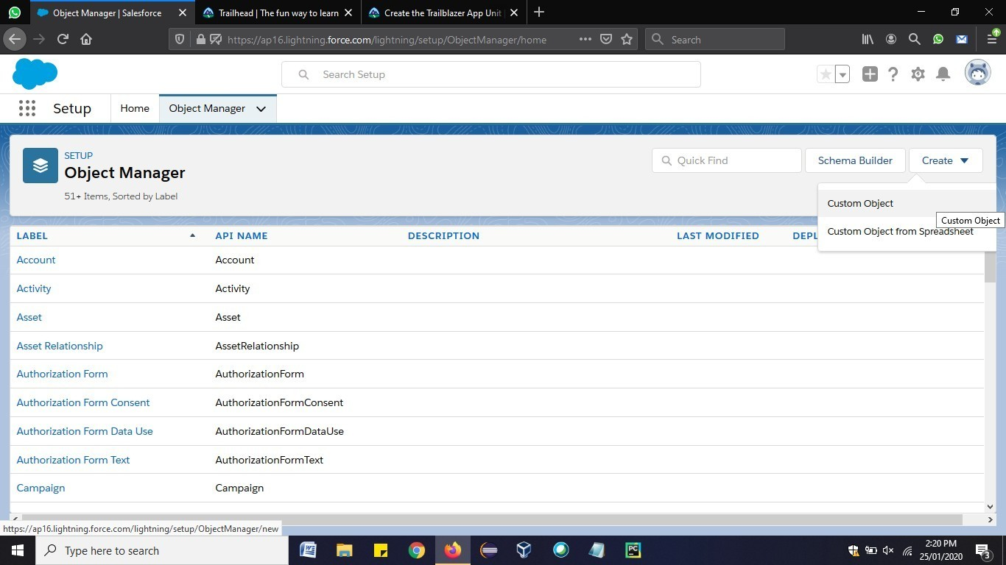

Step 3: Fill in the required fields and under Optional Features, select **Allow Reports** and **Allow Activities**. Click **Save.**

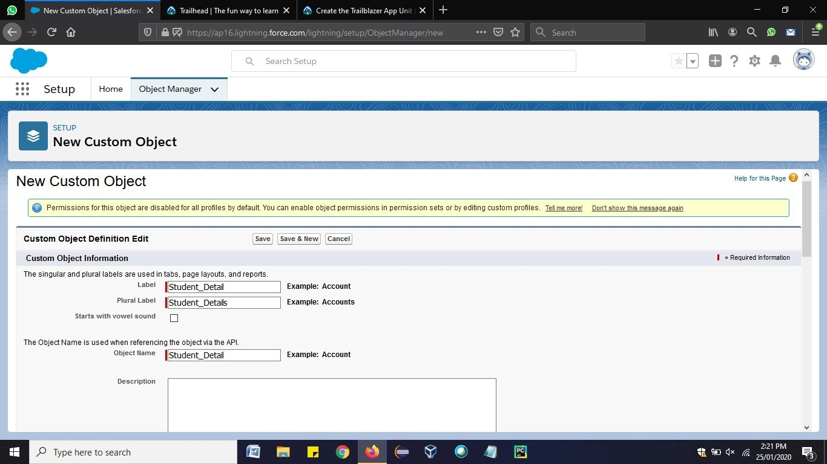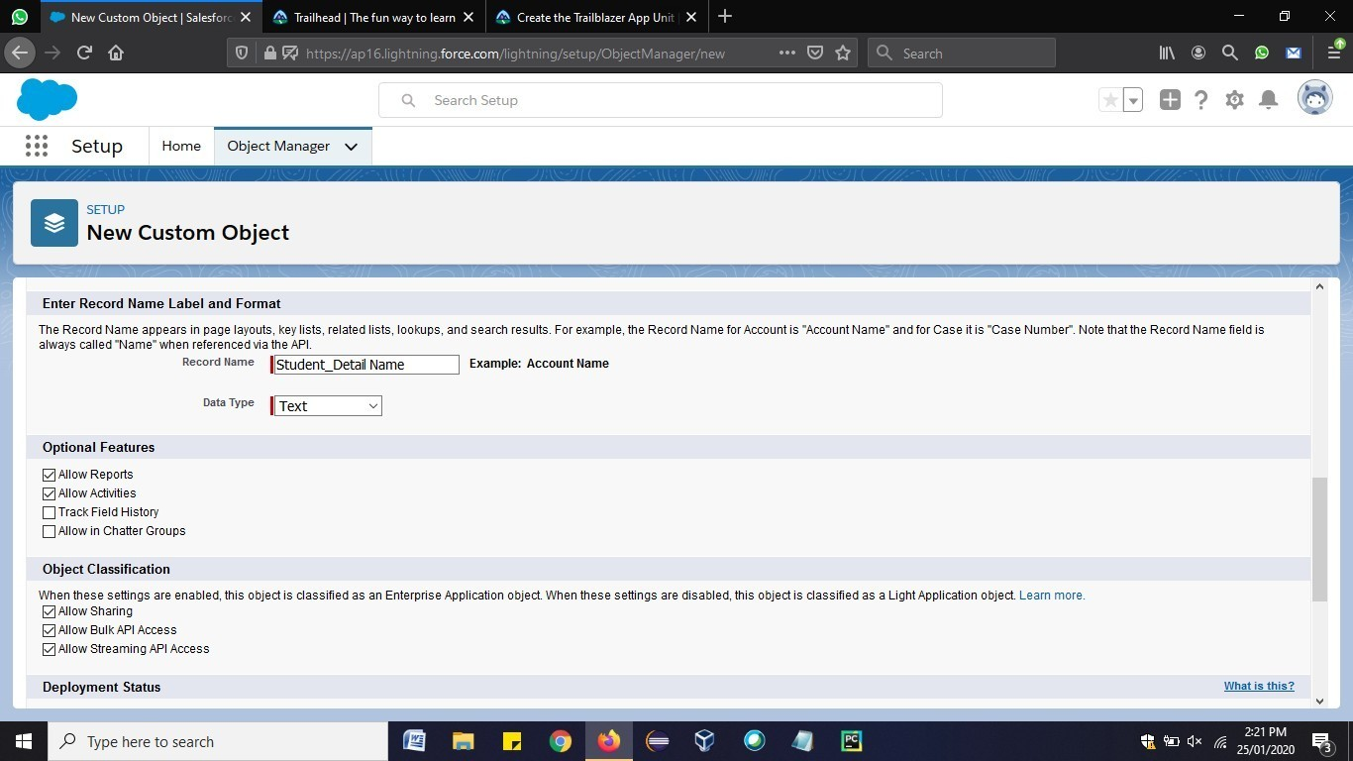

Step 4: Now, Click on Fields & Relations => New.

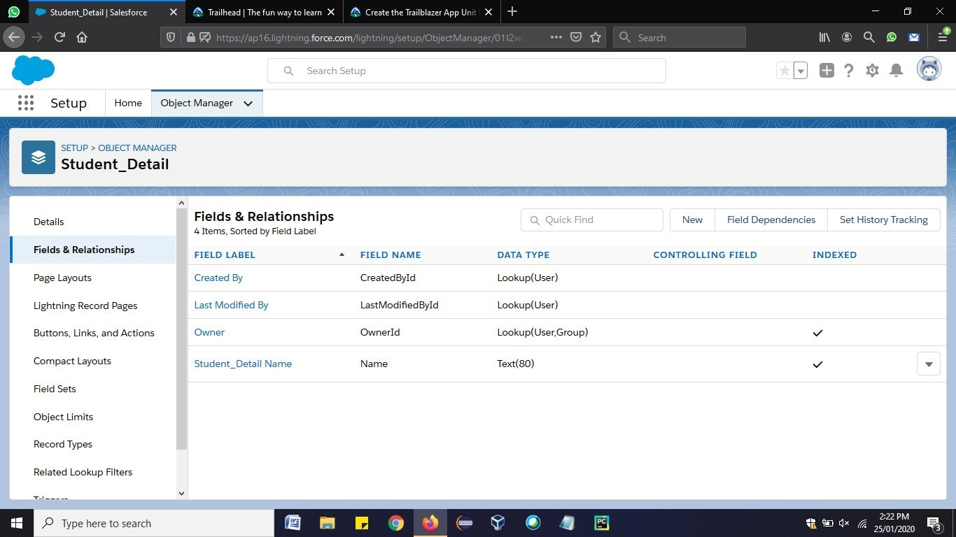

Step 5: Then select option “Email” and click Next-> Next -> Save.

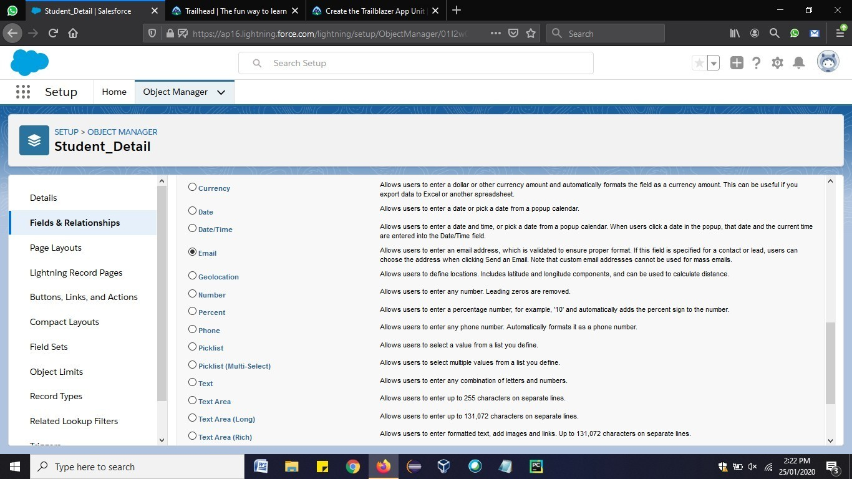

Step 6: Similarly. Repeat steps 4 and 5 to add more fields like Phone, Date of Birth. This is how the custom object will have the various fields.

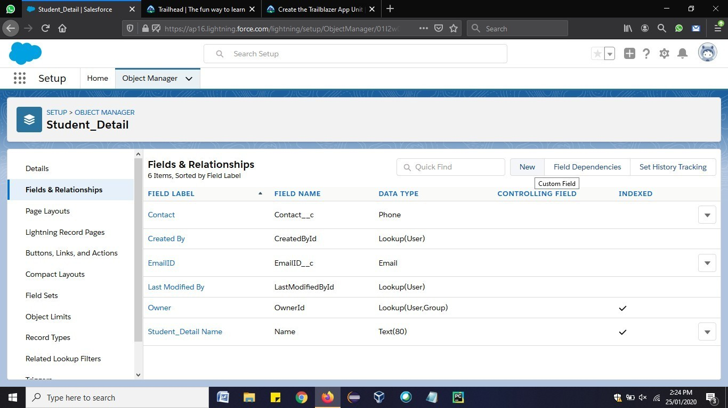

Step 7: Now go to Home => search for “Tabs”. Click on New.

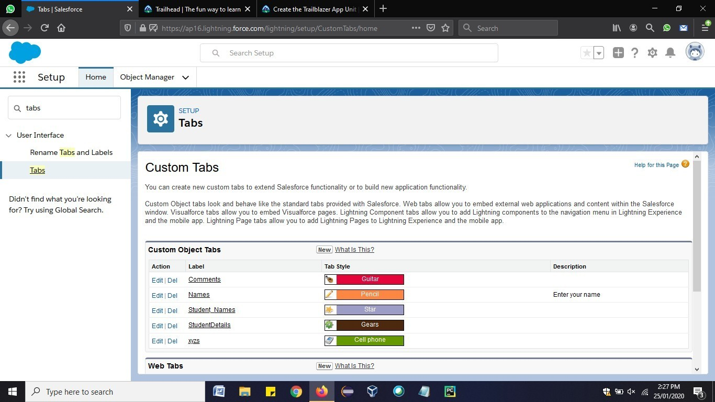

Step 8: Enter the Object name and select any icon for tab style. Leave all defaults as it is. Click

**Next, Next**, and **Save**.

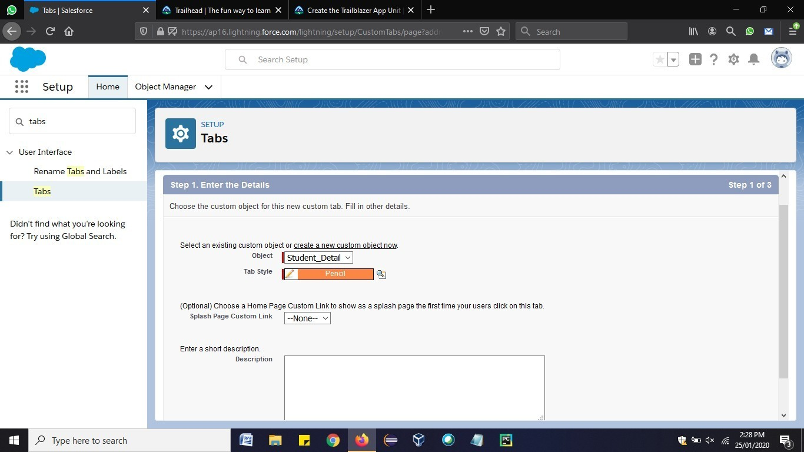

Step 9: In Setup, click **Home**. Enter “App Manager” in Quick Find and select **App Manager**. Click **New Lightning App**.

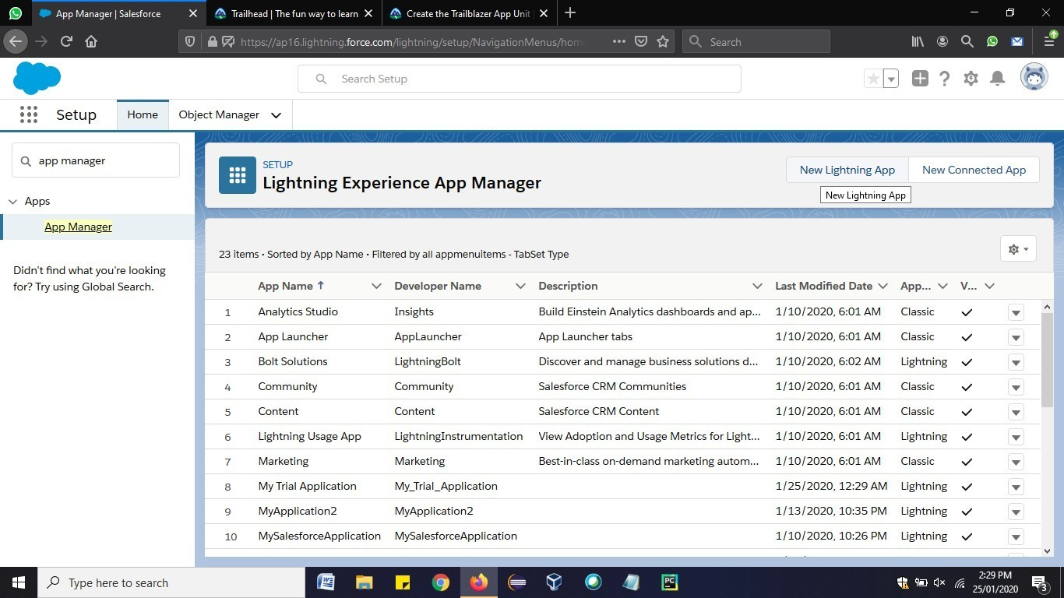

Step 10: Define the new Lightning app as follows:

App Name: Student Details Manager

Developer Name: Student_Details_Manager. Click **Next**.

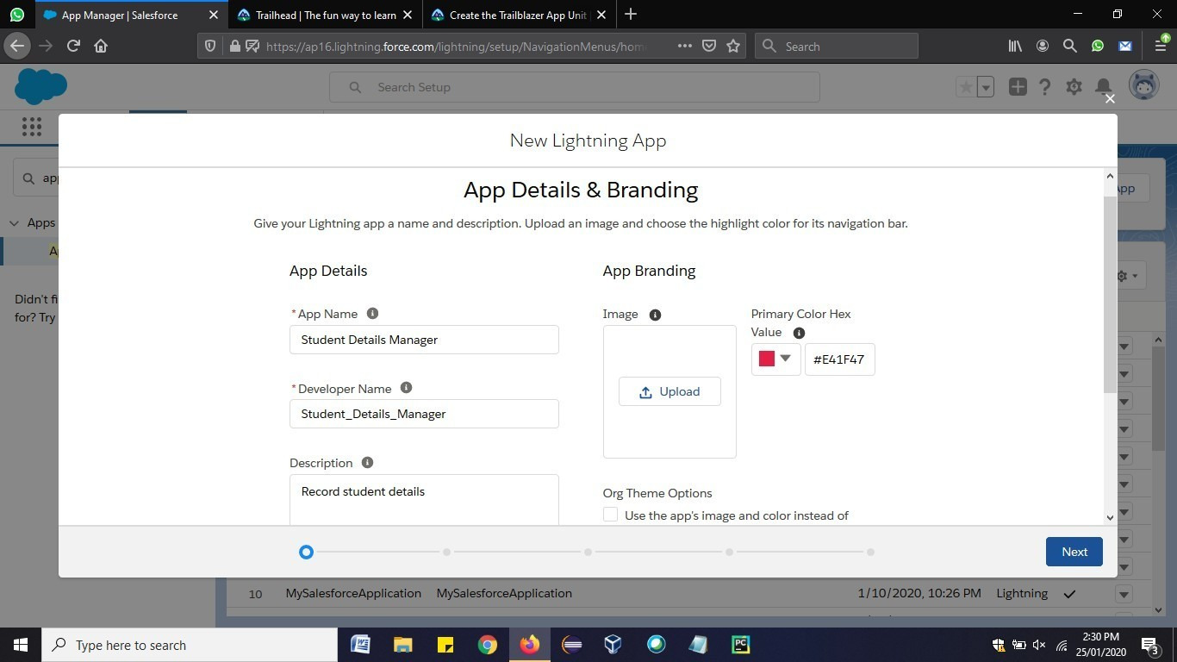

Step 11: On the App Options screen, leave the defaults as is and click **Next**. On the Utility Items screen, leave the defaults as is and click **Next**. On the Navigation Items screen, select **Student_Detail** and move them to the Selected Items box. Then click **Next**.

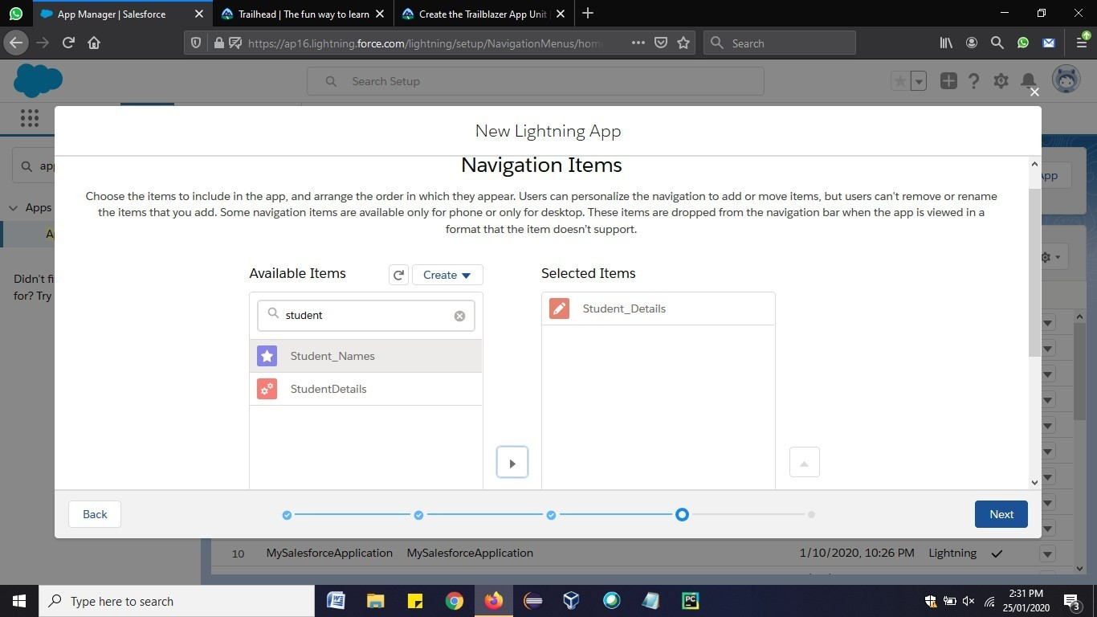

Step 12: On the Assign to User Profiles screen, select **System Administrator** and move it to Selected Profiles. Then click **Save & Finish**.

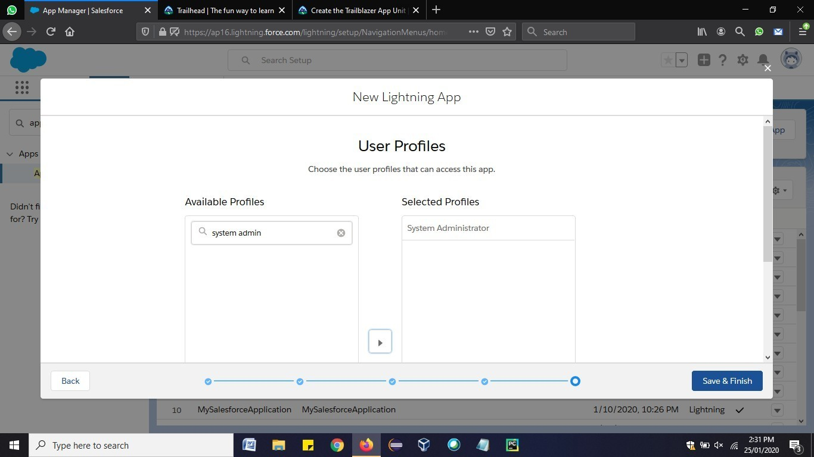

Step 13: Click on App launcher and Open the custom application created.

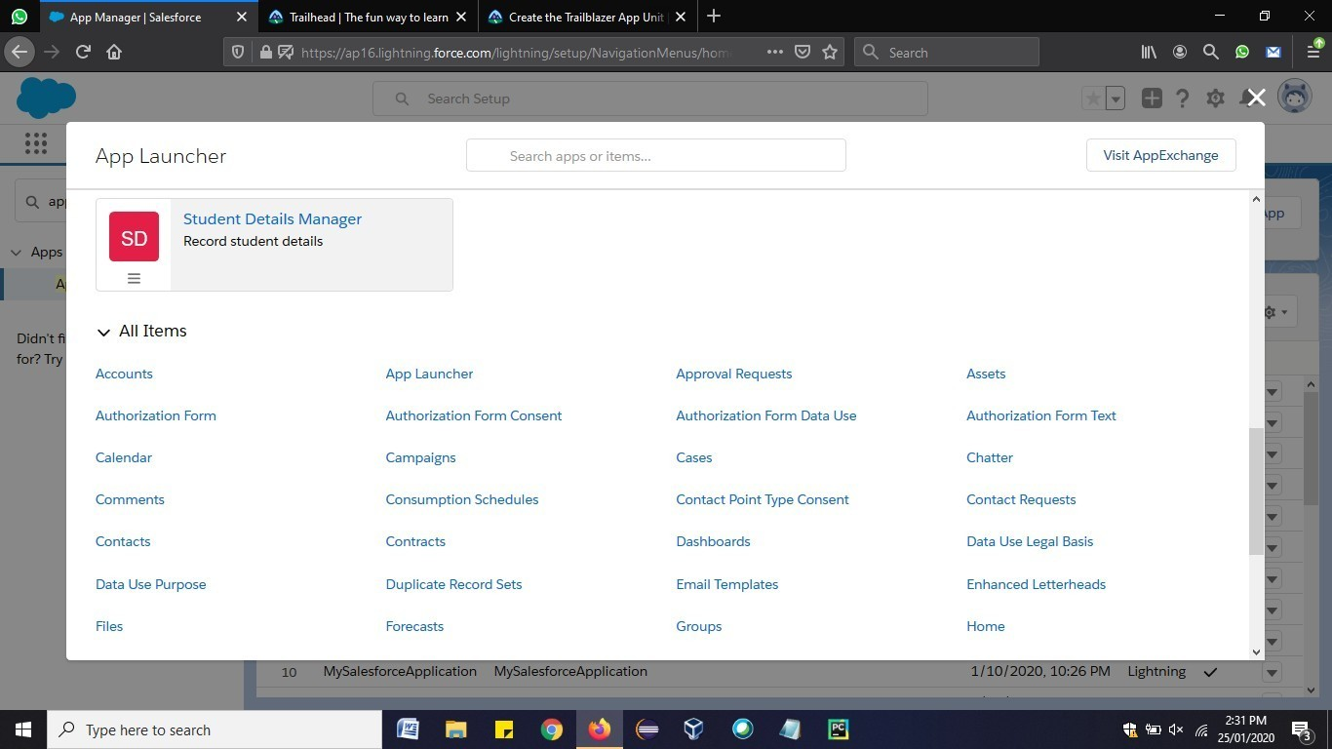

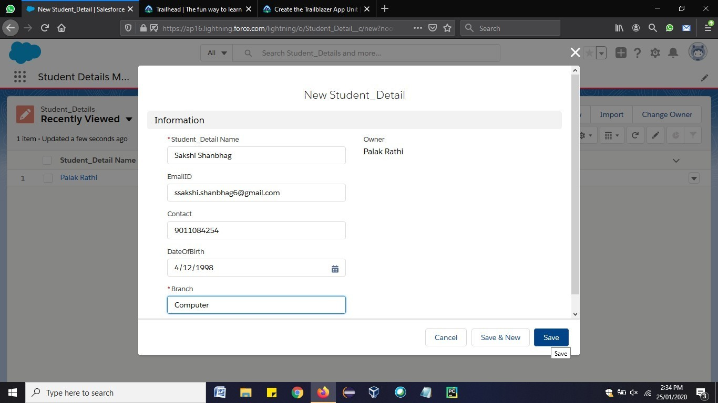

Step 14: Click on Student_Details => New => fill the specified details and copy the URL.

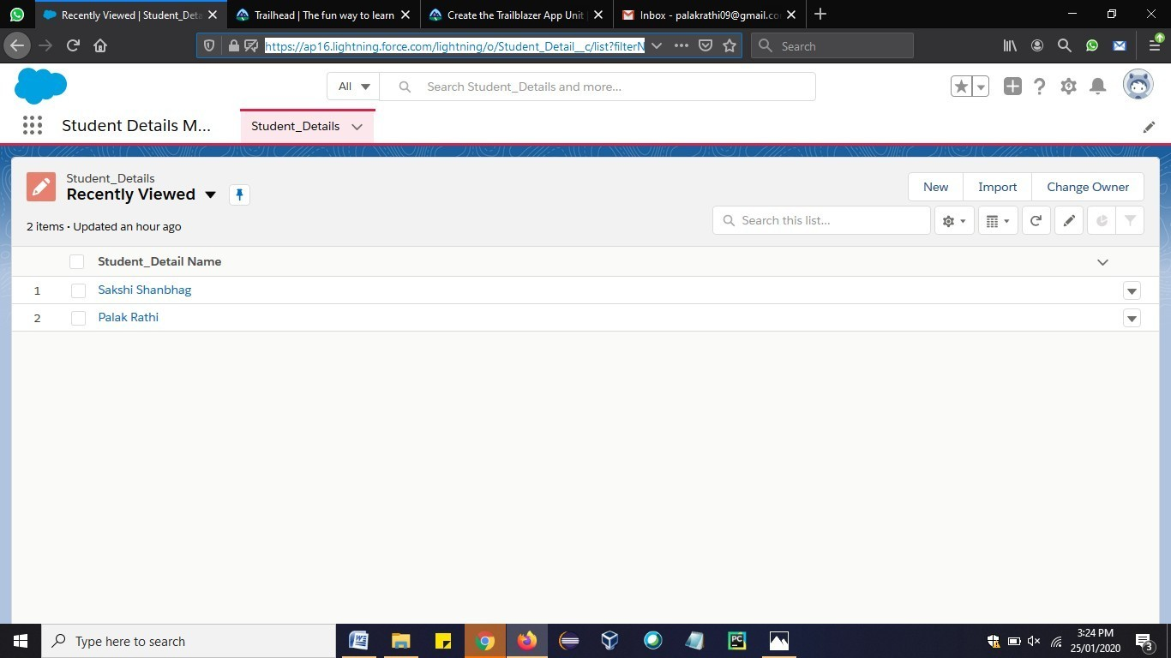

Step 15: Open Google Chrome new Tab => More Tools => Developer Tools and then paste the URL of the application, copied in the previous step.

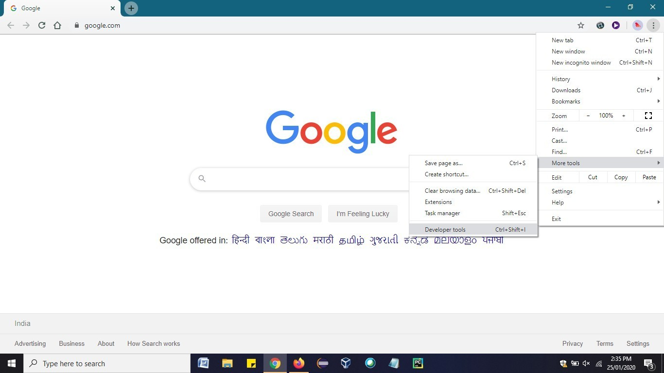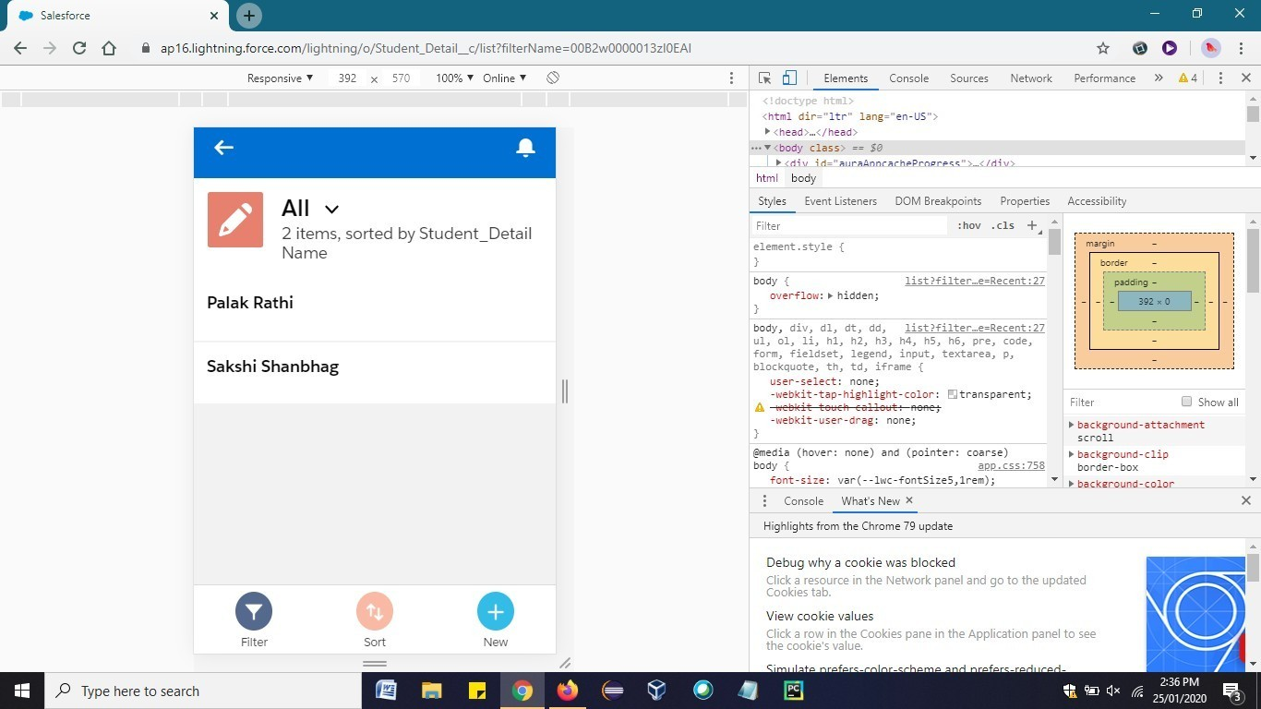

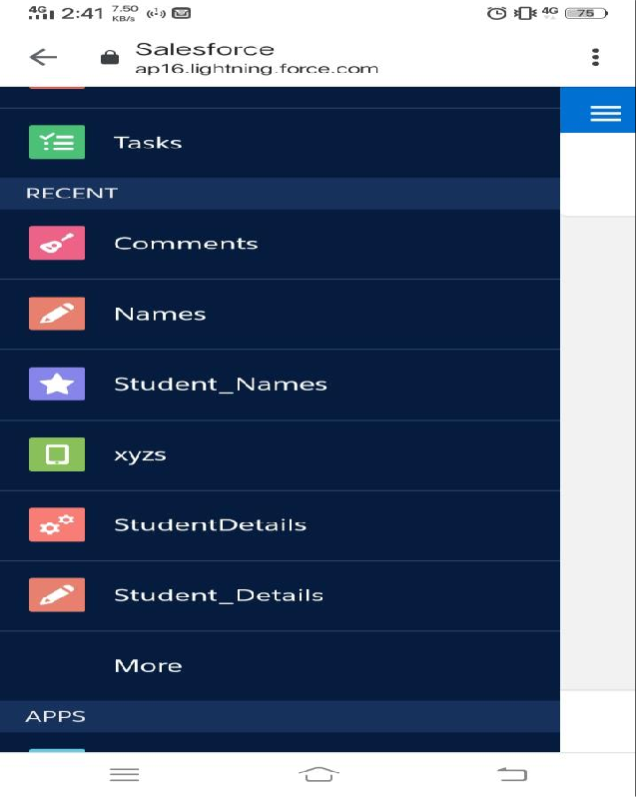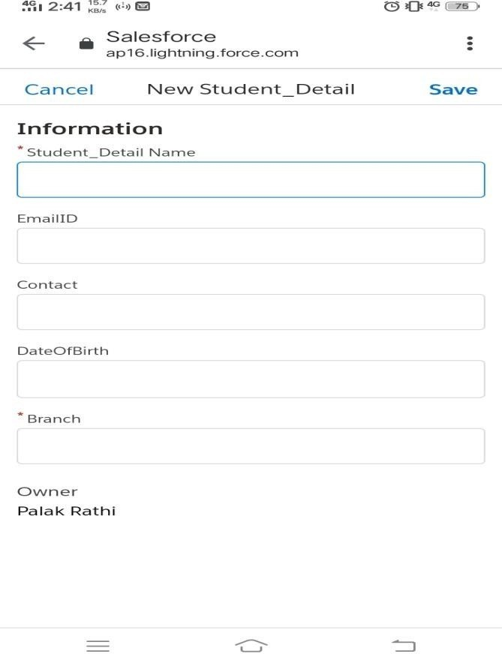

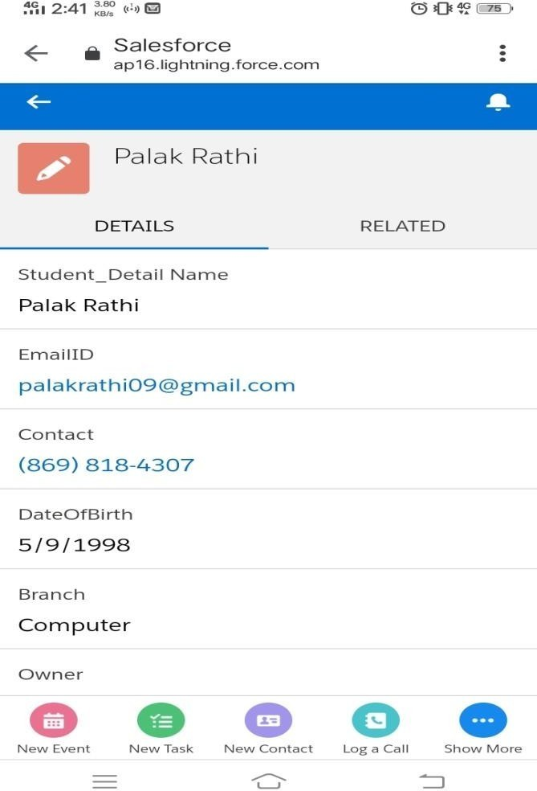

**Conclusion:** We have learnt to create custom application using salesforce Lightning platform.