Game Design Document

Fill up the following document

1. Write the title of your project.

Color Memory

1. What is the goal of the game?

To match the colors with their pair.

1. Write a brief story of your game.

There is not a big story, but, there is a student who would like to go to a lab, but to pass through it he needs slove a simple puzzle in 15 seconds, it’s harder than you think, it requires fast clicking and good memory.

1. Which are the playing characters of this game?

* Playing characters are the ones who respond to the user based on the input from the user.
* Cars, monkeys, dinos, wizards, etc., are the playing characters in the game.

|  |  |  |
| --- | --- | --- |
| Number | Character Name | What can this character do? |
| 1 | Shoto fuyumi | Has good memory and speed. |

1. Which are the Non-Playing Characters of this game?

* Non-Playing characters are the ones that don't have an action or behavior when the user interacts with the game.
* Hurdles, stones, bananas, coins, etc., are non-playing characters in the game.

|  |  |  |
| --- | --- | --- |
| Number | Character Name | What can this character do? |
| 1 | There are none |  |
| 2 |  |  |
| 3 |  |  |
| 4 |  |  |
| 5 |  |  |
| 6 |  |  |
| 7 |  |  |
| 8 |  |  |

Draw your imagination of this game. What does this game look like?

* Draw the game either on your computer or on paper.
* Add images of the game scenes to show each of the playing and non-playing characters at least once.

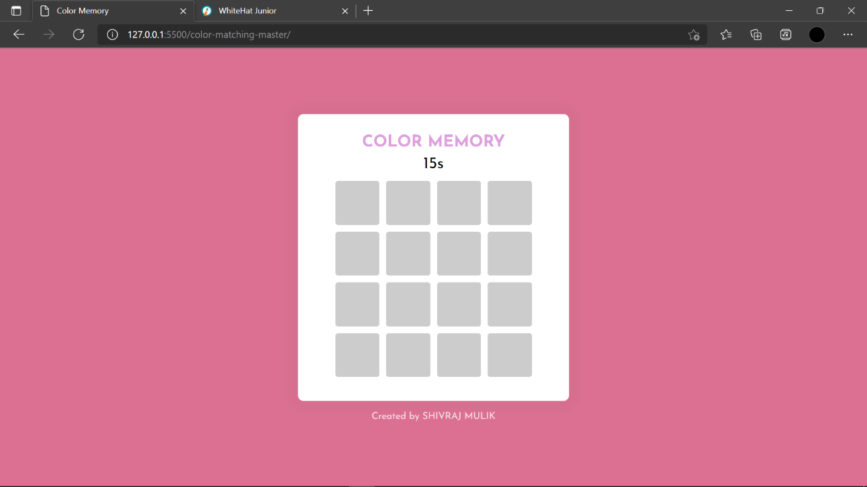

*(Note: This is prototype of my code)*

How do you plan to make your game engaging?

I want it to be very color ful, every time a pair is made, the background will change, this makes it intresting, also the colors are always randomised and this means every time you play you see different varient of the same shade!