Maven

- Command to Create maven project:
mvn archetype:generate -DgroupId=com.pkgs -DartifactId=project_name -DarchetypeArtifactId=maven-archetype-quickstart -DinteractiveMode=false/true

- Some IMP concepts:
- Archetype – An archetype is a project template in Maven.
-A Ready-made project structure.

e.x. 1. Java project
2. Web Project
3. Selenium Project
Why Archetype is used?
- a. Without Archetype:
  - We must manually create folders
  - Create pom.xml
  - Create src/main/java, src/test/java, etc.
- b. With Archetype:
  - Maven creates everything automatically
  - Follows standard structure
  - Saves time and avoids mistakes
How Archetype works?
- When we run → mvn archetype:generate
Maven:
- Downloads the archetype template
- Asks for project details
- Generates the project based on the template

- GroupId:
- groupId is the organization or package name of our project.
e.g com.epam.testing

Why groupId is important?
- Uniquely identifies our project
- Avoids naming conflicts
- Used as Java package structure

How Used?
If groupId is: com.launch.app
Maven Creates: src/main/java/com/launch/app

- ArtifactId:
- artifactId is the project name.
- e.g. automation-framework

Why artifactId is important?
- It becomes:
  - Project folder name
  - JAR file name

How artifactId is Used?
If artifactId is: myapp
Then Maven creates: myapp/
myapp-1.0-SNAPSHOT.jar

- archetypeArtifactId:
What is archetypeArtifactId?
- It specifies which template Maven should use.
- E.g. maven-archetype-quickstart

Why archetypeArtifactId is needed?
- Maven has many archetypes, like:
  - maven-archetype-quickstart -> simple java app
  - maven-archetype-webadd -> Web app
  - maven-archetype-site -> documentation site

How archetypeArtifactId works?
- Maven downloads this template from Maven Central and generates files based on it.

- interactiveMode:
- It controls whether maven asks questions during project creation

Why interactiveMode is used?
- True -> Maven asks details step-by-step
- False -> Maven uses given values directly

How interactiveMode works?
- Interactive mode(default) :
mvn archetype:generate

Maven asks:
groupId?
artifactId?
version?

Non-interactive mode:
-DinteractiveMode=false
Maven:
- Uses command-line values
- No questions
- Faster
- Used in automation / CI/CD

Term | Purpose
Archetype | Project template
groupId | Organization/package
artifactId | Project name
archetypeArtifactId | Template selection
interactiveMode | Prompt control

Q.1. What is Maven?
=> Maven is a build automation tool developed using the Java programming language. It is primarily used for Java-based projects to manage the build process, including source code compilation, testing, packaging, and more. Maven utilizes the Project Object Model (POM), where the pom.xml file describes the project’s configuration and dependency management.

Q.2. Features of Maven?
=> The Maven Build Automation tool provides a lot of features to make the development easy. Below we listed them
- Dependency Management: Automatically downloads and manages external libraries.
- Standard Project Structure: Follows a fixed folder layout for source, test, and other files.
- Build Lifecycle: Defines standard build phases like compile, test, and deploy.
- Plugins: Supports plugins for compiling, testing, packaging, and more.
- POM File: Uses pom.xml to manage configuration and dependencies.
- Central Repository: Fetches dependencies from a shared online repository.
- Build Profiles: Supports different settings for dev, QA, and production.
- Reporting: Can generate Javadoc, test reports, and project documentation.
- IDE Support: Integrates with Eclipse, IntelliJ, NetBeans, etc.

Q.3. Maven Folder Structure?
=> Maven provides a standard Project folder structure you can observe this in the above image.
- src/main/java: It contains the main Java source code.
- src/main/resources: It contains non-Java resources used by the application.
- src/main/webapp: It contains resources for web applications.
- src/test/java: It contains test source code.
- src/test/resources: It contains resources used for testing.
- target: It contains compiled classes, packaged JARs/WARs, and other built artifacts.
- pom.xml: The Project Object Model file that defines the project configuration, dependencies, and build settings.

Q.4. Maven Build Lifecycle?
- Validate: This phase is responsible for validates if the project structure is correct or not.
- Compile: It compiles the source code, converts the .java files to .class, and stores these classes in the target/classes folder.
- Test: It runs unit tests for the maven project
- Package: This phase is responsible for distribute complied code in the format of WAR, JAR and others.
- Integration test: It runs the integration tests for the maven project
- Verify: verify that the project is valid and meets the quality standards.
- Install: This phase is responsible for install packaged code on the system.
- Deploy: copies the packaged code to the remote repository for deployment then other developers can easily access this one.

Q.4. Maven Architecture?
1. The POM (Project Object Model)
The pom.xml is the brain of a Maven project. It contains everything Maven needs to know:
- Identity: groupId (Company), artifactId (Project Name), version.
- Dependencies: External libraries (log4j, junit).
- Plugins: Tools to compile code, run tests, or create JARs.
2. Repositories (Where the JARs Live)
Maven never stores libraries inside your project folder. It downloads them from the internet to a local cache.
1. Local repository: A local repository is a directory on the machine of developer. This repository contains all the dependencies Maven downloads. Maven only needs to download the dependencies once, even if multiple projects depends on them (e.g. ODBC). By default, maven local repository is user_home/m2 directory.
Example - C:\Users\asingh\.m2
2. Central repository: The central Maven repository is created Maven community. Maven looks in this central repository for any dependencies needed but not found in your local repository. Maven then downloads these dependencies into your local repository.
Example: Maven downloading the JUnit library from repo.maven.apache.org.
3. Remote repository: Remote repository is a repository on a web server from which Maven can download dependencies. It often used for hosting projects internal to the organization. Maven then downloads these dependencies into your local repository.
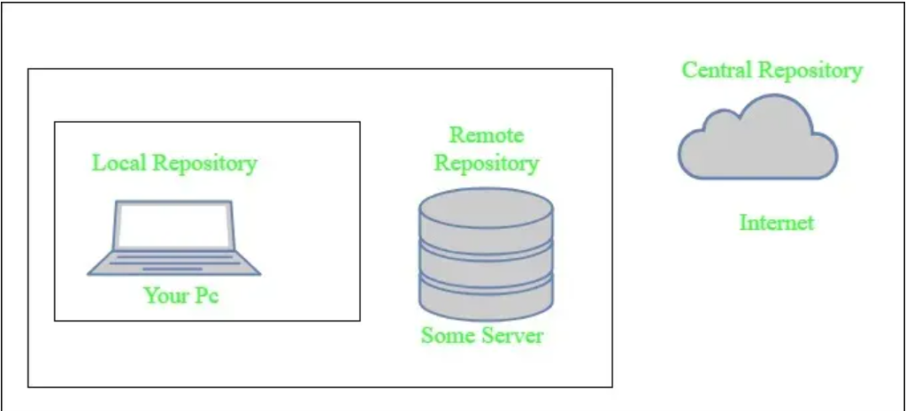

Dependency Management
Maven's superpower is Transitive Dependency Management.
- Scenario: You need Spring Boot Web. You add one dependency to your POM.
- Reality: Spring Boot Web depends on Spring Core, which depends on Logging, which depends on Jackson.
- Maven's Job: It automatically discovers this entire tree and downloads all required JARs for you.
Snapshot vs. Release
- Release (1.0.0): A stable, unchangeable version. Once released, it is frozen forever.
- Snapshot (1.0.0-SNAPSHOT): A development version. Maven checks for updates to Snapshots daily. This allows teams to share "work in progress" code without bumping version numbers constantly.
Build Profiles
Profiles allow you to change the build configuration based on the environment (e.g., Dev vs. Prod).
- Example: In "Dev", you might skip signing the JAR file to save time. In "Prod", signing is mandatory.
- You define profiles in the POM and activate them via the command line: mvn package -P prod.

Essential Commands Cheat Sheet
Command | Description
mvn clean | Deletes the target folder (cleans up old builds).
mvn compile | Compiles source code only.
mvn test | Compiles and runs unit tests.
mvn package | Creates the JAR/WAR file in target.
mvn install | Packages and copies the JAR to your local ~/.m2 repo.
mvn dependency:tree | Visualizes your project's entire dependency tree (great for debugging conflicts).

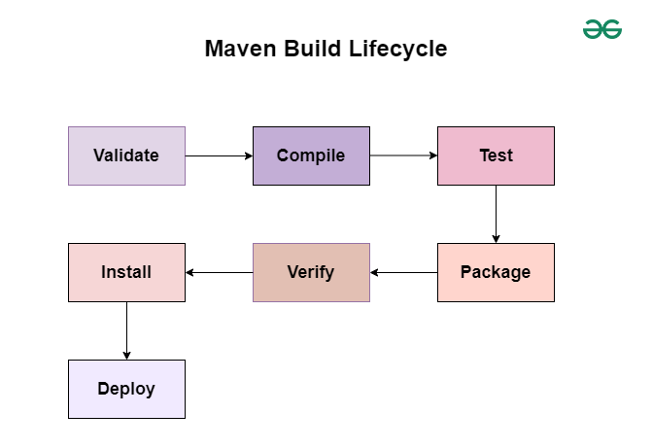
1. Default Lifecycle
The Default Lifecycle is the most commonly used lifecycle, focusing on the build process from validation to deployment.
Phases in this lifecycle are as follows:
- Validate Phase: Checks the project configuration to ensure all necessary information is present and valid.
- Compile Phase: Compiles the source code of the project.
- Test Phase: Runs unit tests using a testing framework to ensure the code works as expected.
- Package Phase: Packages the compiled code into a JAR, WAR, or other artifact format.
- Verify Phase: Performs additional checks on the packaged code to ensure it is valid.
- Install Phase: Installs the packaged artifact into the local repository for use as a dependency in other projects.
- Deploy Phase: Deploys the packaged artifact to a remote repository for sharing with other developers or teams.
2. Clean Lifecycle
The Clean Lifecycle is designed for cleaning the project, ensuring that artifacts generated from previous builds are removed before starting the new build process.
Phases in the Clean Lifecycle:
- pre-clean: Executes processes before cleaning.
- clean: Removes files generated by the previous build.
- post-clean: Executes processes after cleaning.
3. Site Lifecycle
The Site Lifecycle is responsible for generating and deploying project documentation.
Phases in the Site Lifecycle:
- pre-site: Executes processes before generating site documentation.
- site: Generates the site documentation.
- post-site: Executes processes after generating site documentation.
- site-deploy: Deploys the generated site documentation to a web server.
Major Sections of pom.xml
1. Project Information (<project>)
This is the root element of the POM file. It contains all project-related metadata and configuration used by Maven to manage the build process.
<project xmlns="http://maven.apache.org/POM/4.0.0"
xmlns:xsi="http://www.w3.org/2001/XMLSchema-instance"
xsi:schemaLocation="http://maven.apache.org/POM/4.0.0
http://maven.apache.org/xsd/maven-4.0.0.xsd">
2. Project Coordinates
Defines unique identifiers for your project in a Maven repository.
<groupId>com.geeks</groupId>
<artifactId>maven-pom-example</artifactId>
<version>1.0-SNAPSHOT</version>
- groupId: Usually your organization’s domain in reverse.
- artifactId: Project or module name.
- version: Current version of the project.
3. Properties Section
Defines reusable variables to maintain consistency and simplify version updates.
<properties>
<java.version>1.8</java.version>
<selenium.version>4.6.0</selenium.version>
<testng.version>7.4.0</testng.version>
</properties>
Using ${property.name} lets you reference these values across the file.
4. Dependencies Section
Lists all external libraries your project depends on. Maven automatically downloads them from configured repositories.
<dependencies>
<dependency>
<groupId>org.seleniumhq.selenium</groupId>
<artifactId>selenium-java</artifactId>
<version>${selenium.version}</version>
</dependency>
</dependencies>
Each dependency includes:
- groupId: Library’s organization.
- artifactId: Library name.
- version: Library version.
5. Repositories Section
Defines remote repositories from where Maven retrieves dependencies.
<repositories>
<repository>
<id>central</id>
<url>https://repo.maven.apache.org/maven2</url>
</repository>
</repositories>
If no repository is specified, Maven defaults to Maven Central.
6. Build Section
Controls how the project is compiled, packaged, and deployed.
<build>
<plugins>
<plugin>
<groupId>org.apache.maven.plugins</groupId>
<artifactId>maven-compiler-plugin</artifactId>
<version>3.8.1</version>
<configuration>
<source>${java.version}</source>
<target>${java.version}</target>
</configuration>
</plugin>
</plugins>
</build>
- Plugins: Define build tools such as compiler, JAR packager, or reporting tools.
- Configuration: Customizes how each plugin behaves.
7. Profiles Section
Allows defining environment-specific configurations such as development, testing, or production.
<profiles>
<profile>
<id>dev</id>
<properties>
<environment>development</environment>
<debug>true</debug>
</properties>
</profile>
</profiles>
Activate profiles using:
mvn clean install -Pdev
8. Plugin Management Section
Defines default versions and configurations of plugins to ensure consistency across modules.
<pluginManagement>
<plugins>
<plugin>
<groupId>org.apache.maven.plugins</groupId>
<artifactId>maven-dependency-plugin</artifactId>
<version>3.1.2</version>
</plugin>
</plugins>
</pluginManagement>
9. Reporting Section
Specifies plugins used to generate reports like Javadoc or test coverage.
<reporting>
<plugins>
<plugin>
<groupId>org.apache.maven.plugins</groupId>
<artifactId>maven-site-plugin</artifactId>
<version>3.9.1</version>
</plugin>
</plugins>
</reporting>

Plugins:
- Maven plugins are essential components in the Apache Maven build system, designed to extend its functionality. They perform tasks such as compilation, testing, packaging, deployment, and others.

Maven plugins are divided into two main types:
- Build Plugins
- Reporting Plugins

1. Build Plugins
These plugins are executed during the build process, and they are defined in the <build> section in the pom.xml file. For example, the Compiler Plugin, Surefire Plugin, and Assembly Plugin.
Common Build Plugins:
- Compiler Plugin: Compiles Java source code into bytecode.
- Surefire Plugin: Runs unit tests using frameworks like JUnit or TestNG.
- Failsafe Plugin: Executes integration tests, typically for verifying larger system components.
- JAR Plugin: Packages compiled code into a JAR (Java Archive) file.
- WAR Plugin: Creates a WAR (Web Archive) file for web applications.
- Assembly Plugin: Builds custom distributions, such as ZIP files containing project artifacts.
- Spring Boot Maven Plugin: Packages Spring Boot applications into executable JARs or WARs.

2. Reporting Plugins
These plugins are used for generating reports about the project. These are defined in the <reporting> section in the pom.xml file. Examples include the Surefire Report Plugin for generating test reports and the Javadoc Plugin for generating API documentation.
Examples
Here, we created a sample Maven project with the required project dependencies using the Spring Tool Suite IDE.

Example 1: Build Plugins
Here we created a Maven project with basic dependencies. Below we provide the pom file for your reference.
<build>
<plugins>
<plugin>
<groupId>org.springframework.boot</groupId>
<artifactId>spring-boot-maven-plugin</artifactId>
</plugin>
</plugins>
</build>
Example 2: Reporting Plugins
And here, we use java doc reporting plugin for generating project report.
<reporting>
<plugins>
<!-- Javadoc Plugin -->
<plugin>
<groupId>org.apache.maven.plugins</groupId>
<artifactId>maven-javadoc-plugin</artifactId>
<version>3.3.1</version>
<configuration>
<source>1.8</source>
</configuration>
</plugin>
</plugins>
</reporting>

The Maven Wrapper (mvnw)
is a utility that allows you to run Maven projects without needing a pre-installed Maven version. It ensures that the correct Maven version is used, providing consistency across different development environments. This guide explains the main concepts of the Maven Wrapper, demonstrates how to set it up in a Maven project, and provides examples of adding dependencies and configuring plugins in the pom.xml file.
What is Maven Wrapper?
The Maven Wrapper is a script (mvnw or mvnw.cmd) that can be added to a project. It allows you to run Maven commands using a specified Maven version, ensuring that all developers working on the project use the same Maven version and avoiding potential compatibility issues.
Why Use Maven Wrapper?
- Consistency: It ensures all the developers use the same Maven Version.
- Ease of use: No need to install the Maven on every developer's machine.
- Portability: Makes it easier to setup the CI/CD pipelines as the exact Maven version is specified of the application

🔍 Key Differences (Easy to Understand)
Aspect | Maven | Maven Wrapper
Installation | Must be installed on system | No installation needed
Maven version | Depends on system | Fixed per project
Consistency | May differ per machine | Same for everyone
CI/CD friendly | Needs setup | Works out of the box
Command | mvn | mvnw / mvnw.cmd
Configuration | System-level | Project-level

