Assignment –1
Creating sample tables and inserting values.

Create the following tables with the given structures and insert sample data as specified: -

- SALESPEOPLE
Snum int(4)
Sname varchar(10)
City varchar(10)
Comm float(3,2)

CREATE TABLE SALESPEOPLE(Snum int(4),Sname varchar(10),City varchar(10),Comm float(3,2));

- CUSTOMERS
Cnum int(4)
Cname varchar(10)
City varchar(10)
Rating int(4)
Snum int(4)

CREATE TABLE CUSTOMERS (Cnum int(4),Cname varchar(10),City varchar(10),Rating int(4),Snum int(4));

- ORDERS
Onum int(4)
Amt float(7,2) Odate date
Cnum int(4)
Snum int(4)

CREATE TABLE ORDERS (Onum int(4),Amt float(7,2),Odate date,Cnum int(4),Snum int(4));

SALES PEOPLE

SNUM | SNAME | CITY | COMM
1001 | Peel | London | .12
1002 | Serres | San Jose | .13
1004 | Motika | London | .11
1007 | Rifkin | Barcelona | .15
1003 | Axelrod | New York | .10

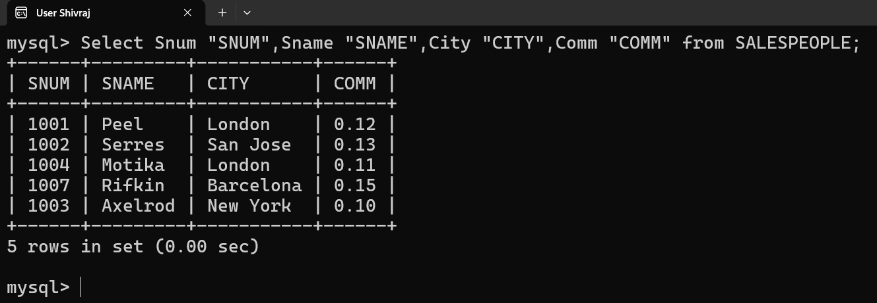

Page: 1

insert into salespeople values (1001, 'Peel', 'London', .12),
(1002, 'Serres', 'San Jose', .13),
(1004, 'Motika', 'London', .11),
(1007, 'Rifkin', 'Barcelona', .15),
(1003, 'Axelrod', 'New York', .10);

CUSTOMERS

CNUM | CNAME | CITY | RATING | SNUM
2001 | Hoffman | London | 100 | 1001
2002 | Giovanni | Rome | 200 | 1003
2003 | Liu | San Jose | 200 | 1002
2004 | Grass | Berlin | 300 | 1002
2006 | Clemens | London | 100 | 1001
2008 | Cisneros | San Jose | 300 | 1007
2007 | Pereira | Rome | 100 | 1004

INSERT INTO CUSTOMERS (Cnum, Cname, City, Rating, Snum) VALUES
(2001, 'Hoffman', 'London', 100, 1001),
(2002, 'Giovanni', 'Rome', 200, 1003),
(2003, 'Liu', 'San Jose', 200, 1002),
(2004, 'Grass', 'Berlin', 300, 1002),
(2006, 'Clemens', 'London', 100, 1001),
(2008, 'Cisneros', 'San Jose', 300, 1007),
(2007, 'Pereira', 'Rome', 100, 1004);
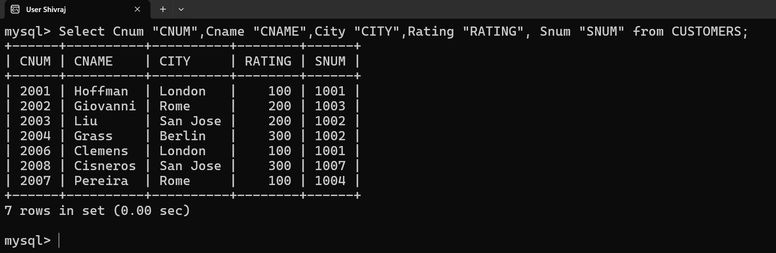

ORDERS

ONUM | AMT | ODATE | CNUM | SNUM
3001 | 18.69 | 03-OCT-1990 | 2008 | 1007
3003 | 767.19 | 03- OCT -1990 | 2001 | 1001
3002 | 1900.10 | 03- OCT -1990 | 2007 | 1004
3005 | 5160.45 | 03- OCT -1990 | 2003 | 1002
3006 | 1098.16 | 03- OCT -1990 | 2008 | 1007
3009 | 1713.23 | 04- OCT -1990 | 2002 | 1003
3007 | 75.75 | 04- OCT -1990 | 2004 | 1002
3008 | 4723.00 | 05- OCT -1990 | 2006 | 1001
3010 | 1309.95 | 06- OCT -1990 | 2004 | 1002
3011 | 9891.88 | 06- OCT -1990 | 2006 | 1001
INSERT INTO ORDERS VALUES (3001,18.69,'1990-10-03',2008,1007) ,(3003, 767.19, '1990-10-03', 2001, 1001),(3002, 1900.10, '1990-10-03', 2007, 1004),(3005, 5160.45, '1990-10-03', 2003, 1002),(3006, 1098.16, '1990-10-03', 2008, 1007),(3009, 1713.23, '1990-10-04', 2002, 1003),(3007, 75.75, '1990-10-04', 2004, 1002),(3008, 4723.00, '1990-10-05', 2006, 1001),(3010, 1309.95, '1990-10-06', 2004, 1002),(3011,9891.88,'1990-10-06',2006,1001);
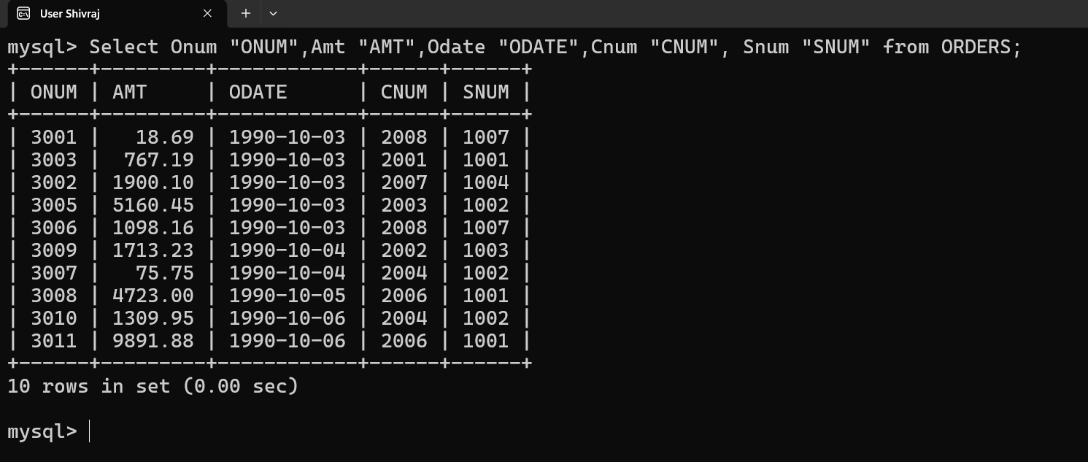

Page: 2

