Assignment –4
Retrieving Information from Tables.

- Write a select command that produces the order number, amount, and date for all rows in the Orders table.

mysql> Select Onum, Amt,Odate from ORDERS;

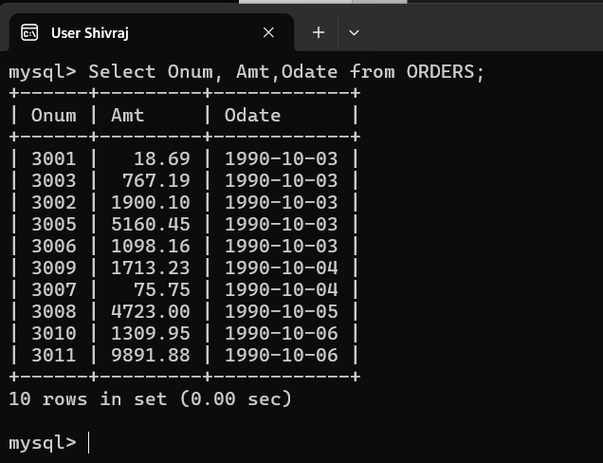

- Write a query that produces all rows from the Customers table for which the salesperson’s number is 1001.

mysql> Select * from Customers where Snum = 1001;
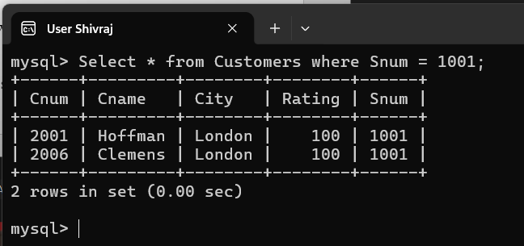

- Write a query that displays the Salespeople table with the columns in the following order: city, sname, snum, comm.

mysql> Select City, Sname, Snum, Comm from SALESPEOPLE;
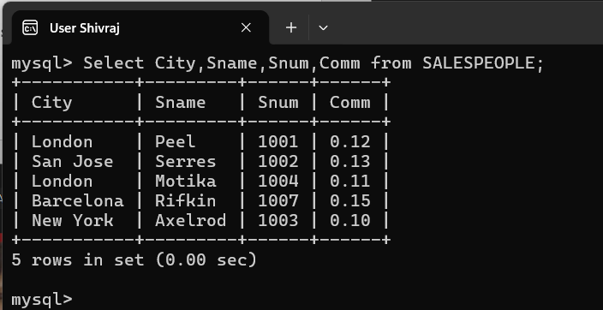

- Write a select command that produces the rating followed by the name of each customer in San Jose.
mysql> Select Rating , Cname from customers where city = 'San Jose';
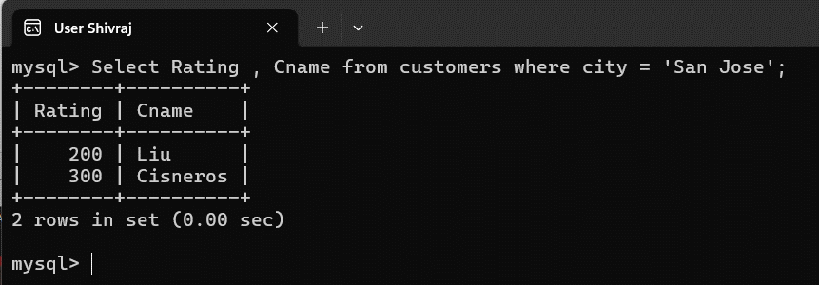

- Write a query that will produce the snum values of all salespeople (suppress the duplicates) with orders in the Orders table.

mysql> Select DISTINCT Snum from SALESPEOPLE ORDERS;
