Assignment –5 Relational and Logical Operators.

- Write a query that will give you all orders for more than Rs. 1,000.
mysql> Select * from ORDERS
-> where amt>1000;
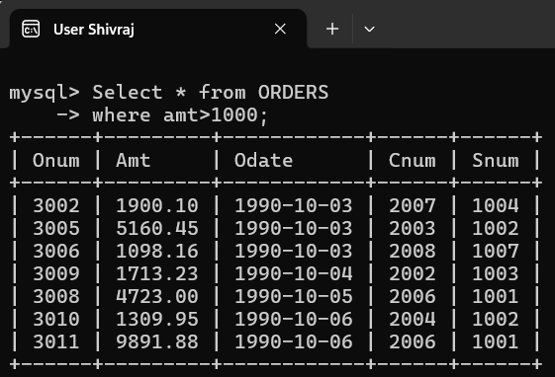

- Write a query that will give you the names and cities of all salespeople in London with a commission above .10.
mysql> Select Sname, City from SALESPEOPLE
-> where City = 'London' AND Comm > .10;
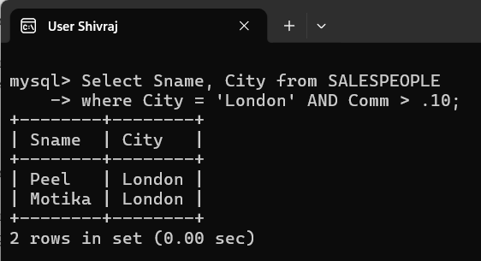

- Write a query on the Customers table whose output will exclude all customers with a rating <= 100, unless they are located in Rome.
mysql> Select * from CUSTOMERS
-> where Rating > 100 OR City ='Rome';
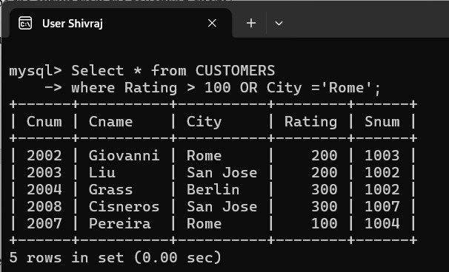

- What will be the output from the following query?

Select * from Orders
where (amt < 1000 OR
NOT (odate = ‘1990-10-03’
AND cnum > 2003));
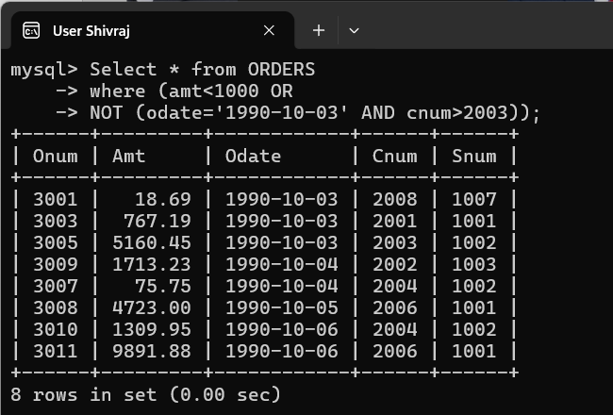

- What will be the output of the following query?

Select * from Orders where NOT ((odate = ‘1990-10-03’ OR snum
>1006) AND amt >= 1500);
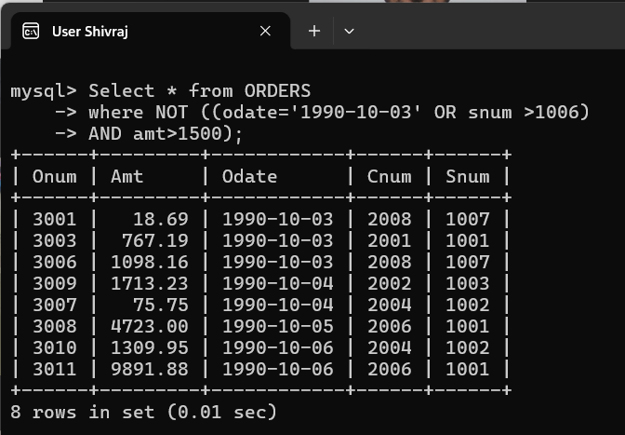

- What is a simpler way to write this query?

Select snum, sname, city, comm From Salespeople where (comm > .12 OR comm <.14);
mysql> Select Snum, Sname, City, Comm from Salespeople; 