Assignment –6
Using Special Operators in Conditions.

- Write two different queries that would produce all orders taken on October 3rd or 4th, 1990.
mysql> SELECT * from orders where odate = '1990-10-03' OR odate = '1990-10-04';
mysql> SELECT * from orders where odate IN ('1990-10-03','1990-10-04');
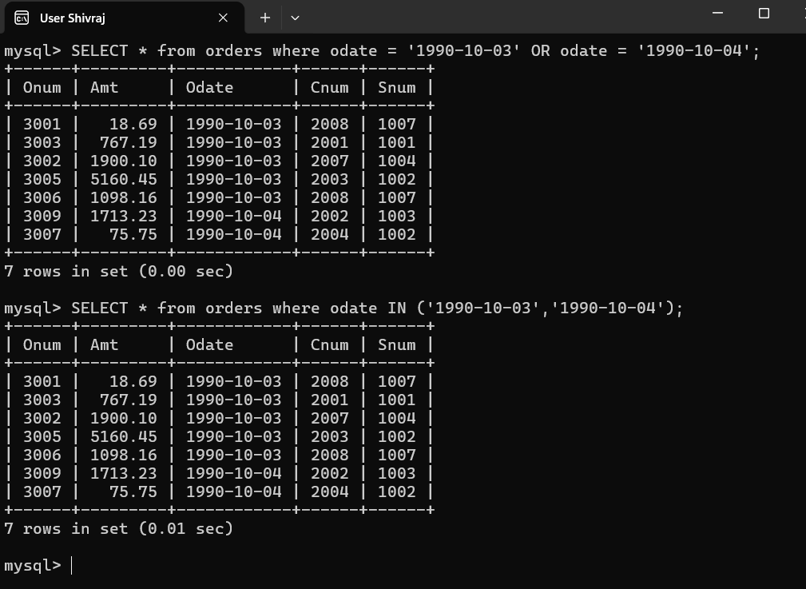

- Write a query that selects all of the customers serviced by Peel or Motika. (Hint: the snum field relates the two tables to one another).
mysql> Select * from customers where Snum in(1001,1004);
OR
mysql> Select * from customers where Snum In(Select Snum from Salespeople where sname='peel' or sname ='motika');
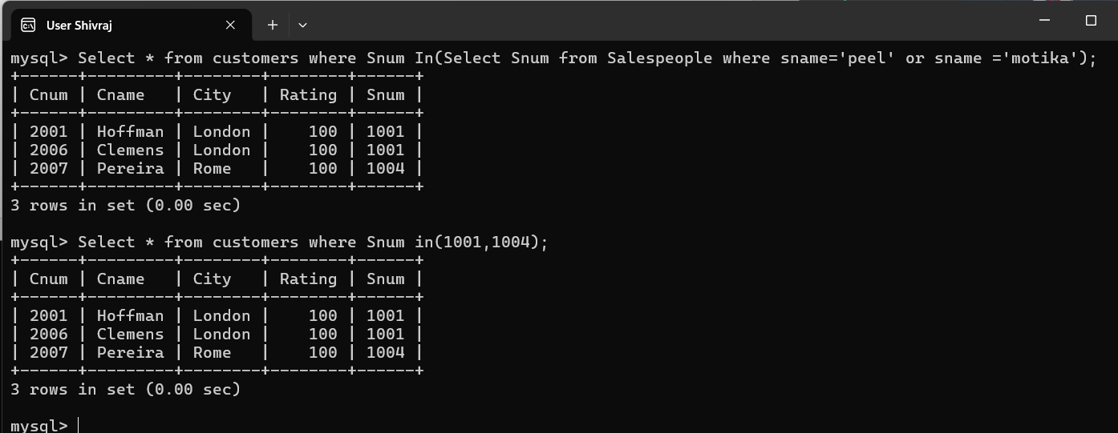
- Write a query that will produce all the customers whose names begin with a letter from ‘A’ to ‘G’.
mysql> Select * from CUSTOMERS where Cname>='A' AND Cname<='G';
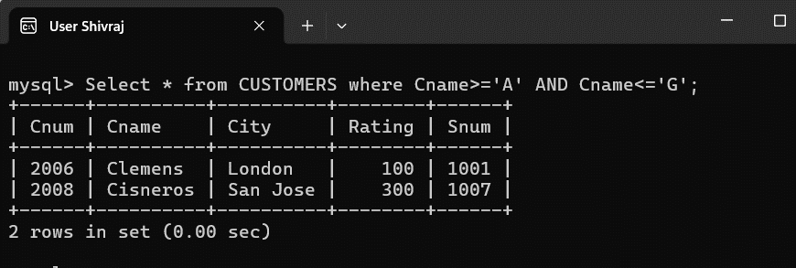

- Write a query that selects all customers whose names begin with the letter ‘C’.
mysql> Select * from CUSTOMERS where Cname like'C%' ;
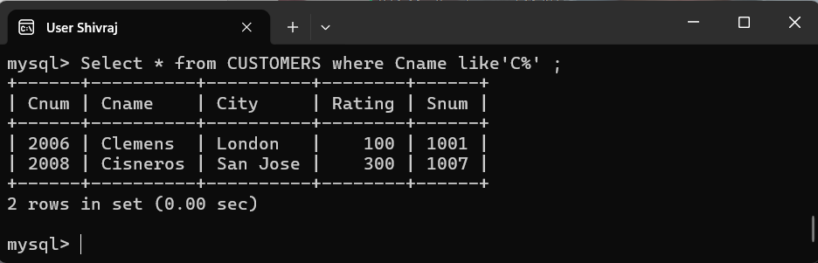

- Write a query that selects all orders except those with zeroes or NULLs in the amt field.
mysql> Select * from orders where Amt IS NOT NULL and amt >0;
