Assignment – 10
Joining a Table to Itself.

- Write a query that produces all pairs of salespeople who are living in the same city. Exclude combinations of salespeople with themselves as well as duplicate rows with the order reversed.
SELECT
s1.sname AS salesperson1,
s2.sname AS salesperson2,
s1.city
FROM salespeople s1
JOIN salespeople s2
ON s1.city = s2.city
AND s1.snum < s2.snum;
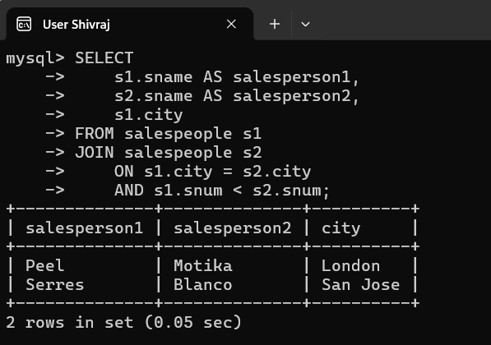

- Write a query that produces the names and cities of all customers with the same rating as Hoffman.
SELECT cname, city
FROM customers
WHERE rating = (
SELECT rating
FROM customers
WHERE cname = 'Hoffman'
);
