Assignment – 11 Subqueries.

- Write a query that uses a subquery to obtain all orders for the customer named Cisneros. Assume you do not know his customer number (cnum).
SELECT *
FROM Orders
WHERE cnum = (SELECT cnum FROM Customers WHERE cname = 'Cisneros');
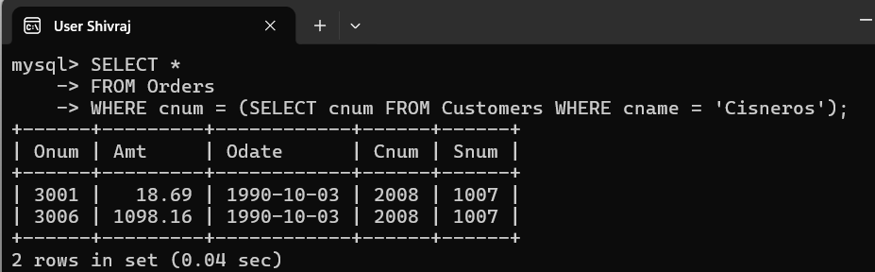

- Write a query that produces the names and ratings of all customers who have above-average orders.
SELECT DISTINCT c.cname, c.rating
FROM Customers c
JOIN Orders o ON c.cnum = o.cnum
WHERE o.amt > (SELECT AVG(amt) FROM Orders);
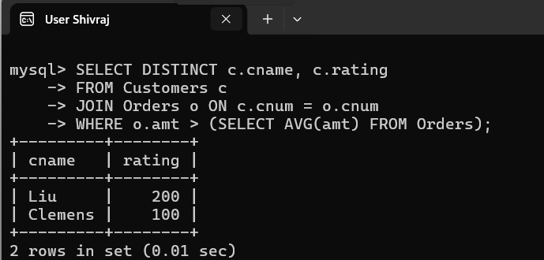

- Write a query that selects the total amount in orders for each salesperson for whom this total is greater than the amount of the largest order in the table.
SELECT snum, SUM(amt)
FROM Orders
GROUP BY snum
HAVING SUM(amt) > (SELECT MAX(amt)FROM Orders);
