Assignment – 12
Using the operators IN, ANY, and ALL.

- Write a query that selects all customers whose ratings are equal to or greater than ANY of Serres’.
SELECT *FROM customers
WHERE Rating >= ANY (
SELECT Rating FROM customers WHERE Cname = 'Serres');
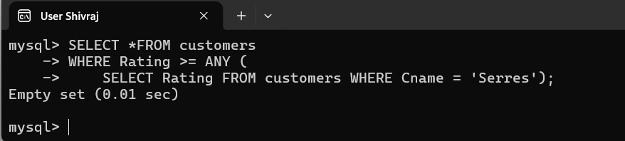

- Write a query using ANY or ALL that will find all salespeople who have no customers located in their city.
SELECT *
FROM Salespeople s
WHERE city <> ALL (SELECT city FROM Customers c WHERE c.Snum = s.Snum);
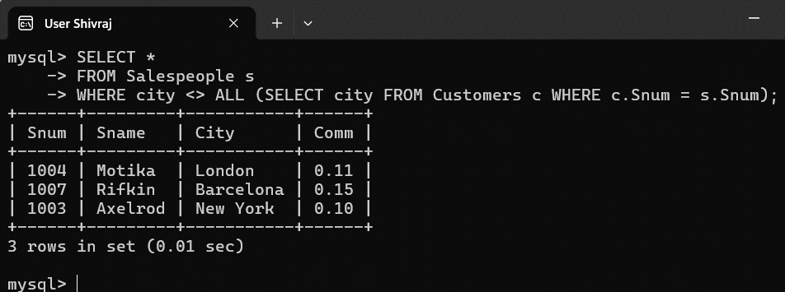

- Write a query that selects all orders for amounts greater than any for the customers in London.
SELECT *
FROM Orders
WHERE amt > ANY (
SELECT o.amt FROM Orders o JOIN Customers c ON o.Cnum = c.Cnum WHERE c.City = 'London');
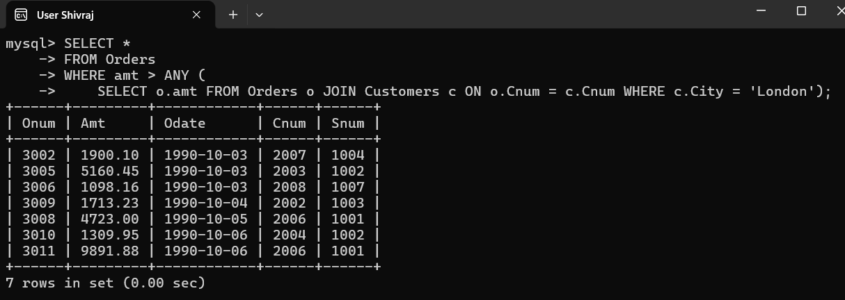

- Write the above query using MIN or MAX.
SELECT *
FROM Orders
WHERE amt > (
SELECT MIN(o.amt)FROM Orders o JOIN Customers c ON o.Cnum = c.Cnum WHERE c.City = 'London');
