Assignment – 13
Using the UNION clause.

- Create a union of two queries that shows the names, cities, and ratings of all customers. Those with rating of 200 or greater will also have the words “High Rating”, while the others will have the words “Low Rating”.
SELECT cname, city, rating, 'High Rating' AS status
FROM Customers WHERE rating >= 200
UNION
SELECT cname, city, rating, 'Low Rating' AS status
FROM Customers WHERE rating < 200;
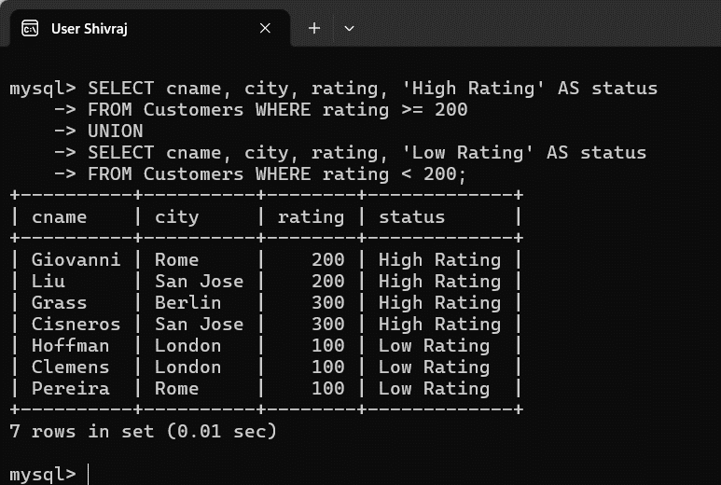

- Write a command that produces the name and number of each salesperson and each customer with more than one current order. Put the results in alphabetical order.
SELECT sname AS name, snum AS number
FROM Salespeople WHERE snum IN (
SELECT snum FROM Orders GROUP BY snum HAVING COUNT(*) >1)
UNION
SELECT cname AS name, cnum AS number
FROM Customers
WHERE cnum IN (
SELECT cnum
FROM Orders GROUP BY cnum HAVING COUNT(*) > 1)ORDER BY name;
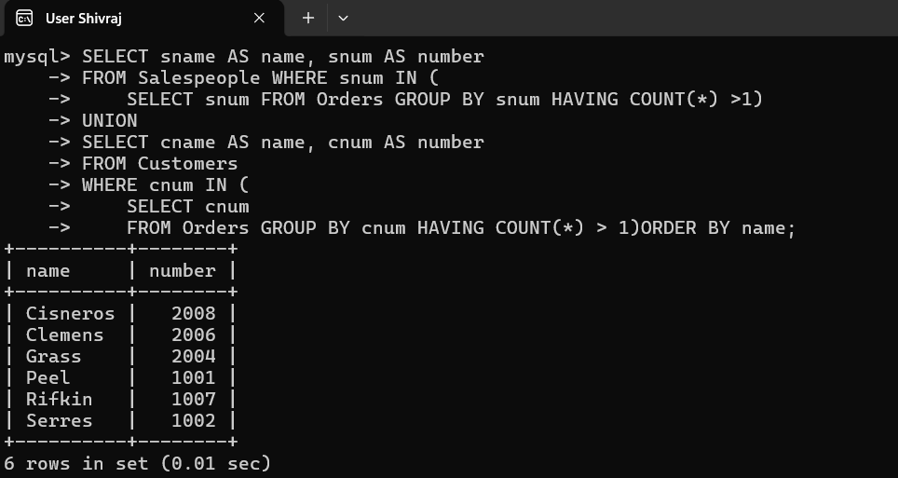

- Form a union of three queries. Have the first select the snums of all salespeople in San Jose; the second, the cnums of all customers in San Jose; and the third the onums of all orders on October 3. Retain duplicates between the last two queries but eliminate any redundancies between either of them and the first.
(Note: in the sample tables as given, there would be no such redundancy. This is besides the point.)
SELECT snum AS num
FROM Salespeople
WHERE city = 'San Jose'
UNION
SELECT cnum
FROM Customers
WHERE city = 'San Jose'
UNION ALL
SELECT onum
FROM Orders
WHERE odate = '1990-10-03';
