Assignment – 14
Entering, Deleting, and Changing Field Values.

- Write a command that puts the following values, in their given order, into the salespeople table: city – San Jose, name – Blanco, comm – NULL, cnum – 1100.
INSERT INTO Salespeople (city, sname, comm, snum)
VALUES ('San Jose', 'Blanco', NULL, 1100);
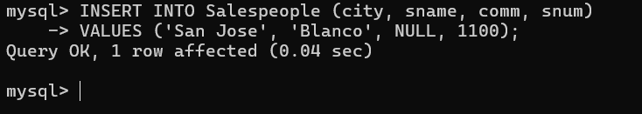

- Write a command that removes all orders from customer Clemens from the Orders table.
delete from orders WHERE Cnum = (SELECT cnum FROM Customers WHERE Cname = 'Clemens');

- Write a command that increases the rating of all customers in Rome by 100.
UPDATE Customers
SET rating = rating + 100
WHERE city = 'Rome';
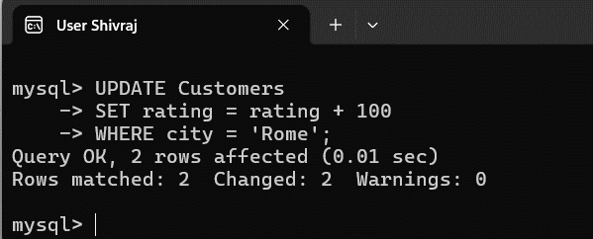

- Salesperson Serres has left the company. Assign her customers to Motika.
UPDATE Customers
SET snum = (
SELECT snum FROM Salespeople WHERE sname = 'Motika')
WHERE snum = (
SELECT snum FROM Salespeople WHERE sname = 'Serres');
