Assignment – 15
Using Subqueries with DML Commands.

- Assume there is a table called Multicust, with all of the same column definitions as Salespeople. Write a command that inserts all salespeople with more than one customer into this table.
CREATE TABLE Multicust AS
SELECT *
FROM Salespeople
WHERE 1 = 0;

INSERT INTO Multicust
SELECT *
FROM Salespeople
WHERE Snum IN (
SELECT Snum
FROM Customers
GROUP BY Snum HAVING COUNT(*) > 1);
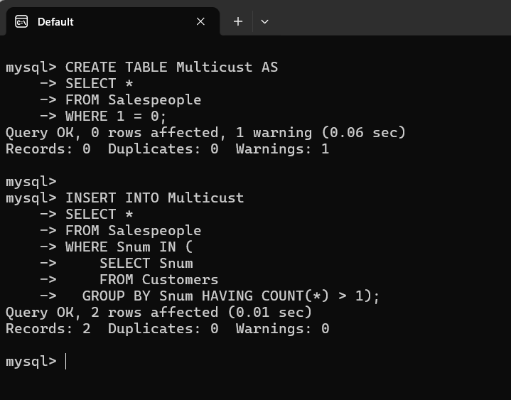

- Write a command that deletes all customers with no current orders.
DELETE FROM Customers
WHERE cnum NOT IN (
SELECT cnum
FROM Orders
);
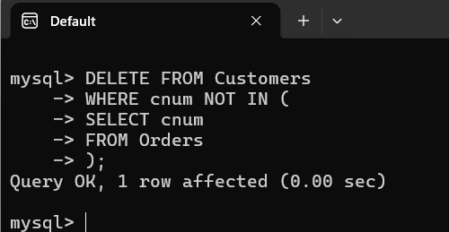

- Write a command that increases by twenty percent the commissions of all salespeople with total orders above Rs. 3,000.
UPDATE Salespeople
SET comm = comm * 1.20
WHERE snum IN (
SELECT snum
FROM Orders
GROUP BY snum
HAVING SUM(amt) > 3000
);
