Assignment – 16
Creating Tables and Indexes.

- Write a command that will enable a user to pull orders grouped by date out of the Orders table quickly.
CREATE INDEX idx_odate
ON Orders (odate);
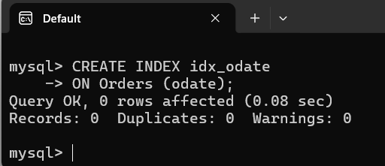

- If the Orders table has already been created, how can you force the onum field to be unique (assume all current values are unique)?
CREATE UNIQUE INDEX idx_onum
ON Orders (onum);
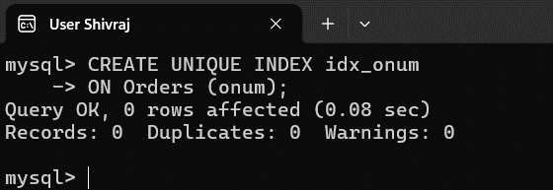

- Create an index that would permit each salesperson to retrieve his or her orders grouped by date quickly.
CREATE INDEX idx_snum_odate
ON Orders (snum, odate);
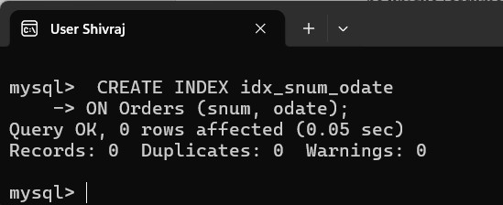

- Let us assume that each salesperson is to have only one customer of a given rating, and that this is currently the case. Enter a command that enforces it.

